**Introduction**

This document describes the low level processing associated with a contest that, in some states that have Open Primaries (ones that contain contest from all eligible parties on a single ballot), allow the voter to select the party whose ballot they intend to vote in the privacy of the voting booth. This contest is a nonpartisan contest that appears on the ballot ahead of any partisan contest and, if a selection is made, protects the voter from spoiling the partisan section of the ballot. See Open Primary Voting Method for a description of Open Primary with and without the use of the Party Preference Contest.

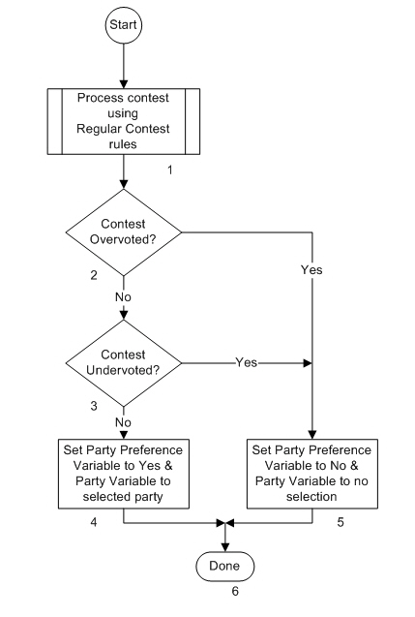The flow chart below indicates the processing flow for the contest and each block in the flow is described.

**Description**

1. Process the Contest using Regular Contest rules.

Although the result of processing this contest has special uses, the processing itself treats it like any other Regular contest. Selections are always limited to one choice so there are 3 possible processing results, a party selected, an undervote (no selection) or an overvote (too many selections).

1. Contest Overvoted?

Was the result of processing the contest an overvote? The Yes path is taken if it was. The No path is taken if it wasn’t.

1. Contest Undervoted?

Was the result of processing the contest an undervote? The Yes path is taken if it was. The No path is taken if it wasn’t.

1. Set Party Preference Variable to Yes & Party Variable to selected Party

This block is only reached if there was a valid party selection made by the voter. The Party Preference Variable is set to Yes and the Party Variable is set to that party. For flow chart purposes, the Party Preference Variable is the term being used to remember whether a valid selection was made in the Party Preference contest. The Party Variable term is being used to identify whether the ballot is already associated with a particular party which is needed when processing selections from partisan contests on the ballot.

1. Set Party Preference Variable to No and Party Variable to no selection

This block is reached if the contest was either not voted or overvoted. In either case there is no valid party selection and the Party Preference Variable is set to No and the Party Variable is set to no selection.

1. Done

Processing of the Party Preference contest is complete.