**Introduction**

The Presidential Delegate contests appear on the closed Presidential Preference Primary ballots of two states, Alabama (both Democratic and Republican ballots) and Rhode Island (Democratic ballot only). It allows the voter to select candidates from various contest groupings to be delegates to the party National Nominating Convention. The allowed selections, however, are limited to those that are representing the presidential candidate chosen by the voter. See Presidential Delegate Voting Method for a description of this special Presidential Preference Primary.

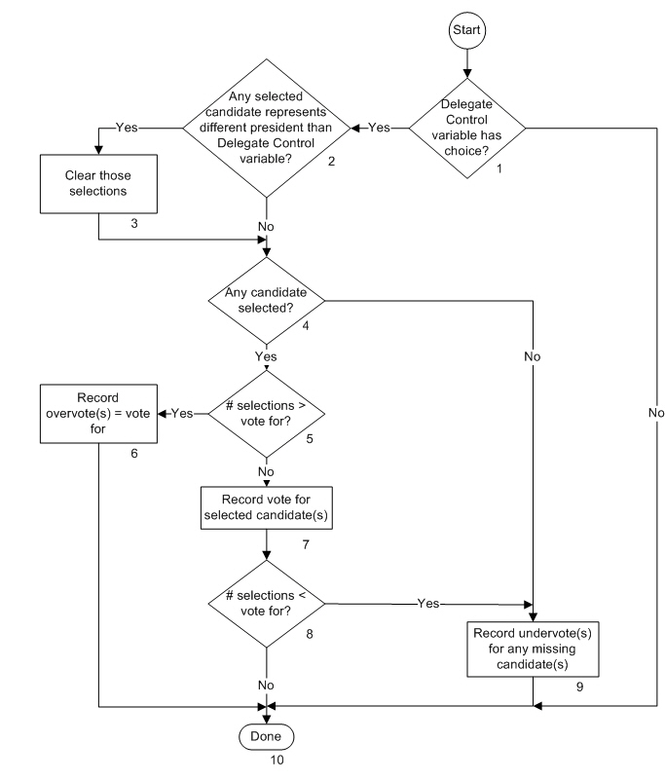The flow chart below indicates the processing flow for the contest and each block in the flow is described.

**Description**

1. Delegate Control variable has choice?

Does the Delegate Control variable contain a Presidential choice? For flow chart purposes, the Delegate Control variable is the term being used to remember the result of processing the Presidential Preference contest. If the variable does not contain a Presidential Preference contest choice, the No path is taken and the contest is not tabulated. The Yes path is taken if there is was choice.

1. Any selected candidate represents different president than Delegate Control variable?

Do any of the selected candidates represent a different presidential candidate than the presidential candidate selected by the voter as identified in the Delegate Control variable? (For flow chart purposes, the Delegate Control Variable is used to remember the selection in the Presidential Preference contest.) The Yes path is taken if there were any. The No path is taken if there are none.

1. Clear those selections

The selection of any chosen delegate candidate that represents a different presidential candidate than the one chosen by the voter will be cleared and processing continues.

1. Any candidate selected?

If there is no remaining selection or was not selection in the contest to being with, the No path is taken. The Yes path is taken if there is at least one candidate selected by the voter.

1. # Selections > vote for?

Are there more selections of allowed candidates than allowed number of selections? The Yes path is taken if there are (an overvote). The No path is taken if there are not. (Number of valid selections is less than or equal to the number allowed.

1. Record overvote(s) = vote for

This block is reached if there are more valid selections than the number allowed. A number of overvotes are recorded equal to the votes allowed in the contest. This completes contest processing.

1. Record vote for selected candidate(s)

All selected candidates that are valid based on presidential candidate selection will receive a vote.

1. # selections < vote for?

Is the number of selected candidates that are valid based on the presidential selection less than the number of selections allowed? The Yes path is taken if there are unused selections so that undervotes can be tabulated. The No path is taken if all choices were used as processing is completed.

1. Record undervote(s) for any missing candidate(s)

If there is no candidate selected in the contest or if there are not as many valid candidates selected as allowed, an undervote is recorded for each vote that has not been allocated. Processing is then completed.

1. Done

Processing of the Presidential Delegate contest is complete.