**Introduction**

Proportional Voting is a voting method that applies to a multi-seat contest. Similar to the Cumulative Voting contest, it allows a voter to allot more than one vote to a candidate. However, it differs from Cumulative Voting in that the distribution of votes is proportional, based on the number of selections. As long as the number of selected candidates is less than or equal to the number of allowed selections, tabulation proportionally allots an equal number of votes to each selected candidate based on the number of votes allowed and the number of candidate selected. Note that this number can be fractional. This voting method was the genesis of the term “bullet vote” as the selection of a single candidate allots all allowed votes to that candidate.

Proportional Voting was used in electing representatives to the Illinois General Assembly for 110 years until it’s elimination in 1980. It applied to both the Primary and the General and the voter had 3 votes to distribute. In the Primary each party had to provide a minimum of two candidates so the fraction could only be ½ (if the voter selected 2 candidates).

The City of Peoria Illinois has used Proportional Voting to elect 5 at large members to their City Council since 1991. If voter a selected 1, 2, 3, 4 or 5 candidates each candidate would get 5, 2½, 1 2 /3, 11/4 or 1 vote respectively.

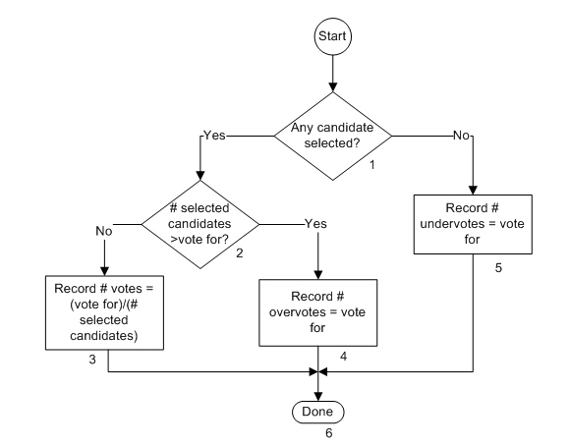The flow chart below indicates the processing flow for the contest and each block in the flow is described.

**Description**

1. Any candidate selected?

If there is no selection in the contest, the No path is taken. The Yes path is taken if there is at least one candidate is selected by the voter.

1. # selected candidates > vote for?

The Yes path is taken if the number of candidates selected is greater than the number of allowed selections. The No path is taken if the number is less than or equal to the number of allowed selections.

1. Record # votes = (vote for)/(# selected candidates)

A number of votes is proportionally distributed and recorded equally among the selected candidates. The number of votes is equal to the number of votes allowed divided by the number of selections. This will be a whole number of votes if there is only 1 selection (candidate gets all allowed votes) or the number of selections is equal to the votes allowed (each gets 1 vote). In all other cases, the recorded vote may contain fractional votes.

1. Record # overvotes = vote for

Since there are more vote selections than allowed, a number of overvotes will be recorded equal to the allowed number of votes.

1. Record # undervotes = vote for

Since there are no vote selections, a number of undervotes will be recorded equal to the allowed number of votes. Note that undervotes can never be recorded if there is a selection.