**Overview**

Ranked Choice Voting (RCV) is a voting method where the voter is able to identify their candidate choices in order of preference. Although voting the ballot is the same, there are many variations used in processing ballot selections to determine the candidates that are elected. Cast Vote Records (CVRs) are required for any form of RCV tabulation.

The “traditional” tabulation process is a multi-round process that is either always used or is used if a candidate (or candidates in a multi-seat contest) does not receive sufficient votes in tabulated first choices to meet the requirements to be elected. In each round the candidate (or candidates) with the least votes is eliminated and, using the CVRs, a vote from the eliminated candidate is reallocated to the next highest ranked continuing candidate. This process proceeds until the requirements are met to have the candidate(s) elected.

This document describes an alternative approach that is required if a candidate does not receive sufficient votes to meet the requirement to get elected. It was previously used by the State of North Carolina in 2010 in several single seat contests. The method attempts to emulate a separate runoff election by making only the top 2 candidates be eligible to win. CVRs are processed for only those ballots where the first choice was not for the eligible candidates but have a valid subsequent choice for an eligible candidate. This choice is reallocated to the eligible candidate and the candidate with the most votes wins after this one additional round.

Using the “traditional” method of tabulation, all CVRs must be available and be processed in its entirety. This is necessary to be able to determine the candidate(s) with the least votes and procede with the round by round iterative process. Using the alternative method, if one or more candidates do not receive the required number of votes to be elected, CVRs do not have to be available at one location and are processed incrementally in any desired batches or groupings once the eligible candidates have been determined from the tabulated valid first choice selections.

Note that this method can be used for multi-seat contests by electing candidates one at a time and, after a candidate is elected, remove that candidate from the eligible list before running the next round.

The following flow chart and ensuing description is an attempt to chart Top 2 Ranked Choice Voting process that emulates a separate runoff election as it applies to single seat contest. See the Process Ranked Choice Voting Contest (IRV or STV) document for handling the “traditional” methods of RCV processing.

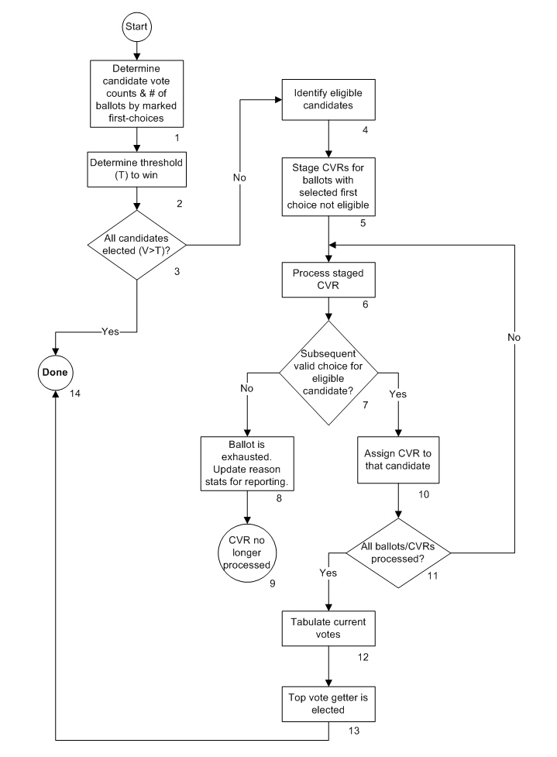

**Description**

1. Determine candidate vote counts & # of ballots by marked first-choices

The number of 1st choice candidate votes used for initial determination of whether a candidate is elected is a tabulated count of valid marked 1st choice selections. The tabulated marked 1st choice count of selections is normally the initial tabulator count and does not require processing of the Cast Vote Record. Note that the RCV process is not needed if a candidate has the required number of votes to be elected per step 2.

1. Determine threshold (T) to win

This is the number of votes needed to be elected which must exceed the calculated threshold. For a single seat contest, the threshold is typically at least 50% of the ballots cast. A candidate would then need 50% of the votes+ 1 vote to be elected. However there can be exceptions and depend on jurisdiction specific rules. The threshold might be based on total votes cast for candidates or might be based on the total number of ballots. The generic formula for any number of candidates to be elected is:

T= B / (N+1)

T is the threshold, B is the number of relevant ballots and N is the number of candidates to be elected. Thus in a contest where only 1 is to be elected the threshold is B/2 and the required number of votes to be elected is one more than that number (50% +1).

1. All candidates elected (V >T)?

Is there a candidate with the number of first choice votes greater than the threshold (is elected)? The Yes path is taken if this is true. The No path is taken if the position has not been filled due to an insufficient candidate number of marked first-choice votes. If a candidate has a number of marked first-choice votes to exceed the threshold, the RCV process is not required.

1. Identify eligible candidates

In a single seat contest, the eligible candidates are the 2 candidates with the most votes.

1. Stage CVRs for ballots with selected first choice not eligible to win

CVRs may be processed in groups such as by precinct, by poll or by other relevant grouping. Only those CVRs are processed that do not have a marked first choice selection for an eligible candidate.

1. Process staged CVR

The next subsequent choice for an eligible candidate, if one exists, will be determined for each staged CVR. Note that there are jurisdiction specific rules when encountering the following conditions on a choice selection while executing the RCV algorithm. The option may also depend on whether the condition is encountered in the 1st choice or subsequent choice selections. These are listed below with the possible options of handling.

* Unvoted choice
  + Ballot considered exhausted
  + Ballot considered exhausted if there are two unvoted choices in succession
  + Skipped and subsequent eligible choice processed, if any
* Overvoted choice
  + Ballot considered exhausted (most common)
  + Not considered overvoted if doesn’t contain more than one continuing candidate
  + Skipped and subsequent eligible choice processed, if any
* Repeated ranking of a previously ranked candidate
  + Ballot considered exhausted
  + Skipped and subsequent eligible choice processed, if any

1. Subsequent valid choice for eligible candidate?

The No path is taken for the processed CVR when there isn’t a valid choice for an eligible candidate. An invalid choice could include selections for more than one eligible candidate depending on jurisdiction rules. The Yes path is taken if there is a valid subsequent choice for an eligible candidate.

1. Ballot is exhausted. Update reason stats for reporting

This CVR (ballot) will not be included in any further processing as there are no more eligible marked candidates selections. This may be due to not containing further ranking selections, an overvote in a the current ranking choice preventing consideration of subsequent rankings, the repeated selection of an already ranked candidate, or all subsequent ranking selections are not for eligible candidates. The reason for the ballot being considered exhausted is recorded for purposes of reporting round results.

1. CVR no longer processed

Indicates that the ballot is no longer part of any processing.

1. Assign CVR to that candidate

The next highest ranked choice on the CVR for an eligible candidate will be assigned to that candidate and contribute a full vote to the final accumulation.

1. All CVRs processed?

The No path is taken to process the next staged CVR if all CVRs have not yet been processed. The Yes path is taken if all staged CVRs have been processed.

1. Tabulate current votes

A count of all candidate votes from the processed CVRs will be tabulated.

1. Top vote getter is elected

The candidate with the most votes is elected. Jurisdiction rules will apply In the event of a tie.

1. Done

Indicates that candidate has been elected and the process is complete.