**Overview**

There is a contest pair, one controlling and the other controlled that are traditionally called Recall. This document describes the low level processing associated with contest that is being controlled by the Recall Controlling contest. See the Recall Contest Control Voting Method document for a full description. The Controlling contest must be voted according to 1 of 2 rules in order for the Controlled contest to be tabulated. Otherwise it is ignored for processing. Depending on the rules, it is either any vote in the controlling contest or only a Yes vote. In traditional use, the Controlling contest is in a referendum format.

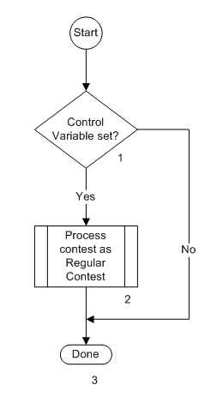The flow chart below indicates the processing flow for the Recall Controlled contest and each block in the flow is described.

**Description**

1. Control Variable set?

Since tabulation of this contest is controlled by vote processing in another contest (the Controlling Contest), for description purposes, the Control variable is the term being used to capture the result of tabulating the Controlling contest. If the Control Variable has been set by the Controlling contest (indicating that the requirement for tabulation has been satisfied), the Yes path is taken. Otherwise the No path is taken and no tabulation (including undervotes) occurs.

1. Process contest as Regular Contest

The contest is process as it would be if it were not controlled. Typically this would be as a Regular contest with no other special rules applied.

1. Done

Processing of the contest is complete