Reference Architecture

The High Level Layered Reference Model below is the most abstract that can capture the essential feature of Big Data architectures. 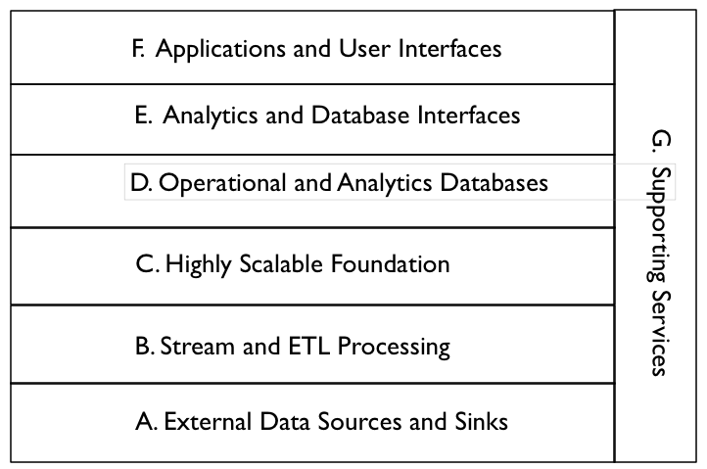
Descriptions of the Components of the High Level Layered Reference Model. Points for future discussion are in bold. Examples are from the Apache Big Data Ecosystem.

A. External Data Sources and Sinks - Provides external data inputs and output to the internal Big Data components. Note that Big Data stores can output data flows to external systems e.g. feeding external databases.

B. Stream and ETL Processing - Filters and transforms data flows between external data resources and internal Big Data systems. This processing should also be scalable by adding additional processors

C. Highly Scalable Foundation - Horizontally scalable data stores and processing that form the foundation of Big Data Architectures. It is essential to represent this layer explicitly in the Reference Architecture.

D. Operational and Analytics Databases - Databases integrated into the Big Data architecture. These can be horizontally scalable databases or single platform databases with data extracted from the foundational data store. Big Data databases (e.g. NoSQL, NewSQL) must be explicitly represented in the Big Data architecture.

E. Analytics and Database Interfaces - These are the interfaces to the data stores for queries, updates, and analytics. They are included in the Reference Architecture because data stores may have multiple interfaces (e.g. Pig and Hive to HDFS) and this is an area of possible standardization.

F. Applications and User Interfaces - These are the applications (e.g. machine learning) and user interfaces (e.g. visualization) that are built on Big Data components. Applications must have an underlying horizontally scalable data storage and processing foundation to qualify as Big Data applications.

G. Supporting Services - These services include the components needed for the implementation and management of robust Big Data systems. The key difference is that services must be enhanced to handle scalable horizontally distributed data sources and processing deployed on relatively low reliability platforms.

The Lower Level Reference Architecture below expands on some of the layers in the High Level Layered Reference Model and shows some of the data flows. It can be drilled down as necessary.
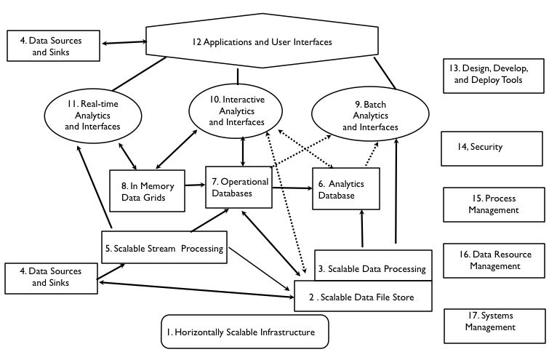

A. External Data Sources and Sinks - Data sources might be separated from sinks in a more detailed model

4. Data Sources and Sinks - These are components in a complete data architecture that clearly defined interfaces to Big Data horizontally scalable internal data stores and applications.

B. Stream and ETL Processing - Stream Processing and Extract, Transform, Load (ETL) processing might be split in a more detailed architecture

5. Scalable Stream Processing - This is processing of “data in movement” between data stores. It can be used for filtering, transforming, or routing data. For Big Data streams, the stream processing must be scalable to support distributed and/or pipelined processing.

C. Highly Scalable Foundation - This is the core of Big Data Technology. There
are several aspects including data stores (e.g. Hadoop File System), e.g. data processing (e.g. MapReduce) and infrastructure (e.g. Clouds)

- Scalable Infrastructure - To support scalable Big Data stores and processing, it is necessary to have an infrastructure that can support the easy addition of new resources. Possible platforms include public and/or private Clouds.

- Scalable Data Stores - This is the essence of Big Data architecture. Horizontal scalability using less expensive components can support the unlimited growth of data storage. However there must be fault tolerance capabilities available to handle component failures.

3 . Scalable Processing - To take advantage of scalable distributed data stores, it is necessary to have scalable distributed parallel processing with similar fault tolerance. In general, processing should be configuring to minimize unnecessary data movement.

D. Operational and Analytics Databases - The databases are split because this is currently a differentiator that effects interfaces and applications

6. Analytics Databases - Analytics databases are generally highly optimized for read-only interactions (e.g. columnar storage, extensive indexing, and denormalization). It is often acceptable for database responses to have high latency (e.g. invoke scalable batch processing over large data sets).

7. Operational Databases - Operation databases generally support efficient write and read operations. NoSQL databases are often used in Big Data architectures in this capacity. Data can be later transformed and loaded into analytic databases to support analytic applications.

8. In Memory Data Grids - These are very high performance data caches and stores that minimize writing to disk. They can be used for large scale real time applications requiring transparent access to data.

The diagram below from http://blogs.the451group.com/information_management/2011/04/15/nosql-newsql-and-beyond/ provides a multiple attribute classification of databases including analytic databases, operational databases, and in memory data grids. Big Data databases are in the shaded boxes.

SPRAIN in the diagram (451group terminology) stands for some of the drivers for using new Big Data databases.

- Scalability – hardware economics
- Performance – MySQL limitations
- Relaxed consistency – CAP theorem
- Agility – polyglot persistence
- Intricacy – big data, total data
- Necessity – open source

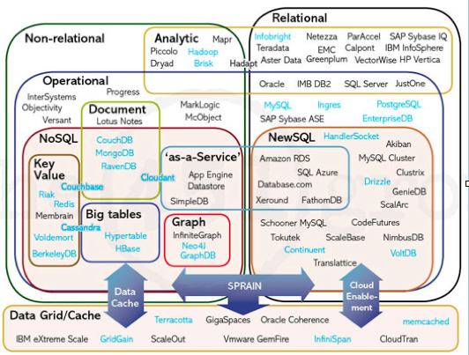

E. Analytics and Database Interfaces - Interfaces and simple analytics
are bundled together because there are overlaps e.g. SQL interfaces and SQL-based analytics, The interfaces and analytics are split into subgroups by latency. There is a definite distinction between interfaces requiring batch processing (e.g. current Hive, Pig), end-user interactive responses (e.g. HBase), and ultrafast real-time responses (e.g machine-based Complex Event Processing).

- Batch Analytics and Interfaces - These are interfaces that use batch scalable
processing (e.g. Map-Reduce) to access data in scalable data stores (e.g Hadoop File System). These interfaces can be SQL-like (e.g. Hive) or programmatic (e.g. Pig).

- Interactive Analytics and Interfaces - These interfaces avoid directly access data
stores to provide interactive responses to end-users. The data stores can be horizontally scalable databases tuned for interactive responses (e.g. HBase) or query languages tuned to data models (e.g. Drill for nested data).

11. Real-Time Analytics and Interfaces - There are applications that require real time responses to events occurring within large data streams (e.g. algorithmic trading). This complex event processing is machine-based analytics requiring very high performance data access to streams and data stores.

F. Applications and User Interfaces - Visualization might be split from applications in a more detailed model.

12. Applications and Visualization - The key new capability available to Big Data analytic applications is the ability to avoid developing complex algorithms by utilizing vast amounts of distributed data (e.g. Google statistical language translation). However taking advantage of the data available requires new distributed and parallel processing algorithms.

G. Supporting Services - These services are available in all robust enterprise architectures. The key extension for Big Data is the ability to handle horizontal components. They could all be expanded in a more detailed Reference Architecture.

- Design, Develop, and Deploy Tools - High level tools are limited for the implementation of Big Data applications (e.g. Cascading). This will have to change to lower the skill levels needed by enterprise and government developers.

- Security - Current Big Data security and privacy controls are limited (e.g. only Kerberos authentication for Hadoop, Knox). They must be expanded in the future by commercial vendors (e.g. Cloudera Sentry) for enterprise and government applications.

- Process Management - Commercial vendors are supplying process management tools to augment the initial open source implementations (e.g. Oozie)

- Data Resource Management - Open Source data governance tools are still immature (e.g. Apache Falcon). These will be augmented in the future by commercial vendors.

- System Management - Open source systems management tools are also
immature (e.g. Ambari). Fortunately robust system management tools are
commercially available for scalable infrastructure (e.g. Cloud-based).

Apache’s Big Data Offerings are mapped to the Reference Architecture in the diagram below for reference. An overview of the Apache ecosystem is at
http://www.revelytix.com/?q=content/hadoop-ecosystem

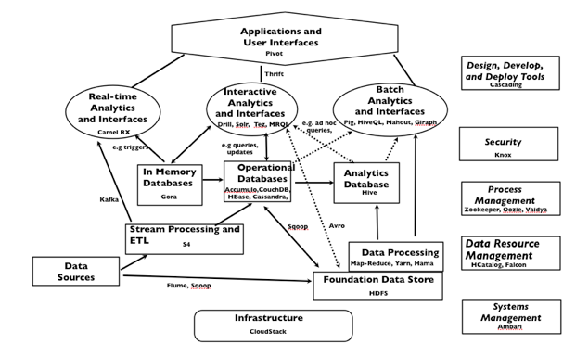

Requirements, Gap Analysis, and Suggested Best Practices

In the Requirements discussion, building block components for use cases will be mapped to elements of the Reference. These components will occur in many use cases across multiple application domains. A short description, possible requirements, gap analysis, and suggested best practices is provided for each building block.

- Data input and output to Big Data File System (ETL, ELT)

Example Diagram:

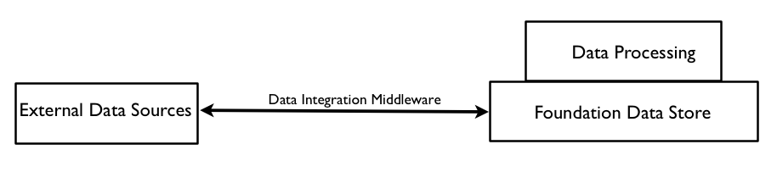
Description: The Foundation Data Store can be used as a repository for very large amounts of data (structured, unstructured, semi-structured). This data can be imported and exported to external data sources using data integration middleware.

Possible Requirements: The data integration middleware should be able to do high performance extraction, transformation and load operations for diverse data models and formats.

Gap Analysis: The technology for fast ETL to external data sources (e.g Apache Flume, Apache Sqoop) is available for most current data flows. There could be problems in the future as the size of data flows increases (e.g. LHC). This may require some filtering or summation to avoid overloading storage and processing capabilities

Suggested Best Practices: Use packages that support data integration. Be aware of the possibilities for Extract-Load-Transform (ELT) where transformations can be done using data processing software after the raw data has been loaded into the data store e.g, Map-Reduce processing on top of HDFS.

- Data exported to Databases from Big Data File System

Example Diagram:

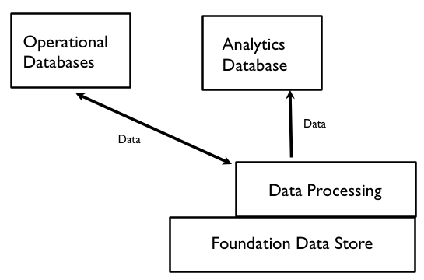

Description: A data processing system can extract, transform, and transmit data to operational and analytic databases.

Possible Requirements: For good through-put performance on very large data sets, the data processing system will require multi-stage parallel processing

Gap Analysis: Technology for ETL is available (e.g. Apache Sqoop for relational databases, MapReduce processing of files). However if high performance multiple passes through the data are necessary, it will be necessary to avoid rewriting intermediate results to files as is done by the original implementations of MapReduce.

Suggested Best Practices: Consider using data processing that does not need to write intermediate results to files e.g. Spark.

3 Big Data File Systems as a data resource for batch and interactive queries

Example Diagram:

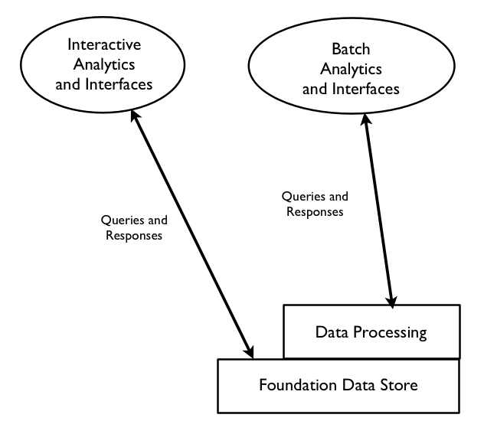

Description: The foundation data store can be queried through interfaces using batch data processing or direct foundation store access.

Possible Requirements: The interfaces should provide good throughput performance for batch queries and low latency performance for direct interactive queries.

Gap Analysis: Optimizations will be necessary in the internal format for file storage to provide high performance (e.g. Hortonworks ORC files, Cloudera Parquet)

Suggested Best Practices: If performance is required, use optimizations for file formats within the foundation data store. If multiple processing steps are required, data processing packages that retain intermediate values in memory.

- Batch Analytics on Big Data File System using Big Data Parallel Processing

Example Diagram:

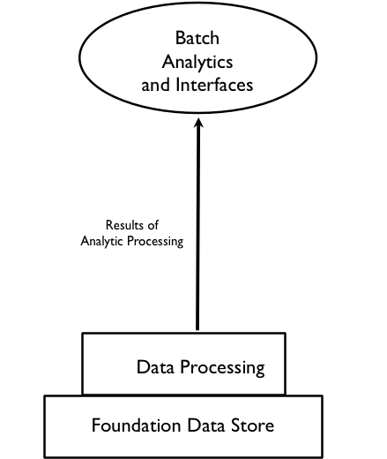

Description: A data processing system augmented by user defined functions can perform batch analytics on data sets stored in the foundation data store.

Possible Requirements: High performance data processing is needed for efficient analytics.

Gap Analysis: Analytics will often use multiple passes through the data. High performance will require the processing engine to avoid writing intermediate results to files as is done in the original version of MapReduce

Suggested Best Practices: If possible, intermediate results of iterations should be kept in memory. Consider moving data to be analyzed into memory or an analytics optimized database.

5. Stream Processing and ETL

Example Diagram:

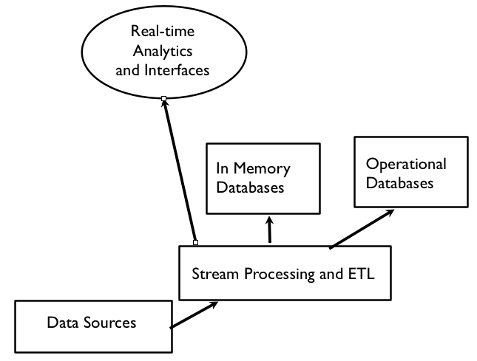

Description: Stream processing software can transform, process, and route data to databases and real time analytics

Possible Requirements: The stream processing software should be capable of high performance processing of large high velocity data streams.

Gap Analysis: Many stream processing solutions are available. In the future, complex analytics will be necessary to enable stream process to perform accurate filtering and summation of very large data streams.

Suggested Best Practices: Parallel processing is necessary for good performance on large data streams.

- Real Time Analytics (e.g. Complex Event Processing)

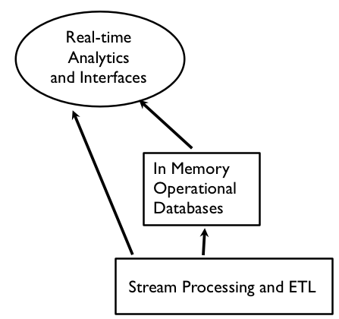

Description: Large high velocity data streams and notifications from in memory operational databases can be analyzed to detect pre-determined patterns, discover new relationships, and provide predictive analytics.

Possible Requirements: Efficient algorithms for pattern matching and/or machine learning are necessary.

Gap Analysis: There are many solutions available for complex event processing. It would be useful to have standards for describing event patterns to enable portability.

Suggested Best Practices: Evaluate commercial packages to determine the best fit for your application.

7. NoSQL (and NewSQL) DBs as operational databases for large-scale updates and queries

Example Diagram:

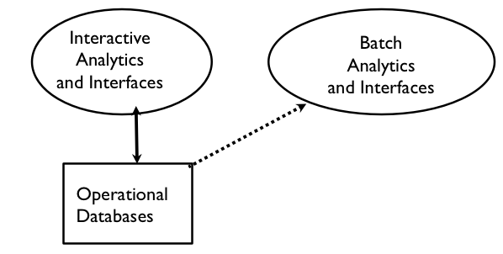
Description: Non-relational databases can be used for high performance for large data volumes (e.g. horizontally scaled). New SQL databases support horizontal scalability within the relational model.

Possible Requirements: It is necessary to decide on the level of consistency vs. availability is needed since the CAP theorem demonstrates that both can not be achieved in horizontally scaled systems.

Gap Analysis: The first generation of horizontal scaled databases emphasized availability over consistency. The current trend seems to be toward increasing the role of consistency. In some cases (e.g. Apache Cassandra), it is possible to adjust the balance between consistency and availability.

Suggested Best Practices: Horizontally scalable databases are experiencing rapid advances in performance and functionality. Choices should be based on application requirements and evaluation testing. Be very careful about choosing a cutting edge solution that has not been used in applications similar to your use case. SQL (or SQL-like) interfaces will better enable future portability until there are standards for NoSQL interfaces.

8. NoSQL DBs for storing diverse data types

Example Diagram:

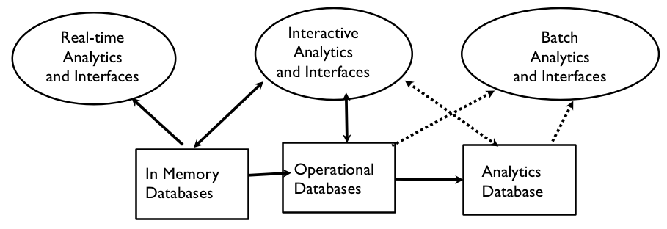

Description: Non-relational databases can store diverse data types (e.g. documents, graphs, heterogeneous rows) that can be retrieved by key or queries.

Possible Requirements: The data types to be stored depend on application data usage requirements and query patterns.

Gap Analysis: In general, the NoSQL databases are not tuned for analytic applications.

Suggested Best Practices: There is a trade off when using non-relational databases. Usually some functionality is given up (e.g. joins, referential integrity) in exchange for some advantages (e.g. higher availability, better performance). Be sure that the trade-off meets application requirements.

9. Databases optimized for complex ad hoc queries

Example Diagram:

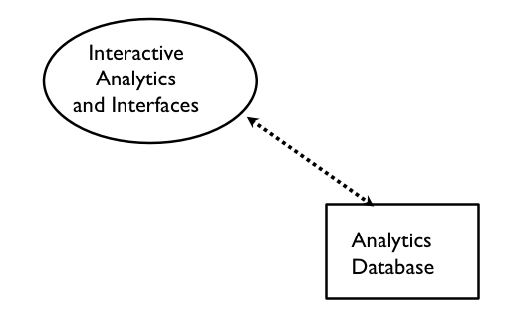
Description: Interactive ad hoc queries and analytics to specialized databases are key Big Data capabilities

Possible Requirements: Analytic databases need high performance on complex queries which require optimizations such as columnar storage, in memory caches, and star schema data models.

Gap Analysis: There is a need for embedded analytics and/or specialized databases for complex analytics applications.

Suggested Best Practices: Use databases that have been optimized for analytics and/or support embedded analytics. It will often be necessary to move data from operational databases and/or foundation data stores using ETL tools.

10. Databases optimized for rapid updates and retrieval (e.g. in memory or SSD)

Example Diagram:

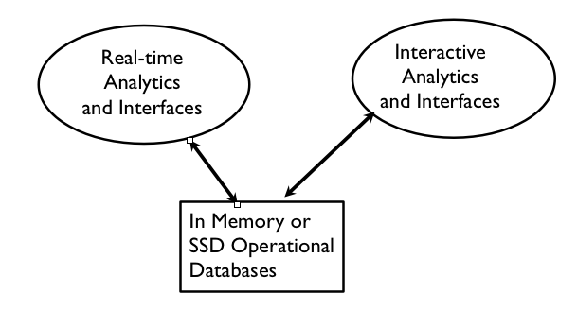

Description: Very high performance operational databases are necessary for some large-scale applications.

Possible Requirements: Very high performance will often require in memory databases and/or solid state drive (SSD) storage.

Gap Analysis: Data retrieval from disk files is extremely slow compared in memory, cache, or SSD access. There will be increased need for these faster options as performance requirements increase.

Suggested Best Practices: In the future, disk drives will be used for archiving or for non-performance oriented applications. Evaluate the use of data stores that can reside in memory, caches, or on SSDs.

11 Visualization Tools for End-Users

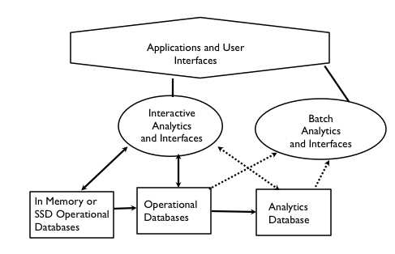

Description: Visualization of data and relationships is a very important capability for end-users trying to understand and use the data

Possible Requirements: Ability to extract data from multiple databases and present in a meaningful user-customizable fashion.

Gap Analysis: There are good first generation visualization tools available for analytic and applications. The increasing volume, velocity, and variety of data sources will provide a challenge for the future

Suggested Best Practices: Choose a visualization tools that satisfies current requirements and has extension and customization capabilities to meet future needs.

