Mapping High Level Big Data Use Cases to Reference Architecture and Areas for Possible Standardization (A Brainstorming Draft)

This brainstorming draft contains:

* A NIST Reference Architecture Diagram and Logical Roles
- High Level Use Cases mapped to the Reference Architecture including some opportunities for standardization
- Generic Standards Opportunities derived from 10 High Level Use Cases
- More Detailed Examples of High Level Use Cases
- A drill-down mapping between Geoffrey Fox’s High Performance Computing - Apache Based Data Stack (HPC-ABDS) and the NIST Reference Architecture

NIST Reference Architecture

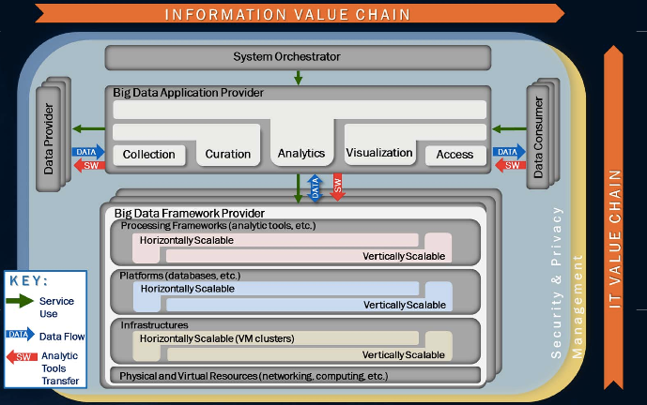

Logical Roles:

Actors can play more than one role:
- Data Provider supplies data
- Data Consumer uses data
- Framework Provider supplies application-independent resources
- Application Provider supplies application-dependent resources
- System Orchestrator can combine multiple applications in a workflow
=============================================================================
High Level Use Cases Mapped to Reference Architecture including Opportunities for Standards

- Multiple users performing interactive queries and updates on databases with basic availability

Mapping: Users are Data Providers and Consumers. Framework Providers manage the databases. Application Providers define schemas for the databases. Users interact with the databases on the Framework Provider using the schemas supplied by the Application Provider.

Opportunities for standards: Interfaces to databases (e.g SQL queries to Hadoop)

- Perform real-time analytics on data streams and notify users when specified events occur

Mapping: Data Providers supply data streams. Application Provider supplies code to process data streams, detect events, and notify users. Framework Providers supplies resources to run the code. Data Consumers receive notification of events

Opportunities for standards: Representation of events

3. Move data from external data sources into a highly horizontally scalable data store, transform it using highly horizontally scalable processing (e.g. Map-Reduce), and return it to the horizontally scalable data store (ELT)

Mapping: Data Provider is the external data source. Framework Provider supplies horizontally scalable data store. Application Provider supplies transformation used by Framework Provider for horizontally scalable processing and return to data store.

Opportunities for standards: Standard descriptions of transformations (e.g. JSON and/or XML to tables)

- Perform batch analytics on the data in a highly horizontally scalable data store using highly horizontally scalable processing(e.g Map-Reduce) with a user-friendly interface (e.g. SQL like)

Mapping: Framework Provider supplies the horizontally scalable data store and processing engine. Application Provider supplies the analytic software that forms the basis of the processing. User selects the appropriate analytics to be performed.

Opportunities for standards: Interface between analytics and data processing. Metadata to support data access and data flow for diverse analytic interfaces.

- Perform interactive analytics on data in analytics-optimized database

Mapping: Framework provides the platform and basic database capabilities. Application Provider supplies optimized schema and configuration to support analytic queries. Data Consumer submits analytic queries.

Opportunities for standards: Standard descriptions of database schemas and configurations to support analytics.

- Visualize data extracted from horizontally scalable Big Data store

Mapping: Data provider supplies data. Application Provider supplies visualization tools (user interface, data cache, mappings from horizontally scalable data store to data cache) Platform Provider supplies horizontally scalable data store and processing platforms. Data Consumer uses the visualization tools to better understand the data.

Opportunities for standards: Query language f`or visualization data caches to enable the separation of user interface from data cache.

- Move data from a horizontally scalable data store into a traditional Enterprise Data Warehouse

Mapping: Platform Provider supplies horizontally scalable data store and database to support the Enterprise Data Warehouse.. Application Provider supplies mapping to move data from horizontally scalable data store to Enterprise Data Warehouse

Opportunities for standards: Transformations from unstructured data to Enterprise Data Warehouse relational schema.

- Extract, process, and move data from data stores to archives

Mapping: Data Provider supplies data in data stores. Framework Provider hosts source data stores and archival data store. Application Provider supplies ETL, curation and packaging applications for archiving.

Opportunities for standards: Standards for describing archival data store schemas and possibly generating ETL, curation, and packaging code

- Combine data from Cloud databases and on premise data stores for analytics and data mining,

Mapping: Data Providers include external Cloud and on premise data stores. Framework Providers include internal and external actors. Application Provider supplies code to integrate data from diverse sources. Data Consumers should have seamless access to the integrated data.

Opportunities for standards: Standard representations for data sets (e.g. schemas, data types, semantics) to enable data integration from multiple source.

10. Orchestrate multiple sequential and parallel data transformations and/or analytic processing using a workflow manager

Mapping: System Orchestrator combines multiple use cases to provide a complete system for end-user from Data Provider through multiple data transformations and analytic processing.

Opportunities for standards: Declarative format for workflow across multiple operations.

=============================================================================
Generic Standard Opportunities derived from the 10 High Level Use Cases

1. Standard interfaces to data stores for end-user queries, analytics application, and visualization tools.
2. Standard metadata descriptions of data for extraction, transformation, and/or loading
3. Standard pattern descriptions for event processing and declarative queries
- Standard descriptions of workflows for system orchestration
=============================================================================
More Detailed Examples of High Level Use Cases

1. Multiple users performing interactive queries and updates on a database with basic availability and eventual consistency (BASE)
Big Data File Systems as a data resource for batch and interactive queries
NoSQL (and NewSQL) DBs as operational databases for large-scale updates and queries
NoSQL DBs for storing diverse data types NoSQL DBs for storing diverse data types
Databases optimized for rapid updates and retrieval (e.g. in memory or SSD)

2. Perform real-time analytics on data streams and notify users when specified events occur
Operations Analysis
Stream Processing and ETL
Real Time Analytics (e.g. Complex Event Processing)

3. Move data from external data sources into a highly horizontally scalable data store, transform it using highly horizontally scalable processing (e.g. Map-Reduce), and return it to the horizontally scalable data store (ELT)
Data input and output to Big Data File System (ETL, ELT)
Stream Processing and ETL

4. Perform batch analytics on the data in a highly horizontally scalable data store using highly horizontally scalable processing(e.g Map-Reduce) with a user-friendly interface (e.g. SQL like)
Big Data Exploration
Data Warehouse Augmentation
Big Data File Systems as a data resource for batch and interactive queries

5. Perform interactive analytics on data in analytics-optimized database
Big Data Exploration
Data Warehouse Augmentation
Databases optimized for complex ad hoc queries
Databases optimized for rapid updates and retrieval (e.g. in memory or SSD)
Big Data File Systems used as a data resource for interactive queries

6. Visualize data extracted from horizontally scalable Big Data score
Big Data Exploration
Visualization Tools for End-Users

7. Move data from a horizontally scalable data store into a traditional Enterprise Data Warehouse
Data input and output to Big Data File System (ETL, ELT)
Data exported to Databases from Big Data File System
Data Warehouse Augmentation

8. Extract, process, and move data from data stores to archives

- Combine data from Cloud databases and on premise data stores for analytics and data mining,

10. Orchestrate multiple sequential and parallel data transformations and/or analytic processing using a workflow manager
Big Data Exploration
Enhanced 360º View of the Customer
Security/Intelligence Extension

============================================================================
Mapping from Geoffrey Fox’s HPC-ABDS to the NIST Reference Architecture

Reference Architecture components in Bold followed by HPC-ABDS elements

System Orchestrator - Orchestration and Workflow
Application Provider - Builds application-specific analytics from Data Analytic Libraries
Framework Provider -
Processing:
Integrated High Level Systems for Data Processing
Parallel Horizontally Scalable Parallel Processing (Batch, Stream, Graph)
Interprocess Communication (HPC, ABDS)
Data Transformation (Object <-> Relational, Unstructured -> Structured)

Platform Data Stores:
In-memory Databases
NoSQL (Columnar, Key-Value, Document, Graph, Matrix., Tuples)
Relational
Data Grids
File Systems(HPC, ABDS)

Infrastructure:
Cluster Resource Management (HPC, ABDS)
Computational Grids
IaaS Clouds

A reduced HPC-ABDS diagram is below. An expanded more readable diagram is at
http://www.exascale.org/bdec/sites/www.exascale.org.bdec/files/whitepapers/fox.pdf

=============================================================================

