Big Data Architecture Models:
A Survey

Version 1.2

Reference Architecture Subgroup
NIST Big Data Working Group (NBD-WG)
September, 2013

1 Introduction 3
1.1 Objectives 3
1.2 How This Report Was Produced 3
1.3 Structure of This Report 3
2 Big Data Architecture Proposals Received 4
2.1 Big Data Layered Architecture by Bob Marcus 4
2.2 Big Data Ecosystem by Microsoft 8
2.3 Proposal #3: Gary Mazzaferro (soon) 11
2.4 Big Data Architecture Framework (BDAF) by University of Amsterdam 12
3 Big Data Architecture Survey 15
3.1 IBM 15
3.2 Oracle 19
3.3 Booz Allen Hamilton (* need contact *) 21
3.4 Pivotal (Spinoff from EMC) 22
3.5 SAP (soon) 25
3.6 9sight 26
3.7 LexisNexis 28
4 Big Data Architecture Comparison based on Key Feature Components 30
5 Reference Architecture Components Recommendations 30
6 Reference 30

Introduction

Objectives
[This survey of existing Big Data architectures will help better formulate the NIST standard Big Data Reference Architecture with the goal to identify common key components.]

How This Report Was Produced
[This survey contains a collection of architectures from NBD WG members as well as other sources such standards bodies, industry, government, and academia.]

Structure of This Report
[This survey should include a section for comparing the collected architectures against the identified key components such as Data Sources, Transformation, Capability Management, and Data Usage.]

Big Data Architecture Proposals Received

Big Data Layered Architecture by Bob Marcus

General Architecture Description
The Layered Reference Model and detailed Reference Architecture in this section are designed to support mappings from Big Data use cases, requirements, and technology gaps. The Layered Reference Model is at a similar level to the Working Group Reference Architecture. The Reference Architecture below is a detailed drill-down from the Layered Reference Model.

Architecture Model
The High Level Layered Reference Model in Figure-1 captures the essential feature of Big Data architectures. 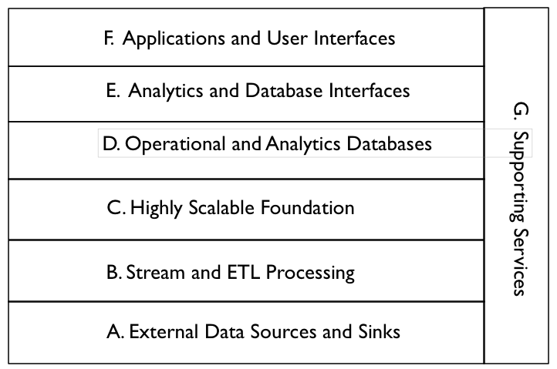
Figure-1: Description of the Components of the High Level Reference Model

- External Data Sources and Sinks - Provides external data inputs and output to the internal Big Data components.

- Stream and ETL Processing - Filters and transforms data flows between external data resources and internal Big Data systems.

- Highly Scalable Foundation - Horizontally scalable data stores and processing that form the foundation of Big Data Architectures.

- Operational and Analytics Databases - Databases integrated into the Big Data architecture. These can be horizontally scalable databases or single platform databases with data extracted from the foundational data store.

- Analytics and Database Interfaces - These are the interfaces to the data stores for queries, updates, and analytics.

- Applications and User Interfaces - These are the applications (e.g. machine learning) and user interfaces (e.g. visualization) that are built on Big Data components.

- Supporting Services - These services include the components needed for the implementation and management of robust Big Data systems.

Key Components and Their Descriptions
The Lower Level Reference Architecture in Figure-2 expands on some of the layers in the High Level Reference Model and shows some of the data flows.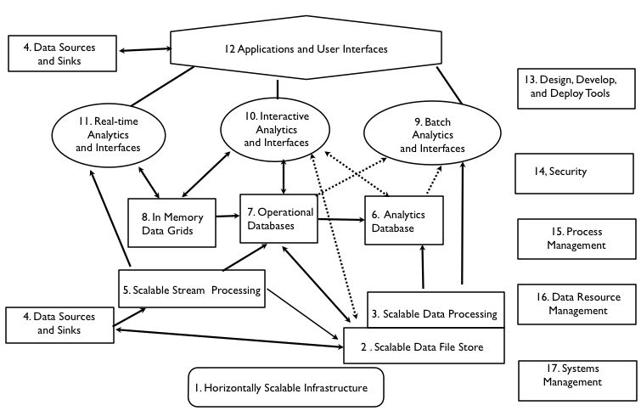
Figure-2: Description of the Components of the Low Level Reference Model

- External Data Sources and Sinks

4. Data Sources and Sinks - These are components in a complete data architecture that clearly defined interfaces to Big Data horizontally scalable internal data stores and applications.

- Stream and ETL Processing

5. Scalable Stream Processing - This is processing of “data in movement” between data stores. It can be used for filtering, transforming, or routing data. For Big Data streams, the stream processing must be scalable to support distributed and/or pipelined processing.

C. Highly Scalable Foundation

1. Scalable Infrastructure - To support scalable Big Data stores and processing, it is necessary to have an infrastructure that can support the easy addition of new resources. Possible platforms include public and/or private Clouds.

2. Scalable Data Stores - This is the essence of Big Data architecture. Horizontal scalability using less expensive components can support the unlimited growth of data storage. However there must be fault tolerance capabilities available to handle component failures.

3. Scalable Processing - To take advantage of scalable distributed data stores, it is necessary to have scalable distributed parallel processing with similar fault tolerance. In general, processing should be configuring to minimize unnecessary data movement.

- Operational and Analytics Databases

6. Analytics Databases - Analytics databases are generally highly optimized for read-only interactions (e.g. columnar storage, extensive indexing, and denormalization). It is often acceptable for database responses to have high latency (e.g. invoke scalable batch processing over large data sets).

7. Operational Databases - Operation databases generally support efficient write and read operations. NoSQL databases are often used in Big Data architectures in this capacity. Data can be later transformed and loaded into analytic databases to support analytic applications.

8. In Memory Data Grids - These are high performance data caches and stores that minimize writing to disk. They can be used for large scale real time applications requiring transparent access to data.

- Analytics and Database Interfaces

9. Batch Analytics and Interfaces - These are interfaces that use batch scalable processing (e.g. Map-Reduce) to access data in scalable data stores (e.g. Hadoop File System). These interfaces can be SQL-like (e.g. Hive) or programmatic (e.g. Pig).

10. Interactive Analytics and Interfaces - These interfaces avoid directly access data stores to provide interactive responses to end-users. The data stores can be horizontally scalable databases tuned for interactive responses (e.g. HBase) or query languages tuned to data models (e.g. Drill for nested data).

11. Real-Time Analytics and Interfaces - There are applications that require real time responses to events occurring within large data streams (e.g. algorithmic trading). This complex event processing is machine-based analytics requiring very high performance data access to streams and data stores.

- Applications and User Interfaces

12. Applications and Visualization - The key new capability available to Big Data analytic applications is the ability to avoid developing complex algorithms by utilizing vast amounts of distributed data (e.g. Google statistical language translation). However taking advantage of the data available requires new distributed and parallel processing algorithms.

- Supporting Services

13. Design, Develop, and Deploy Tools - High level tools are limited for the implementation of Big Data applications (e.g. Cascading). This will have to change to lower the skill levels needed by enterprise and government developers.

14. Security - Current Big Data security and privacy controls are limited (e.g. only Kerberos authentication for Hadoop, Knox). They must be expanded in the future by commercial vendors (e.g. Cloudera Sentry) for enterprise and government applications.

15. Process Management - Commercial vendors are supplying process management tools to augment the initial open source implementations (e.g. Oozie)

16. Data Resource Management - Open Source data governance tools are still immature (e.g. Apache Falcon). These will be augmented in the future by commercial vendors.

17. System Management - Open source systems management tools are also immature (e.g. Ambari). Fortunately robust system management tools are commercially available for scalable infrastructure (e.g. Cloud-based).

Big Data Ecosystem by Microsoft

General Architecture Description
This big data ecosystem reference architecture is a high level data-centric diagram that depicts the big data flow and possible data transformations from collection to usage.
Architecture Model
The big data ecosystem is comprised of four main components: Sources, Transformation, Infrastructure and Usage, as shown on Figure-3. Security and Management are shown as examples of additional supporting cross-cutting sub-systems that provide backdrop services and functionality to the rest of the big data ecosystem.

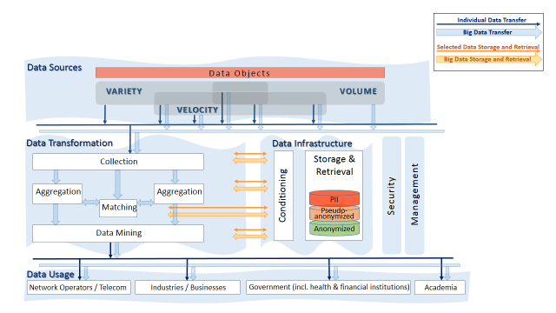
Figure-3: Big Data Ecosystem Reference Architecture
Key Components and Their Descriptions
- Data Sources: Typically, the data behind “big data” is collected for a specific purpose, creating the data objects in a form that supports the known use at the data collection time. Once data is collected, it can be reused for a variety of purposes, some potentially unknown at the collection time. Data sources are shown as classified by three characteristics that define big data and are independent of the data content or context: Volume, Velocity, and Variety.

- Data Transformation: As data propagates through the ecosystem, it is being processed and transformed in different ways in order to extract the value from the information. For the purpose of defining interoperability surfaces, it is important to identify common transformations that are implemented by independent modules, systems, or deployed as stand-alone services. The transformation functional blocks shown in Figure 1 can be performed by separate systems or organizations, with data moving between those entities, such the case with the advertising ecosystem. Similar and additional transformational blocks are being used in enterprise data warehouses, but typically they are closely integrated and rely on a common data base to exchange the information.

Each transformation function may have its specific pre-processing stage including registration and metadata creation, may use different specialized data infrastructure best fitted for its requirements, and may have its own privacy and other policy considerations. Common data transformation shown on the figure are:

- Collection: Data can be collected in different types and forms. At the initial collection stage, sets of data (e.g., data records) from similar sources and of similar structure are collected (and combined) resulting in uniform security considerations, policies, etc. Initial metadata is created (e.g., subjects with keys are identified) to facilitate subsequent aggregation or lookup method(s).
- Aggregation: Sets of existing data collections with easily correlated metadata (e.g., identical keys) are aggregated into a larger collection. As a result, the information about each object is enriched or the number of objects in the collection grows. Security considerations and policies concerning the resultant collection are typically similar to the original collections.
- Matching: Sets of existing data collections with dissimilar metadata (e.g., keys) are aggregated into a larger collection. (For example, in advertising industry matching services correlate HTTP cookies’ values with person’s real name.) As a result, the information about each object is enriched. The security considerations and policies concerning the resultant collection are subject to data exchange interfaces design.
- Data Mining: According to DBTA, “[d]ata mining can be defined as the process of extracting data, analyzing it from many dimensions or perspectives, then producing a summary of the information in a useful form that identifies relationships within the data. There are two types of data mining: descriptive, which gives information about existing data; and predictive, which makes forecasts based on the data.”

- Data Infrastructure: Big data infrastructure is a bundle of data storage or database software, servers, storage, and networking used in support of the data transformation functions and for storage of data as needed. Data Infrastructure is placed to the right of the Data Transformation, to emphasize the natural role of Data Infrastructure in support of data transformations. Note that the horizontal data retrieval and storage paths exist between the two, which are different from the vertical data paths between them and Data Sources and Data Usage.

In order to achieve high efficiencies, data of different volume, variety and velocity would typically be stored and processed using computing and storage technologies tailored to those characteristics. The choice of processing and storage technology is also dependent on the transformation itself. As a result, often the same data can be transformed (either sequentially or in parallel) multiple times using independent data infrastructure.
Examples of Conditioning include de-identification, sampling, and fuzzing.

Examples of Storage and Retrieval include NoSQL and SQL Databases with various specialized types of data load and queries.

- Data Usage: The results can be provided in different formats, different granularity and under different security considerations.

Proposal #3: Gary Mazzaferro (soon)

Big Data Architecture Framework (BDAF) by University of Amsterdam

General Architecture Description
This Big Data Architecture Framework intends to support the extended Big Data definition proposed by the authors and presented in the SNE technical report [SNE-BDAF] and reflect the main components and processes in the Big Data Ecosystem (BDE). The proposed BDAF definition comprises of the following 5 components that address different Big Data definition aspects:

- Data Models, Structures, Types that should support variety of data types produced by different data sources and need to be stored and processed, on one hand, and which will to some extent define the Big Data infrastructure technologies and solutions.
- Big Data Management Infrastructure and Services that include should support Big Data Lifecycle Management, provenance, curation, and archiving. Big Data Lifecycle Management should support the major data transformations stages such as: data collection and registration; data filtering, classification; data analysis, modeling, prediction; data delivery, presentation, visualization; and can be completed with the customer data analytics and visualization. Big Data Management capabilities can be partly addressed by defining scientific or business workflow and using corresponding workflow management systems.
- Big Data Analytics and Tools that specifically address required data transformation functionalities and related infrastructure components
- Big Data Infrastructure (BDI) that includes storage, compute, network infrastructure, and also sensor network and target/actionable devices
- Big Data Security that should protect data in-rest, in-move, ensure trusted processing environments and reliable BDI operation, provide fine grained access control and protect users personal information.
Architecture Model
Figure-2 illustrates the basic Big Data Analytics capabilities as a part of the overall cloud based BDI. Besides the general cloud based infrastructure services (storage, compute, infrastructure/VM management) the following specific applications and services will be required to support Big Data and other data centric applications:

- High-Performance Cluster systems
- Hadoop related services and tools; distributed file systems
- General analytics tools/systems: batch, real-time, interactive
- Specialist data analytics tools (logs, events, data mining, etc.)
- Databases: operational and analytics; in-memory databases; streaming databases; SQL, NoSQL, key-value storage, etc.
- Streaming analytics and ETL processing (Extract, Transform, Load)
- Data reporting, visualization

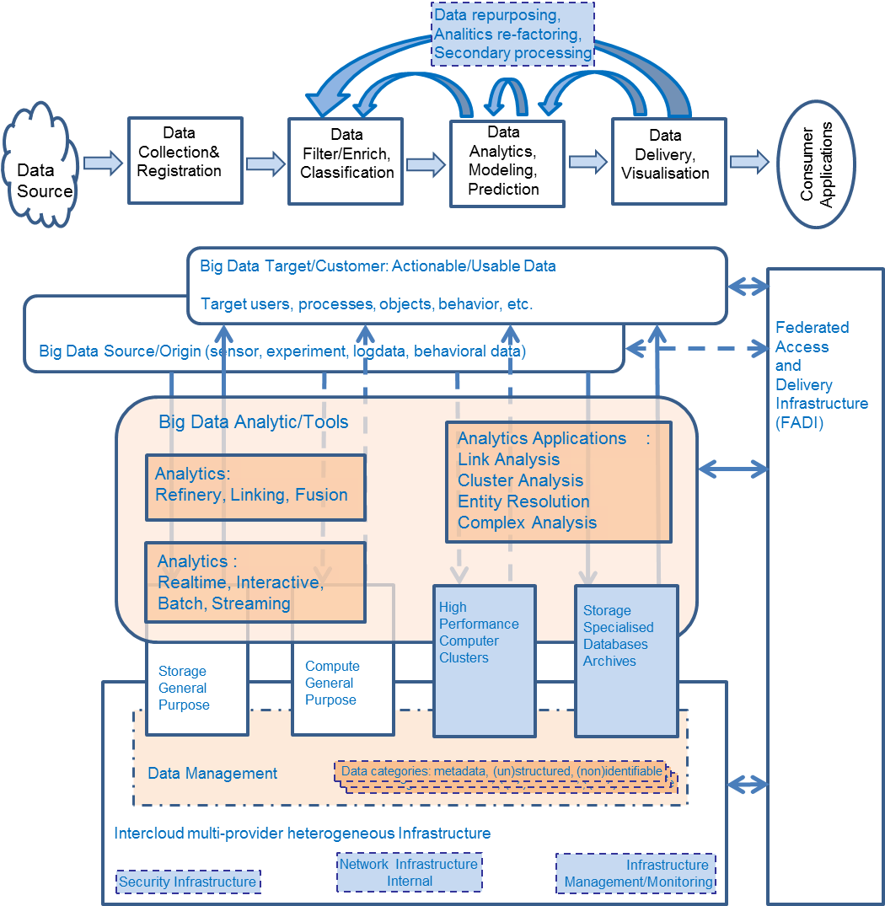
Figure-2: Big Data Architecture Framework
Big Data analytics platforms need to be scalable vertically and horizontally what can be naturally achieved when using cloud based platform and Intercloud integration models/architecture [Cloud-ICAF].

Key Components and Their Descriptions
The Big Data infrastructure that includes the general infrastructure for general data management, typically cloud based, and the Big Data Analytics part that will use the High-Performance Computing (HPC) architectures and technologies can be shown as in Figure XXX. General BDI includes the following capabilities, services and components to support the whole Big Data lifecycle

- General Cloud based infrastructure, platform, services and applications to support creation, deployment and operation of Big Data infrastructures and applications (using generic cloud features of provisioning on-demand, scalability, measured services)
- Big Data Management services and infrastructure that includes data backup, replication, curation, provenance
- Registries, indexing/search, metadata, ontologies, namespaces
- Security infrastructure (access control, policy enforcement, confidentiality, trust, availability, accounting, identity management, privacy)
- Collaborative environment infrastructure (groups management) and user facing capabilities (user portals, identity management/federation)

Big Data Infrastructure will require broad network access and advanced network infrastructure that will play key role in distributed heterogeneous BDI integration and reliable operation:
- Network infrastructure that interconnects typically distributed and increasingly multi-provider BDI components that may include intra-cloud (intra-provider) and Inter-cloud network infrastructure. HPC clusters require high-speed network infrastructure with low latency. Inter-cloud network infrastructure may require dedicated network links and connectivity provisioned on demand.
- Federated Access and Delivery Infrastructure (FADI) is presented in Figure-2 as a separate infrastructure/structural component to reflect its importance, however it can treated as a part of the general Intercloud infrastructure of the BDI. FADI combines both inter-cloud network infrastructure and corresponding federated security infrastructure to support infrastructure components integration and users federation.

Heterogeneous multi-provider cloud services integration is addressed by the Intercloud Architecture Framework (ICAF) and in particular Intercloud Federation Framework (ICFF) being developed by the authors [Cloud-ICAF], [IETF-Cloud], [Cloud-ICFF]. ICAF provides a common basis for building adaptive and on-demand provisioned multi-provider cloud based services.

FADI is an important component of the overall cloud and Big Data infrastructure that interconnects all the major components and domains in the multi-provider inter-cloud infrastructure including non-cloud and legacy resources. Using federation model for integrating multi-provider heterogeneous services and resources reflects current practice in building and managing complex infrastructures and allows for inter-organizational resource sharing and identity federation.

References (will move to end of the document)
[SNE-BDAF] Big Data Architecture Framework (BDAF) by UvA
Architecture Framework and Components for the Big Data Ecosystem. Draft Version 0.2
http://www.uazone.org/demch/worksinprogress/sne-2013-02-techreport-bdaf-draft02.pdf

[SDI-BD] Demchenko, Y., P.Membrey, P.Grosso, C. de Laat, Addressing Big Data Issues in Scientific Data Infrastructure. First International Symposium on Big Data and Data Analytics in Collaboration (BDDAC 2013). Part of The 2013 Int. Conf. on Collaboration Technologies and Systems (CTS 2013), May 20-24, 2013, San Diego, California, USA.

[Cloud-ICAF] Demchenko, Y., M. Makkes, R.Strijkers, C.Ngo, C. de Laat, Intercloud Architecture Framework for Heterogeneous Multi-Provider Cloud based Infrastructure Services Provisioning, The International Journal of Next-Generation Computing (IJNGC), Volume 4, Issue 2, July 2013

[Cloud-ICFF] Makkes, Marc, Canh Ngo, Yuri Demchenko, Rudolf Strijkers, Robert Meijer, Cees de Laat, Defining Intercloud Federation Framework for Multi-provider Cloud Services Integration, The Fourth International Conference on Cloud Computing, GRIDs, and Virtualization (CLOUD COMPUTING 2013), May 27 - June 1, 2013,Valencia, Spain.

[IETF-Cloud] Cloud Reference Framework. Internet-Draft, version 0.5. July 2, 2013. http://www.ietf.org/id/draft-khasnabish-cloud-reference-framework-05.txt.

Big Data Architecture Survey

IBM

General Architecture Description
A Big Data platform has to support all of the data and must be able to run all of the computations that are needed to drive the analytics.

Architecture Model
To achieve these objectives, any Big Data platform as shown in Figure-3 must address six key imperatives:
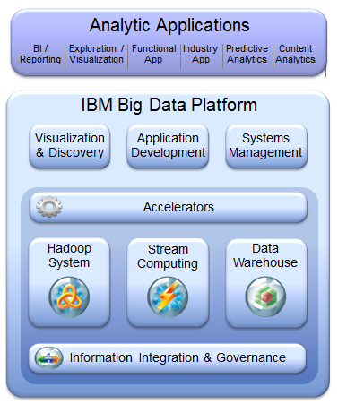
Figure-3: IBM Big Data Platform

      - Data Discovery and Exploration: The process of data analysis begins with understanding data sources, figuring out what data is available within a particular source, and getting a sense of its quality and its relationship to other data elements. This process, known as data discovery, enables data scientists to create the right analytic model and computational strategy. Traditional approaches required data to be physically moved to a central location before it could be discovered. With Big Data, this approach is too expensive and impractical. To facilitate data discovery and unlock resident value within Big Data, the platform must be able to discover data “in place.” It has to be able to support the indexing, searching, and navigation of different sources of Big Data. It has to be able to facilitate discovery of a diverse set of data sources, such as databases, flat files, content management systems—pretty much any persistent data store that contains structured, semistructured, or unstructured data. The security profile of the underlying data systems needs to be strictly adhered-to and preserved. These capabilities benefit analysts and data scientists by helping them to quickly incorporate or discover new data sources in their analytic applications.

- Extreme Performance: Run Analytics Closer to the Data: Traditional architectures decoupled analytical environments from data environments. Analytical software would run on its own infrastructure and retrieve data from back-end data warehouses or other systems to perform complex analytics. The rationale behind this was that data environments were optimized for faster access to data, but not necessarily for advanced mathematical computations. Hence, analytics were treated as a distinct workload that had to be managed in a separate infrastructure. This architecture was expensive to manage and operate, created data redundancy, and performed poorly with increasing data volumes. The analytic architecture of the future needs to run both data processing and complex analytics on the same platform. It needs to deliver petabyte scale performance throughput by seamlessly executing analytic models inside the platform, against the entire data set, without replicating or sampling data. It must enable data scientists to iterate through different models more quickly to facilitate discovery and experimentation with a “best fit” yield.

- Manage and Analyze Unstructured Data: For a long time, data has been classified on the basis of its type—structured, semistructured, or structured. Existing infrastructures typically have barriers that prevented the seamless correlation and holistic analysis of this data; for example, independent systems to store and manage these different data types. We’ve also seen the emergence of hybrid systems that often let us down because they don’t natively manage all data types. One thing that always strikes us as odd is that nobody ever affirms the obvious: organizational processes don’t distinguish between data types. When you want to analyze customer support effectiveness, structured information about a CSR conversation (such as call duration, call outcome, customer satisfaction, survey response, and so on) is as important as unstructured information gleaned from that conversation (such as sentiment, customer feedback, and verbally expressed concerns). Effective analysis needs to factor in all components of an interaction, and analyze them within the same context, regardless of whether the underlying data is structured or not. A game-changing analytics platform must be able to manage, store, and retrieve both unstructured and structured data. It also has to provide tools for unstructured data exploration and analysis.

- Analyze Data in Real Time: Performing analytics on activity as it unfolds presents a huge untapped opportunity for the analytic enterprise. Historically, analytic models and computations ran on data that was stored in databases. This worked well for transpired events from a few minutes, hours, or even days back. These databases relied on disk drives to store and retrieve data. Even the best performing disk drives had unacceptable latencies for reacting to certain events in real time. Enterprises that want to boost their Big Data IQ need the capability to analyze data as it’s being generated, and then to take appropriate action. It’s about deriving insight before the data gets stored on physical disks. We refer to this this type of data as streaming data, and the resulting analysis as analytics of data in motion. Depending on time of day, or other contexts, the volume of the data stream can vary dramatically. For example, consider a stream of data carrying stock trades in an exchange. Depending on trading activity, that stream can quickly swell from 10 to 100 times its normal volume. This implies that a Big Data platform not only has to be able to support analytics of data in motion, but also has to scale effectively to manage increasing volumes of data streams.

- A Rich Library of Analytical Functions and Tool Sets: One of the key goals of a Big Data platform should be to reduce the analytic cycle time, the amount of time that it takes to discover and transform data, develop and score models, and analyze and publish results. We noted earlier that when your platform empowers you to run extremely fast analytics, you have a foundation on which to support multiple analytic iterations and speed up model development (the snowball gets bigger and rotates faster). Although this is the desired end goal, there needs to be a focus on improving developer productivity. By making it easy to discover data, develop and deploy models, visualize results, and integrate with front-end applications, your organization can enable practitioners, such as analysts and data scientists, to be more effective in their respective jobs. We refer to this concept as the art of consumability. Let’s be honest, most companies aren’t like LinkedIn or Facebook, with hundreds (if not thousands) of developers on hand, who are skilled in new age technologies. Consumability is key to democratizing Big Data across the enterprise. You shouldn’t just want, you should always demand that your Big Data platform flatten the time-to-analysis curve with a rich set of accelerators, libraries of analytic functions, and a tool set that accelerates the development and visualization process. Because analytics is an emerging discipline, it’s not uncommon to find data scientists who have their own preferred mechanisms for creating and visualizing models. They might use packaged applications, use emerging open source libraries, or adopt the “roll your own” approach and build the models using procedural languages. Creating a restrictive development environment curtails their productivity. A Big Data platform needs to support interaction with the most commonly available analytic packages, with deep integration that facilitates pushing computationally intensive activities from those packages, such as model scoring, into the platform. It needs to have a rich set of “parallelizable” algorithms that have been developed and tested to run on Big Data. It has to have specific capabilities for unstructured data analytics, such as text analytics routines and a framework for developing additional algorithms. It must also provide the ability to visualize and publish results in an intuitive and easy-to-use manner.

- Integrate and Govern All Data Sources: Over the last few years, the information management community has made enormous progress in developing sound data management principles. These include policies, tools, and technologies for data quality, security, governance, master data management, data integration, and information lifecycle management. They establish veracity and trust in the data, and are extremely critical to the success of any analytics program.

Key Components and Their Descriptions
The technological capabilities to address these key strategic imperatives are:

    - Tools: These components support visualization, discovery, application development, and systems management.

    - Data Warehouse: This component supports business intelligence, advanced analytics, data governance, and master data management on structured data.

    - Hadoop: This component support managing and analyzing unstructured Data. To support this requirement, IBM InfoSphere BigInsights and PureData System for Hadoop suppo

    - Stream Computing: This component supports analyzing in-motion data in real time.

    - Accelerators: This component provides a rich library of analytical functions, schemas, tool sets and other artifacts for rapid development and delivery of value in big-data projects.

Information Integration and Governance: This component supports integration and governance of all data sources. Its capabilities include data integration, data quality, security, lifecycle management, and master data management.

Oracle

General Architecture Description
Oracle’s Reference Architecture for Big Data provides a complete view of related technical capabilities, how they fit together, and how they integrate into the larger information ecosystem. This helps to clarify Oracle’s Big Data strategy and to map specific products that support that strategy.

Conceptual Model
Figure # shows a high-level view of the Information Management ecosystem:

Architecture Model
Figure # shows a Big Data reference architecture that details the infrastructure services, data sources, and information provisioning and analysis components.
Oracle offers an integrated solution to address enterprise big data requirements. Oracle’s big data strategy is centered on extending current enterprise information architectures to incorporate big data. Big Data technologies, such as Hadoop and Oracle NoSQL database, run alongside Oracle data warehouse solutions to address big data requirements for Acquiring, Organizing, and Analyzing data in support of critical organizational decision-making.

Booz Allen Hamilton (* need contact *)
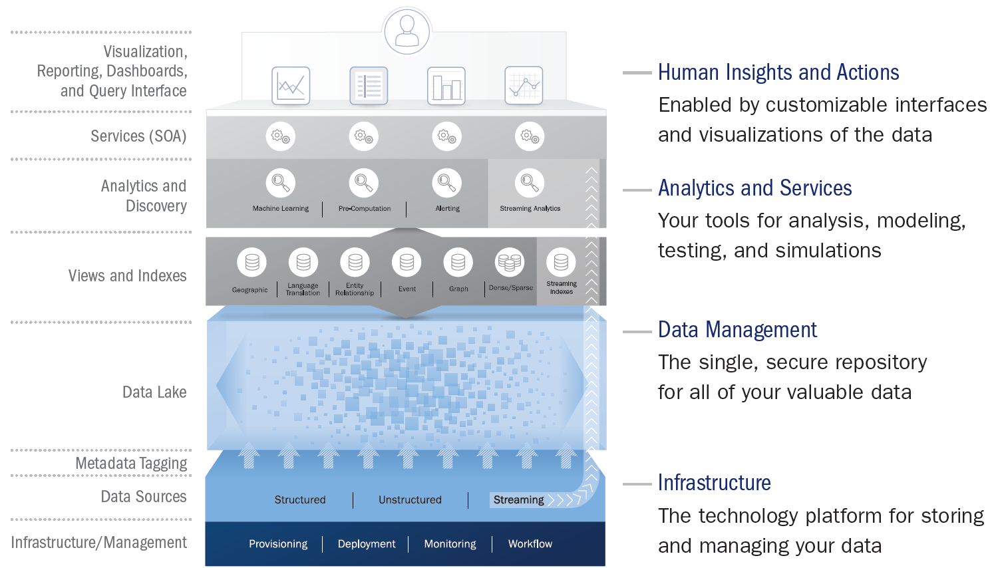
Booz Allen’s Cloud analytics Reference Architecture
http://www.boozallen.com/media/file/the-cloud-analytics-reference-architecture-vp.pdf

Pivotal (Spinoff from EMC)

General Architecture Description
Pivotal believes that Hadoop Distributed File System (HDFS) has emerged as a standard interface between the data and the analytics layer. Marching on that path of providing a unified platform, Pivotal integrated the Greenplum Database technology to work directly on HDFS. It now has first standards-compliant interactive SQL query engine, HAWQ to store and query both structured and semi-structured data on HDFS. Pivotal is also in the late stages of integrating real-time, in-memory analytics platforms with HDFS. Making HDFS a standard interface results in storage optimization where a single copy of the data is stored and gives developers freedom to use an appropriate analytics layer for generating insights for data applications.
Architecture Model
Pivotal Big Data architecture is composed of three different layers: Infrastructure, Data Ingestion & Analytics, and Data-enabled Applications. These layers, or fabrics, have to seamlessly integrate to provide a frictionless environment for users of Big Data systems.

Infrastructure
- Most of the early Big Data platforms instances assumed a networked bare metal infrastructure. Speed to market drove the early adopters to offer this platform as a service on the bare metal platforms. Monitoring and management capabilities were built around managing a bare metal cluster at scale. The numbers of Big Data platform nodes at some of the early adopters are in the multiple of 10s of thousands. Custom management tools were developed for implemented limited elasticity by adding nodes, retiring nodes and monitoring and alerting in case of infrastructure failures.
- Since then, Virtualization has been widely adopted in enterprises, since it offers enhanced isolation, utilization, elasticity, and management capabilities inherent in most virtualization technologies.
- Customers now expect a platform that will enable them to take advantage of their investments in virtualized infrastructure, whether deployed on-premise, such as with VMWare vSphere, or in public clouds, such as Amazon AWS.

Data Storage and Analytics
- Big Data platforms deal with the gravity of data (difficulty of moving large amounts of data over existing network capabilities) by moving processing very close to the storage tier. As a result, analytics and data storage tier were fused together. Every attempt was made to move analytics closer to the data layer. Now high-speed datacenter interconnects (with 10+ Gbps bandwidth) are getting affordable, making it possible to keep the processing within the same subnet and still deliver acceptable performance.
- Virtualization technology is also innovating to add data locality awareness to the compute node selection, thereby speeding up analytics workloads over large amounts of data, while offering benefits of resource isolation, better security and improved utilization, than the underlying bare metal platform.
- We find “Data Lake” is one of the most prevalent emerging usage patterns of the Big Data platforms. Data Lake – a design pattern where streams of data are stored and available for historical and operational analytics on the Big Data platform – is the starting point for most of the enterprises. Once the data is available in one place, business users experiment with use cases and solutions to business problems, resulting in second order benefits.

Big Data applications
- We consider extraction of insights from the data out of the Big Data platform for consumption and actions as Big Data applications. Excel spreadsheets, and PowerPoint presentations are used for early demonstrations of these insights and once the business cases are approved, applications need to be built to act on these insights. Developers are looking for flexibility to integrate these new Big Data applications with existing applications or build completely new applications. A good platform will make it easier for the developers to do both at the same time.
- In addition, the operations team for the application requires a platform to easily deploy, manage and scale the application as the usage increases. These operability requirements are very critical in enterprise customers.

Key Components and Their Descriptions/Information components
Pivotal Data Fabric and Analytics
Analytics is all about distilling all the information (structured, unstructured across varying latencies) to generate some insights. Various stages in the distillation have distinctly different platform needs.

Hypothesis: Historical structured and unstructured access pattern.
Analytics problem typically start with a hypothesis that is tested on the historical data. This requires analyzing massive amounts of historical data and the ability to combine various genres of data, to extract features relevant to the problem at hand. Ability to query, mix and match large amounts of data and performance are the key requirements at this phase. Customers use the Hadoop interfaces when working with ‘truly’ unstructured data (Video, voice and images). For semi-unstructured data (machine generated, text analytics and transactional data) customers prefer structured interfaces (such as SQL) for analytics.

Modelling: Model building require interactive response times when accessing structured data
Once features and relevant attributes are clearly defined and understood – models need to be built and interactive response times become one of the most important requirements. Customers get tremendous performance gains by utilizing in-database analytics techniques, which optimize for reducing data movements. HAWQ delivers interactive response time by parallelizing analytical computation. Most of the enterprise customers have built internal teams of business analyst who are very well versed with SQL. Leveraging the SQL interfaces customer extend the life of their resource investment to continue business innovation at a much faster pace.

Model Operationalization: Run models in operational systems
Hypothesis validation and analytics finally results in analytical models that need to be operationalized. Operationalizing is a process where the coefficients from the models are used in the big data applications to generate insights and scores for decision making. Some customers are building real time applications that generate insights and alerts based on the computed features.
Requirements from the customers across the three stages of Analytics
- Interface compatibility across the three stages – SQL is a common standard for accessing data. Pivotal Data Fabric is focused on providing a single consistent interface for all data on HDFS.
- Quality of Service – Support varying response time for access to same data. Customers are looking to get batch, interactive and real-time access to same datasets. The window of data access drives the response times expected.
- Ability to manage and monitor the models. Our advanced customers are using the Application Fabric technologies to build data applications.

Pivotal Data Fabric treats HDFS as the storage layer for all the data - Low latency data, structured interactive data and unstructured batch data. This improves the storage efficiency and minimizes friction as the same data can be accessed via the varying interfaces at varying latencies. Pivotal data fabric comprises of three core technologies. Pivotal HD for providing the HDFS capabilities along with the Hadoop interfaces to access data (Pig, Hive, HBase and MapReduce), HAWQ for interactive analytics for the data stored on HDFS and GemFire/SQLFire for real time access to the data streaming in and depositing the data on HDFS.

The Data Fabric in addition is architecture to run on bare metal platform or in the public/private clouds. The deployment flexibility allows our enterprise customers to select the ideal environment for managing their analytical environments without worrying about changing the interfaces for their internal users. As the enterprise needs change the deployment infrastructure can be changed accordingly.

SAP (soon)
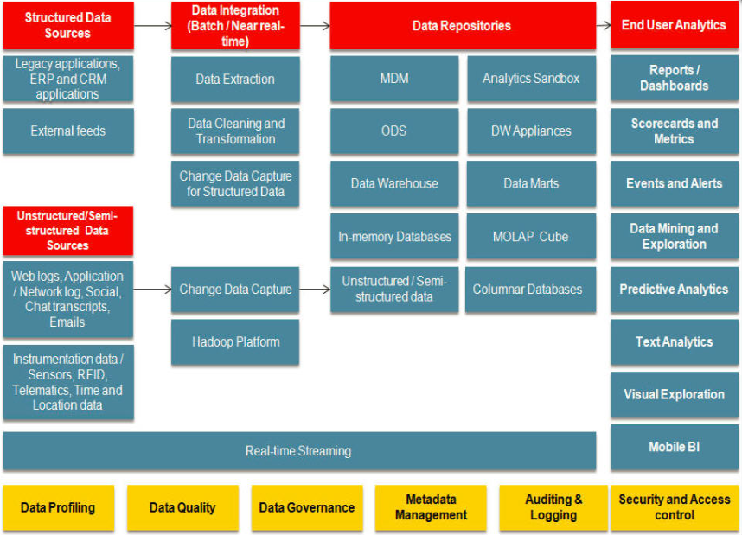
SAP Big Data Reference Architecture
http://scn.sap.com/community/hana-in-memory/blog/2013/04/30/big-data-technologies-applications

9sight

General Architecture Description
This simple picture sets the overall scope for the discussion and design between business and IT of systems supporting modern business needs that include big data and real-time operation in a “biz-tech ecosystem”. IDEAL stands for the characteristics of the architecture: Integrated, Distributed, Emergent, Adaptive and Latent.
Each layer is described it terms of three axes or dimensions. For information, the dimensions are:

- Timeliness/Consistency: the balance between these two demands commonly drives layering of data, e.g. in data warehousing.
- Structure/Context: an elaboration of structured/unstructured descriptions that defines the transformation of information to data.
- Reliance/Usage: information trustworthiness based on its sourcing and pre-processing.

The typical list of big data “v-words” is subsumed in these characteristic dimensions.

Architecture Model
The REAL (Realistic, Extensible, Actionable, Labile) architecture is aimed at IT to support building an IT environment capable of supporting big data in the context of all business activities. (Business is used here to cover all social organizations of people with the intention of pursuing a set of broadly related goals, including both profit-making and nonprofit enterprises, governmental and nongovernmental concerns, etc.) It covers all information and all processes that occur in such a business. It does not attempt to architect people!
Business applications/workflows—operational, informational or collaborative—with their business focus and wide variety of goals and actions, are gathered together in a single component, utilization.

Three information processing components are identified. Instantiation is the means by which measures, events and messages from the physical world are represented as or converted to transactions or instances of information within the enterprise environment. Assimilation creates reconciled and consistent information, using ETL and data virtualization tools, before users have access to it. Reification, sitting between all utilization functions and the information itself, provides a consistent, cross-pillar view of information according to an overarching model and access to it in real-time, and corresponds to data virtualization for “online” use. Modern data warehouse architectures use such functions extensively, but the naming is often overlapping and confusing; hence the unusual function names used here.

The Service Oriented Architecture (SOA) process- and services-based approach to delivering process uses an underlying choreography infrastructure, which coordinates the actions of all participating elements to produce desired outcomes. There are two subcomponents: adaptive workflow management and an extensible message bus. These functions are well-known in standard SOA work.

Finally, the organization component covers all design, management and governance activities relating to both processes and information.

Key Components and Their Descriptions/Information components
Information/data is represented in pillars for three distinct classes:
- Human-sourced information: Information originates from people, because context comes only from the human intellect. This information is the highly subjective record of human experiences and is now almost entirely digitized and electronically stored everywhere from tweets to movies. Loosely structured and often ungoverned, this information may not reliably represent for the business what has happened in the real world.
- Process-mediated data: Business processes record well-defined, legally binding business events. This process-mediated data is highly structured and regulated, and includes transactions, reference tables and relationships, and the metadata that sets its context. Process-mediated data includes operational and BI systems and was the vast majority of what IT managed in the past. It is amenable to information management, and to storage and manipulation in relational database systems.
- Machine-generated data: Sourced from the sensors, computers, etc. used to record events and measures in the physical world, such data is well-structured and usually reliable. As the Internet of Things grows, well-structured machine-generated data is of growing importance to business. Some claim that its size and speed is beyond traditional RDBMS, mandating NoSQL stores. However, high-performance RDBMSs are also often used.

Context setting information (metadata) is an integral part of the information resource, spanning all pillars.

LexisNexis

General Architecture Description
The High Performance Computing Cluster (HPCC) Systems platform is designed to handle massive, multi-structured datasets ranging from hundreds of terabytes to tens of petabytes, serving as the backbone for both LexisNexis online applications and programs within the US Federal Government alike. The technology has been in existence for over a decade, and was built from the ground up to address internal company requirements pertaining to scalability, flexibility, agility and security. Prior to the technology being released to the open source community in June 2011, the HPCC had been deployed to customer premises as an appliance (software fused onto a preferred vendor’s hardware), but has since become hardware-agnostic in an effort to meet the requirements of an expanding user base.

Architecture Model
The HPCC is based on a distributed, shared-nothing architecture and contains two cluster types – one optimized for ‘data refinery’ activities (Thor) and the other for ‘data delivery’ (Roxie). The nodes comprising both cluster types are homogenous, meaning all processing, memory and disk components are the same and based on commercial-off-the-shelf (COTS) technology.
In addition to compute clusters, HPCC environment also contains a number of system servers which act as a gateway between the clusters and the outside world. The system servers are often referred to collectively as the HPCC “middleware”, and include:

- The ECL compiler, executable code generator and job server (ECL Server): Serves as the code generator and compiler that translate ECL code.
- System data store, Dali: Used for environment configuration, message queue maintenance, and enforcement of LDAP security restrictions.
- Archiving server, Sasha: Serves as a companion “housekeeping” server to Dali.
- Distributed File Utility (DFU Server): Controls the spraying and despraying operations used to move data onto and out of THOR.
- The inter-component communication server (ESP Server): The inter-component communication server that allows multiple services to be “plugged in” to provide various types of functionality to client applications via multiple protocols.

Key Components and Their Descriptions
Core components of the HPCC include the THOR data refinery engine, ROXIE data delivery engine, and an implicitly parallel, declarative programming language, ECL. Each component is outlined below in further detail:
- THOR Data Refinery: THOR is a massively parallel Extract Transform and Load engine that can be used for performing a variety of tasks such as massive: joins, merges, sorts, transformations, clustering, and scaling. Essentially, THOR permits any problem with computational complexities O(n2) or higher to become tractable.

- ROXIE Data Delivery: ROXIE serves as a massively parallel, high throughput, structured query response engine. It is suitable for performing volumes of structured queries and full text ranked Boolean search, and can also operate in highly available (HA) environments due to its read-only nature. ROXIE also provides real-time analytics capabilities, to address real-time classifications, prediction, fraud detection and other problems that normally require handling processing and analytics on data streams.

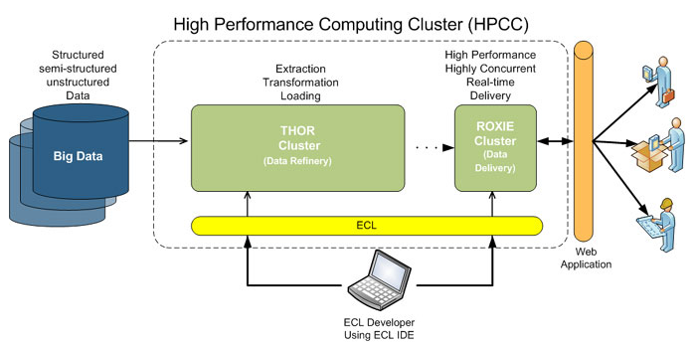
- The Enterprise Control Language (ECL): ECL is an open source, data-centric programming language used by both THOR and ROXIE for large-scale data management and query processing. ECL’s declarative nature enables users to solely focus on what they need to do with their data, while leaving the exact steps for how this is accomplished within a massively parallel processing architecture (MPP) to the ECL compiler.
As multi-structured data is ingested into the system and sprayed across the nodes of a THOR cluster, users can begin to perform a multitude of ETL-like functions, to include:
- Mapping of source fields to common record layouts used in the data
- Splitting or combining of source files, records, or fields to match the required layout
- Standardization and cleaning of vital searchable fields, such as names, addresses, dates, etc.
- Evaluation of current and historical timeframe of vital information for chronological identification and location of subjects
- Statistical and other direct analysis of the data for determining and maintaining quality as new sources and updates are included.
- Mapping and translating source field data into common record layouts, depending on their purpose.
- Applying duplication and combination rules to each source dataset and the common build datasets, as required.

THOR is capable of operating either independent or in tandem with ROXIE; when ROXIE is present it hosts THOR results and makes them available to the end-user through a web service API.

Big Data Architecture Comparison based on Key Feature Components

Reference Architecture Components Recommendations

Reference

Gartner Press Release, “Gartner Says Solving ‘Big Data’ Challenge Involves More Than Just Managing Volumes of Data”, June 27, 2011.
DataBase Trends and Applications, http://www.dbta.com/Articles/Editorial/Trends-and-Applications/What-is-Data-Analysis-and-Data-Mining-73503.aspx, Jan 7, 2011

