Big Data Open Source Maturity Model

The purpose of this note is to describe an Open Source Maturity Model, give an example showing why it is necessary, and suggest that the Technology Roadmap subgroup consider recommending the future of the Maturity Model.

When the NIST Cloud Standards Roadmap subgroup was considering the status of standards, I proposed using a Standards Maturity Model. This was necessary to enable Cloud project planners to distinguish between immature emerging standards and deployed production standards. The model is in the table below

From NIST Cloud Standards Roadmap Document Page 32
http://www.nist.gov/itl/cloud/upload/NIST_SP-500-291_Jul5A.pdf
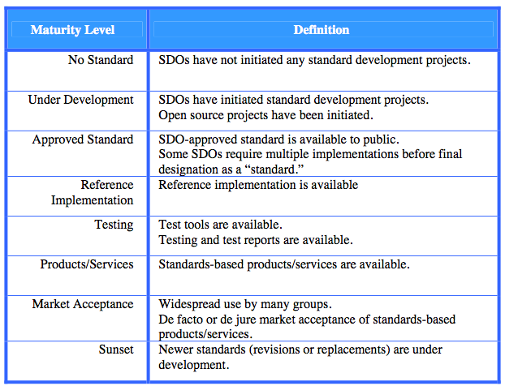

Unfortunately there are very few de jure standards under development for Big Data. (Query languages for NoSQL databases should be a future area for standards exploration.) Standardization is moving forward in the widespread use of specific open source packages (e.g. Hadoop).

Project planners are faced with the problem of understanding the maturity of open source packages similar to the earlier need to evaluate Cloud standards. One possible solution is to develop an Open Source Maturity Model in analogy with the Cloud Standards model. The levels in the Model should be based on objectively measurable attributes. A first cut is below,

Open Source Maturity Model - Objectively Measurable Levels

Maturity Level | Defition
Under development | Code available for viewing and testing
Released | Code available for prototyping, evaluation, and early use
Commercial Support | Code has commercial support and enhancements
Initial Production | Code used in a significant production application
Multiple Production | Code use in multiple production applications
Industry Standard | Code is the clearly dominant software in its domain of use
Replacement initiated | An enhanced alternative under development
Replacement available | An enhanced alternative code base is available

Example of the Need for a Maturity Model: Apache Yarn

Apache Yarn is a next generation open source resource manager that was created by separating resource management from data processing in MapReduce. See the first diagram below. Yarn has the ability to run multiple processing engines simultaneously on top of the Hadoop File System (HDFS). See the second diagram below. Microsoft has just announced a Retainable Evaluator Execution Framework (REEF) that will run on top of Yarn and be released as open source. See the third diagram below. Yarn is part of the Hadoop 2.0 package and has just moved from Level 1 to Level 2 in the Maturity Model. http://hadoop.apache.org/releases.html#1+Aug%2C+2013%3A+Release+1.2.1+%28stable%29+available

A Big Data Open Source Maturity Model will be very valuable in helping project planners understand the status of Yarn and Reef. The objective basis for the level setting will make it possible to do vendor and technology neutral evaluations. The Technology Roadmap subgroup could recommend the use of a Maturity Model and possibly provide some examples in the September deliverables.

From http://hortonworks.com/hadoop/yarn/

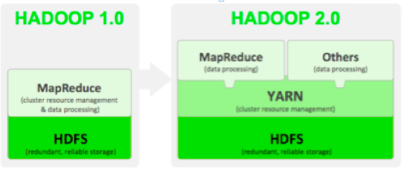

“As part of Hadoop 2.0, YARN takes the resource management capabilities that were in MapReduce and packages them so they can be used by new engines. This also streamlines MapReduce to do what it does best, process data. With YARN, you can now run multiple applications in Hadoop, all sharing a common resource management. Many organizations are already building applications on YARN in order to bring them IN to Hadoop.”

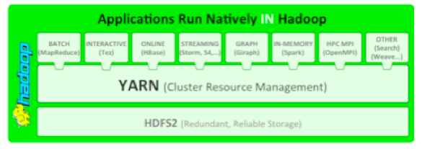

From http://gigaom.com/2013/08/12/microsoft-to-open-source-a-big-data-framework-called-reef/

“Microsoft has developed a big data framework called REEF (Retainable Evaluator Execution Framework) that the company intends to open source in about a month. REEF is designed to run on top of YARN, “
