Item # | Type | Page # | Line # | Section | Comment (with rationale) | Suggested Change
1 | E | 10 | 316 | 3 | Include a Purpose Domains layer to Fig.2 reference architecture. The purpose domains layer provides specific context, purpose, and requirements to the big data pursuit. | Add a Purpose Domains layer to the diagram and insert a subsection 3.1 text to define the layer and its expected roles in the architecture. (see Item #1 details)

Item #1

Current:
Figure 2: NIST Big Data Reference Architecture (NBDRA)

Change to:
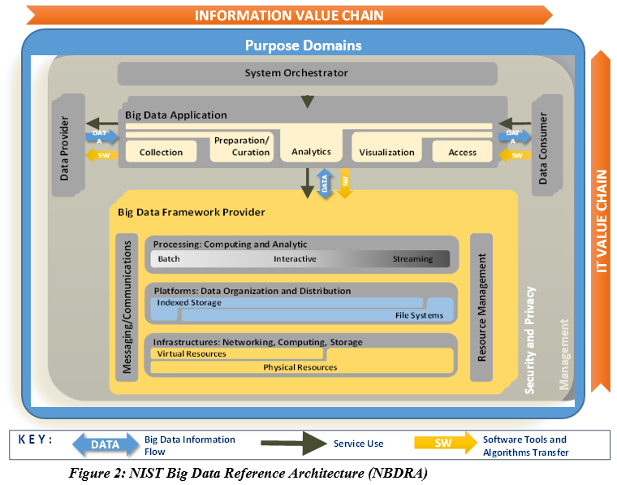

Text to insert before the current section 3.1 (before line 378):

3.1 Purpose Domains
The Purpose Domains layer of the Reference Architecture indicates what context and purpose the bid data pursuit is operated in. This layer provides the business or mission context of the big data effort; the goals and objectives of the effort; the requirements and constraints; the environment, culture, and other background factors; the stakeholders; and any other factors related to the specific business or mission domains.

Those domain factors affect the value proposition, the direction, the requirements and constraints, and the choices of business, management, security, and technical decisions of any big data efforts. The design of a big data architecture needs to incorporate the domain factors for the big data effort to assure delivering needed values within constraints to the business.

The common factors in the Purpose Domains layer may include, but are not limited to:
- The mission of the organization
- The goals and objectives of the big data pursuit
- The standard processes or best practice of the industry
- The types of business questions that need answers
- Stakeholders and their relevant needs
- Regulatory and other mandates
- Customer expectations
- Budget and resources constraints
- Time constraints
- …

Explicitly identifying and incorporating those purpose domain factors in the right stages of a big data pursuit will prevent the pursuit from becoming a failure or a wasteful effort.

