NIST Big Data Public Working Group (NBD-PWG)
NBD-PWD-2015/M0399

Source: NBD-PWG
Status: Draft
Title: Possible Big Data Use Cases Implementation using NBDRA
Author: Afzal Godil (NIST), Wo Chang (NIST)

To support Version 2 development, here are six unique Big Data use cases (with publicly available datasets and analytic algorithms) for implementation using the NIST Big Data Reference Architecture (NBDRA). We encourage NBD-PWG members to help implement them using NBDRA so that we can learn about the dataflow as well as their interactions between NBDRA key components.

Fingerprint Matching

Introduction

Fingerprint recognition refers to the automated method for verifying a match between two fingerprints and that is used to identify individuals and verify their identity. Fingerprints (Figure 1.) are the most widely used form of biometric used to identify individuals.

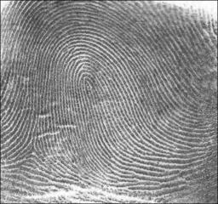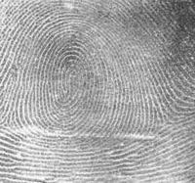
Figure 1. Shows two sample fingerprints.

The automated fingerprint matching generally required the detection of different fingerprint features (aggregate characteristics of ridges, and minutia points) and then the use of fingerprint matching algorithm, which can do both one-to-one and one-to-many matching operations. Based on the number of matches a proximity score (distance or similarity) can be calculated.

Algorithms
For this work we will use the following algorithms:

MINDTCT: The NIST minutiae detector, which automatically locates and records ridge ending and bifurcations in a fingerprint image. (http://www.nist.gov/itl/iad/ig/nbis.cfm)

BOZORTH3: A NIST fingerprint matching algorithm, which is a minutiae based fingerprint-matching algorithm. It can do both one-to-one and one-to-many matching operations. (http://www.nist.gov/itl/iad/ig/nbis.cfm)

Datasets
We use the following NIST dataset for the study:

Special Database 14 - NIST Mated Fingerprint Card Pairs 2.
(http://www.nist.gov/itl/iad/ig/special_dbases.cfm)

Specific Questions
- Match the fingerprint images from a probe set to a gallery set and report a match scores?
- What is the most efficient and high-throughput way to match fingerprint images from a probe set to a large fingerprint gallery set?

Possible Development Tools
Big-Data:
Apache Hadoop, Apache Spark, Apache HBase, DataMPI
Languages:
Java, Python, Scala

Human and Face Detection from Video (simulated streaming data)

Introduction
Detecting humans and faces in images or videos is a challenging task due the variability of pose, appearance and lighting conditions. Also the algorithms have to be sufficiently robust to occlusion and clutter present in the backgrounds. Figure 1 and Figure 2, shows human and face detection examples.

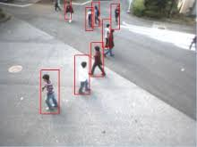
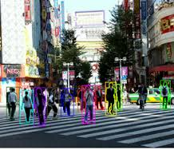
Figure 1. Human detection

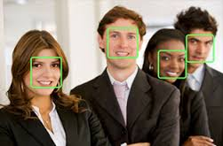
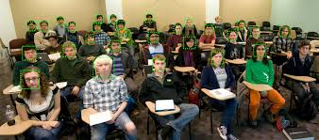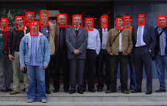
Figure 2. Face detection

Algorithms:
One of the most widely used methods for human detection is the HOG (Histograms of oriented gradients) [1].
[1] Dalal, Navneet, and Bill Triggs. "Histograms of oriented gradients for human detection." In Computer Vision and Pattern Recognition, 2005. CVPR 2005. IEEE Computer Society Conference on, vol. 1, pp. 886-893. IEEE, 2005.

For face detection one popular method is based on Harr wavelet and SVM classifier described in the paper [2].
[2] Viola, Paul, and Michael J. Jones. "Robust real-time face detection." International journal of computer vision 57.2 (2004): 137-154.

We could use the OpenCV implementation of human and face detection for our project [3].
Mahout and/or Spark’s MLlib library for machine learning consisting of common learning algorithms could be used for classification for human and face detection.
(http://spark.apache.org/docs/1.2.1/mllib-guide.html)

[3] Bradski, Gary, and Adrian Kaehler. Learning OpenCV: Computer vision with the OpenCV library. " O'Reilly Media, Inc.", 2008.
To download the code: http://opencv.org/

Datasets:
The input data will be a simulated video stream and the output will be the bounding box for human and face detection.

Video Datasets:
INRIA Person Dataset
http://pascal.inrialpes.fr/data/human/

This dataset was collected as part of research work on detection of upright people in images and video. The research is described in detail in [1].

Specific Questions:
- Detect all the humans and faces from the video steam and report the bounding box?
- What is the most efficient and high-throughput way to implement this Use Case when you have a large number of video streams?

Possible Development Tools:
Big-Data:
Apache Hadoop, Apache Spark, OpenCV, Apache Mahout, MLlib -Machine Learning Library, DataMPI
Languages:
Java, Python, Scala

Live Twitter Analysis

Introduction
Social media for many people has become integral part of their daily life. Social media metrics are now considered parts of altmetrics, which are non-traditional metrics proposed as an alternative to more traditional metrics.

Twitter is an online social networking service that enables users to send and read short 140-character messages called "tweets". Registered users can post and read tweets, but general public can also read them. This is unlike Facebook, where social interactions are often private. Users access Twitter through the website interface, SMS, or mobile device app.

We will develop a program(s) for live Twitter Analysis based on using Twitter's Search and Streaming APIs for sentiment analysis and visualization of results (Figure 1). We will also analyze and visualize NIST Twitter network. We can track and statistically analysis the NIST mentions, followers, retweets, compare it to other National labs, and many more things. The analysis could help NIST, measure and improve our effectiveness in engaging public about our work and our outreach effort on Twitter.

We could develop the application based on Apache Storm, a distributed computation framework, which adds reliable real-time data processing capabilities to Apache Hadoop. It is fast, scalable, and reliable and can be programmed using a variety of programming languages (Python, Java, Scala). Its architecture consists of three primary node sets: Nimbus nodes, Zookeeper nodes, and Supervisor nodes.

Algorithms

Sentiment Analysis:
Sentiment analysis or opinion mining refers to the use of natural language processing and text analysis to identify and extract subjective information in source materials. Normally speaking, sentiment analysis aims to determine the attitude of a speaker or a writer with respect to some topic or the overall contextual of a document(s).

Examples of words used for Sentiment analysis:
Positive: nice, awesome, cool, superb, etc.
Negative: bad, uninspired, expensive, disappointed, recommend others to avoid, etc.

Datasets
Live Twitter feed

Specific Questions:
Develop tools for location based sentiment analysis of Twitter feed in real-time?

Possible Development Tools
Big-Data: Apache Strom, Apache HBase, Twitter's Search and Streaming APIs
Visualization tools: D3 Visualization, Tableau visualization.
Natural Language Processing Algorithms: Python Natural Language Toolkit (NLTK), AlchemyAPI Service
Languages:
Java, Python, Scala, Javascript, JQuery

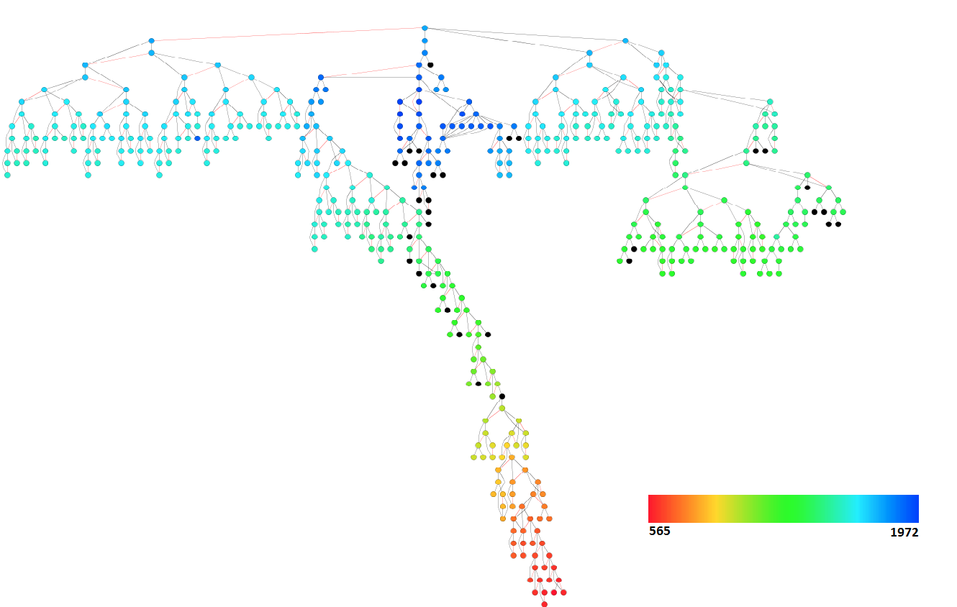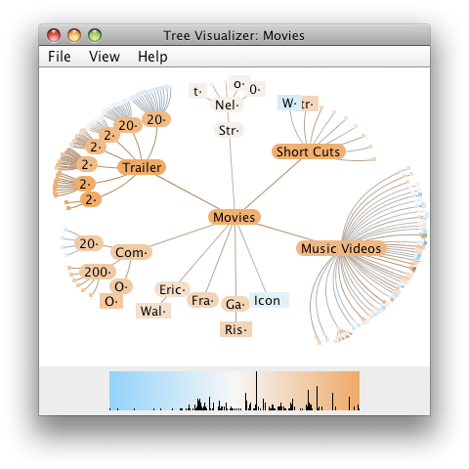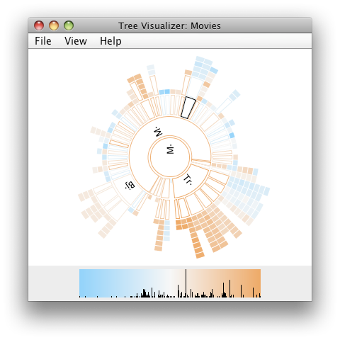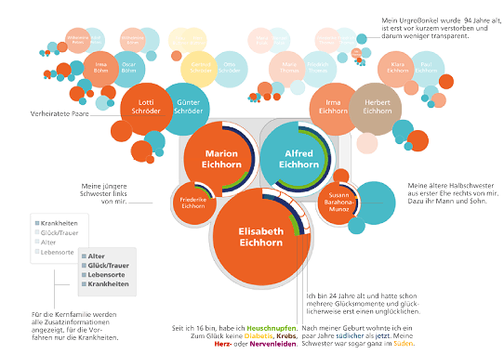
Figure 1. Show different Twitter visualizations

Big data Analytics for Healthcare Data/Health informatics

Introduction
Big data is defined as high-volume, high-velocity, and high-variety information assets that demand cost-effective, innovative forms of information processing for enhanced insight and decision-making. Healthcare data certainly fits the definition of big data.

Large amount healthcare data is produced continually and store in different databases. With the wide adoption of electronic health records that has increased the amount of data available exponentially. Nevertheless, the healthcare providers has been slow to leverage the vast amount of data to improve heath care system or use data to improve efficiency to reduce overall cost of healthcare.

Health care data has the potential to innovate the procedure of health care delivery in the US and inform healthcare providers about the most efficient and effective treatments. Value-based healthcare programs will provide incentives to both healthcare providers and insurers to explore new ways to leverage healthcare data to measure the quality and efficiency of care.

Healthcare use:

It is estimated that in the US healthcare spending approximately, $75B to $265B is lost each year to healthcare fraud. [1]

[1] White SE. Predictive modeling 101. How CMS’s newest fraud prevention tool works and what it means for providers. J AHIMA. 2011;82(9): 46–47.

With the amount of healthcare fraud, the importance of identifying fraud and abuse in healthcare cannot be ignored; so healthcare providers must develop automated systems to identify fraud, waste and abuse to reduce its harmful impact on their business.

Algorithms: Develop statistical analysis, visualization, and machine learning tools to statistically analyze and develop predictive models for healthcare payment data and possibly detect irregularities and prevent healthcare payment fraud.

Dataset:
The Healthcare dataset: Center for Medicare and Medicaid Services (CMS) (http://www.cms.gov), released in the dataset into the public domain known as “Medicare Part-B in 2014”. The dataset includes a set of records documenting about transactions between over 900,000 medical providers and CMS. Datasets can be found at:
[Note: This Compressed ZIP package contains the tab delimited data file (Medicare_Provider_Util_Payment_PUF_CY2012.txt) which is 1.7GB uncompressed and contains more than 9 million records, thus importing this file into Microsoft Excel will result in an incomplete loading of data. Use of database or statistical software is required; a SAS® read-in statement is supplied. Additionally, this ZIP package contains the following supporting documents: CMS_AMA_CPT_license_agreement.pdf, and Medicare-Provider-Util-Payment-PUF-SAS-Infile.sas]

http://www.cms.gov/Research-Statistics-Data-and-Systems/Statistics-Trends-and-Reports/Medicare-Provider-Charge-Data/Physician-and-Other-Supplier2012.html

Or the direct link to the dataset (446MB compressed; 1.7 GB after uncompressed) is:

http://download.cms.gov/Research-Statistics-Data-and-Systems/Statistics-Trends-and-Reports/Medicare-Provider-Charge-Data/Downloads/Medicare_Provider_Util_Payment_PUF_CY2012_update.zip?agree=yes&next=Accept

Specific Questions:
What machine learning tools can be used for detecting irregularities in Healthcare Data?

Possible Development Tools
Big Data:
Apache Hadoop, Apache Spark, Apache HBase, Apache Mahout, Apache Lucene/Solr, MLlib -Machine Learning Library
Visualization:
D3 Visualization, Tableau visualization
Languages:
Java, Python, Scala, Javascript, JQuery

Spatial Big data/Spatial Statistics/Geographic Information Systems

Introduction
Big data is defined as high-volume, high-velocity, and high-variety information assets that demand cost-effective, innovative forms of information processing for enhanced insight and decision-making. Geospatial data certainly fits the definition of big data.

Now that Big Data Tools Analytics have been developed. The same tools can be applied to geospatial data and it will allow users to analyze massive volumes of geospatial data. Petabyte of remotely sensed geospatial data are capture yearly and been store in different databases. Increasingly, however, the size, variety, and update rate of datasets exceed the capacity of commonly used spatial computing and spatial database technologies to learn, manage, and process the data with reasonable effort. We believe that developing and harnessing Spatial Big Data represents the next group of GIS services. Also, to create a smart city requires the collection of real-time geospatial data and other sensor data and then to exploit the necessary information and apply it effectively.

Some tools that needed for Spatial Big Data are: indexing, retrieval, routing, spatial statistics, and big data analysis, and visualization.

Dataset
Uber Ride Sharing GPS Data (GPS data is publically available on infochimps.com)

Algorithm
We will be analyzing a public available GPS dataset from a popular ride sharing service Uber.

Specific Questions:
What are most popular zip codes over time of the starting and end points of the Uber rides on weekdays and how to visualize the results?

We also try to answer the following questions:

- Does the usage of the ride sharing service change over time?
- Where do most people go during the weekends?
- Where do most people go during the weekdays?
- Visualizing the traffic patterns with D3 and Tableau visualization software

Possible Development Tools
Big-Data:
Apache Hadoop, Apache Spark, GIS-tools, Apache Mahout, MLlib -Machine Learning Library
Visualization:
D3 Visualization, Tableau visualization, etc.
Languages:
Java, Python, Scala, Javascript, JQuery

Data Warehousing and Data mining

Introduction

​Big data is defined as high-volume, high-velocity, and high-variety information assets that demand cost-effective, innovative forms of information processing for enhanced insight and decision-making. Both data mining and data warehousing are applied to big data and are business intelligence tools that are used to turn data into high value and useful information.

The important differences between the two tools are the methods and processes each uses to achieve these goals. The data warehouse is a system used for reporting and data analysis. Data mining (also known as knowledge discovery) is the process of mining and analyzing massive sets of data and then extracting the meaning of the data. Data mining tools predict actions and future trends, allow businesses to make practical, knowledge-driven decisions. Data mining tools can answer questions that traditionally were too time consuming to be done before.

Dataset
2010 Census Data Products: United States (http://www.census.gov/population/www/cen2010/glance/)

Algorithms
We will upload datasets to the HBase database and use Hive and Pig for reporting and data analysis. We use the machine learning libraries in Hadoop and Spark for data mining. The data mining tasks are: 1) Association rules and patterns, 2) Classification and prediction, 3) Regression, 3) clustering, 4) Outlier Detection, 5) Time series analysis, 6) Statistical summarization, 7) Tex mining, and 8) Data visualization.

Specific Questions:
What zip code has the highest population density increase in the last 5 years? And how is this correlated to unemployment rate in the area?

Possible Development Tools
Big-Data:
Apache Hadoop, Apache Spark, Apache HBase, MongoDB, Hive, Pig, Apache Mahout, apache Lucene/Solr, MLlib -Machine Learning Library
Visualization:
D3 Visualization, Tableau visualization.
Languages:
Java, Python, Scala, Javascript, JQuery

