Big Data Reference Architecture Description

The High Level Layered Reference Architecture below captures the essential features of Big Data architectures. It is a drill-down from the NBD-WG’s four layer RA.
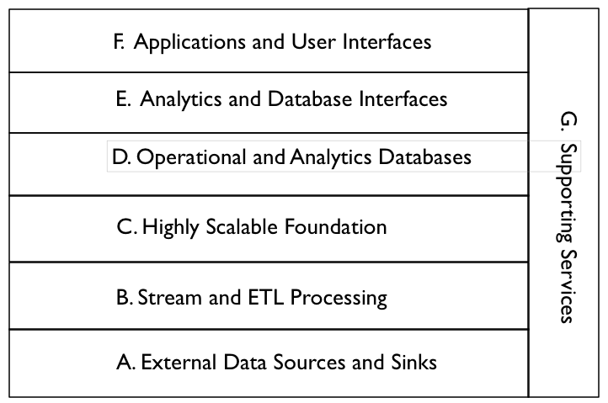
Descriptions of the Components of the High Level Reference Architecture. Points for future discussion are in bold. Examples are from the Apache Big Data Ecosystem.

A. External Data Sources and Sinks - Provides external data inputs and output to the internal Big Data components. Note that Big Data stores can output data flows to external systems e.g. feeding external databases.

B. Stream and ETL Processing - Filters and transforms data flows between external data resources and internal Big Data systems. This processing should also be scalable by adding additional processors

C. Highly Scalable Foundation - Horizontally scalable data stores and processing that form the foundation of Big Data Architectures. It is essential to represent this layer explicitly in the Reference Architecture.

D. Operational and Analytics Databases - Databases integrated into the Big Data architecture. These can be horizontally scalable databases or single platform databases with data extracted from the foundational data store. Big Data databases (e.g. NoSQL, NewSQL) must be explicitly represented in the Big Data architecture.

E. Analytics and Database Interfaces - These are the interfaces to the data stores for queries, updates, and analytics. They are included in the Reference Architecture because data stores may have multiple interfaces (e.g. Pig and Hive to HDFS) and this is an area of possible standardization.

F. Applications and User Interfaces - These are the applications (e.g. machine learning) and user interfaces (e.g. visualization) that are built on Big Data components. Applications must have an underlying horizontally scalable data storage and processing foundation to qualify as Big Data applications.

- Supporting Services - These services include the components needed for the implementation and management of robust Big Data systems. The key difference is that services must be enhanced to handle scalable horizontally distributed data sources and processing deployed on relatively low reliability platforms.

The Lower Level Reference Architecture below expands on some of the layers in the High Level Reference Architecture and shows some of the data flows. It can be drilled down if necessary.
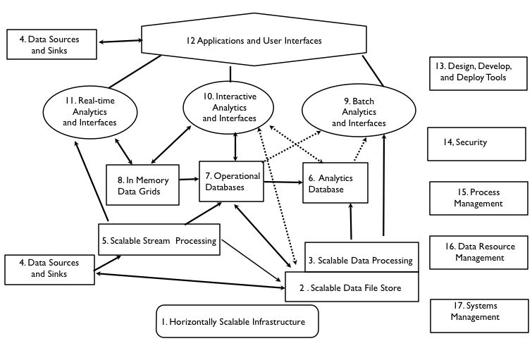

A. External Data Sources and Sinks - Data sources might be separated from sinks in a more detailed model

4. Data Sources and Sinks - These are components in a complete data architecture that clearly defined interfaces to Big Data horizontally scalable internal data stores and applications.

B. Stream and ETL Processing - Stream Processing and Extract, Transform, Load (ETL) processing might be split in a more detailed architecture

5. Scalable Stream Processing - This is processing of “data in movement” between data stores. It can be used for filtering, transforming, or routing data. For Big Data streams, the stream processing must be scalable to support distributed and/or pipelined processing.

- Highly Scalable Foundation - This is the core of Big Data Technology. There
are several aspects including data stores (e.g. Hadoop File System), e.g. data processing (e.g. MapReduce) and infrastructure (e.g. Clouds)

- Scalable Infrastructure - To support scalable Big Data stores and processing, it is necessary to have an infrastructure that can support the easy addition of new resources. Possible platforms include public and/or private Clouds.

- Scalable Data Stores - This is the essence of Big Data architecture. Horizontal scalability using less expensive components can support the unlimited growth of data storage. However there must be fault tolerance capabilities available to handle component failures.

3 . Scalable Processing - To take advantage of scalable distributed data stores, it is necessary to have scalable distributed parallel processing with similar fault tolerance. In general, processing should be configuring to minimize unnecessary data movement.

D. Operational and Analytics Databases - The databases are split because this is currently a differentiator that effects interfaces and applications

6. Analytics Databases - Analytics databases are generally highly optimized for read-only interactions (e.g. columnar storage, extensive indexing, and denormalization). It is often acceptable for database responses to have high latency (e.g. invoke scalable batch processing over large data sets).

7. Operational Databases - Operation databases generally support efficient write and read operations. NoSQL databases are often used in Big Data architectures in this capacity. Data can be later transformed and loaded into analytic databases to support analytic applications.

8. In Memory Data Grids - These are very high performance data caches and stores that minimize writing to disk. They can be used for large scale real time applications requiring transparent access to data.

- Analytics and Database Interfaces - Interfaces and simple analytics
are bundled together because there are overlaps e.g. SQL interfaces and SQL-based analytics, The interfaces and analytics are split into subgroups by latency. There is a definite distinction between interfaces requiring batch processing (e.g. current Hive, Pig), end-user interactive responses (e.g. HBase), and ultrafast real-time responses (e.g machine-based Complex Event Processing).

- Batch Analytics and Interfaces - These are interfaces that use batch scalable
processing (e.g. Map-Reduce) to access data in scalable data stores (e.g Hadoop File System). These interfaces can be SQL-like (e.g. Hive) or programmatic (e.g. Pig).

- Interactive Analytics and Interfaces - These interfaces avoid directly access data
stores to provide interactive responses to end-users. The data stores can be horizontally scalable databases tuned for interactive responses (e.g. HBase) or query languages tuned to data models (e.g. Drill for nested data).

11. Real-Time Analytics and Interfaces - There are applications that require real time responses to events occurring within large data streams (e.g. algorithmic trading). This complex event processing is machine-based analytics requiring very high performance data access to streams and data stores.

F. Applications and User Interfaces - Visualization might be split from applications in a more detailed model.

12. Applications and Visualization - The key new capability available to Big Data analytic applications is the ability to avoid developing complex algorithms by utilizing vast amounts of distributed data (e.g. Google statistical language translation). However taking advantage of the data available requires new distributed and parallel processing algorithms.

G. Supporting Services - These services are available in all robust enterprise architectures. The key extension for Big Data is the ability to handle horizontal components. They could all be expanded in a more detailed Reference Architecture.

- Design, Develop, and Deploy Tools - High level tools are limited for the implementation of Big Data applications (e.g. Cascading). This will have to change to lower the skill levels needed by enterprise and government developers.

- Security - Current Big Data security and privacy controls are limited (e.g. only Kerberos authentication for Hadoop, Knox). They must be expanded in the future by commercial vendors (e.g. Cloudera Sentry) for enterprise and government applications.

- Process Management - Commercial vendors are supplying process management tools to augment the initial open source implementations (e.g. Oozie)

- Data Resource Management - Open Source data governance tools are still immature (e.g. Apache Falcon). These will be augmented in the future by commercial vendors.

- System Management - Open source systems management tools are also
immature (e.g. Ambari). Fortunately robust system management tools are
commercially available for scalable infrastructure (e.g. Cloud-based).

Additional References

Apache’s Big Data Offerings mapped to Reference Architecture

An overview of the Apache ecosystem is at
http://www.revelytix.com/?q=content/hadoop-ecosystem

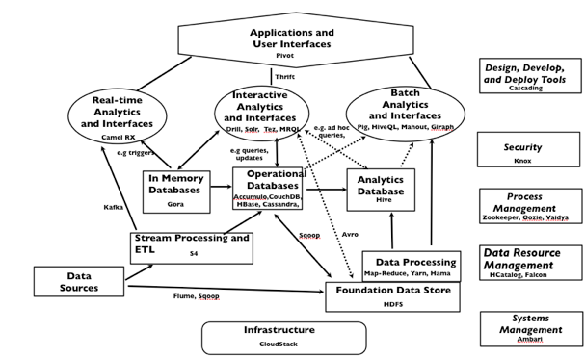

Two Other Reference Architectures for Comparison

From http://www.slideshare.net/Hadoop_Summit/dont-be-hadooped-when-looking-for-big-data-roi
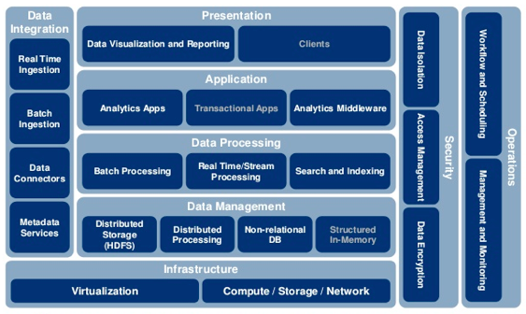

From “ Big Data Governance” Book by Sunil Soares
