**Template #1: Geoffrey Fox Use Case sample**

|  |  |
| --- | --- |
| **Use Case Title** | Analysis of LHC Data (Discovery of Higgs particle) |
| **Actors** | cloud-subscriber, cloud-provider-1, cloud-provider-2, transport-agent |
| **Goals** | Understanding of properties of fundamental particles |
| **Data Source and Nature** | CERN LHC Accelerator and Monte Carlo producing events describing particle-apparatus interaction. Processed information defines physics properties of events (lists of particles with type and momenta) |
| **Data Size** | 15 Petabytes per year |
| **Analysis/ Compute Model** | 200,000 cores running “continuously” arranged in 3 tiers (CERN, “Continents/Countries”. “Universities”). Uses “High Throughput Computing” (Pleasing parallel). Can use commercial or academic clouds but analysis infrastructure built before clouds available |
| **Data Analytics** | Initial analysis is processing of experimental data specific to each experiment (ALICE, ATLAS, CMS, LHCb) producing summary information. Second step in analysis uses “exploration” (histograms, scatter-plots) with model fits. Substantial Monte-Carlo computations to estimate analysis quality. |
| **Security & Privacy** |  |
| **More Information** | <http://grids.ucs.indiana.edu/ptliupages/publications/Where%20does%20all%20the%20data%20c> |

**Template #2: NIST Cloud Use Case sample**

|  |  |
| --- | --- |
| **Use Case Title** | Copy Data Objects between Cloud-Providers |
| **Actors** | cloud-subscriber, cloud-provider-1, cloud-provider-2, transport-agent |
| **Goals** | Copy data objects from a cloud-provider-1's system to a cloud-provider-2's system on the initiative of a cloud-subscriber. |
| **Assumptions** | Cloud-subscriber has established an account with cloud-provider-1 and cloud-provider-2. |
| **Success Scenario**  **(copy, IaaS)** | A cloud-subscriber mutually authenticates to cloud-provider-1 (where the data object initially resides) using cloud-provider-1's mutual authentication mechanisms, and starts a command shell (or equivalent) on cloud-provider-1. From cloud-provider-1, the cloud-subscriber may access other systems on the Internet. The cloud-subscriber determines the object identifiers of the data objects that the cloud-subscriber wishes to copy from cloud-provider-1 to cloud-provider-2. From the command shell on cloud-provider-1 the cloud-subscriber authenticates to cloud-provider-2 using cloud-provider-2's authentication mechanisms (note: this approach passes authentication through cloud-provider-1). The cloud-subscriber locates a container (e.g., a directory) on cloud-provider-2 where the copied object will reside. The cloud-subscriber may have to create a container. For each data object that the cloud-subscriber wishes to copy, the cloud-subscriber: 1) downloads the contents of the object to the virtual machine the cloud-subscriber is using in cloud-provider-1 2) uploads the data as a new object in cloud-provider-2's object store, and 3) deletes the copy of the data just created in the virtual machine in cloud-provider-1. The copy of the data just created in virtual machine in cloud-provider-1 is deleted as described in Use Case 3.6 (Erase Data Objects in Clouds). |
| **Failure Conditions** | (1) The cloud-subscriber is unable to authenticate to cloud provider-1; (2) the cloud-subscriber has insufficient privileges for the requested actions. |
| **Failure Handling** | The cloud-providers notify the subscriber of the failure and provide a description of the failure (e.g. expired certificate, insufficient privileges, etc.). |
| **Credit** | TBD |
| **Note:** Success Scenario 3 or New Use Case – Version Control - : - idea of several versions of same data object copied across multiple clouds and version control – distributed CVS | |

**Template #3: NIST Internal Big Data Use Case Survey**

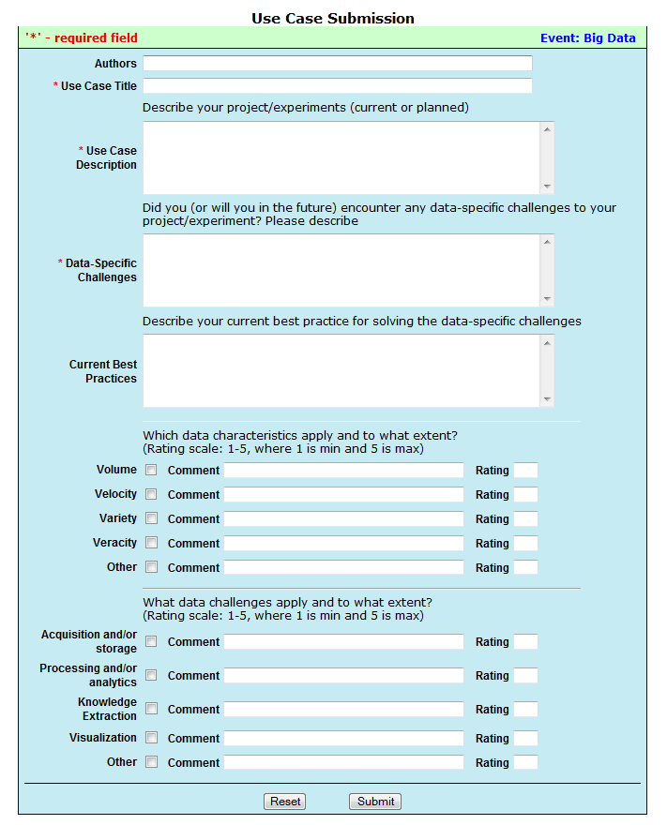

**Template #4: NBD Use Case Requirements (Proposal)**

|  |  |
| --- | --- |
| **Use Case Title** |  |
| **Author/Company** |  |
| **Actors** |  |
| **Roles and Responsibilities** |  |
| **Goals** |  |
| **Use Case Description** |  |
| **Current Solutions** |  |
| **Data Size (per year/month)** |  |
| **Big Data Specific Challenges** |  |
| **Big Data Requirements** |  |
| **Security & Privacy**  **Requirements** |  |
| **More Information (URL)** |  |
| **Note:** <additional comments> | |