**NIST Big Data Working Group (NBD-WD)**

**NBD-WD-2013/M0039**

**Source: Ref. Architecture Subgroup**

**Status: Draft**

**Title: Collection of Architectures and Discussions for NBD Reference Architecture**

**Authors: Orit Levin (Microsoft), James Ketner (AT&T), Don Krapohl (Augmented Intelligence)**

***Abstract***

This is a working document trying to capture various architectural features which may benefit for the development of the NBD Ref. Architecture.

**Note: From the NBD-WG Charter: “...The aim is to create vendor-neutral, technology and infrastructure agnostic deliverables to enable Big Data stakeholders to pick-and-choose best analytics tools for their processing and visualization requirements on the most suitable computing platforms and clusters while allowing value-added from Big Data service providers and flow of data between the stakeholders in a cohesive and secure manner. “**

Author: Bob Marcus

Reference: <http://bigdatawg.nist.gov/_uploadfiles/M0014_v1_3993569620.pdf>, page 7

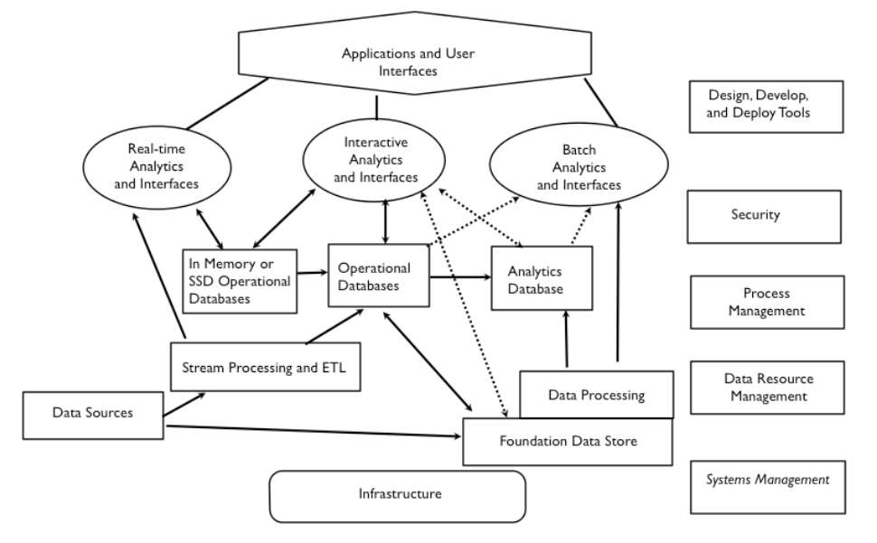

Author: Orit Levin

Reference: <http://bigdatawg.nist.gov/_uploadfiles/M0017_v2_4175727836.pdf>, page 4

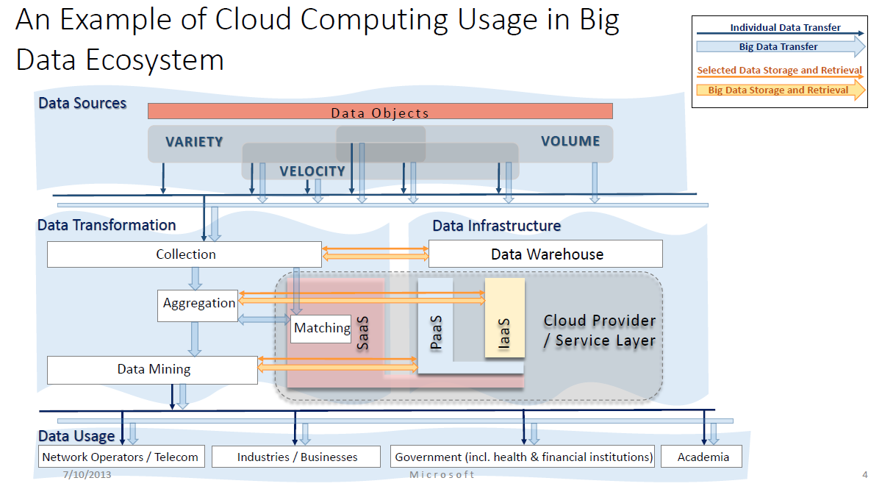

Author: Wo Chang

Reference: <http://bigdatawg.nist.gov/_uploadfiles/M0036_v1_7458216169.pdf>, page 6

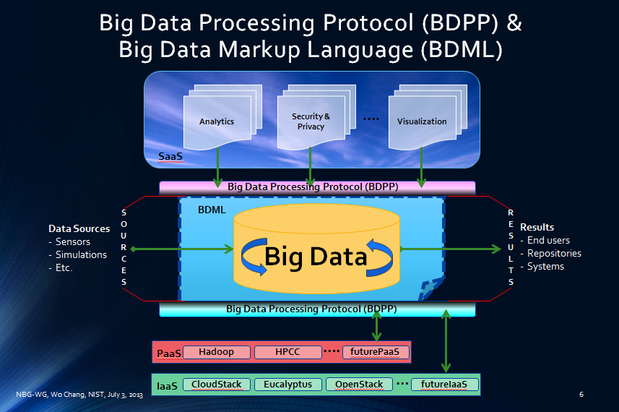

Author: Gary Mazzaferro

Reference: ??

