## Technological Readiness

The technological readiness for Big Data serves as metric useful in assessing both the overall maturity of a technology across all implementers as well as the readiness of a technology for broad use within an organization. Technology readiness evaluates readiness types in a manner similar to that of technology readiness in Service-Oriented Architectures (SOA). However, the scale of readiness is adapted to better mimic the growth of open source technologies, notably those which follow models similar to the Apache Software Foundation (ASF). Figure 1 provides a superimposition of the readiness scale on a widely recognized "hype curve." This ensures that organizations which have successfully evaluated and adopted aspects of SOA can apply similar processes to assessing and deploying Big Data technologies.

### Types of Readiness

* **Architecture**: Capabilities concerning the overall architecture of the technology and some parts of the underlying infrastructure
* **Deployment**: Capabilities concerning the architecture realization infrastructure deployment, and tools
* **Information**: Capabilities concerning information management: data models, message formats, master data management, etc.
* **Operations, Administration and Management**: Capabilities concerning post-deployment management and administration of the technology

### Scale of Technological Readiness

1. **Emerging**

* Technology is largely still in research and development
* Access is limited to the developers of the technology
* Research is largely being conducted within academic or commercial laboratories
* Scalability of the technology is not assessed

1. **Incubating**

* Technology is functional outside laboratory environments
* Builds may be unstable
* Release cycles are rapid
* Documentation is sparse or rapidly evolving
* Scalability of the technology is demonstrated but not widely applied

1. **Reference Implementation**

* One or more reference implementations are available
* Reference implementations are usable at scale
* The technology may have limited adoption outside of its core development community
* Documentation is available and mainly accurate

1. **Emerging Adoption**

* Wider adoption beyond the core community of developers
* Proven in a range of applications and environments
* Significant training and documentation is available

1. **Evolving**

* Enhancement-specific implementations may be available
* Tool suites are available to ease interaction with the technology
* The technology competes with others for market share

1. **Standardized**

* Draft standards are in place
* Mature processes exist for implementation
* Best practices are defined

## Organizational Readiness and Adoption

Technological readiness is useful for assessing the maturity of the technology components which make up Big Data implementations. However, successful utilization of Big Data technologies within an organization strongly benefits from an assessment of both the readiness of the organization and its level of adoption with respect to Big Data technologies. As with the domains and measures for the Technology Readiness scale, we choose definitions similar to those used for SOA.

### Types of Readiness

#### Organizational Readiness Domains

* **Business and Strategy:** Capabilities that provide organizational constructs necessary for Big Data initiatives to succeed. These include a clear and compelling business motivation for adopting Big Data technologies, expected benefits, funding models etc.
* **Governance:** The readiness of governance policies and processes to be applied to the technologies adopted as part of a Big Data initiative. Additionally, readiness of governance policies and processes for application to the data managed and operated on as part of a Big Data initiative.
* **Projects, Portfolios, and Services:** Readiness with respect to the planning and implementation of Big Data efforts. Readiness extends to quality and integration of data, as well as readiness for planning and usage of Big Data technology solutions.
* **Organization:** Competence and skills development within an organization regarding the use and management of Big Data technologies. This includes, but is not limited to, readiness within IT departments (e.g., service delivery, security, and infrastructure) and analyst groups (e.g. methodologies, integration strategies, etc.).

### Scale of Organizational Readiness

1. **No Big Data**

* No awareness or efforts around Big Data exist in the organization

1. **Ad Hoc**

* Awareness of Big Data exists
* Some groups are building solutions
* No Big Data plan is being followed

1. **Opportunistic**

* An approach to building Big Data solutions is being determined
* The approach is opportunistically applied, but is not widely accepted or adopted within the organization

1. **Systematic**

* The organizational approach to Big Data has been reviewed and accepted by multiple affected parties.
* The approach is repeatable throughout the organization and nearly-always followed.

1. **Managed**

* Metrics have been defined and are routinely collected for Big Data projects
* Defined metrics are routinely assessed and provide insight into the effectiveness of Big Data projects

1. **Optimized**

* Metrics are always gathered and assessed to incrementally improve Big Data capabilities within the organization.
* Guidelines and assets are maintained to ensure relevancy and correctness

### Scale of Organizational Adoption

1. **No Adoption**

* No current adoption of Big Data technologies within the organization

1. **Project**

* Individual projects implement Big Data technologies as they are appropriate

1. **Program**

* A small group of projects share an implementation of Big Data technologies
* The group of projects share a single management structure and are smaller than a business unit

1. **Divisional**

* Big Data technologies are implemented consistently across a business unit

1. **Cross-Divisional**

* Big Data technologies are consistently implemented by multiple divisions with a common approach
* Big Data technologies across divisions are at an organizational readiness level of Systematic or higher

1. **Enterprise**

* Big Data technologies are implemented consistently across the enterprise
* Organizational readiness is at level of Systematic or higher

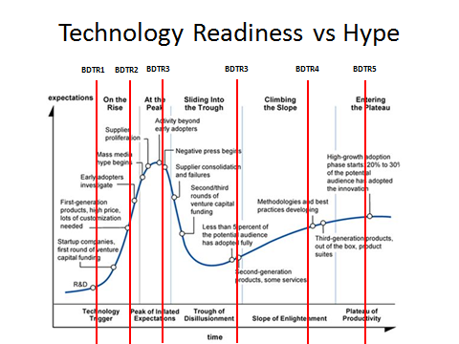

Figure Technology Readiness levels visualized along Gartner's "hype curve."