“Fabric” not “Cross-Cutting”

# Introduction

One important concept in the NIST Big Data Public WG (NBDPWG) Reference Model is “fabric.” A security / privacy fabric, as explained in Vol 4 of the WG’s publication, is a notion which applies a framework over all facets of the Reference Architecture.

The proposed change from “fabric” to “cross-cutting” is substitutes one design pattern (fabric) with modest adoption across telecom, services frameworks and software engineering for a compound modifier (“cross-cutting”) that has no visible adoption in information technology circles. For this reason, we recommend that the SC27 WG not implement this change in terminology.

# Rationale

Figure 1 shows the fabric as an all-encompassing dimension which touches every facet of the Reference Architecture (Grady, 2016).

The fabric analogy has been used in several other settings. We list several. The implication is that the analogy is well suited to the design patterns found in diverse technology sectors. The analogy is specific, whereas “cross-cutting” is generic, implying nothing about how pieces are to be stitched together. Microsoft’s use of fabric for a microservice-centric model is especially telling.

We are not recommending wholesale adoption of any of these concepts directly, though the citations might prove useful to standards readers seeking a better understanding of how the fabric concept can be applied in their context.

## Cisco and Cisco/McAfee

In 2014 Cisco published a report on technology which declared that big data fabric is essentially made up of Hadoop frameworks, NoSQL databases, and “Other big data tech.” This definition is certainly not comprehensive enough. As presented in their 2016 Wave for Big Data Fabric Vendors, fabric functions involve: “access, discovery, transformation, integration, security, governance, lineage, and orchestration of big data sources to support big data workloads and use cases.”

In Figure 2, Cisco’s subsidiary McAfee offers the notion of a security framework, and a 2017 Cisco data sheet refers to the Company’s Fabric Manager (Cisco, 2016).

## Forrester Wave Report

(Yuhanna, 2016) A 2014 Forrester Wave for MM offers one realistic definition:

“MDM exists within a comprehensive portfolio of products to help… create a fabric to integrate data and application infrastructure.”

This definition of fabric keeps it in line with the concept of a quilt, a scaffolding to support integration, comprehensive yet easy to grasp. The 2016 Forrester Big Wave report continues with the fabric analogy.

## Microsoft

Microsoft embraces fabric as an umbrella description for its Azure cloud service, “Azure Service Fabric, recently described as:

Azure Service Fabric is a distributed systems platform that makes it easy to package, deploy, and manage scalable and reliable microservices and containers. Service Fabric also addresses the significant challenges in developing and managing cloud native applications. Developers and administrators can avoid complex infrastructure problems and focus on implementing mission-critical, demanding workloads that are scalable, reliable, and manageable. Service Fabric represents the next-generation platform for building and managing these enterprise-class, tier-1, cloud-scale applications running in containers.

# Support from Other Sources

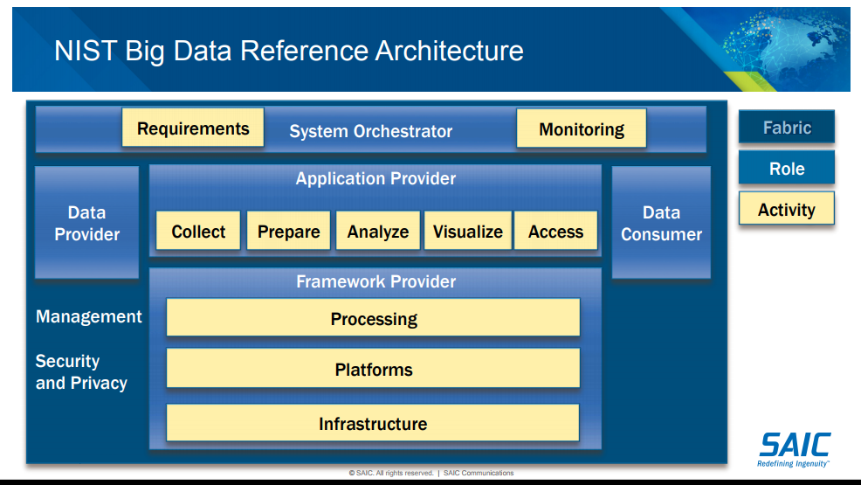

Figure 1. Reference model showing fabric (Grady, 2016)

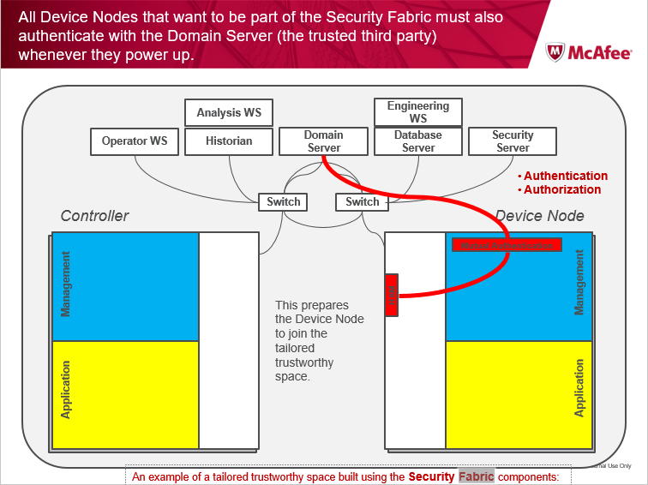

Figure 2 Cisco McAfee Security Fabric Components

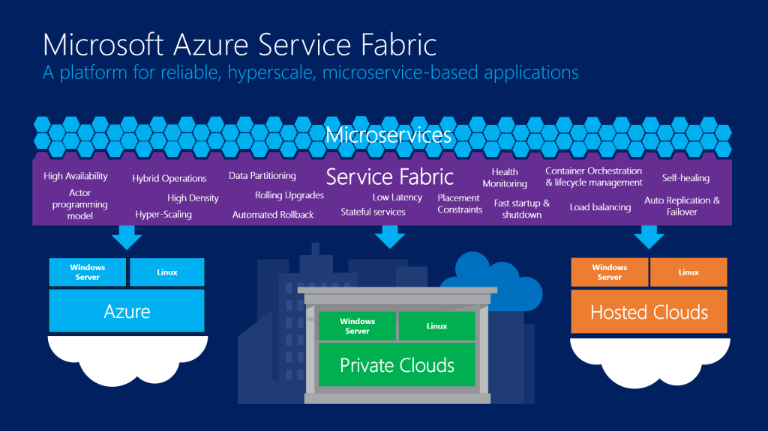

Figure 3. Microsoft Service Fabric (via [Techcrunch](https://techcrunch.com/2015/04/20/microsoft-announces-azure-service-fabric-a-new-framework-for-building-scalable-cloud-services/), April 2015)

# References

Cisco, "Cisco Nexus Fabric Manager," Web, Cisco, San Jose, CA, Tech. Rep., Sep. 2017. [Online]. Available: <https://www.cisco.com/c/dam/en/us/products/collateral/cloud-systems-management/nexus-fabric-manager/at-a-glance-c45-736500.pdf>

N. W. Grady, "KDD meets big data," in *2016 IEEE International Conference on Big Data (Big Data)*, 2016, pp. 1603-1608. [Online]. Available: <http://dx.doi.org/10.1109/BigData.2016.7840770>

Microsoft. (2017, Jul.) Overview of azure fabric. web. Microsoft. Redmond, WA. [Online]. Available: <https://docs.microsoft.com/en-us/azure/service-fabric/service-fabric-overview>

N. Yuhanna, "The Forrester Wave: Big data fabric Q4 2016," Forrester Research, Cambridge, MA, Tech. Rep., Nov. 2016. [Online]. Available on request from Informatica.

# Contributors

Russell Reinsch, Arnab Roy, Mark Underwood

# Version History

|  |  |
| --- | --- |
| Version | Change Description |
| 1.0 | Integrate RR comments. Add references and outline. |
|  |  |