NIST Normative Test Process Document: LOI-EHR Test Tool for Transmission of Laboratory Orders

Test Tool and Test Descriptions to Conduct HIT Conformance Testing
NIST Approved Version 1.0
Date: November 16, 2016

Developed by the National Institute of Standards and Technology (NIST) in collaboration with the Association of Public Health Laboratories (APHL) and the Centers for Disease Control and Prevention (CDC)

List of Contents

Conformance Criteria

Description of the specifications for conformance testing

Explanation of Terms

A table containing a key of equivalents for names and terms used frequently in this document

Informative Test Description

Key background information for conducting the conformance testing; includes information about
- Definition of “Tester” for this document
- Care settings and profiles that are in-scope for the testing
- Capabilities the Health IT Module must be able to demonstrate during the conformance testing

Normative Test Description

Detailed description of the testing process, including Derived Test Requirement(s), Testing Workflow Diagram(s), Required Vendor Information, Required Testing Actions, and Inspection Test Guides

Test Data

Detailed description of the purpose and use of the provided test data, including allowed exceptions

Navigating a Test Case

Detailed description of the information and instructions available in the NIST Test Tool related to the Test Cases

How to Interpret the Message Content Data Sheet

Detailed description of the purpose of and information available in the Message Content Data Sheet, including the meaning of the NIST Test Data Categories and Qualifiers

Conformance Test Tools

Links to the web-based NIST Test Tool and Support sites

Document History

Listing of Version Numbers and Publication Dates for the final published versions of the NIST Testing Process document

NIST Normative Test Process Document for LOI-EHR: Transmit laboratory orders
This document explains the testing process for which a National Institute of Standards and Technology (NIST) validation test tool is used in evaluating conformance of a health information technology module (Health IT Module) for creating HL7 laboratory order messages in accordance with the HL7 Version 2.5.1 Implementation Guide: S&I Framework Laboratory Orders from EHR, Release 1, DSTU Release 2 - US Realm (November 2015) interoperability standard and, at a minimum, the LOINC version 2.50 vocabulary standard.

Conformance Criteria

Transmit laboratory orders
Health IT Module (e.g., an electronic health record system (EHR-S)) must be able to create laboratory orders for electronic transmission in accordance with HL7 Version 2.5.1 Implementation Guide: S&I Framework Laboratory Orders from EHR, Release 1, DSTU Release 2 - US Realm (November 2015) interoperability standard and, at a minimum, the Logical Observation Identifiers Names and Codes (LOINC) version 2.50 vocabulary standard

Explanation of Terms

Key for Names and Terms Used Frequently in this Document
Referenced Names and Terms | Equivalent Used in Document
HL7 Version 2.5.1 Implementation Guide: S&I Framework Laboratory Orders from EHR, Release 1, DSTU Release 2 - US Realm (November 2015) | “LOI Implementation Guide” or “LOI IG”
Logical Observation Identifiers Names and Codes (LOINC) version 2.50 | “LOINC” or “LOINC v2.50”
Health IT Module | “HIT Module” or “Module”
NIST Laboratory Order Interface Test Tool | “LOI Test Tool” or “LOI-EHR Test Tool” or “Tool”
Context-based LOI-EHR Test Plan | “LOI-EHR Test Plan” or “LOI Test Plan” “LOI Test Cases”

Informative Test Description
This section provides an executive summary describing how the NIST testing process is organized and conducted. The Understanding LOI-EHR Messaging Conformance Testing document is available via the Documentation tab in the NIST LOI Test Tool; this document is an additional resource that explains the process of Health IT Module conformance testing for HL7 v2 LOI Messaging.

This document has been developed to be used by testers in conformance testing of Health IT Modules. The term “Tester”, when used in this document, refers to a person (such as a testing lab employee) acting on behalf of a testing lab or other entity for conformance testing of a Vendor’s HIT Module. In addition, a Vendor may use this document to test their own HIT Modules during development of their product and in preparation for conformance testing by a testing lab, and individual implementations of the LOI IG may use this document when verifying conformance on the sender side.

The test evaluates the capability for a Health IT Module in the ambulatory setting to generate laboratory orders for electronic transmission via messages that are conformant to the
- HL7 Version 2.5.1 Implementation Guide: S&I Framework Laboratory Orders from EHR, Release 1, DSTU Release 2 - US Realm (November 2015) and
- Logical Observation Identifiers Names and Codes (LOINC) version 2.50 vocabulary standard

During the process of building the LOI Test Tool, NIST discovered conformance requirements that were either conflicting or unclear in the named standards documents and the associated errata. The “HL7 Version 2.5.1 Implementation Guide: S&I Framework Laboratory Orders (LOI) from EHR, Release 1, DSTU Release 2 - US Realm Draft Standard for Trial Use November 2015 NIST LOI Clarifications and Validation Guidelines” document clarifies these issues and indicates how they are interpreted in the Tool. This document can be accessed via the Documentation Tab on the LOI Test Tool.

The LOI IG defines four profile options relevant for conformance testing:

- LOI_GU_PRU_PROFILE – ID: 2.16.840.1.113883.9.85
- LOI_GU_PRN_PROFILE – ID: 2.16.840.1.113883.9.86
- LOI_NG_PRU_PROFILE – ID: 2.16.840.1.113883.9.87
- LOI_NG_PRN_PROFILE – ID: 2.16.840.1.113883.9.88

The Context-based LOI-EHR Test Plan in the NIST LOI Test Tool includes ten Test Cases with one or more Test Steps (and specific test data) for testing each profile option. For the purpose of conformance testing, the Vendor must declare to which profile they are claiming conformance—only one is required. Test Cases are provided for each profile option. Information regarding the Test Steps that are available for each profile option are provided in Table 1 in the Test Data section of this testing process document.

For this test procedure, the Tester shall execute the mandatory Test Steps for all ten Test Cases listed below.

- PT (Minimally populated “smoke test” messages)
Step 1: Create order for PT & INR lab test (sent to LIS or EHR-S lab module)
- Basic support for lab order messaging is tested for all Required elements per the LOI IG to detect failures severe enough to preclude further testing
- Blood specimen is to be collected by the laboratory’s patient service center
Step 2: Accept Acknowledgement (received from LIS or EHR-S lab module)
- Basic ability to receive and process Accept ACK message is tested to detect failures severe enough to preclude further testing
Step 3: Application Acknowledgement (received from LIS or EHR-S lab module)
- Basic ability to receive and process Application ACK (ORL) message is tested to detect failures severe enough to preclude further testing
Step 4: Accept Acknowledgement for the Application Acknowledgement (sent to LIS or EHR-S lab module)
- Basic ability to create Accept ACK message is tested to detect failures severe enough to preclude further testing
- SED Rate (maximally populated messages)
Step 1: Create new order for a single lab test (sent to LIS or EHR-S lab module)
- Blood specimen is to be collected by the laboratory’s patient service center
- Results are to be copied to two providers in addition to the ordering provider
Step 2: Create a cancel order message from a provider for a previously ordered test (sent to LIS or EHR-S lab module)
- Monitoring the patient’s signs and symptoms is determined by the ordering provider to be more appropriate than performing the lab test
- Sed Rate test is cancelled by the ordering provider prior to the blood specimen being collected
- CBC (typically populated message)
Step 1: Create new order for a lab test panel (sent to LIS or EHR-S lab module)
- Blood specimen is collected by the ordering provider
- Results are to be copied to a provider in addition to the ordering provider
Step 2: Receive a cancel order message from a laboratory for a previously ordered test (received from LIS or EHR-S lab module)
    - Lab received blood specimen, but specimen collection tube was broken and the specimen had leaked out
    - Lab sends a cancel order message to the ordering provider
- Lipid Panel (typically populated message with Ask-at-Order-Entry question)
Step 1: Create new order for a lab test panel (sent to LIS or EHR-S lab module)
- Blood specimen is collected by the ordering provider’s nurse
- Ask-at-Order-Entry question (fasting status) is required for this order
- Results are to be copied to a provider in addition to the ordering provider
- Culture and Susceptibility (typically populated message)
Step 1: Create new order for a microbiology test with automatic reflex (sent to LIS or EHR-S lab module)
- Stool specimen is collected by the ordering provider’s office personnel
- Results are to be copied to a provider in addition to the ordering provider
- Reflex - Hepatitis (typically populated message with automatic reflex and Ask-at-Order-Entry question)
Step 1: Create new order for a lab test panel with automatic reflex (sent to LIS or EHR-S lab module)
- Serum specimen is collected by the clinic staff
- Associated party is correctional facility
- Ask-at-Order-Entry question (pregnancy status) is required for this order
- Pap Smear (typically populated message for anatomic pathology with Ask-at-Order-Entry questions)
Step 1: Create new order for a commonly ordered anatomic pathology test
- Cervical cytology specimen is collected by the ordering provider
- Ask-at-Order-Entry questions are required for this order
  - Date of last menstrual period
  - "Did the patient have a previous abnormal Pap report, treatment, or biopsy?" with “Yes”/”No”/”Unknown” as allowed answers
- GHP (maximally populated messages) (Note: execute either the PRU or PRN Test Steps)
PRU
Step 1: Create new order for a general health profile (GHP) containing multiple panels and single tests
- Is a future order
- Blood specimen is to be collected by the laboratory’s patient service center
- Patient is a minor; Next-of-Kin are the parents
Step 2: Create confirmatory LOI order message for an add-on telephone order for a single test to the GHP that was previously ordered
- Based on results of GHP lab test, a confirmatory add-on lab test is ordered
- Same blood specimen is to be used for add-on lab test
OR
PRN
Step 1: Create new order for a general health profile (GHP) containing multiple panels and single tests
- Is a future order
- Blood specimen is to be collected by the laboratory’s patient service center
- Patient is a minor; Next-of-Kin are the parents
Step 2: Create confirmatory LOI order message for an add-on telephone order for a single test to the GHP that was previously ordered
    - Based on results of GHP lab test, a confirmatory add-on lab test is ordered
    - Same blood specimen is to be used for add-on lab test
- Creatinine Clearance (maximally populated messages) (Note: execute either the PRU or PRN Test Steps)
PRU
Step 1: Create new order of a single test panel and a single test with multiple specimens with multiple Ask-at-Order-Entry questions
- 24-hour urine and blood sample for creatinine clearance panel are collected by the patient and ordering provider
- 24-hour urine also is tested for protein
- Ask-at-Order-Entry questions (Pregnancy Status, Patient Weight, and Collection Volume of 24 Hour Urine) are required for this order
OR
PRN
Step 1: Create new order of a single test panel and a single test with multiple specimens with multiple Ask-at-Order-Entry questions
- 24-hour urine and blood sample for creatinine clearance panel are collected by the patient and ordering provider
- 24-hour urine also is tested for protein
- Ask-at-Order-Entry questions (Pregnancy Status, Patient Weight, and Collection Volume of 24 Hour Urine) are required for this order
- Prostate Biopsy (minimally populated message)
Step 1: Create new order new order for a commonly ordered anatomic pathology test.
- Prostate Pathology biopsy report is ordered by a clinic-based provider
- Ten biopsy samples are collected in individual specimen containers by the ordering provider and then sent to the clinical lab at a hospital

In addition to the mandatory Test Steps included in the above ten Test Cases, the Tester also may execute the following optional Test Steps for the Lipid Panel and Reflex – Hepatitis Test Cases (support for the capabilities in these Test Steps is preferred, but not required):

Lipid Panel (typically populated message with Ask-at-Order-Entry question)
Step 1: Create new order for a lab test panel with optional Financial Profile (sent to LIS or EHR-S lab module)
- Blood specimen is collected by the ordering provider’s nurse
- Ask-at-Order-Entry question (fasting status) is required for this order
- Results are to be copied to a provider in addition to the ordering provider
- Payer is a third party, billed to Medicare
Reflex - Hepatitis (typically populated message with automatic reflex and Ask-at-Order-Entry question)
Step 1: Create new order for a lab test panel with automatic reflex for the optional Public Health Profile (sent to LIS or EHR-S lab module)
- Serum specimen is collected by the clinic staff
- Patient is ward of court; associated party is an organization (correctional facility) acting as Next-of-Kin
- Ask-at-Order-Entry question (pregnancy status) is required for this order

The Test Cases and the test data for them were developed by the Association of Public Health Laboratories (APHL) and the Centers for Disease Control and Prevention (CDC) in collaboration with NIST.

Test Data Documents, which are accessible from the NIST LOI Test Tool identified in the Conformance Test Tools section of this testing process document, contain the test data that are specific to each Test Case. Instructions for use of the provided test data are listed in the Normative Test Description and Test Data sections of this testing process document.

Note: Regarding messages/capabilities that are out-of-scope for the Health IT conformance testing
- The focus of conformance testing is on the ability of the Health IT Module to create conformant LOI messages and is not on the operational aspect of transporting the messages.
- The NIST Test Tool support for validation of optional data elements is limited to checking for conformance to the HL7 v2.5.1 base standard.

Normative Test Description
Using the NIST LOI Test Tool, conformance testing can be completed in either of the following two ways:
- Single message (step by step) LOI testing
- Multiple message (multiple step) LOI testing

Single message (step by step) LOI testing is a separate validation of each message in an opened Test Scenario or Test Case. After accessing the LOI-EHR Test Plan, opening either the GU or NG option, and then opening a Test Case, the Tester will select each of the Test Steps in their given sequence, will click on “Load Test Step”, and validate the creation of each message individually. Using the features provided on the Test Execution page of the Tool, the Tester is able to keep the default Validation Result value produced by the Tool or use the drop-down menu to select a different value; the Tester also is able to enter free-text into the Comments field by clicking on the pen icon that displays there and then typing into the field. These Validation Result values and free-text Comments become part of the Validation Report generated by the Tool. The Derived Test Requirements (DTR) listed in this document provide the detailed explanation regarding how single message LOI testing is performed.

Multiple message LOI testing is similar to single message (step by step) LOI testing, except with the capability of loading a complete Test Case (all Test Steps) at once instead of selecting individual Test Steps. After accessing the LOI-EHR Test Plan and opening either the GU or NG option, the Tester will click on a Test Case, and then will click on the “Load Test Case” button to load the complete Test Scenario or Test Case. This mode allows the Tester to progress from one Test Step to another by clicking the “Next” button after each Test Step message is validated. Using the features provided on the Test Execution page of the Tool, the Tester is able to keep the default Validation Result value produced by the Tool or use the drop-down menu to select a different value; the Tester also is able to enter free-text into the Comments field by clicking on the pen icon that displays there and then typing into the field. These Validation Result values and free-text Comments become part of the Validation Report generated by the Tool. When all Test Steps have been validated, the Tester will click on the “Test Summary” button to complete the testing of the Test Case and download the validation reports.

Derived Test Requirements

Due to the variety of testing workflows necessary to test the laboratory order interface requirements using the NIST HL7 v2.5.1 Lab Order Interface Test Tool, several of the Derived Test Requirements have been customized specifically for certain Test Cases.

Derived Test Requirements for the PT Test Case (smoke test)
LOI-EHR_DTR – 1: Electronically Create PT Test Order Message
LOI-EHR_DTR – 2: Electronically Receive and Process Accept Acknowledgement (ACK) Message for PT Test Order
LOI-EHR_DTR – 3: Electronically Receive and Process Application Acknowledgement (ORL) Message for PT Test Order
LOI-EHR_DTR – 4: Electronically Create Accept Acknowledgement (ACK) Message in Response to Application Acknowledgement (ORL) Message for PT Test Order

Derived Test Requirements for the Sed Rate Test Case
LOI-EHR_DTR – 5: Electronically Create Sed Rate Test Order Message
LOI-EHR_DTR – 6: Electronically Create Sed Rate Test Cancel Order Message

Derived Test Requirements for the CBC Test Case
LOI-EHR_DTR – 7: Electronically Create CBC Test Order Message
LOI-EHR_DTR – 8: Electronically Receive CBC Test Cancel Order Message

Derived Test Requirements for the GHP Test Case
LOI-EHR_DTR – 9: Electronically Create GHP Test Order Message
LOI-EHR_DTR – 10: Electronically Create GHP Confirmatory Order Message for Add-on Test Telephone Order

Derived Test Requirement for the Create Lab Test Order Test Cases
LOI-EHR_DTR – 11: Electronically Create Lab Test Order Message
Use for conducting conformance testing for the following Test Cases provided in the Tool:
- Lipid Panel (mandatory and optional Test Cases)
- Culture and Suscep
- Reflex Hepatitis (mandatory and optional Test Cases)
- Pap Smear
- Creatinine Clearance (PRU or PRN profile)
- Prostate Biopsy

Derived Test Requirements for the PT Test Case

LOI-EHR_DTR – 1: Electronically Create PT Test Order Message

Figure 1 Create PT Order Message Testing Workflow
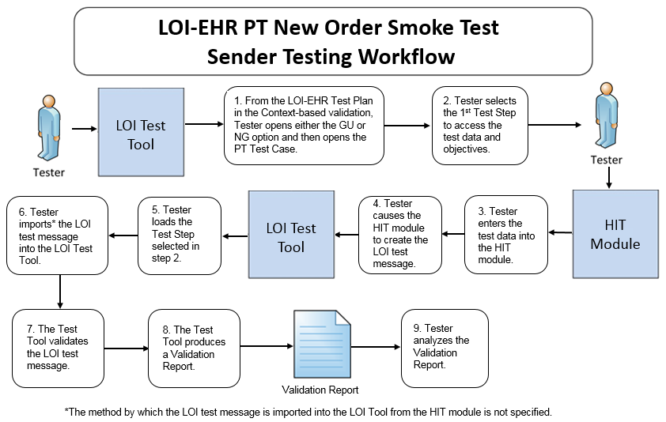

The instructions in the testing process listed below reference the numbered test steps in Figure 1.

Required Vendor Information
- Vendor shall identify the Health IT Module function(s) that are available to 1) create patient records in the Health IT Module and input the test data for the test patients, 2) create laboratory order messages using the test data, and 3) import the laboratory order messages into the NIST Test Tool
- Vendor shall provide the mechanism necessary to capture and import the laboratory order messages
- Vendor shall declare conformance to GU/PRU, GU/PRN, NG/PRU, or NG/PRN profile

Required Testing Actions
- Using the Context-based capability provided in the Tool identified in the Conformance Test Tools section of this testing process document, the Tester shall access the LOI-EHR Test Plan and shall open either the GU or NG option and then shall open the PT Test Case [Figure 1, Step 1]
- The Tester shall select the first Test Step [Figure 1, Step 2]
- Using the capabilities in the Health IT Module and the Test Step-specific Test Data Specification provided in the Tool, the Tester shall
  - Input the provided test data for the selected Test Step (input can be performed using a manual or automated process) [Figure 1, Step 3]
- Cause the Module to generate the laboratory order message [Figure 1, Step 4]
- In the NIST Tool, the Tester shall load the selected Test Step and import the laboratory order message generated by the Health IT Module [Figure 1, Steps 5, & 6]
- The NIST Tool validates the message and produces a Validation Report [Figure 1, Steps 7 & 8]
- Using the Inspection Test Guide, the Tester shall verify that the laboratory order message is conformant to the referenced standards and that the message includes the specified laboratory order information

Inspection Test Guide
- Using the Validation Report produced by the NIST Tool, the Tester shall analyze the Report and verify that the message created by the Health IT Module meets the conformance requirements in the LOI IG [Figure 1, Step 9]
  - If the Tester determines that the ICD-10CM code in the message created by the Module is a valid code for the diagnosis even though it may be different from the ICD-10CM code provided in the test data for that message, the Tester shall allow an exception

LOI-EHR_DTR – 2: Electronically Receive and Process Accept Acknowledgement (ACK) Message for PT Test Order

Figure 2 Receive and Process Accept Acknowledgment Message Testing Workflow
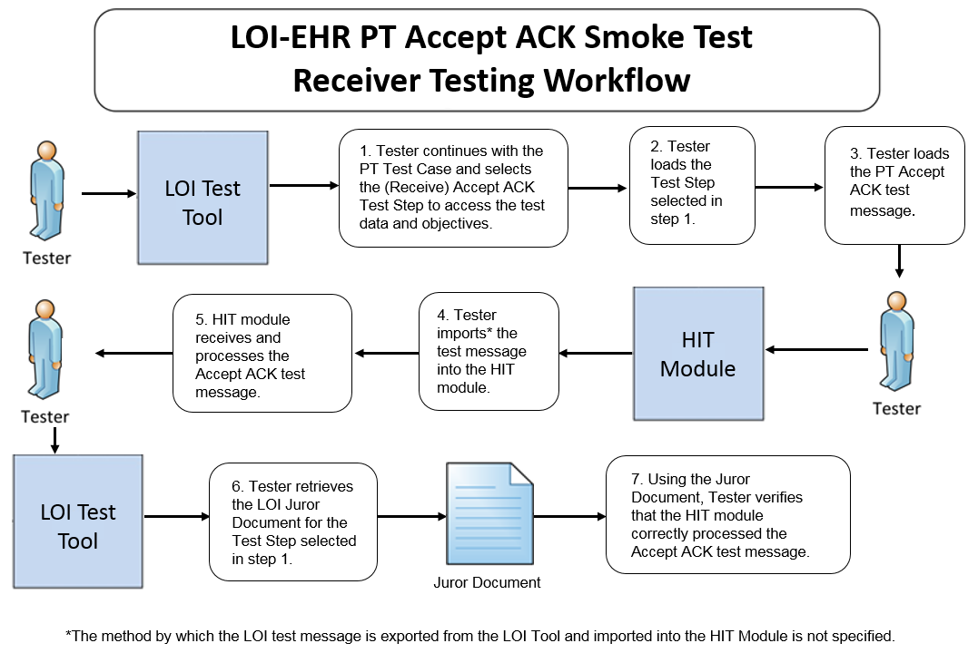

The instructions in the testing process listed below reference the numbered test steps in Figure 2.

Required Vendor Information
- The Vendor shall identify the HIT module function(s) that are available to verify that an Accept ACK message has been received and processed
- Vendor shall provide the mechanism necessary to capture and import the Accept ACK message

Required Testing Actions
- In the Tool, the Tester shall continue with the PT Test Case and shall
  - Select and load the Accept ACK Test Step [Figure 2, Steps 1 & 2]
  - Load the example Accept ACK test message [Figure 2, Step 3]
- Using the capabilities in the HIT Module, the Tester shall
  - Import the Accept ACK test message into the Module [Figure 2, Step 4]
  - Observe the Module receiving and processing the LOI Accept ACK message [Figure 2, Step 5]
- The Tester shall retrieve the LOI Juror Document from the NIST Tool for the Test Step selected [Figure 2, Step 6]
- Using the Inspection Test Guide, the Tester shall verify that the HIT Module processed the message

Inspection Test Guide
- Using the functions in the HIT Module, the provided example Accept ACK message, and the Test Step-specific Juror Document retrieved from the NIST Tool, the Tester shall verify that the Module received and processed the Accept ACK message according to the named standards [Figure 2, Step 7]

LOI-EHR_DTR – 3: Electronically Receive and Process Application Acknowledgement (ORL) Message for PT Test Order

Figure 3 Receive and Process Application Acknowledgment Message Testing Workflow
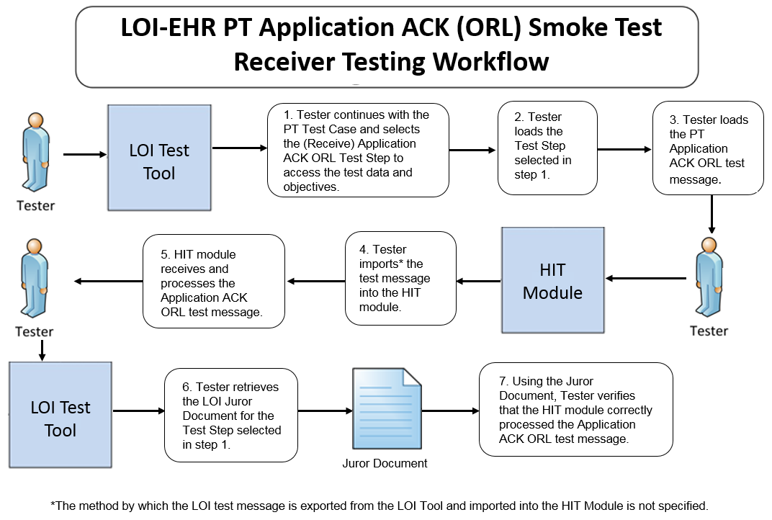

The instructions in the testing process listed below reference the numbered test steps in Figure 3.

Required Vendor Information
- The Vendor shall identify the HIT module function(s) that are available to verify that an Application ACK (ORL) message has been received and processed
- Vendor shall provide the mechanism necessary to capture and import the ORL message

Required Testing Actions
- In the Tool, the Tester shall continue with the PT Test Case and shall
  - Select and load the Application ACK (ORL) Test Step [Figure 3, Steps 1 & 2]
  - Load the example Application ACK (ORL) test message [Figure 3, Step 3]
- Using the capabilities in the HIT Module, the Tester shall
  - Import the Application ACK (ORL) test message into the Module [Figure 3, Step 4]
  - Observe the Module receiving and processing the LOI Application ACK (ORL) message [Figure 3, Step 5]
- The Tester shall retrieve the LOI Juror Document from the NIST Tool for the Test Step selected [Figure 3, Step 6]
- Using the Inspection Test Guide, the Tester shall verify that the HIT Module processed the message

Inspection Test Guide
- Using the functions in the HIT Module, the provided example Application ACK (ORL) message, and the Test Step-specific Juror Document retrieved from the NIST Tool, the Tester shall verify that the Module received and processed the Accept ACK message according to the named standards [Figure 3, Step 7]

LOI-EHR_DTR – 4: Electronically Create Accept Acknowledgement (ACK) Message in Response to Application Acknowledgement (ORL) Message for PT Test Order

Figure 4 Create Accept Acknowledgment Message Testing Workflow
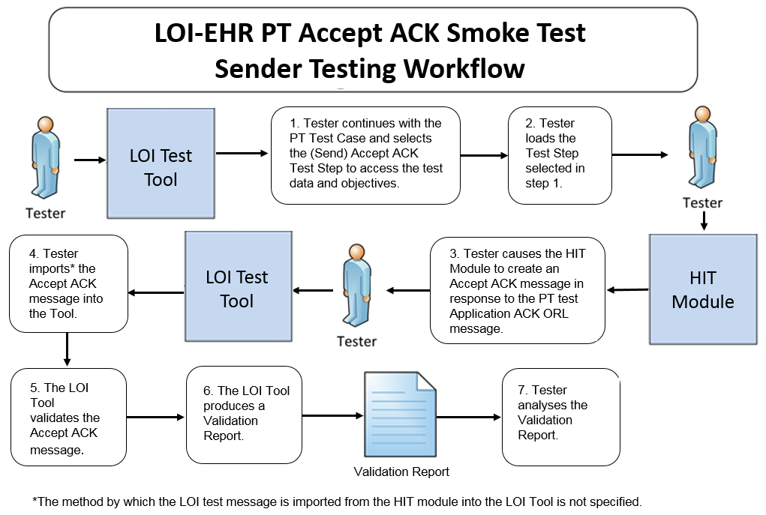

The instructions in the testing process listed below reference the numbered test steps in Figure 4.

Required Vendor Information
- The Vendor shall identify the HIT module function(s) that are available to create an Acknowledgement (ACK) message in response to an Application ACK (ORL) message
- Vendor shall identify the HIT function(s) that are available to export the Accept ACK message

Required Testing Actions
- In the Tool, the Tester shall continue with the PT Test Case and shall
- Select the LOI Accept ACK Test Step for creation of a response message to receiving the Application ACK (ORL) [Figure 4, Step 1]
- Load the LOI Accept ACK Test Step [Figure 4, Step 2]
- The Tester shall use the function(s) in the HIT Module to generate the Accept ACK message created in response to the LOI Application ACK (ORL) message [Figure 4, Step 3]
- The Tester shall import the Accept ACK message into the Tool [Figure 4, Step 4]
- The Tool validates the LOI Accept ACK message and produces a Validation Report [Figure 4, Steps 5 & 6]
- Using the Inspection Test Guide, the Tester shall verify the conformance of the Accept ACK message generated by the Module

Inspection Test Guide
- Using the Validation Report, the Tester shall analyze the Report and verify that the LOI Accept ACK message created by the HIT Module meets the conformance requirements in the named standards [Figure 4, Step 7]

Derived Test Requirements for the Sed Rate Test Case

LOI-EHR_DTR – 5: Electronically Create Sed Rate Test Order Message

Figure 5 Create Sed Rate Order Message Testing Workflow
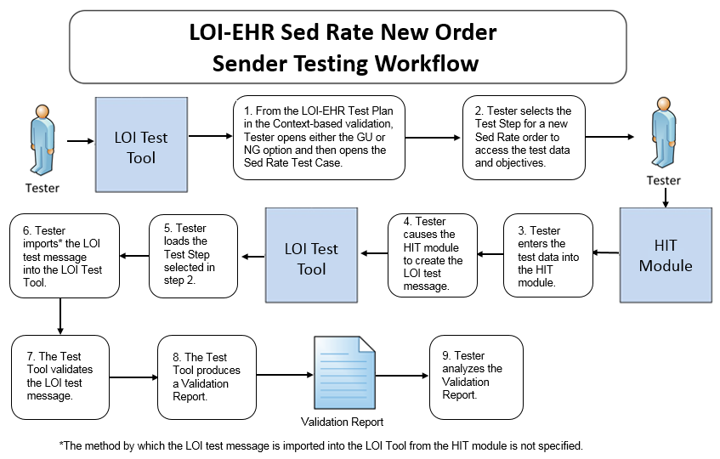

The instructions in the testing process listed below reference the numbered test steps in Figure 5.

Required Vendor Information
Same as for LOI-EHR_DTR – 1

Required Testing Actions
- Using the Context-based capability provided in the Tool identified in the Conformance Test Tools section of this testing process document, the Tester shall access the LOI-EHR Test Plan and shall open either the GU or NG option and then shall open the Sed Rate Test Case [Figure 5, Step 1]
- The Tester shall select the Test Step for a new Sed Rate order [Figure 5, Step 2]
- Using the capabilities in the Health IT Module and the Test Step-specific Test Data Specification provided in the Tool, the Tester shall
  - Input the provided test data for the selected Test Step (input can be performed using a manual or automated process) [Figure 5, Step 3]
- Cause the Module to generate the laboratory order message [Figure 5, Step 4]
- In the NIST Tool, the Tester shall load the selected Test Step and import the laboratory order message generated by the Health IT Module [Figure 5, Steps 5, & 6]
- The NIST Tool validates the message and produces a Validation Report [Figure 5, Steps 7 & 8]
- Using the Inspection Test Guide, the Tester shall verify that the laboratory order message is conformant to the referenced standards and that the message includes the specified laboratory order information

Inspection Test Guide
- Using the Validation Report produced by the NIST Tool, the Tester shall analyze the Report and verify that the message created by the Health IT Module meets the conformance requirements in the LOI IG [Figure 5, Step 9]
- If the Tester determines that the LOINC and/or ICD-10CM codes in the message created by the Module are valid codes for a data item (e.g., lab test) even though they may be different from the LOINC and/or ICD-10CM codes provided for those data items in the test data for that message, the Tester shall allow an exception

LOI-EHR_DTR – 6: Electronically Create Sed Rate Test Cancel Order Message

Figure 6 Create Sed Rate Cancel Order Message Testing Workflow
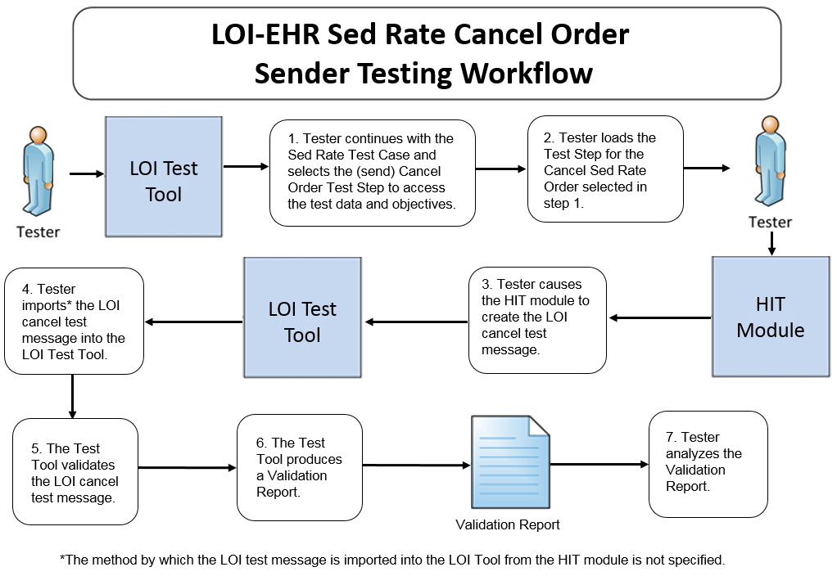

The instructions in the testing process listed below reference the numbered test steps in Figure 6.

Required Vendor Information
Same as for LOI-EHR_DTR – 1

Required Testing Actions
- In the Tool, the Tester shall continue with the Sed Rate Test Case and shall
  - Select the Test Step for a Cancel Sed Rate Order [Figure 6, Step 1]
  - Load the Test Step for a Cancel Sed Rate Order [Figure 6, Step 2]
- Using the capabilities in the Health IT Module and the Test Step-specific Test Data Specification provided in the Tool, the Tester shall cause the Module to generate the LOI cancel test message [Figure 6, Step 3]
- In the NIST Tool, the Tester shall import the LOI cancel test message generated by the Health IT Module [Figure 6, Step 4]
- The NIST Tool validates the message and produces a Validation Report [Figure 6, Steps 5 & 6]
- Using the Inspection Test Guide, the Tester shall verify that the LOI cancel test message is conformant to the referenced standards

Inspection Test Guide
- Using the Validation Report produced by the NIST Tool, the Tester shall analyze the Report and verify that the message created by the Health IT Module meets the conformance requirements in the LOI IG [Figure 6, Step 7]
- If the Tester determines that the LOINC code(s) in the message created by the Module is a valid code(s) for a data item (e.g., lab test) even though it may be different from the LOINC code(s) provided for those data items in the test data for that message, the Tester shall allow an exception

Derived Test Requirements for the CBC Test Case

LOI-EHR_DTR – 7: Electronically Create CBC Test Order Message

Figure 7 Create CBC Order Message Testing Workflow
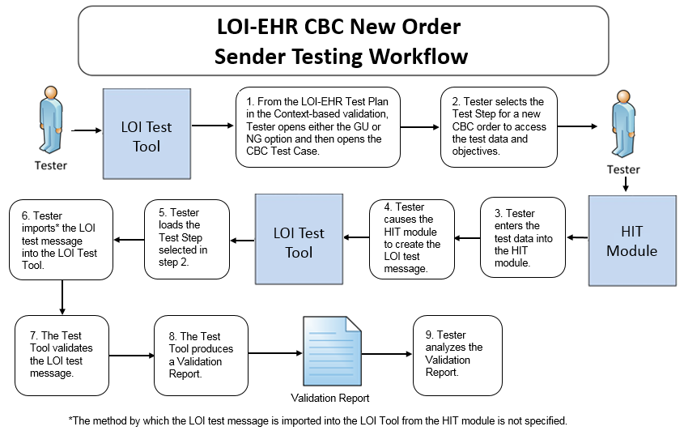

The instructions in the testing process listed below reference the numbered test steps in Figure 7.

Required Vendor Information
Same as for LOI-EHR_DTR – 1

Required Testing Actions
- Using the Context-based capability provided in the Tool identified in the Conformance Test Tools section of this testing process document, the Tester shall access the LOI-EHR Test Plan and shall open either the GU or NG option and then shall open the CBC Test Case [Figure 7, Step 1]
- The Tester shall select the Test Step for a new CBC order [Figure 7, Step 2]
- Using the capabilities in the Health IT Module and the Test Step-specific Test Data Specification provided in the Tool, the Tester shall
  - Input the provided test data for the selected Test Step (input can be performed using a manual or automated process) [Figure 7, Step 3]
  - Cause the Module to generate the laboratory order message [Figure 7, Step 4]
- In the NIST Tool, the Tester shall load the selected Test Step and import the laboratory order message generated by the Health IT Module [Figure 7, Steps 5, & 6]
- The NIST Tool validates the message and produces a Validation Report [Figure 7, Steps 7 & 8]
- Using the Inspection Test Guide, the Tester shall verify that the laboratory order message is conformant to the referenced standards and that the message includes the specified laboratory order information

Inspection Test Guide
- Using the Validation Report produced by the NIST Tool, the Tester shall analyze the Report and verify that the message created by the Health IT Module meets the conformance requirements in the LOI IG [Figure 7, Step 9]
- If the Tester determines that the LOINC and/or ICD-10CM codes in the message created by the Module are valid codes for a data item (e.g., lab test) even though they may be different from the LOINC and/or ICD-10CM codes provided for those data items in the test data for that message, the Tester shall allow an exception

LOI-EHR_DTR – 8: Electronically Receive CBC Test Cancel Order Message

Figure 8 Receive CBC Cancel Order Message Testing Workflow
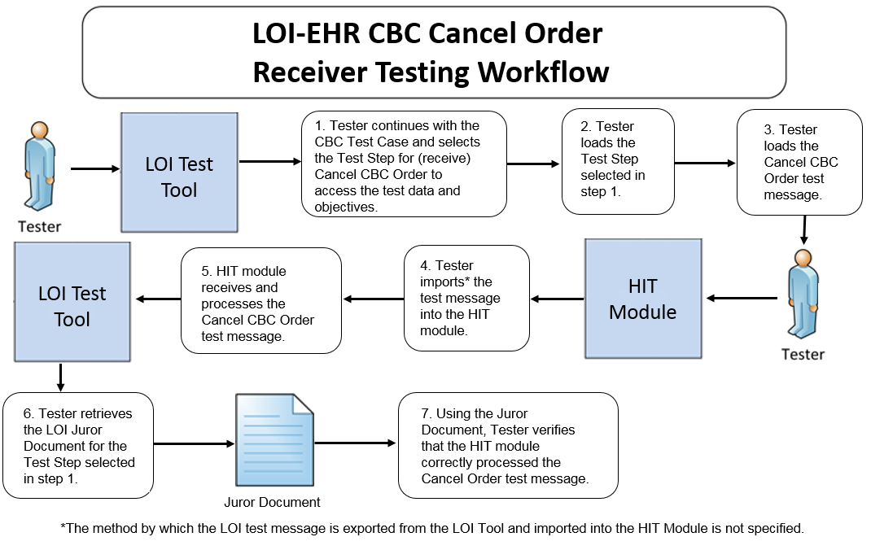

The instructions in the testing process listed below reference the numbered test steps in Figure 8.

Required Vendor Information
- The Vendor shall identify the HIT module function(s) that are available to verify that a cancel order message has been received and processed
- Vendor shall provide the mechanism necessary to capture and import the cancel order message

Required Testing Actions
- In the Tool, the Tester shall continue with the CBC Test Case and shall
- Select and load the Test Step for a Cancel CBC Order [Figure 8, Steps 1 & 2]
- Load the example Cancel CBC Order test message [Figure 8, Step 3]
- Using the capabilities in the HIT Module, the Tester shall
  - Import the Cancel CBC Order test message into the Module [Figure 8, Step 4]
  - Observe the Module receiving and processing the Cancel CBC Order message [Figure 8, Step 5]
- The Tester shall retrieve the LOI Juror Document from the NIST Tool for the Test Step selected [Figure 8, Step 6]
- Using the Inspection Test Guide, the Tester shall verify that the HIT Module processed the message

Inspection Test Guide
- Using the functions in the HIT Module, the provided example Cancel CBC Order test message, and the Test Step-specific Juror Document retrieved from the NIST Tool, the Tester shall verify that the Module received and processed the Cancel CBC Order message according to the named standards [Figure 8, Step 7]
  - If the Tester determines that the LOINC codes in the message created by the Module are valid codes for a data item (e.g., lab test) even though they may be different from the LOINC codes provided for those data items in the test data for that message, the Tester shall allow an exception

Derived Test Requirements for the GHP Test Case

LOI-EHR_DTR – 9: Electronically Create GHP Test Order Message

Figure 9 Create GHP Order Message Testing Workflow
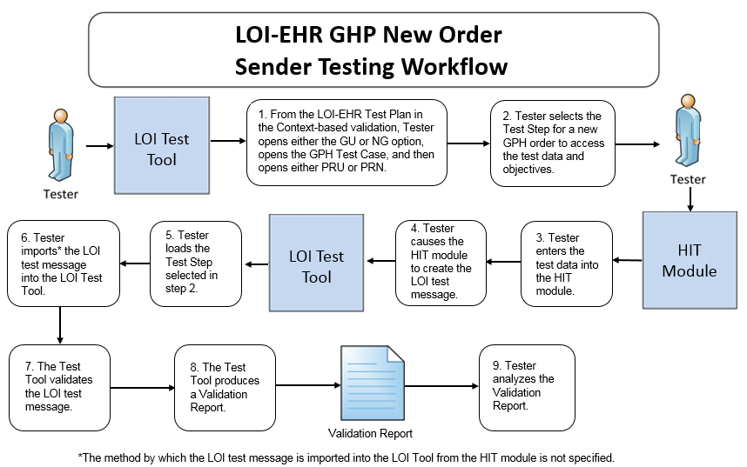

The instructions in the testing process listed below reference the numbered test steps in Figure 9.

Required Vendor Information
Same as for LOI-EHR_DTR – 1

Required Testing Actions
- Using the Context-based capability provided in the Tool identified in the Conformance Test Tools section of this testing process document, the Tester shall access the LOI-EHR Test Plan and shall open either the GU or NG option, then shall open the GHP Test Case, and then shall open either the PRU or PRN profile [Figure 9, Step 1]
- The Tester shall select the Test Step for a new GHP order [Figure 9, Step 2]
- Using the capabilities in the Health IT Module and the Test Step-specific Test Data Specification provided in the Tool, the Tester shall
  - Input the provided test data for the selected Test Step (input can be performed using a manual or automated process) [Figure 9, Step 3]
  - Cause the Module to generate the laboratory order message [Figure 9, Step 4]
- In the NIST Tool, the Tester shall load the selected Test Step and import the laboratory order message generated by the Health IT Module [Figure 9, Steps 5, & 6]
- The NIST Tool validates the message and produces a Validation Report [Figure 9, Steps 7 & 8]
- Using the Inspection Test Guide, the Tester shall verify that the laboratory order message is conformant to the referenced standards and that the message includes the specified laboratory order information

Inspection Test Guide
- Using the Validation Report produced by the NIST Tool, the Tester shall analyze the Report and verify that the message created by the Health IT Module meets the conformance requirements in the LOI IG [Figure 9, Step 9]
  - If the Tester determines that the LOINC and/or ICD-10CM codes in the message created by the Module are valid codes for a data item (e.g., lab test) even though they may be different from the LOINC and/or ICD-10CM codes provided for those data items in the test data for that message, the Tester shall allow an exception

LOI-EHR_DTR – 10: Electronically Create GHP Confirmatory Order Message for Add-on Test Telephone Order

Figure 10 Create GHP Confirmatory Order Message Testing Workflow
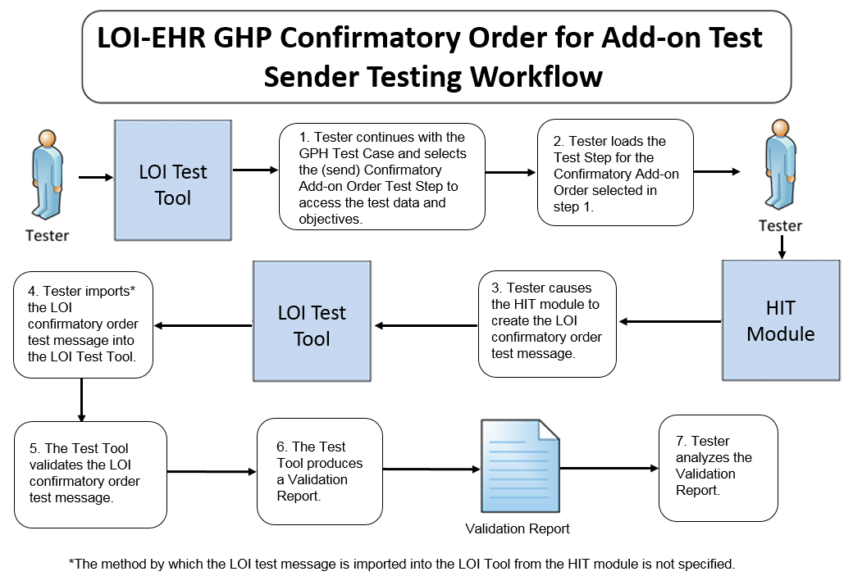

The instructions in the testing process listed below reference the numbered test steps in Figure 10.

Required Vendor Information
Same as for LOI-EHR_DTR – 1

Required Testing Actions
- In the Tool, the Tester shall continue with the same GHP Test Case and PRU/PRN profile combination and shall
  - Select the Test Step for the Confirmatory Order for Add-On Test [Figure 10, Step 1]
  - Load the Test Step for the Confirmatory Order for Add-On Test [Figure 10, Step 2]
- Using the capabilities in the Health IT Module and the Test Step-specific Test Data Specification provided in the Tool, the Tester shall cause the Module to generate Confirmatory Order for Add-On Test message [Figure 10, Step 3]
- In the NIST Tool, the Tester shall import the Confirmatory Order for Add-On Test message generated by the Health IT Module [Figure 10, Step 4]
- The NIST Tool validates the message and produces a Validation Report [Figure 10, Steps 5 & 6]
- Using the Inspection Test Guide, the Tester shall verify that the LOI cancel test message is conformant to the referenced standards

Inspection Test Guide
- Using the Validation Report produced by the NIST Tool, the Tester shall analyze the Report and verify that the message created by the Health IT Module meets the conformance requirements in the LOI IG [Figure 6, Step 7]
  - If the Tester determines that the LOINC and/or ICD-10CM codes in the message created by the Module are valid codes for a data item (e.g., lab test) even though they may be different from the LOINC and/or ICD-10CM codes provided for those data items in the test data for that message, the Tester shall allow an exception

Derived Test Requirement for Create Lab Test Order Test Cases

LOI-EHR_DTR – 11: Electronically Create Lab Test Order Message

Figure 11 Create Lab Test Order Message Testing Workflow
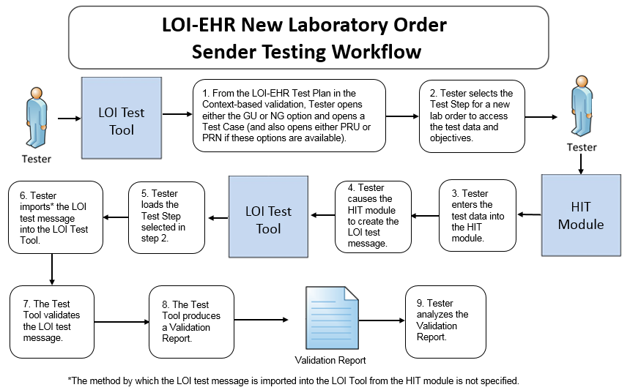

The instructions in the testing process listed below reference the numbered test steps in Figure 11.

Required Vendor Information
Same as for LOI-EHR_DTR – 1

Required Testing Actions
- Using the Context-based capability provided in the Tool identified in the Conformance Test Tools section of this testing process document, the Tester shall access the LOI-EHR Test Plan and shall open either the GU or NG option (then shall open either the PRU or PRN Test Case if these options are available) and then shall open a Test Case for creating a new lab test order message [Figure 11, Step 1]
- The Tester shall select the Test Step for a new lab test order [Figure 11, Step 2]
- Using the capabilities in the Health IT Module and the Test Step-specific Test Data Specification provided in the Tool, the Tester shall
  - Input the provided test data for the selected Test Step (input can be performed using a manual or automated process) [Figure 11, Step 3]
  - Cause the Module to generate the laboratory order message [Figure 11, Step 4]
- In the NIST Tool, the Tester shall load the selected Test Step and import the laboratory order message generated by the Health IT Module [Figure 11, Steps 5, & 6]
- The NIST Tool validates the message and produces a Validation Report [Figure 11, Steps 7 & 8]
- Using the Inspection Test Guide, the Tester shall verify that the laboratory order message is conformant to the referenced standards and that the message includes the specified laboratory order information

Inspection Test Guide
- Using the Validation Report produced by the NIST Tool, the Tester shall analyze the Report and verify that the message created by the Health IT Module meets the conformance requirements in the LOI IG [Figure 11, Step 9]
  - If the Tester determines that the LOINC and/or ICD-10CM codes in the message created by the Module are valid codes for a data item (e.g., lab test) even though they may be different from the LOINC and/or ICD-10CM codes provided for those data items in the test data for that message, the Tester shall allow an exception

Test Data
Test data are provided for the testing process to ensure that the applicable requirements identified in the conformance criteria can be adequately evaluated, as well as to provide consistency in the testing process across multiple testing entities. The provided test data focus on evaluating the basic capabilities required of the Health IT Module, rather than exercising the full breadth/depth of capability that installed Health IT Modules might be expected to support. The test data are formatted for ease of use by the Tester during the testing process; the format is not intended to prescribe the design of the display presented to the end-user for viewing the data. No additional requirements should be drawn from the format.

The Tester shall use and apply the provided test data during the testing, without exception, unless one of the following conditions exists:
- The Tester determines that the Health IT Module is sufficiently specialized that the provided test data need to be modified in order to conduct an adequate test. Having made the determination that some modification to the provided test data is necessary, the Tester shall record the modifications made as part of the test documentation.
- The Tester determines that changes to the test data will improve the efficiency of the testing process (for example, using consistent demographic data throughout the testing workflow). The Tester shall ensure that the functional and interoperable requirements identified in the criteria can be adequately evaluated for conformance, and that the modified test data provide a comparable level of robustness.
- The Tester determines that a LOINC or ICD-10CM code in a message created by the Health IT Module is a valid code for a data item (e.g., lab test) even though it is different from the LOINC or ICD-10CM code provided for that data item in the test data for that message

Any departure from the provided test data shall focus on meeting the basic capabilities required of the Health IT Module relative to the conformance criteria rather than exercising the full breadth/depth of capability that the installed Health IT Module might be expected to support.

The testing process requires that the applicable test data be entered into the Health IT Module being evaluated for conformance. The intent is that the Tester performs or observes the process of entering the test data in order to ensure that the data are correctly entered as specified in the testing process.

For conformance testing, the primary purpose of the provided test data is to assist the Tester in verifying that the vendor’s Module is capable of supporting the required functions. The clinical test data are relevant for the given Test Stories; however, these data should not be expected to represent standards of practice.

Test data for conformance testing related to the LOI Transmit laboratory orders criterion are available in the NIST LOI Test Tool (see the Conformance Test Tools section of this testing process document for instructions on how to access the Test Tool).

Navigating a Test Case
A LOI Test Case contains one or more Test Steps, each consisting of a Test Story, a Test Data Specification, a Message Content Data Sheet, and an Example Message, and, where applicable, a Juror Document. All of these artifacts are accessible via the NIST Tool.
- The Test Story describes a real-world situation that provides the context for the Test Step.
- The Test Data Specification provides the data associated with the Test Story and lists the information that would typically be available for a given situation in the specified clinical setting. Together, the Test Story and the Test Data Specification provide sufficient information for the Testers and Health IT Module Vendors to enter into the Module in order to create the LOI message for a particular Test Step. The message is to be created using these data and the Health IT Module functions.
- The Message Content Data Sheet shows a conformant message instance for the Test Case. The message content is organized in a table format that provides the HL7 v2 message elements and the data associated with the message elements for a given Test Case. The Message Content Data Sheet may provide assistance to the Tester and Health IT Module Vendor for resolving issues discovered during conformance testing. This data sheet can be thought of as the “answer” to the scenario (“question”) provided by the Test Story and the Test Data Specification.
- The Example HL7 Message shows a conformant encoded LOI message for the Test Step.
- The Juror Document provides very basic instructions to the Tester for use during conformance testing when assessing the Health IT Module’s ability to receive and process (1) an Acknowledgement message with no errors that is sent by a LIS or an EHR-S lab module or (2) a cancel order message that is sent by a LIS or an EHR-S lab module. The format of the Juror Document is for ease-of-use by the Tester and does not indicate how the Health IT Module display must be designed.

The LOI Implementation Guide defines four profile options relevant for conformance testing:

- LOI_GU_PRU_PROFILE – ID: 2.16.840.1.113883.9.85
- LOI_GU_PRN_PROFILE – ID: 2.16.840.1.113883.9.86
- LOI_NG_PRU_PROFILE – ID: 2.16.840.1.113883.9.87
- LOI_NG_PRN_PROFILE – ID: 2.16.840.1.113883.9.88

For the purpose of conformance testing, the Vendor must declare to which profile they are claiming conformance—only one is required. Test Cases and Test Steps (and hence specific test data) are provided in the Tool for each profile option. Table 1 (LOI-EHR Test Cases and Associated Test Steps) lists the alpha-numeric labels, along with a description, for each of the mandatory and optional NG and GU Test Steps included in the ten Test Cases.

Table 1: LOI-EHR Test Cases and Associated Test Steps

Test Cases | NG Test Steps | GU Test Steps | Description
1 - Minimally populated PT Messages (Smoke Test) | LOI_0.0_1.1-NG | LOI_0.0_1.1-GU | New order of a single test panel to demonstrate ability to generate a basic LOI message  Corresponds to the LRI test result message for the PT and INR Test Step
 | ACK_0.0_1.1-NG | ACK_0.0_1.1-GU | Accept Acknowledgement message to reveal simple failures of the acknowledgment message severe enough to preclude further testing.
 | ORL_0.0_1.1-NG | ORL_0.0_1.1-GU | ORL Application Acknowledgement message to reveal simple failures of the acknowledgment message severe enough to preclude further testing.
 | ACK_0.0_2.1-NG | ACK_0.0_2.1-GU | Acknowledgement message to demonstrate capability to create a positive Accept Acknowledgment message in response to successful receipt of the ORL message
2 - Maximally Populated SED Rate Messages | LOI_1.0_1.1-NG | LOI_1.0_1.1-GU | - New order of a single test  - Corresponds to the LRI test result message for the Sed Rate Test Steps
 | LOI_1.0_2.1-NG_CP | LOI_1.0_2.1-GU_CP | - Cancel order message from a provider to an LIS for a previously ordered test prior to sample collection
3 - Typically Populated CBC Message | LOI_2.0_1.1-NG | LOI_2.0_1.1-GU | - New order of a single test panel to generate a typical LOI message  - Corresponds to the LRI test result message for the CBC Test Steps
 | LOI_2.0_2.1-NG | LOI_2.0_2.1-GU | - Cancel order message from a laboratory to an EHR-S for a previously ordered test due to broken specimen container
4 - Typically Populated Lipid Panel Messages | LOI_3.0_1.1-NG | LOI_3.0_1.1-GU | - New order of a single test panel to generate a typical LOI message  - Ask-at-Order-Entry: Fasting status  - Corresponds to the LRI test result message for the Lipid Panel Test Steps
 | LOI_3.1_1.1-NG_FI  (Optional) | LOI_3.1_1.1-GU_FI  (Optional) | - New order of a single test panel to generate a typical LOI message  - Ask-at-Order-Entry: Fasting status  - Corresponds to the LRI test result message for the Lipid Panel Test Steps  - Tests for the optional Financial Profile  - Payer is a third party; billed to Medicare.
5 - Typically Populated Culture & Susceptibility Messages | LOI_4.0_1.1-NG | LOI_4.0_1.1-GU | - New order of a single test panel for a microbiology test with automatic reflex  - Corresponds to the LRI test result message for the Culture and Suscep Test Steps
6 - Typically Populated Reflex Hepatitis Messages | LOI_5.0_1.1-NG | LOI_5.0_1.1-GU | - New order of a single test panel with automatic reflex  - Ask-at-Order-Entry: Pregnancy status  - Corresponds to the LRI test result message for the Reflex Hepatitis Test Steps
 | LOI_5.1_1.1-NG_PH  (Optional) | LOI_5.1_1.1-GU_PH  (Optional) | - New order of a single test panel with automatic reflex for the optional Public Health Profile  - Ask-at-Order-Entry: Pregnancy status  - Payer is a third party; billed to private insurance  - Corresponds to the ELR test result messages for the Final Quantitative Result with Reflex Testing Test Steps
7 - Typically Populated Pap Smear AP Message | LOI_6.0_1.1-NG | LOI_6.0_1.1-GU | - New order for commonly ordered anatomic pathology test  - Ask-at-Order-Entry:  - Date of last menstrual period  - "Did the patient have a previous abnormal Pap report, treatment, or biopsy?" (Yes/No/Unknown)  - Corresponds to the LRI test result message for the Pap Smear Test Step
8 - Maximally Populated GHP Messages | LOI_7.0_1.1-NG_PRU  AND  LOI_7.0_2.1-NG_PRU  OR  LOI_7.0_1.1-NG_PRN  AND  LOI_7.0_2.1-NG_PRN | LOI_7.0_1.1-GU_PRU  AND  LOI_7.0_2.1-GU_PRN  OR  LOI_7.0_1.1-GU_PRN  AND  LOI_7.0_2.1-GU_PRN | PRU New (future) order for general health profile (GHP) containing multiple panels and single test
- Confirmatory order for a telephone order for an add-on single test to the previously ordered general health profile
- LOI_7.0_1.1-NG/GU_PRU GHP has been ordered and resulted.
 |  |  | PRN New (future) order for general health profile (GHP) containing multiple panels and single test
- Confirmatory order for a telephone order for an add-on single test to the previously ordered general health profile
- LOI_7.0_1.1-NG/GU_PRN GHP has been ordered and resulted.
9 - Maximally Populated Creatinine Clearance Messages | LOI_9.0_1.1-NG_PRU  OR  LOI_9.0_1.1-NG_PRN | LOI_9.0_1.1-GU_PRU  OR  LOI_9.0_1.1-GU_PRN | - PRU or PRN New order of a single test panel and a single test with multiple specimens  - Ask-at-Order-Entry:  - Pregnancy Status  - Patient Weight  - Collection Volume of 24 Hour Urine
10 - Minimally Populated Prostate Biopsy Message | LOI_10.0_1.1-NG | LOI_10.0_1.1-GU | New order for commonly ordered anatomic pathology test

Details for each Test Step, including the test story, test objectives, test data, message content sheet, example HL7 message, and juror document (where applicable) are provided via the tabs that are displayed when a user selects a Test Step in the Conformance Test Tool (See the “LOI-EHR Test Plan” using the Context-based tab). These artifacts also are available in PDF files accessible via the tabs displayed with the Test Step as well as via the Test Tool Documentation tab. The Tester shall follow the instructions in the Normative Test Description section of this testing process document to conduct the conformance testing.

HOW TO INTERPRET THE MESSAGE CONTENT DATA SHEET

The Message Content Data Sheet indicates the location and data of the message for a particular Test Step. The Message Content Data Sheet can be used to assist the Tester in loading the HIT Module with the test step-specific data and provides a classification of the data. This classification indicates the type and the expected source of the data. How the data are classified is directly related to how the message content is validated. In some cases, the validator is examining the message element for the presence or absence of data, whereas in other cases it is examining the message element for both the presence of data and exact content. Table 2 shows an excerpt of a Message Content Data Sheet.

Table 2 Message Content Data Sheet Excerpt for an ORC Segment in an LOI Message
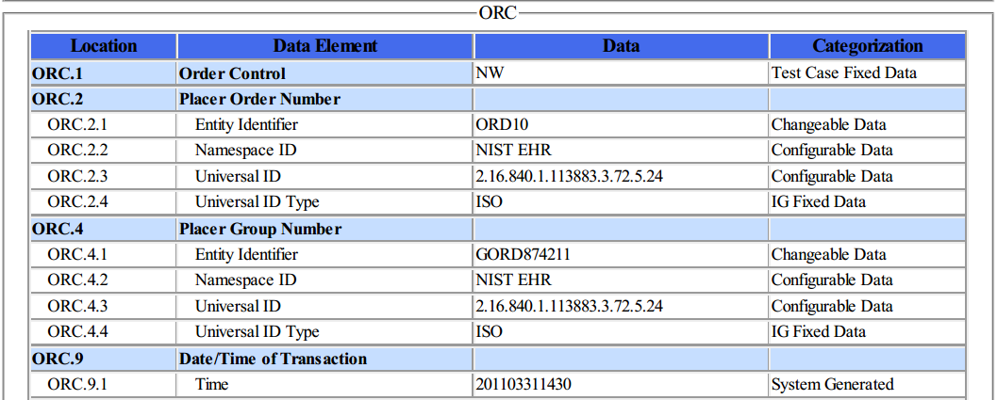

The information in the Location column indicates the canonical element location in the HL7 V2 message. For example, ORC-2.3 represents the 3rd component in the 2nd field of the ORC segment. The Data Element column indicates the name of the data element as specified by the Profile contained in the LOI Implementation Guide.

The Test Data column provides the expected data (if applicable) for that message element. The Categorization column indicates the validation category of the data. Table 3 lists the test data categorization options, a description of the categorization, and how each data category is being validated. Additional information about the test data Categories is available in the Understanding LOI-EHR Messaging Conformance Testing document, which is accessed via the Documentation tab in the LOI Test Tool.

Table 3 Description of Data Classification and Validation

Data Categorization | Description | Validation
Configurable | Data typically configured by the system  (customer-definable). Example data are provided. | Validate for the presence of data
System Generated | Data typically generated automatically by the system, e.g., message time. Example data are provided. | Validate for the presence of data
IG Fixed | Data that are fixed by the implementation guide;  data can’t be changed. Specific data are provided. | Validate for the presence and data content
Test Case Fixed | Data that are specific and fixed by the test case; data should not be changed. Specific data are provided | Validate for the presence and selectively validate for data content
Changeable | Data where the exact content is not relevant for the test case and can be changed for the purposes of testing. Example data are provided. | Validate for the presence of data

The Test Cases and the context-based validation test tool are tightly-coupled. In addition to validating message conformance, the test tool performs selective content validation based on the Test Story and Test Data Specification provided. Deviation from the test data may cause the test tool to issue Errors. For this reason, the Tester should use the test data as specified.

The HL7 v2 standard provides flexibility in messaging—many different message instances for a given test case can be considered conformant. The test tool is designed to support such instances; however, it is not a certainty. If the test tool issues an error for a message instance, the Vendor shall provide evidence of equivalency to the Tester.

Conformance Test Tools
The following testing tool is available to evaluate conformance to the standards referenced in this testing process document:
- NIST HL7 v2 Validation tool - Laboratory Order Interface – an HL7v2 messaging validation tool; designed to support the NIST conformance testing process
  - The tool is available as a Web Application
- The application can be downloaded for local installation
- The NIST Lab Order Interface test tool Web application is available at:

hl7v2-loi-r1-testing.nist.gov

Support for this tool is available by submitting questions to the following user’s group:
https://groups.google.com/d/forum/hl7v2-lab-orders-interface-testing

Inquiries may also be sent to this user group via email:
hl7v2-lab-orders-interface-testing@googlegroup.com

Several browsers may be used to access the HL7 v2 LOI Test Tool; Firefox (recommended), Chrome (recommended), Safari, and IE 9+ are the supported browsers.

The following information is provided to assist the Tester in interpreting the Validation Reports generated by the LOI Tool:

The Context-based capability in the Tool evaluates conformance requirements that are specified or have been derived from the standards and implementation guides identified in the conformance criteria and the test data provided for this testing process. The Test Tool evaluates the submitted HL7 message for each conformance requirement, and then produces a Validation Report.

The Tester should consider a Validation Report that contains only Warning and Alert messages to be indicative of a sufficient level of conformance to the standard and test data expectations. If reported, Errors should be considered significant departures from the standard or test data requirements, and these Errors must be corrected in order to claim conformance. Testers will need to further analyze each Error to determine if, in the context of meeting the conformance criterion, the Error results in a failure of the testing process by the Health IT Module.

The NIST context-based testing performs specific content validation depending on the Category/Qualifier combination assigned to the Data Elements in the message (see How to Interpret the Message Content Data Sheet section for more details). In some cases, in order to perform this type of validation the NIST Tool expects the fields/segments/segment groups in the message to be sequenced in a certain order. The complexity of automatically evaluating specific content necessitates this approach. If the Message Validation Result generated by the NIST Tool indicates content-related errors, the Tester may change the order of the fields/segments/segment groups in the test message to match the Test Step once the message has been loaded into the Message Content window of the Test Tool. These kinds of content-related errors do not imply a failure of the vendor product nor a requirement to create the message with the fields/segments/segment groups in a certain order (beyond the base message structure).

Document History

Version Number | Description of Change | Date Published
1.0 | Initial Version Normative Test Process Document | November 16, 2016

Minimally populated means the LOI example messages contain single occurrences of all required ("R") elements
Maximally populated means the LOI example messages contain all the R, RE, C(a/b) elements defined in the implementation guide, including multiple occurrences, where permitted
Typically populated means the LOI example message contains data that are routinely sent whether the data element is R (Required) or RE (Required, but may be empty)
During conformance testing, the mechanism by which the lab order test message is imported (sent) from or to the Health IT Module being tested is not specified. The Tester may have their own utility, they may allow the Module vendor to use a utility created by that vendor, or the message can be cut from the Module and pasted into the NIST Test Tool or cut from the NIST Test Tool and pasted into the Module. For conformance testing, the key requirement is for the Module to demonstrate real time/dynamic import.

