NIST Normative Test Process Document: LRI-EHR Test Tool for Incorporate Laboratory Values/Results

Test Tool and Test Descriptions to Conduct HIT Conformance Testing
NIST Approved Version 1.4
Date: November 16, 2016

Developed by the National Institute of Standards and Technology (NIST) in collaboration with the Association of Public Health Laboratories (APHL) and the Centers for Disease Control and Prevention (CDC)

List of Contents

Conformance Criteria

Description of the specifications for conformance testing

Explanation of Terms

A table containing a key of equivalents for names and terms used frequently in this document

Informative Test Description

Key background information for conducting the conformance testing; includes information about
- Definition of “Tester” for this document
- Care settings and profiles that are in-scope for the testing
- Capabilities the Health IT Module must be able to demonstrate during the conformance testing

Normative Test Description

Detailed description of the testing process, including Derived Test Requirement(s), Testing Workflow Diagram(s), Required Vendor Information, Required Testing Actions, and Inspection Test Guide

Test Data

Detailed description of the purpose and use of the provided test data, including allowed exceptions

Navigating a Test Case

Detailed description of the information and instructions available in the NIST Test Tool related to the Test Cases

How to Interpret and Use the Juror Document

Detailed description of the purpose of and information available in the Juror Document, including the legends for Display Verification and Incorporate Verification related to the data in an LRI message

Conformance Test Tools

Links to the web-based NIST Test Tool and Support sites

Document History

Listing of Version Numbers and Publication Dates for the final published versions of the NIST Testing Process document

NIST Normative Test Process Document for LRI-EHR: Incorporate laboratory tests and values/results
This document explains the testing process for which a National Institute of Standards and Technology (NIST) validation test tool is used in evaluating conformance of a health information technology module (Health IT Module) receiving and incorporating HL7 laboratory result messages in accordance with the HL7 Version 2.5.1 Implementation Guide: S&I Framework Lab Results Interface, Release 1, DSTU Release 2 – US Realm, September 2015 interoperability standard and, at a minimum, the LOINC version 2.50 vocabulary standard.

Conformance Criteria

Incorporate laboratory tests and values/results
(i) Receive and incorporate clinical laboratory tests and values/results in accordance with the HL7 Version 2.5.1 Implementation Guide: S&I Framework Lab Results Interface, Release 1, DSTU Release 2 – US Realm, September 2015, interoperability standard; the HL7 EHR-S Functional Requirements: S&I Framework Laboratory Results Messages, Release 1 - US Realm, STU May 2016; and, at a minimum, the Logical Observation Identifiers Names and Codes (LOINC) version 2.50 vocabulary standard
(ii) Display the tests and values/results received in human readable format.
(iii) Display the test report information:
(A) Specified in 42 CFR 493.1291(a)(1) and (c)(1) through (7);
(B) Related to reference intervals or normal values as specified in 42 CFR 493.1291(d);
(D) For corrected reports as specified in 42 CFR 493.1291(k)(2).
(iv) Attribute, associate, or link a laboratory test and value/result with a laboratory order or patient record.

Explanation of Terms

Key for Names and Terms Used Frequently in this Document
Referenced Names and Terms | Equivalent Used in Document
Version 2.5.1 Implementation Guide: S&I Framework Lab Results Interface, Release 1, DSTU Release 2 – US Realm, September 2015 | “LRI Implementation Guide” or “LRI IG”
HL7 EHR-S Functional Requirements: S&I Framework Laboratory Results Messages, Release 1 - US Realm, STU May 2016 | “EHR-S Functional Requirements for LRI” or “EHR-S FR for LRI”
Logical Observation Identifiers Names and Codes (LOINC) version 2.50 | “LOINC” or “LOINC v2.50”
Health IT Module | “HIT Module” or “Module”
NIST HL7 v2 Validation tool - Laboratory Results Interface, Release 2 - US Realm | “LRI Test Tool” or “Tool”
Context-based EHR Test Plan | “Context-based LRI-EHR Test Plan” or “LRI-EHR Test Cases”

Informative Test Description
This section provides an executive summary describing how the NIST testing process is organized and conducted. The Understanding LRI-EHR Messaging Conformance Testing document is available via the Documentation tab in the NIST LRI Test Tool; this document is an additional resource that explains the process of Health IT Module conformance testing for HL7 v2 LRI Messaging on the EHR-S receiver side.

This document has been developed to be used by testers in conformance testing of Health IT Modules. The term “Tester”, when used in this document, refers to a person (such as a testing lab employee) acting on behalf of a testing lab or other entity for conformance testing of a Vendor’s HIT Module. In addition, a Vendor may use this document to test their own HIT Modules during development of their product and in preparation for conformance testing by a testing lab, and individual implementations of the LRI IG may use this document when verifying conformance on the receiver side.

The test evaluates the capability for a Health IT Module to receive and incorporate electronically transmitted lab result messages
- That are conformant to the
  - HL7 Version 2.5.1 Implementation Guide: S&I Framework Lab Results Interface, Release 1, DSTU Release 2 – US Realm, September 2015
  - HL7 EHR-S Functional Requirements: S&I Framework Laboratory Results Messages, Release 1 - US Realm, STU May 2016
  - Logical Observation Identifiers Names and Codes (LOINC) version 2.50 vocabulary standard
- From which the lab results are
  - Displayed in a format that enables a human to read and easily comprehend the information presented to them regardless of the method of presentation (e.g., computer screen, handheld device, electronic document)
  - Displayed in the test report information according to the following specifications
    - Results reported from calculated data.
    - The test report must indicate the following (See LRI guide section 8.2 for more details):
(1) For positive patient identification, either the patient's name and identification number, or a unique patient identifier and identification number.
(2) The name and address of the laboratory location where the test was performed.
(3) The test report date.
(4) The test performed.
(5) Specimen source, when appropriate.
(6) The test result and, if applicable, the units of measurement or interpretation, or both.
(7) Any information regarding the condition and disposition of specimens that do not meet the laboratory's criteria for acceptability.
- Pertinent “reference intervals” or “normal” values, as determined by the laboratory performing the tests, must be available to the authorized person who ordered the tests and, if applicable, the individual responsible for using the test results.
- When errors in the reported patient test results are detected, the laboratory must issue corrected reports [promptly] to the authorized person ordering the test and, if applicable, the individual using the test results.
- Attributed, associated, or linked to a laboratory order or patient record.

During the process of building the LRI Test Tool, NIST (National Institute of Standards and Technology) discovered conformance requirements that were either conflicting or unclear in the named standard documents and the associated errata. The NIST Clarifications and Validation Guidelines for HL7 Version 2.5.1 Implementation Guide: S&I Framework Lab Results Interface, Release 1, DSTU Release 2 – US Realm, September 2015 document clarifies these issues and indicates how they are interpreted in the Tool. This document can be accessed via the Documentation Tab on the LRI Test Tool.

The LRI IG defines four profile options relevant for conformance testing:

- LRI_GU_FRU_Profile – ID: 2.16.840.1.113883.9.195.3.1
- LRI_GU_FRN_Profile – ID: 2.16.840.1.113883.9.195.3.2
- LRI_NG_FRU_Profile – ID: 2.16.840.1.113883.9.195.3.3
- LRI_NG_FRN_Profile – ID: 2.16.840.1.113883.9.195.3.4

The Context-based LRI-EHR Test Plan in the NIST LRI Test Tool includes seven Test Scenarios with one or more Test Cases or Test Steps (and specific test data) for testing each profile option. For the purpose of conformance testing, the Vendor can declare to which profile they are claiming conformance—only one is required. Test Cases or Test Steps are provided for each profile option. Instructions regarding which Test Scenarios and Test Cases to use for each profile option are provided in the Test Data section of this testing process document.

For this test procedure, the Tester shall execute all seven Test Scenarios listed below (and for certain Test Scenarios all of their associated Test Cases and/or Test Steps):

- PT and INR (Smoke Test – minimally populated messages)
Step 1: Final Result (sent to EHR-S)
Step 2: Accept Acknowledgement (sent from EHR-S)
Step 3: Application Acknowledgement (sent from EHR-S)
Step 4: Accept Acknowledgement for the Application Acknowledgement (sent to EHR-S)
- SED rate (maximally populated messages)
Final result to corrected
Step 1: Final Result (sent to EHR-S)
Step 2: Corrected Result (sent to EHR-S) (result value is corrected)
Specimen rejected (sent to EHR-S)
- CBC (typically populated messages)
Partial result to final
Step 1: Partial Result (sent to EHR-S)
Step 2: Final Result (sent to EHR-S)
Final result to wrong patient
Step 1: Final Result (sent to EHR-S)
Step 2: Corrected Result (sent to EHR-S)
- Lipid Panel (typically populated messages)
Step 1: Final Results with handling of Ask-at-Order-Entry question (sent to EHR-S)
OBR-13 Relevant Clinical Information:
- Patient was fasting prior to the procedure
Step 2: Final Results duplicate report with handling of Ask-at-Order-Entry question (sent to EHR-S)
OBR-13 Relevant Clinical Information:
- Patient was fasting prior to the procedure
- Culture and Susceptibility (typically populated parent and parent-child messages)
Preliminary result (sent to EHR-S)
Final result to corrected
Step 1: Final Result (sent to EHR-S)
- Reflex - Hepatitis (typically populated parent-child messages with reflex order)
Parent child
Step 1: Final Results – Parent (sent to EHR-S)
Step 2: Reflex Result – Child (sent to EHR-S)
- Pap Smear (typically populated message for anatomic pathology)
Ask-at-Order-Entry questions are included in this result as OBX segments
  - Date of last menstrual period
  - "Did the patient have a previous abnormal Pap report, treatment, or biopsy?" with “Yes”/”No”/”Unknown” as allowed answers

In addition to the Test Steps included in these seven Test Scenarios, the Tester also may execute the following Test Steps for their respective Scenarios (support for the capabilities in these Test Steps is preferred, but not required).:

CBC (typically populated messages)
Final result to amended
Step 1: Final Result (sent to EHR-S)
Step 2: Amended Result (sent to EHR-S) (demographic data are corrected)
Culture and Susceptibility (typically populated parent and parent-child messages)
Final result to corrected
Step 1: Final Result (sent to EHR-S) [same Step 1 as for the mandatory Culture and Susceptibility scenario above]
Step 2: Corrected Result (sent to EHR-S) (susceptibility flag sent in final result is corrected)
Step 3: Corrected Result (sent to EHR-S) (susceptibility result added to final result)

These scenarios and the test data contained in them were developed by the Association of Public Health Laboratories (APHL) and the Center for Disease Control and Prevention (CDC), in collaboration with NIST.

Test Data Documents, which are accessible from the NIST LRI Test Tool identified in the Conformance Test Tools section of this testing process document, contain the test data that are specific to each Test Case. Instructions for use of the provided test data are listed in the Normative Test Description and Test Data sections of this testing process document.

Note: Regarding messages/capabilities that are out-of-scope for the Health IT conformance testing
- The focus of conformance testing is on the ability of the Health IT Module to process conformant LRI messages and is not on the operational aspect of transporting and processing the messages.
- The NIST Test Tool support for validation of optional data elements is limited to checking for conformance to the HL7 v2.5.1 base standard.

Normative Test Description
Using the NIST LRI Test Tool, conformance testing can be completed in either of the following two ways:
- Single message (step by step) LRI-EHR testing
- Multiple message (multiple step) LRI-EHR testing

Single message (step by step) LRI-EHR testing is a separate validation of each message in an opened Test Scenario or Test Case. After accessing the EHR Test Plan, opening either the GU or NG option, and then opening a Test Scenario or a Test Case, the Tester will select each of the Test Steps in their given sequence, will click on “Load Test Step”, and validate the incorporation or creation of each message individually. Using the features provided on the Test Execution page of the Tool, the Tester is able to keep the default Validation Result value produced by the Tool or use the drop-down menu to select a different value; the Tester also is able to enter free-text into the Comments field by clicking on the pen icon that displays there and then typing into the field. These Validation Result values and free-text Comments become part of the Validation Report generated by the Tool. The Derived Test Requirements (DTR) listed in this document provide the detailed explanation regarding how single message LRI-EHR testing is performed.

Multiple message LRI-EHR testing is similar to single message (step by step) LRI-EHR testing, except with the capability of loading a complete Test Scenario or Test Case (all Test Steps) at once instead of selecting individual Test Steps. After accessing the EHR Test Plan and opening either the GU or NG option, the Tester will click on a Test Scenario or Test Case, and then will click on the “Load Test Case” button to load the complete Test Scenario or Test Case. This mode allows the Tester to progress from one Test Step to another by clicking the “Next” button after each Test Step message is validated. Using the features provided on the Test Execution page of the Tool, the Tester is able to keep the default Validation Result value produced by the Tool or use the drop-down menu to select a different value; the Tester also is able to enter free-text into the Comments field by clicking on the pen icon that displays there and then typing into the field. These Validation Result values and free-text Comments become part of the Validation Report generated by the Tool. When all Test Steps have been validated, the Tester will click on the “Test Summary” button to complete the testing of the Test Case and download the validation reports.

Derived Test Requirements
For the Test Steps in the seven Test Scenarios described in the Test Data section of this testing process document, when the HIT Module is being tested for receiving lab result messages follow the instructions in LRI-EHR_DTR - 1 below; and when the Module is being tested for creating or receiving the Acknowledgement (ACK) messages in the PT & INR Test Scenario follow the instructions in LRI_EHR_DTRs 2, 3, and 4 below.

LRI-EHR_DTR – 1: Electronically Receive, Display, and Incorporate LRI Messages
LRI-EHR_DTR – 2: Electronically Create LRI Accept Acknowledgement Message
LRI-EHR_DTR – 3: Electronically Create LRI Application Acknowledgement Message
LRI-EHR_DTR – 4: Electronically Receive LRI Accept Acknowledgement Message for the Application Acknowledgement

LRI-EHR_DTR - 1: Electronically Receive, Display, and Incorporate LRI Messages

Figure 1 Receive and Incorporate LRI Messages Testing Workflow
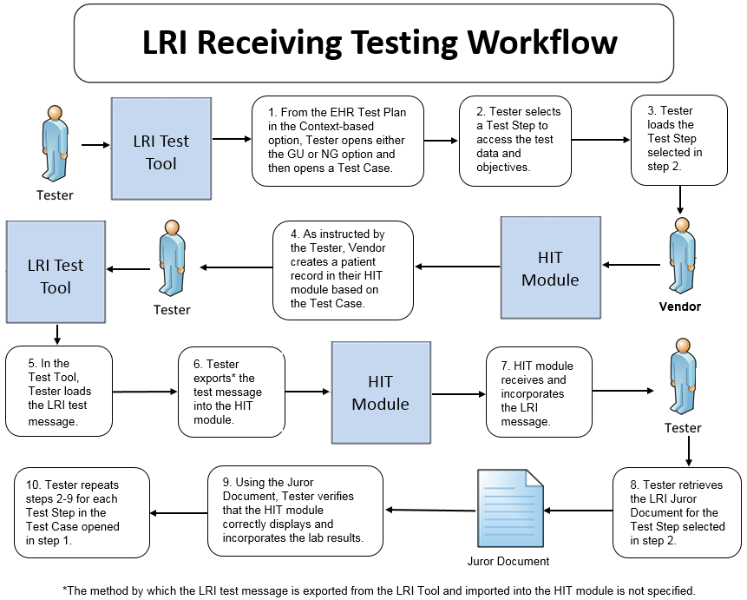

The instructions in the testing process listed below reference the numbered test steps in Figure 1.

Required Vendor Information
- The Vendor shall identify the HIT module function(s) that are available to 1) select the test patients’ records, 2) view laboratory tests and values/results in human readable format when received from an external source, 3) display all of the required data on a laboratory Test Report as indicated by the Display Verification section of the Juror Document, and 4) demonstrate that the HIT module has incorporated a laboratory test and value/result into the patient record in the manner indicated by the Incorporate Verification section of the Juror Document

- Vendor shall provide the mechanism necessary to capture and import LRI messages
- Vendor shall declare conformance to GU/FRU, GU/FRN, NG/FRU, or NG/FRN profile

Required Testing Actions
- Using the Context-based capability provided in the Tool identified in the Conformance Test Tools section of this testing process document, the Tester shall access the EHR Test Plan and shall open either the GU or NG option and then shall open a Test Case [Figure 1, Step 1] (the Tester shall open either the FRU or FRN Test Case for the Culture & Susceptibility and the Reflex Hepatitis parent-child Test Steps)
- The Tester shall select a Test Step [Figure 1, Step 2]
- The Tester shall load the Test Step [Figure 1, Step 3]
- Using the capabilities in the HIT Module, the Vendor shall create a patient record based on the test data for the Test Case [Figure 1, Step 4]
- In the NIST Tool, the Tester shall load the LRI test message for the selected Test Step and shall export the test message into the Module [Figure 1, Steps 5 & 6]
- Using the capabilities in the HIT Module, the Tester shall observe the Module receiving and incorporating the LRI test message that was loaded and exported [Figure 1, Step 7]
- The Tester shall retrieve the LRI Juror Document from the NIST Tool for the Test Step selected [Figure 1, Step 8]
- Using the Inspection Test Guide, the Tester shall verify that the HIT Module received and incorporated the message correctly according to the named standards [Figure 1, Step 9]
- The Tester shall repeat Required Testing Actions 2 – 7 using the next sequential Test Step until all Test Steps in the opened Test Case are completed [Figure 1, Step 10]
(Note: for the PT & INR Test Case, the Tester shall proceed now with LRI-EHR_DTR – 2, LRI-EHR_DTR – 3, and LRI-EHR_DTR – 4)

Inspection Test Guide
- Using the functions in the HIT Module, the test patient, the provided test data, and the Test Step-specific Juror Document retrieved from the NIST Tool, the Tester shall verify [Figure 1, Step 9]
- The specified data elements in the LRI test message exported from the Tool are displayed electronically for the test patient
- The laboratory test results are complete and accurate and are displayed in a human readable format
- The specified data elements in the LRI test message exported from the Tool are incorporated into the record for the test patient

LRI-EHR_DTR – 2: Electronically Create LRI Accept Acknowledgement Message

Figure 2 Create LRI Accept Acknowledgement Message Testing Workflow

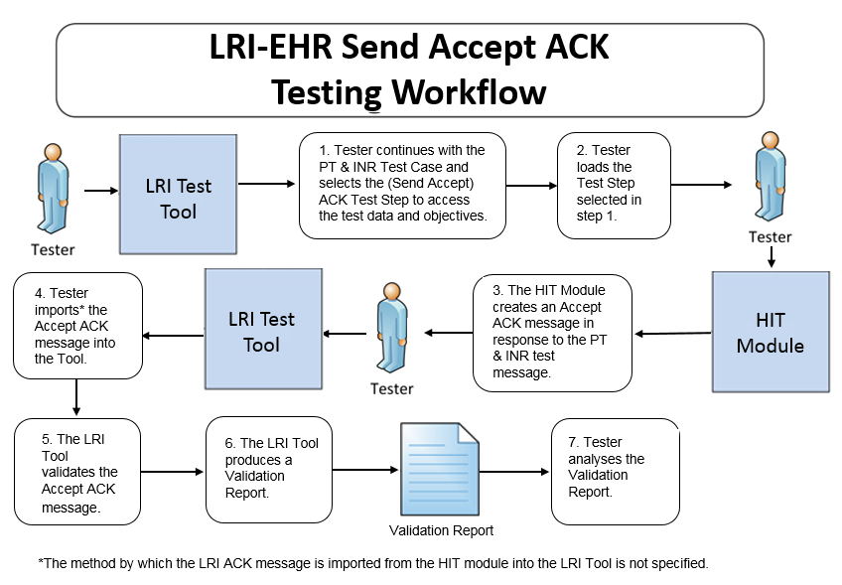

The instructions in the testing process listed below reference the numbered test steps in Figure 2.

Required Vendor Information
- The Vendor shall identify the HIT module function(s) that are available to create an Acknowledgement (ACK) message
- Vendor shall identify the HIT function(s) that are available to export the ACK message

Required Testing Actions
- Continuing with the PT & INR Test Case in the Context-based capability, the Tester shall select the first ACK message Test Step [Figure 2, Step 1], which covers the LRI Accept ACK message being sent from the HIT Module to the NIST Tool (which is functioning as a LIS)
- The Tester shall load the Test Step in the NIST Tool [Figure 2, Step 2]
- The Tester shall use the function(s) in the HIT Module to generate the Accept ACK message created in response to the LRI message [Figure 2, Step 3]
- The Tester shall import the Accept ACK message into the NIST Tool [Figure 2, Step 4]
- The Tool validates the Accept ACK message into the NIST Tool [Figure 2, Step 5] and produces a Validation Report [Figure 2, Step 6]
- Using the Inspection Test Guide, the Tester shall verify the conformance of the ACK message generated by the Module

Inspection Test Guide
- Using the Validation Report, the Tester shall analyze the Report and verify that the Accept ACK message created by the HIT Module meets the conformance requirements in the named standards [Figure 2, Step 7]

LRI-EHR_DTR – 3: Electronically Create LRI Application Acknowledgement Message

Figure 3 Create LRI Application Acknowledgement Message Testing Workflow
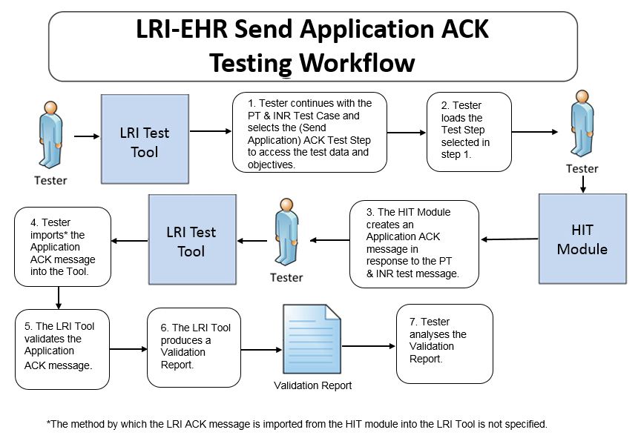
The instructions in the testing process listed below reference the numbered test steps in Figure 3.

Required Vendor Information
- As defined in LRI-EHR_DTR – 2, no additional information is required

Required Testing Actions
- Continuing with the PT & INR Test Case in the Context-based capability, the Tester shall select the second ACK message Test Step [Figure 3, Step 1], which covers the LRI Application ACK message being sent from the HIT Module to the NIST Tool (which is functioning as a LIS)
- The Tester shall load the Test Step in the NIST Tool [Figure 3, Step 2]
- The Tester shall use the function(s) in the HIT Module to generate the Application ACK message created in response to the LRI message [Figure 3, Step 3]
- The Tester shall import the Application ACK message into the NIST Tool [Figure 3, Step 4]
- The Tool validates the Application ACK message [Figure 3 Step 5] and produces a Validation Report [Figure 3, Step 6]
- Using the Inspection Test Guide, the Tester shall verify the conformance of the ACK message generated by the Module

Inspection Test Guide
- Using the Validation Report, the Tester shall analyze the Report and verify that the Application ACK message created by the HIT Module meets the conformance requirements in the named standards [Figure 3, Step 7]

LRI-EHR_DTR – 4: Electronically Receive LRI Accept Acknowledgement Message for the Application Acknowledgement

Figure 4 Receive and Process LRI Accept Acknowledgement Message Testing Workflow

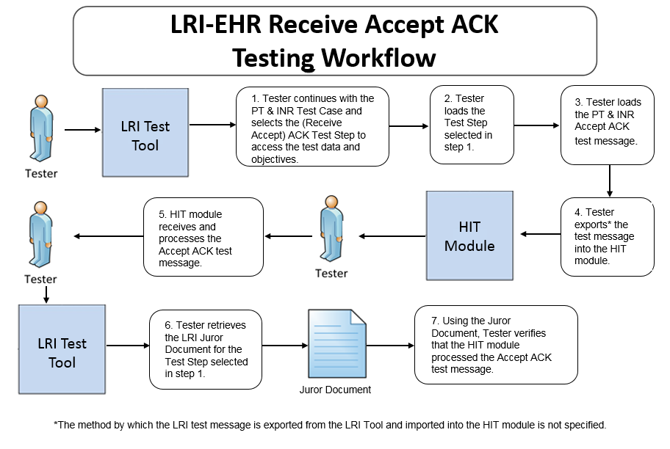 The instructions in the testing process listed below reference the numbered test steps in Figure 4.

Required Vendor Information
- The Vendor shall identify the HIT module function(s) that are available to verify that an ACK message has been received and processed
- Vendor shall provide the mechanism necessary to capture and import the ACK messages

Required Testing Actions
- Continuing with the PT & INR Test Case in the Context-based capability, the Tester shall select the third ACK message Test Step [Figure 4, Step 1], which covers the LRI Accept ACK message being sent to the HIT Module from the NIST Tool (which is functioning as a LIS)
- The Tester shall load the Test Step in the NIST Tool [Figure 4, Step 2]
- The Tester shall load the LRI Accept ACK message for the selected Test Step and shall export the test message into the Module [Figure 4, Steps 3 & 4]
- Using the capabilities in the HIT Module, the Tester shall observe the Module receiving and processing the LRI Accept ACK message that was loaded and exported [Figure 4, Step 5]
- The Tester shall retrieve the LRI Juror Document from the NIST Tool for the Test Step selected [Figure 4, Step 6]
- Using the Inspection Test Guide, the Tester shall verify that the HIT Module processed the message

Inspection Test Guide
- Using the functions in the HIT Module, the provided example Accept ACK message, and the Test Step-specific Juror Document retrieved from the NIST Tool, the Tester shall verify that the Module received and processed the Accept ACK message according to the named standards [Figure 4, Step 7]

Test Data
Test data are provided for the testing process to ensure that the applicable requirements identified in the conformance criteria can be adequately evaluated, as well as to provide consistency in the testing process across multiple testing entities. The provided test data focus on evaluating the basic capabilities required of the Health IT Module, rather than exercising the full breadth/depth of capability that installed Health IT Modules might be expected to support. The test data are formatted for ease of use by the Tester during the testing process; the format is not intended to prescribe the design of the display presented to the end-user for viewing the data. No additional requirements should be drawn from the format.

The Tester shall use and apply the provided test data during the testing, without exception, unless one of the following conditions exists:
- The Tester determines that the Health IT Module is sufficiently specialized that the provided test data need to be modified in order to conduct an adequate test. Having made the determination that some modification to the provided test data is necessary, the Tester shall record the modifications made as part of the test documentation.
- The Tester determines that changes to the test data will improve the efficiency of the testing process (for example, using consistent demographic data throughout the testing workflow). The Tester shall ensure that the functional and interoperable requirements identified in the criteria can be adequately evaluated for conformance, and that the modified test data provide a comparable level of robustness.
- The Tester determines that the LOINC or SNOMED CT code in a message created by the Health IT Module is a valid code for a data item (e.g., lab test) even though it is different from the LOINC or SNOMED CT code provided for that data item in the test data for that message

Any departure from the provided test data shall focus on meeting the basic capabilities required of the Health IT Module relative to the conformance criteria rather than exercising the full breadth/depth of capability that the installed Health IT Module might be expected to support.

The testing process requires that the applicable test data be entered into the Health IT Module being evaluated for conformance. The intent is that the Tester performs or observes the process of entering the test data in order to ensure that the data are correctly entered as specified in the testing process.

For conformance testing, the primary purpose of the provided test data is to assist the Tester in verifying that the vendor’s Module is capable of supporting the required functions. The clinical test data are relevant for the given Test Stories; however, these data should not be expected to represent standards of practice.

Test data for conformance testing related to the LRI-EHR Incorporate Lab Values/Results criterion are available in the NIST LRI Test Tool (see the Conformance Test Tools section of this testing process document for instructions on how to access the Test Tool).

Navigating a Test Case
A LRI-EHR Test Case contains multiple Test Steps, each consisting of a Test Story, a Test Data Specification, a Message Content Data Sheet, and, where applicable, a Juror Document. All of these artifacts are accessible via the NIST Tool.
- The Test Story describes a real-world situation that provides the context for the Test Step.
- The Test Data Specification provides the data associated with the Test Story and lists the information that would typically be available for a given situation in the specified clinical setting. Together, the Test Story and the Test Data Specification provide sufficient information for the Testers and Health IT Module Vendors to enter into the Module in order to create the patient record for each Test Step.
- The Message Content Data Sheet shows a conformant message instance for the Test Step. The message content is organized in a table format that provides the HL7 v2 message elements and the data associated with the message elements for a given Test Step. The Message Content Data Sheet may provide assistance to the Tester and Health IT Module Vendor for resolving issues discovered during conformance testing.
- The Juror Document provides a checklist for the Tester to use during conformance testing for assessing the Health IT Module’s ability to display and incorporate required data elements from the information received in the LRI message. Additional data from the message or from the Health IT Module are permitted to be displayed by the Module. Grayed-out fields in the Juror Document indicate where no data for a given data element were included in the message for the particular Test Case. The format of the Juror Document is for ease-of-use by the Tester and does not indicate how the Health IT Module display must be designed.
Note: The Juror Document for the Acknowledgment Test Step in the PT and INR Test Scenario provides very basic instructions to the Tester for use during conformance testing when assessing the Health IT Module’s ability to receive and process an Accept Acknowledgement message with no errors that is sent by a LIS. The HIT Module need not make a positive notification visible in the system indicating that the Acknowledgement message was processed correctly.

The LRI Implementation Guide defines four profile options relevant for conformance testing:

- LRI_GU_FRU_Profile – ID: 2.16.840.1.113883.9.195.3.1
- LRI_GU_FRN_Profile – ID: 2.16.840.1.113883.9.195.3.2
- LRI_NG_FRU_Profile – ID: 2.16.840.1.113883.9.195.3.3
- LRI_NG_FRN_Profile – ID: 2.16.840.1.113883.9.195.3.4

For the purpose of conformance testing, the Vendor can declare to which profile they are claiming conformance—only one is required. Test Cases and/or Test Steps (and hence specific test data) are provided for each profile option. Table 1 (LRI Test Scenarios and Associated Test Cases and Test Steps) lists the seven Test Scenarios and identifies the Test Cases or Test Steps for each scenario.

If the Vendor selects the GU/GU_FRU profile, the Tester shall conduct: the GU Test Scenarios 1 and 2; GU Test Scenario 3 – Partial Result to Final, Final Result to Wrong Patient, and, optionally, the Final Result to Amended Test Steps; GU Test Scenario 4; GU Test Scenario 5 - Preliminary Result, Final Result GU-FRU, and, optionally, either or both of the Final Result to Corrected GU-FRU Test Steps; GU Test Scenario 6 – both GU-FRU Test Steps; and GU Test Scenario 7 - Pap Smear Test Step

If the Vendor selects the GU/GU_FRN profile, the Tester shall conduct: the GU Test Scenarios 1 and 2; GU Test Scenario 3 – Partial Result to Final, Final Result to Wrong Patient, and, optionally, the Final Result to Amended Test Steps; GU Test Scenario 4; GU Test Scenario 5 - Preliminary Result, Final Result GU-FRN, and, optionally, either or both of the Final Result to Corrected GU-FRN Test Steps; GU Test Scenario 6 – both GU-FRN Test Steps; and GU Test Scenario 7 - Pap Smear Test Step

If the Vendor selects the NG/NG_FRU profile, the Tester shall conduct: the NG Test Scenarios 1 and 2; NG Test Scenario 3 – Partial Result to Final, Final Result to Wrong Patient, and, optionally, the Final Result to Amended Test Steps; NG Test Scenario 4; NG Test Scenario 5 - Preliminary Result, Final Result NG-FRU, and, optionally, either or both of the Final Result to Corrected GU-FRU Test Steps; NG Test Scenario 6 - both NG-FRU Test Steps; and NG Test Scenario 7 - Pap Smear Test Step.

If the Vendor selects the NG/NG_FRN profile, the Tester shall conduct: the NG Test Scenarios 1 and 2; NG Test Scenario 3 – Partial Result to Final, Final Result to Wrong Patient, and, optionally, the Final Result to Amended Test Steps; NG Test Scenario 4; NG Test Scenario 5 - Preliminary Result, Final Result NG-FRN, and, optionally, either or both of the Final Result to Corrected NG_FRN Test Steps; NG Test Scenario 6 - both NG_FRN Test Steps; and NG Test Scenario 7 - Pap Smear Test Step.

Table 1: LRI Test Scenarios and Associated Test Cases and Test Steps

Test Scenarios | NG Test Cases | NG Test Steps | GU Test Cases | GU Test Steps
1 - Minimally populated PT and INR Messages (Smoke Test) | Not Applicable | LRI_0.0-1.1-NG  (Final Result)  ACK_0.0-3.1-NG  (Send Accept Acknowledgement)  ACK_0.0-4.1-NG  (Send Application Acknowledgement)  ACK_0.0-5.1-NG  (Receive Accept Acknowledgement) | Not Applicable | LRI_0.0-1.1-GU  (Final Result)  ACK_0.0-3.1-GU  (Send Accept Acknowledgement)  ACK_0.0-4.1-GU  (Send Application Acknowledgement)  ACK_0.0-5.1-GU  (Receive Accept Acknowledgement)
2 - Maximally Populated SED Rate Messages | Final Results to Corrected | LRI_1.0_1.1-NG  LRI_1.0_2.1-NG | Final Results to Corrected | LRI_1.0_1.1-GU  LRI_1.0_2.1-GU
 | Specimen Rejected | LRI_1.2_1.1-NG | Specimen Rejected | LRI_1.2_1.1-GU
3 - Typically Populated CBC Messages | Partial Results to Final | LRI_2.0_0.1-NG  LRI_2.0_1.1-NG | Partial Results to Final | LRI_2.0_0.1-GU  LRI_2.0_1.1-GU
 | Final Results to Wrong Patient | LRI_2.1_1.1-NG  LRI_2.1_2.1-NG | Final Results to Wrong Patient | LRI_2.1_1.1-GU  LRI_2.1_2.1-GU
 | Final Result to Amended  (Optional) | LRI_2.2_1.1-NG  LRI_2.2_2.1-NG | Final Result to Amended  (Optional) | LRI_2.2_1.1-GU  LRI_2.2_2.1-GU
4 - Typically Populated Lipid Panel Messages | LRI_3.0_1.1-NG  (Final Results w/AOE)  - OBR-13 Relevant Clinical Information:  - Patient was fasting prior to the procedure. | Not Applicable | LRI_3.0_1.1-GU  (Final Results w/AOE)  - OBR-13 Relevant Clinical Information:  - Patient was fasting prior to the procedure. | Not Applicable
 | LRI_3.0_2.1-NG  (Final Results w/AOE – Duplicate Reports)  - OBR-13 Relevant Clinical Information:  - Patient was fasting prior to the procedure. | Not Applicable | LRI_3.0_2.1-GU  (Final Results w/AOE – Duplicate Reports)  - OBR-13 Relevant Clinical Information:  - Patient was fasting prior to the procedure. | Not Applicable
5 - Typically Populated Culture & Susceptibility Messages | Preliminary Results | LRI_4.0_1.1-NG | Preliminary Results | LRI_4.0_1.1-GU
 | Final Results | LRI_4.1_2.1-NG_FRU  OR  LRI_4.2_2.1-NG_FRN | Final Results | LRI_4.1_2.1-GU_FRU  OR  LRI_4.2_2.1-GU_FRN
 | Corrected Susceptibility Flag  (Optional)  AND / OR  Antibiotic Results Missing  (Optional) | LRI_4.1_3.1-NG_FRU OR  LRI_4.2_3.1-NG_FRN  AND / OR  LRI_4.1_4.1-NG_FRU OR  LRI_4.2_4.1-NG_FRN | Corrected Susceptibility Flag  (Optional)  AND / OR  Antibiotic Results Missing  (Optional) | LRI_4.1_3.1-GU_FRU OR  LRI_4.2_3.1-GU_FRN  AND / OR  LRI_4.1_4.1-GU_FRU OR  LRI_4.2_4.1-GU_FRN
6 - Typically Populated Reflex Hepatitis Messages | Final Results | LRI_5.0_1.1-NG_FRU OR  LRI_5.1_1.1-NG_FRN | Final Results | LRI_5.0_1.1-GU_FRU OR  LRI_5.1_1.1-GU_FRN
 | Reflex Results | LRI_5.0_2.1-NG_FRU OR  LRI_5.1_2.1-NG_FRN | Reflex Results | LRI_5.0_2.1-GU_FRU OR  LRI_5.1_2.1-GU_FRN
7 - Typically Populated Pap Smear AP Message | Not Applicable | LRI_6.0_1.1-NG  (Final Results)  - Ask-at-Order-Entry:  - Date of last menstrual period  - "Did the patient have a previous abnormal Pap report, treatment, or biopsy?" (Yes/No/Unknown) | Not Applicable | LRI_6.0_1.1-GU  (Final Results)  - Ask-at-Order-Entry:  - Date of last menstrual period  - "Did the patient have a previous abnormal Pap report, treatment, or biopsy?" (Yes/No/Unknown)

Details for each Test Step, including the test story, test objectives, test data, example HL7 message, and juror document (where applicable) are provided via the tabs that are displayed when a user selects a Test Step in the Conformance Test Tool (See the “EHR Test Plan” using the Context-based tab). These artifacts also are available in PDF files accessible via the tabs displayed with the Test Step as well as via the Test Tool Documentation tab. The Tester shall follow the instructions in the Normative Test Description section of this testing process document to conduct the conformance testing.

HOW TO INTERPRET AND USE THE JUROR DOCUMENT

The Juror Document categorizes test data according to how the display and incorporation of data in the HIT Module are verified. This document is composed of two sets of tables: one set (labeled “Display Verification”) lists the data that are required to be displayed in the Module in accordance with the EHR-S Functional Requirements for LRI; the other set (labeled “Incorporate Verification”) lists the data that are required to be incorporated into or stored in the Module in accordance with the EHR-S Functional Requirements for LRI. Some elements contained in the message are subject to neither verification, and these elements are not provided in the Juror Document.

Table 2 describes the Display categorizations, and Table 3 describes the Incorporate categorizations used in the Juror Documents. For additional details, refer to the Test Step-specific Juror Documents provided in the Tool identified in the Conformance Test Tools section of this testing process document.

Table 2 Data Element Display Categorization

Legend | Description | Example
Data in bold red text | HIT Module must display exact version of stored data | OBX.5 when the Datatype is TX
Data in bold black italics text | HIT Module must display exact version of data received in the LRI message | OBX-24.1.1 Performing Organization Street Address
Data in regular black text | HIT Module may display equivalent version of stored data | OBX-8 Abnormal Flag

Table 3 Data Element Incorporation Categorization

Legend | Description | Example
S-EX | Store exact: HIT Module must be designed to incorporate/store only the exact data received in the LRI message. | OBR-13.9 Relevant Clinical Information - Original Text
S-EX-A | Store exact by association: The Module must be designed (1) to incorporate/store the exact data received in the LRI message OR (2) to use a pointer to a location (e.g., file/table in or accessible to the HIT Module) where the exact data can be obtained. | OBR-13.2 Relevant Clinical Information - Text
S-EQ | Store equivalent: The Module must be designed to transform the exact data received in the LRI message to an equivalent format and then incorporate/store the equivalent format. | PID-7.1 Date/Time of Birth
S-TR-R | Translate and store translation: The Module must be designed to transform the exact data received in the LRI message to an equivalent value and then incorporate/store the equivalent value. | OBX-3.1 Observation Identifier - Identifier
S-RC | Process and re-create: The Module must be designed to process and incorporate/store in an “abstract-able manner” (e.g., using the HIT Module’s data model) the exact data received in the LRI message and to re-create the exact data (e.g., from the HIT Module’s data model). | OBR-28.13 Result Copies To- Identifier Type Code

Conformance Test Tools
The following testing tool is available to evaluate conformance to the standards referenced in this testing process document:
- NIST HL7 V2 Validation tool - Laboratory Results Interface – an HL7v2 messaging validation tool; designed to support the NIST conformance testing process
  - The tool is available as a Web Application
- The application can be downloaded for local installation
- The NIST Lab Results Interface test tool Web application is available at:
http://hl7v2-lab-r2-testing.nist.gov/lri-r2/

Support for this tool is available by submitting questions to the following user’s group:
https://groups.google.com/forum/#!forum/hl7v2-lab-testing

Inquiries may also be sent to this user group via email: hl7v2-lab-testing@googlegroups.com

Several browsers may be used to access the HL7 v2 LRI Test Tool; Firefox (recommended), Chrome (recommended), Safari, and IE 9+ are the supported browsers.

The following information is provided to assist the Tester in interpreting the Validation Reports generated by the LRI Tool:

The Context-based capability in the Tool evaluates conformance requirements that are specified or have been derived from the standards and implementation guides identified in the conformance criteria and the test data provided for this testing process. The Test Tool evaluates the submitted HL7 message for each conformance requirement, and then produces a Validation Report.

The Tester should consider a Validation Report that contains only Warning and Alert messages to be indicative of a sufficient level of conformance to the standard and test data expectations. If reported, Errors should be considered significant departures from the standard or test data requirements, and these Errors must be corrected in order to claim conformance. Testers will need to further analyze each Error to determine if, in the context of meeting the conformance criterion, the Error results in a failure of the testing process by the Health IT Module.

The NIST context-based testing performs specific content validation depending on the Category/Qualifier combination assigned to the Data Elements in the message (see How to Interpret the Message Content Data Sheet section for more details). In some cases, in order to perform this type of validation the NIST Tool expects the fields/segments/segment groups in the message to be sequenced in a certain order. The complexity of automatically evaluating specific content necessitates this approach. If the Message Validation Result generated by the NIST Tool indicates content-related errors, the Tester may change the order of the fields/segments/segment groups in the test message to match the Test Step once the message has been loaded into the Message Content window of the Test Tool. These kinds of content-related errors do not imply a failure of the vendor product nor a requirement to create the message with the fields/segments/segment groups in a certain order (beyond the base message structure).

Document History

Version Number | Description of Change | Date Published
1.0 | Approved Normative Test Process Document | June 28, 2016
1.1 | HL7 EHR-System Functional Model: S&I Framework EHR-S Functional Requirements For Laboratory Results Messages, Release 1, DSTU 1 - US Realm, April 2016  changed to  HL7 EHR-S Functional Requirements: S&I Framework Laboratory Results Messages, Release 1 - US Realm, STU May 2016  in the following sections  - Conformance Criteria  - Explanation of Terms  - Informative Test Description | July 7, 2016
1.2 | Conformance Test Tools Section  “IE 9+” added to set of browsers supported | July 18, 2016
1.3 | Normative Test Description Section  - Replaced Figure 1 Receive and Incorporate LRI Messages Testing Workflow; verbiage in step 10 changed from “Tester repeats steps 2-10 for each Test Step in the Test Case opened in step 2.” to “Tester repeats steps 2-9 for each Test Step in the Test Case opened in step 1.” | August 2, 2016
1.4 | Added Ask-at-Order-Entry question information for Lipid Panel and Pap Smear messages  - Informative Test Description Section  - Test Data Section, Table 1 | November 16, 2016

This requirement is assessed during conformance testing via the Tester using the Incorporate Verification section of the Juror Document
Minimally populated means the LRI example messages contain single occurrences of all required ("R") elements
Maximally populated means the LRI example messages contain all the R, RE, C(a/b) elements defined in the implementation guide
Typically populated means the LRI example message contains data that are routinely sent whether the data element is R (Required) or RE (Required, but may be empty)
During conformance testing, the mechanism by which the lab result test message is imported (sent) from or to the Health IT Module being tested is not specified. The Tester may have their own utility, they may allow the Module vendor to use a utility created by that vendor, or the message can be cut from the Module and pasted into the NIST Test Tool or cut from the NIST Test Tool and pasted into the Module. For conformance testing, the key requirement is for the Module to demonstrate real time/dynamic import.

