**Immunization Test Suite**

**Receiver SOAP Connectivity Testing**

**Version 1.0**

**March 29, 2016**

**Immunization Test Case**

**Receiver**

**SOAPCON_1_BasicMessage_Connectivity**

**BasicMessage_Connectivity**

**Test Description**

Description

|  |
| --- |
|  |
| This test evaluates the capability of a receiver (responder) technology conforming to the SOAP 1.2 standard and CDC WSDL 1.0 to receive a request message from a sender (initiator) technology, and to generate and transmit an appropriate response message, in order to verify the accessibility of an Immunization Information System (IIS). |

Test Objectives

|  |
| --- |
|  |
| The receiver (responder) technology will demonstrate the ability to:   * Receive a SOAP message with the Body element containing the element **connectivityTest** and corresponding child element *echoBack*, as defined in the CDC WSDL 1.0 * Transmit a SOAP response message to the sender (initiator) which contains   + the element **connectivityTestResponse** as defined in the CDC WSDL 1.0   + the child element *return* as defined in the CDC WSDL 1.0, with a string value containing the string received in the *echoBack* element in the request message |

**SOAP Connectivity Testing Diagram**

**Receiver**

**SOAPCON_1_BasicMessage_Connectivity**

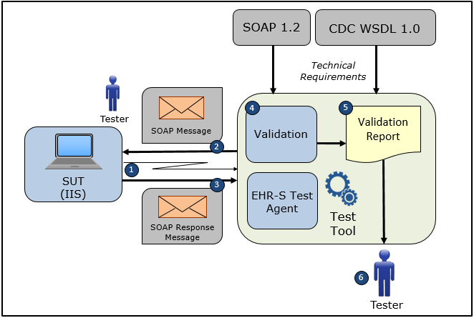

1. The Tester accesses the System Under Test (IIS) and causes it to connect to the NIST Test Tool representing an EHR-S Test Agent
2. The Tester causes the NIST Test Tool to electronically generate and transmit to the System Under Test a SOAP connectivity request message **connectivityTest** that conforms to the SOAP 1.2 standard and CDC WSDL 1.0 in order to verify the accessibility of the IIS NIST Test Agent

3) The System Under Test electronically generates and transmits to the EHR-S Test Agent in the NIST Test Tool a SOAP connectivity response message **connectivityTestResponse** that conforms to the SOAP 1.2 standard and CDC WSDL 1.0 and that confirms the accessibility of the IIS

4) The Test Tool validates the SOAP connectivity response message for conformance to the SOAP 1.2 standard and CDC WSDL 1.0, and also validates that the **connectivityTestResponse** *return* element contains the string sent to the System Under Test (IIS) in the *echoBack* element of the **connectivityTest** message, and the Tester can view the validation results on-line

5) The Test Tool generates a Validation Report listing the results of the validation

6) The Tester reviews the Validation Report and compares the results to the Objectives and Evaluation Criteria associated with the Receiver SOAPCON_1_BasicMessage_Connectivity Test Case

**Test Data Specification**

Connectivity Response Message Information

|  |  |  |
| --- | --- | --- |
| **Element Name** | **Data** | **Classification of Data** |
| connectivityTest: *echoBack* | Hello world! | Changeable |

Explanation of Data Classification

|  |  |  |
| --- | --- | --- |
| **Data Classification** | **Description** | **Validation** |
| **Configurable** | Data typically that are configured by the system (customer-definable). Example data are provided. | Validate for the presence of data |
| **System Generated** | Data typically generated automatically by system, e.g., message time. Example data are provided. | Validate for the presence of data |
| **IG Fixed** | Data that are fixed by the implementation guide; data can’t be changed. Specific data are provided. | Validate for the presence and data content |
| **Test Case Fixed** | Data that are specific and fixed by the test case; data should not be changed. Specific data are provided. | Validate for the presence and selectively validate for data content |
| **Changeable** | Data where the exact content is not relevant for the test case and can be changed for the purposes of testing. Example data are provided. | Validate for the presence of data |
| **Test Tool-Assigned** | Data that are assigned by the test tool for the specific System Under Test in real-time. Example data are provided. | Validate for the presence and for data content |
| **Test System-Provided** | Data that are provided by the System Under Test in real-time. Example data are provided. | Validate for the presence and for data content |

**Message Content Table**

Test Case Information

|  |  |
| --- | --- |
| **Element Name** | **Data** |
| Test Case ID | Receiver SOAPCON_1_BasicMessage_Connectivity |

Connectivity Response

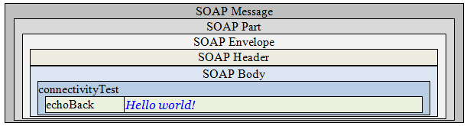

**Message Content**

**Response Message Sent by Receiver System**

<?xml version='1.0' encoding='UTF-8'?>

<Envelope xmlns="http://www.w3.org/2003/05/soap-envelope">

<Header />

<Body>

<connectivityTest xmlns="urn:cdc:iisb:2011">

<echoBack>Hello world!</echoBack>

</connectivityTest>

</Body>

</Envelope>