**Immunization Test Suite**

**Sender SOAP Connectivity Testing**

**Version 1.0**

**March 29, 2016**

**Immunization Test Case**

**Sender**

**SOAPCON_1_BasicMessage_Connectivity**

**BasicMessage_Connectivity**

**Test Description**

Description

|  |
| --- |
|  |
| This test evaluates the capability of a sender (initiator) technology to connect to a specified web service – a NIST Test Agent representing an Immunization Information System (IIS) – and transmit a message that conforms to the SOAP 1.2 standard and CDC WSDL 1.0 which is used to verify the accessibility of the IIS. |

Test Objectives

|  |
| --- |
|  |
| The sender (initiator) technology will demonstrate the ability to:   * Connect to a web service endpoint specified by the NIST test tool and transmit a SOAP message with a Body element containing:   + the element **connectivityTest**, as defined in the CDC WSDL 1.0   + user-chosen, non-empty, conformant string value for the child element of **connectivityTest**:  *echoBack* |

**SOAP Connectivity Testing Diagram**

**Sender**

**SOAPCON_1_BasicMessage_Connectivity**

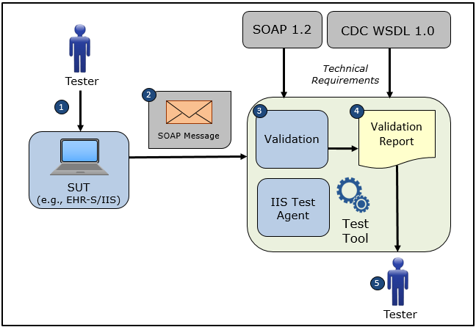

1. The Tester causes the System Under Test (EHR-S) to connect to a NIST Test Tool representing an IIS Test Agent using the NIST web service endpoint specified on the screen of the Test Tool
2. The Tester causes the System Under Test to electronically generate and transmit to the NIST Test Tool the SOAP **connectivityTest** request message that conforms to the SOAP 1.2 standard and CDC WSDL 1.0 in order to verify the accessibility of the IIS NIST Test Agent
3. The Test Tool validates the SOAP **connectivityTest** request message for conformance to the SOAP 1.2 standard and CDC WSDL 1.0 and the Tester can view the validation results on-line
4. The Test Tool generates a Validation Report listing the results of the validation
5. The Tester reviews the Validation Report and compares the results to the Objectives and Evaluation Criteria associated with the Sender SOAPCON_1_BasicMessage_Connectivity Test Case

**Test Data Specification**

Connectivity Request Message Information

|  |  |  |
| --- | --- | --- |
| **Element Name** | **Data** | **Classification of Data** |
| **connectivityTest**: *echoBack* | Hello world! | Changeable |

Explanation of Data Classification

|  |  |  |
| --- | --- | --- |
| **Data Classification** | **Description** | **Validation** |
| **Configurable** | Data typically that are configured by the system (customer-definable). Example data are provided. | Validate for the presence of data |
| **System Generated** | Data typically generated automatically by system, e.g., message time. Example data are provided. | Validate for the presence of data |
| **IG Fixed** | Data that are fixed by the implementation guide; data can’t be changed. Specific data are provided. | Validate for the presence and data content |
| **Test Case Fixed** | Data that are specific and fixed by the test case; data should not be changed. Specific data are provided. | Validate for the presence and selectively validate for data content |
| **Changeable** | Data where the exact content is not relevant for the test case and can be changed for the purposes of testing. Example data are provided. | Validate for the presence of data |
| **Test Tool-Assigned** | Data that are assigned by the test tool for the specific System Under Test in real-time. Example data are provided. | Validate for the presence and for data content |
| **Test System-Provided** | Data that are provided by the System Under Test in real-time. Example data are provided. | Validate for the presence and for data content |

**Message Content Tables**

Test Case Information

|  |  |
| --- | --- |
| **Element Name** | **Data** |
| Test Case ID | Sender SOAPCON_1_BasicMessage_Connectivity |

Connectivity Request

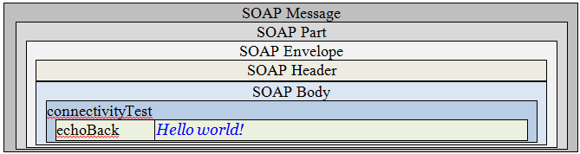

**Message Content**

**Request Message Sent by Sender System**

<?xml version='1.0' encoding='UTF-8'?>

<Envelope xmlns="http://www.w3.org/2003/05/soap-envelope">

<Header/>

<Body>

<connectivityTest xmlns="urn:cdc:iisb:2011">

<echoBack>Hello world!</echoBack>

</connectivityTest>

</Body>

</Envelope>