**Immunization Test Suite**

**SOAP Envelope Testing**

**Version 1.0**

**March 29, 2016**

**Immunization Test Case**

**Generic**

**SOAPENV_1_MinTest**

**MinimalTest_Create_SOAP_Envelope**

**Test Description**

Description

|  |
| --- |
|  |
| This test evaluates the capability of a technology to generate a message envelope conforming to the minimal requirements of the SOAP 1.2 standard. |

Test Objectives

|  |
| --- |
|  |
| The generated SOAP message will demonstrate these minimal capabilities:   * element *Envelope* with child element *Body* as defined by the SOAP 1.2 standard * user-chosen (conformant) XML content within *Body* (including no content) is permitted * optional SOAP 1.2 elements (e.g. *Header*) are permissible but not required |

**SOAP Envelope Testing Diagram**

**Generic - SOAPENV_1_MinTest**

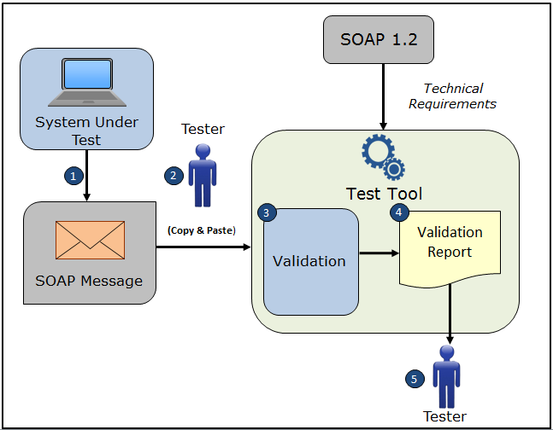

1. The System Under Test (SUT) generates a SOAP message envelope
2. The Tester copies this SOAP message envelope and pastes it into the Test Tool
3. The Test Tool validates the SOAP message envelope for conformance to the minimal requirements of the SOAP 1.2 standard
4. The Test Tool generates a Validation Report listing the results of the validation
5. The Tester reviews the Validation Report and compares the results to the Objectives and Evaluation Criteria associated with the SOAPENV_1_MinTest Test Case

**Envelope Content (Example) Table**

Test Case Information

|  |  |
| --- | --- |
| **Element Name** | **Data** |
| Test Case ID | Generic SOAPENV_1_MinTest |

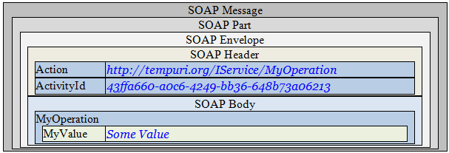

**Example Envelope Content**

**Simple SOAP Message**

<?xml version='1.0' encoding='UTF-8'?>

<!-- this is just an example SOAP message with non-empty Header and Body from the Web -->

<Envelope xmlns="http://www.w3.org/2003/05/soap-envelope">

<Header>

<Action mustUnderstand="1"

xmlns="http://schemas.microsoft.com/ws/2005/05/addressing/none">

http://tempuri.org/IService/MyOperation

</Action>

<ActivityId CorrelationId="7224e2a9-8f9c-4acb-a924-17cb6af67b23" xmlns="http://schemas.microsoft.com/2004/09/ServiceModel/Diagnostics">

43ffa660-a0c6-4249-bb36-648b73a06213</ActivityId>

</Header>

<Body>

<MyOperation xmlns="http://tempuri.org">

<MyValue>Some Value</MyValue>

</MyOperation>

</Body>

</Envelope>