## Test Procedure for SOAP Envelope Testing – NIST-CDC Immunization Test Suite

This document describes the test procedure for evaluating generation of a generic message envelope in conformance to the Simple Object Access protocol **(**SOAP) standard. The test procedure may be updated to reflect on-going feedback received during the testing activities.

Questions or concerns regarding this test procedure document should be directed to ___ at [___.___@___.___](mailto:___.___@___.___) .

### Test Criterion Description

Creation of message envelope using specified standard. Technology must be able to electronically create a generic message envelope for electronic transmission in accordance with the SOAP 1.2 standard.

### Informative Test Description

This section provides an informative description of how the test procedure is organized and conducted. It does not provide normative statements of the testing requirements.

As illustrated in **Figure 1**, this test evaluates the capability for a technology to electronically generate a message envelope that is in conformance with the SOAP 1.2 standard.

Figure . SOAP Envelope Testing

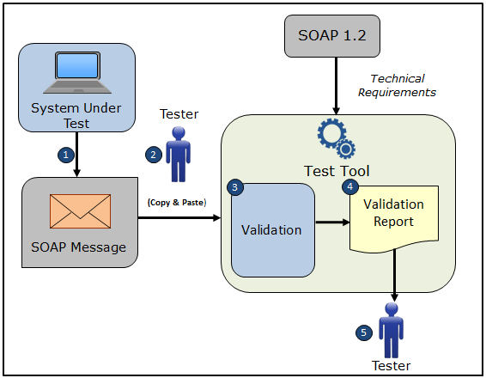

The Vendor supplies the test data for this test procedure. Example envelope content test data are provided in the test tool, and these data may be used if preferred.

The test procedure is organized into one section: Create SOAP Envelope.

* Create SOAP Envelope – evaluates the capability of the technology to electronically generate a generic message envelope conformant to the SOAP 1.2 standard
  + Using the Vendor-identified system function(s), the Tester inputs vendor-supplied or the provided example test data for generation of the SOAP 1.2 conformant message envelope content (if content is preferred for the message envelope) (input can be performed using a manual or automated process)
* Using the Vendor-identified system function(s) and the vendor-supplied or the provided example test data (if content is preferred for the message envelope), the Tester causes the system to generate the indicated message envelope using the SOAP 1.2 standard
* Using the Vendor-identified system function(s), the Tester imports the SOAP conformant message envelope into the NIST Immunization Test Tool
* Using the Evaluation Criteria listed in the Test Case Package* and the Validation Report produced by the NIST Immunization Test Tool, the Tester verifies that the message envelope meets the SOAP conformance requirements being tested

*The Test Case Package containing the Evaluation Criteria associated with each Test Case is available via the Test Tool as a pdf. document.

### Referenced Standards

|  |  |
| --- | --- |
| Standard. SOAP 1.2 |  |

### Normative Test Procedures

**Derived Test Requirements**

DTR-IZ-CRT-SOAPENV - 1: Electronically Create SOAP Conformant Message Envelope

Figure . Create SOAP Conformant Message Envelope

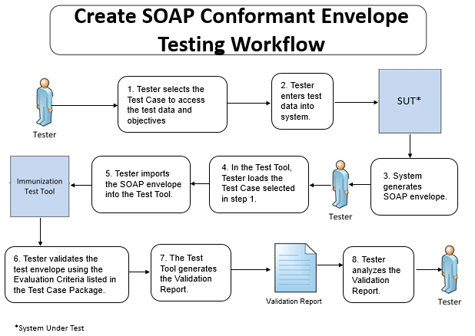

The instructions in the derived test procedure listed below reference the numbered test steps in **Figure 2**.

**DTR-IZ-CRT-SOAPENV** **- 1: Electronically Create SOAP Conformant Message Envelope**

Required Vendor Information

VE-IZ-CRT-SOAPENV – 1.01: Vendor shall identify the system function(s) that are available to 1) input the vendor-supplied or the provided example test data into the system for the test cases, 2) create a SOAP message envelope (using the test data if preferred), and 3) import the SOAP message envelope into the NIST Immunization Test Tool

VE-IZ-CRT-SOAPENV – 1.02: Vendor shall provide the mechanism necessary to capture and import the SOAP message envelope into the NIST Immunization Test Tool

Required Test Procedures

TE-IZ-CRT-SOAPENV – 1.01: Tester shall select the Test Case for the SOAP envelope testing [Figure 2, Step 1]

TE-IZ-CRT-SOAPENV – 1.02: Using the Vendor-identified system function(s), the Tester shall input the vendor-supplied test data (if content is preferred for the message envelope) for the SOAP envelope test selected in TE-IZ-CRT-SOAPENV – 1.01 (test data input can be performed using a manual or automated process) [Figure 2, Step 2]

TE-IZ-CRT-SOAPENV – 1.03: Using the Vendor-identified system function(s) and the vendor-supplied or provided example test data (if content is preferred for the message envelope) for the SOAP message envelope, the Tester shall

* Cause the system to generate the indicated SOAP message envelope based on the SOAP 1.2 standard [Figure 2, Step 3]
* Load the Test Case selected in TE-IZ-CRT-SOAPENV – 1.01 [Figure 2, Step 4]
* Import the SOAP message envelope into the NIST Immunization Test Tool identified in the Conformance Test Tools section of this test procedure [Figure 2, Step 5]

TE-IZ-CRT-SOAPENV – 1.04: Using the Inspection Test Guide, the Tester shall verify that the SOAP envelope is conformant to the SOAP 1.2 standard

Inspection Test Guide

IN-IZ-CRT-SOAPENV - 1.01: Using the Evaluation Criteria listed in the Test Case-specific Test Case Package**,** theTester shall verify that the SOAP 1.2 standard conformance requirements being tested are met [Figure 2, Step 6]

IN-IZ-CRT-SOAPENV - 1.02: Using the Validation Report produced by the NIST Immunization Test Tool identified in the Conformance Test Tools section of this test procedure**,** theTester shall analyze the Report and verify that the SOAP 1.2 standard conformance requirements being tested are met [Figure 2, Steps 7 & 8]

### Test Data

This Test Procedure allows the vendor to supply the test data or to use the example test data provided in the test tool. The Tester shall address the following:

* Vendor-supplied test data shall ensure that the functional and interoperable requirements identified in the test criterion can be adequately evaluated for conformance
* Vendor-supplied test data shall strictly focus on meeting the basic capabilities required of a technology relative to the test criterion rather than exercising the full breadth/depth of capability that an installed technology might be expected to support
* Tester shall record as part of the test documentation the specific Vendor-supplied test data that were utilized for testing

For this test procedure the Tester shall select the Test Case from the Test Scenario listed. The Tester shall follow the normative test procedures to conduct the test. Table 1 (SOAP Envelope Test Case) lists the Test Case included in the test tool for the Scenario. Details of the Test Case, including the test description, test objectives, and evaluation criteria, are accessible dynamically in the test tool; and they are provided in PDF files that also are accessible in the test tool (See the Context-based Validation tab in the test tool).

Table 1. SOAP Envelope Test Case

|  |  |
| --- | --- |
| **Test Scenario** | **Test Case** |
| MinimalTest_Create_SOAP_Envelope | Generic SOAPENV_1_MinTest |

### Conformance Test Tools

The following test tool is available to evaluate conformance to the standards referenced in this test procedure:

* HL7 v2 – NIST provides an HL7 v2 validation tool designed specifically to support this test procedure. The tool is available as a Web Application.
* The validation tool is available via the Web site for pre-testing
* The application can be downloaded for local installation
* The web application validation service is available at:

<http://hl7v2-iz-testing.nist.gov>

Support for these tools is available by submitting questions to the following user’s group:

<https://groups.google.com/d/forum/hl7v2-immunization-testing>

The following information is provided to assist the Tester in interpreting the validation reports generated by the NIST test tools:

The NIST Test Tool evaluates conformance requirements that are specified or have been derived from the standards identified in this test procedure document. The Test Tool evaluates the submitted envelope for each conformance requirement, and then produces a validation report. The Tester should consider that a report containing only Alerts and Warning notifications indicates a sufficient level of conformance to the standard and test data expectations. If an Error notification is reported, it should be considered a signal that significant departures from the standard or test data requirements have been found that need to be corrected in order for the EHR technology being tested to claim conformance. Testers will need to further analyze each Error notification to determine if, in the context of meeting the test criterion, the error results in a failure of the test procedure by the EHR technology.

## Document History

| **Version Number** | **Description** | **Date Published** |
| --- | --- | --- |
| 1.0 | Released for public comment | Month D, 2014 |

## 