**Immunization Test Suite**

**Receiver SOAP Envelope Testing**

**Version 1.0**

**March 29, 2016**

**Immunization Test Case**

**Receiver**

**SOAPENV_1_ConnectivityTest_Response**

**ConnectivityTest_Response**

**Test Description**

Description

|  |
| --- |
|  |
| This test evaluates the capability of a Receiver technology to generate a valid message conforming to the SOAP 1.2 standard and CDC WSDL 1.0 that may be used for confirming the accessibility of the Immunization Information System (IIS) Web Service. |

Test Objectives

|  |
| --- |
|  |
| The Receiver technology will demonstrate the ability to generate the SOAP message where the body of the message contains:   * the element **connectivityTestResponse**, as defined in the CDC WSDL 1.0 * arbitrary string value for the child element of **connectivityTestResponse**:  *return*. |

**SOAP Envelope Testing Diagram**

**Receiver**

**SOAPENV_1_ConnectivityTest_Response**

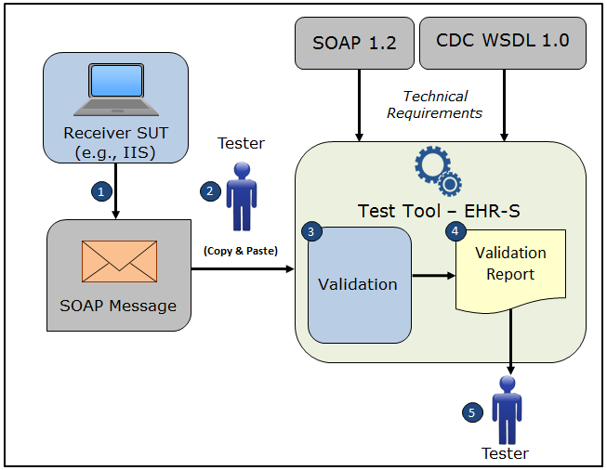

1. The System Under Test (SUT) generates a valid **connectivityTestResponse** message envelope that conforms to the SOAP 1.2 standard and CDC WSDL 1.0 and that confirms the accessibility of the Immunization Information System (IIS) Web Service
2. The Tester copies this SOAP **connectivityTestResponse** message envelope and pastes it into the Test Tool, which is functioning as the initiator system (e.g., EHR-S)
3. The Test Tool validates the SOAP **connectivityTestResponse** message envelope for conformance to the SOAP 1.2 standard and CDC WSDL 1.0
4. The Test Tool generates a Validation Report listing the results of the validation
5. The Tester reviews the Validation Report and compares the results to the Objectives and Evaluation Criteria associated with the SOAPENV_1_ConnectivityTest_Response Test Case

**Test Data Specification**

Message Information

|  |  |  |
| --- | --- | --- |
| **Element Name** | **Data** | **Classification of Data** |
| **connectivityTestResponse**: *return* | You sent: Hello world! | Changeable |

Explanation of Data Classification

|  |  |  |
| --- | --- | --- |
| **Data Classification** | **Description** | **Validation** |
| **Configurable** | Data typically that are configured by the system (customer-definable). Example data are provided. | Validate for the presence of data |
| **System Generated** | Data typically generated automatically by system, e.g., message time. Example data are provided. | Validate for the presence of data |
| **IG Fixed** | Data that are fixed by the implementation guide; data can’t be changed. Specific data are provided. | Validate for the presence and data content |
| **Test Case Fixed** | Data that are specific and fixed by the test case; data should not be changed. Specific data are provided. | Validate for the presence and selectively validate for data content |
| **Changeable** | Data where the exact content is not relevant for the test case and can be changed for the purposes of testing. Example data are provided. | Validate for the presence of data |

**Envelope Content Table**

Test Case Information

|  |  |
| --- | --- |
| **Element Name** | **Data** |
| Test Case ID | Receiver SOAPENV_1_ConnectivityTest_Response |

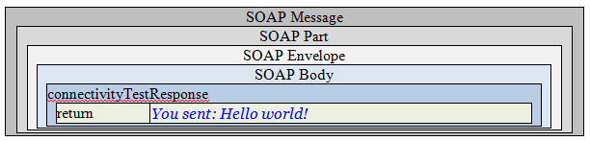

**Envelope Content**

**Connectivity Test Response Message Sent by Receiver System**

<?xml version='1.0' encoding='UTF-8'?>

<Envelope xmlns="http://www.w3.org/2003/05/soap-envelope">

<Body>

<connectivityTestResponse xmlns="urn:cdc:iisb:2011">

<return>You sent: Hello world!</return>

</connectivityTestResponse>

</Body>

</Envelope>