**Immunization Test Suite**

**Receiver SOAP Envelope Testing**

**Version 1.0**

**March 29, 2016**

**Immunization Test Case**

**Receiver**

**SOAPENV_2_SubmitSingleMessage_Response**

**SubmitSingleMessage_Response**

**Test Description**

Description

|  |
| --- |
|  |
| This test evaluates the capability of a Receiver technology to generate a valid message conforming to the SOAP 1.2 standard and CDC WSDL 1.0 that may be used for transporting an HL7 response message to an electronic health record system (EHR-S) or an Immunization Information System (IIS). |

Test Objectives

|  |
| --- |
|  |
| The Receiver technology will demonstrate the ability to generate the SOAP message where the body of the message contains:   * the element **submitSingleMessageResponse**, as defined in the CDC WSDL 1.0 * arbitrary string values for the child element of **submitSingleMessageResponse**:  *return*. |

**SOAP Envelope Testing Diagram**

**Receiver**

**SOAPENV_2_SubmitSingleMessage_Response**

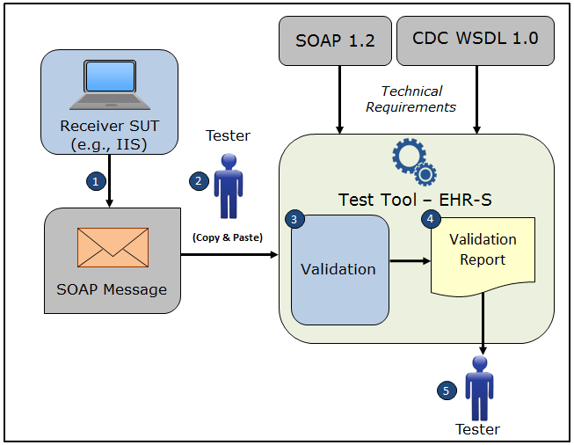

1. The System Under Test (SUT) generates a SOAP **submitSingleMessageResponse** message envelope
2. The Tester copies this SOAP **submitSingleMessageResponse** message envelope and pastes it into the Test Tool, which is functioning as the initiator system (e.g., EHR-S)
3. The Test Tool validates the SOAP **submitSingleMessageResponse** message envelope for conformance to the SOAP 1.2 standard and CDC WSDL 1.0
4. The Test Tool generates a Validation Report listing the results of the validation
5. The Tester reviews the Validation Report and compares the results to the Objectives and Evaluation Criteria associated with the SOAPENV_2_SubmitSingleMessage_Response Test Case

**Test Data Specification**

Message Information

|  |  |  |
| --- | --- | --- |
| **Element Name** | **Data** | **Classification of Data** |
| **submitSingleMessageResponse:** *return* | MSH|^~|&|IISSUT|IISSUT|NISTEHR||<date/timeMSG>||ACK^V04^ACK|<msgControlID>|P|2.5.1|||NE | Changeable |

Explanation of Data Classification

|  |  |  |
| --- | --- | --- |
| **Data Classification** | **Description** | **Validation** |
| **Configurable** | Data typically that are configured by the system (customer-definable). Example data are provided. | Validate for the presence of data |
| **System Generated** | Data typically generated automatically by system, e.g., message time. Example data are provided. | Validate for the presence of data |
| **IG Fixed** | Data that are fixed by the implementation guide; data can’t be changed. Specific data are provided. | Validate for the presence and data content |
| **Test Case Fixed** | Data that are specific and fixed by the test case; data should not be changed. Specific data are provided. | Validate for the presence and selectively validate for data content |
| **Changeable** | Data where the exact content is not relevant for the test case and can be changed for the purposes of testing. Example data are provided. | Validate for the presence of data |

**Envelope Content Table**

Test Case Information

|  |  |
| --- | --- |
| **Element Name** | **Data** |
| Test Case ID | Receiver SOAPENV_2_SubmitSingleMessage_Response |

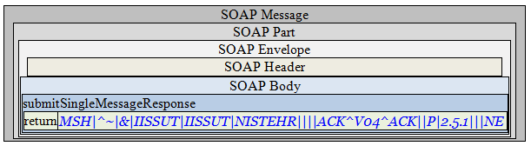

**Envelope Content**

**Response Message Sent by Receiver System**

<?xml version='1.0' encoding='UTF-8'?>

<Envelope xmlns="http://www.w3.org/2003/05/soap-envelope">

<Header />

<Body>

<submitSingleMessageResponse xmlns="urn:cdc:iisb:2011">

<return><![CDATA[MSH|^~|&|IISSUT|IISSUT|NISTEHR||<date/timeMSG>||ACK^V04^ACK|<msgControlID>|P|2.5.1|||NE]]></return>

</submitSingleMessageResponse>

</Body>

</Envelope>