**Immunization Test Suite**

**Receiver SOAP Envelope Testing**

**Version 1.0**

**March 29, 2016**

**Immunization Test Case**

**Receiver**

**SOAPENV_5_UnsupportedOperation_Fault**

**UnsupportedOperation_Fault**

**Test Description**

Description

|  |
| --- |
|  |
| This test evaluates the capability of a Receiver technology to generate a valid message conforming to the SOAP 1.2 standard and CDC WSDL 1.0 which may be used to return an **UnsupportedOperationFault_Message** in response to a **submitSingleMessage** request from a Sender (EHR-S or IIS). |

Test Objectives

|  |
| --- |
|  |
| The Receiver technology will demonstrate the ability to generate the SOAP message where the body of the message contains:   * the *Fault*/*Code*/*Value* element set to the string ‘Receiver’ * the *Fault*/*Reason*/*Text* element set to an arbitrary string value * the *Fault*/*Detail* element set to **UnsupportedOperationFault**, as defined in the CDC WSDL 1.0 * the **UnsupportedOperationFault**/*Code* element set to an arbitrary integer value * the **UnsupportedOperationFault***/Reason* element set to the string ‘UnsupportedOperation’ * the **UnsupportedOperationFault***/Detail* element set to an arbitrary string value * SOAP Fault elements not specified here are optional and if used must conform to SOAP 1.2 |

**SOAP Envelope Testing Diagram**

**Receiver**

**SOAPENV_5_UnsupportedOperation_Fault**

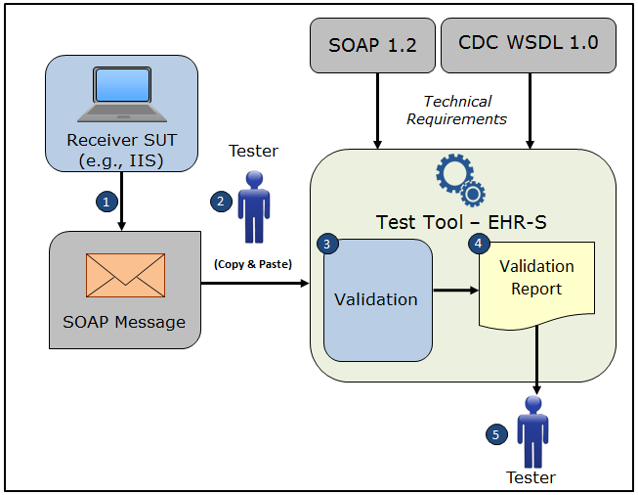

1. The System Under Test (SUT) generates a valid **UnsupportedOperationFault** SOAP response message envelope that conforms to the SOAP 1.2 standard and CDC WSDL 1.0 and that would be in response to a **submitSingleMessage** SOAPrequest from a Sender system
2. The Tester copies this **UnsupportedOperationFault** SOAP response message envelope and pastes it into the Test Tool, which is functioning as the initiator system (e.g., EHR-S)
3. The Test Tool validates the **UnsupportedOperationFault** SOAP response message envelope for conformance to the SOAP 1.2 standard and CDC WSDL 1.0
4. The Test Tool generates a Validation Report listing the results of the validation
5. The Tester reviews the Validation Report and compares the results to the Objectives and Evaluation Criteria associated with the SOAPENV_5_UnsupportedOperation_Fault Test Case

**Test Data Specification**

Message Information

|  |  |  |
| --- | --- | --- |
| **Element Name** | **Data** | **Classification of Data** |
| Fault/Code/Value | Sender | Test Case Fixed |
| Fault/Reason/Text | Unsupported Operation Fault Message Here | Changeable |
| Fault/Detail | UnsupportedOperationFault | Test Case Fixed |
| **UnsupportedOperationFault**/Code | 8675309 | Changeable |
| **UnsupportedOperationFault**/Reason | UnsupportedOperation | Test Case Fixed |
| **UnsupportedOperationFault**/Detail | This Operation is not supported | Changeable |

Explanation of Data Classification

|  |  |  |
| --- | --- | --- |
| **Data Classification** | **Description** | **Validation** |
| **Configurable** | Data typically that are configured by the system (customer-definable). Example data are provided. | Validate for the presence of data |
| **System Generated** | Data typically generated automatically by system, e.g., message time. Example data are provided. | Validate for the presence of data |
| **IG Fixed** | Data that are fixed by the implementation guide; data can’t be changed. Specific data are provided. | Validate for the presence and data content |
| **Test Case Fixed** | Data that are specific and fixed by the test case; data should not be changed. Specific data are provided. | Validate for the presence and selectively validate for data content |
| **Changeable** | Data where the exact content is not relevant for the test case and can be changed for the purposes of testing. Example data are provided. | Validate for the presence of data |

**Envelope Content Table**

Test Case Information

|  |  |
| --- | --- |
| **Element Name** | **Data** |
| Test Case ID | Receiver SOAPENV_5_UnsupportedOperation_Fault |

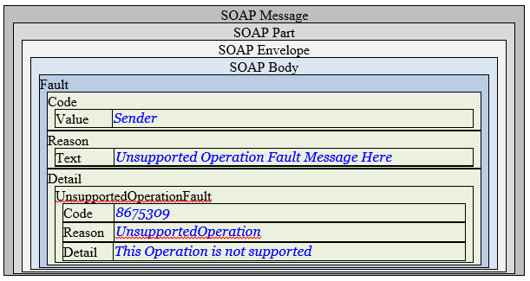

**Envelope Content**

**Fault Response Message Sent by Receiver System**

<?xml version='1.0' encoding='UTF-8'?>

<Envelope xmlns="http://www.w3.org/2003/05/soap-envelope">

<Body>

<Fault xmlns:ns4="http://schemas.xmlsoap.org/soap/envelope/">

<Code>

<Value>Sender</Value>

</Code>

<Reason>

<Text xml:lang="en">Unsupported Operation Fault Message Here</Text>

</Reason>

<Detail>

<UnsupportedOperationFault xmlns="urn:cdc:iisb:2011">

<Code>8675309</Code>

<Reason xmlns:xs="http://www.w3.org/2001/XMLSchema" xmlns:xsi="http://www.w3.org/2001/XMLSchema-instance" xsi:type="xs:string">UnsupportedOperation</Reason>

<Detail>This Operation is not supported</Detail>

</UnsupportedOperationFault>

</Detail>

</Fault>

</Body>

</Envelope>