## Test Procedure for Receiver SOAP Envelope Testing – NIST-CDC Immunization Test Suite

This document describes the test procedure for evaluating a receiver technology’s ability

1. to generate a connectivity response message that is conformant to the Simple Object Access protocol **(**SOAP) standard and to the CDC[1] Web Service Description Language (WSDL); and
2. to generate a response message envelope in conformance to the SOAP standard and to the CDC WSDL.

The test procedure may be updated to reflect on-going feedback received during the testing activities.

Questions or concerns regarding this test procedure document should be directed to ___ at [___.___@___.___](mailto:___.___@___.___) .

### Test Criterion Description

Creation of a response message envelope by a receiver using specified standards. Receiver technology (e.g., immunization information system (IIS)) must be able to electronically generate:

1. A connectivity response message conforming to the SOAP 1.2 standard and CDC WSDL 1.0 that may be used to electronically confirm the accessibility of an IIS Web Service
2. A response message envelope for electronic transmission in accordance with the SOAP 1.2 standard and CDC WSDL 1.0 that may be used for transporting an HL7 response message to a Sender technology (e.g., electronic health record system (EHR-S) or immunization information system (IIS)).

### Informative Test Description

This section provides an informative description of how the test procedure is organized and conducted. It does not provide normative statements of the testing requirements.

As illustrated in **Figure 1**, this test evaluates the capability for a receiver technology to electronically generate a response message that is in conformance with the SOAP 1.2 standard and CDC WSDL 1.0 that may be used for transporting an HL7 response message to an EHR-S or IIS.

The National Institute of Standards and Technology (NIST), provided the test scenarios, test cases, and test data for this test procedure.

Figure 1. Receiver Technology SOAP Envelope Testing

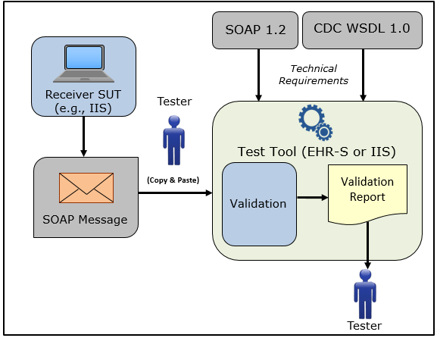

The test procedure is organized into two sections: Create SOAP Connectivity Response Message and Create SOAP Response Message Envelope.

* Create SOAP Connectivity Response Message – evaluates the capability of the receiver technology to electronically generate a connectivity response message that may be used to electronically confirm the accessibility of a IIS Web Service, and that is conformant to the SOAP 1.2 standard and CDC WSDL 1.0
* Using the Vendor-identified system function(s), the Tester causes the system to generate the indicated connectivity response message that is conformant with the SOAP 1.2 standard and CDC WSDL 1.0
* Using the Vendor-identified system function(s), the Tester imports the SOAP and WSDL conformant connectivity response message into the NIST Immunization Test Tool
* Using the Evaluation Criteria listed in the Test Case Package* and the Validation Report produced by the NIST Immunization Test Tool, the Tester verifies that the connectivity response message meets the SOAP and WSDL conformance requirements being tested

*The Test Case Package contains the Evaluation Criteria associated with each Test Case and is available via the Test Tool as a PDF document.

* Create SOAP Response Message Envelope – evaluates the capability of the receiver technology to electronically generate a response message conformant to the SOAP 1.2 standard and CDC WSDL 1.0
  + Using the Vendor-identified system (e.g., IIS) function(s), the Tester inputs the provided test data for the test patients (input can be performed using a manual or automated process)
* Using the Vendor-identified system function(s) and the provided test data, the Tester causes the system to generate the indicated response message using the SOAP 1.2 standard and CDC WSDL 1.0
* Using the Vendor-identified system function(s), the Tester imports the SOAP and WSDL conformant response message into the NIST Immunization Test Tool
* Using the Evaluation Criteria listed in the Test Case Package* and the Validation Report produced by the NIST Immunization Test Tool, the Tester verifies that the response message meets the SOAP and WSDL conformance requirements being tested

### Referenced Standards

|  |  |
| --- | --- |
| Standard. SOAP 1.2 |  |
| Standard. CDC WSDL 1.0 |  |

### Normative Test Procedures

**Derived Test Requirements**

DTR-IZ-CRT-RCVRCON-SOAP - 1: Electronically Create a SOAP Connectivity Response Message

DTR-IZ-CRT-RCVR-SOAPENV - 1: Electronically Create a SOAP Response Message

**DTR-IZ-CRT-RCVRCON-SOAP** **- 1: Electronically Create a SOAP Connectivity Response Message**

Figure 2. Create SOAP Connectivity Message

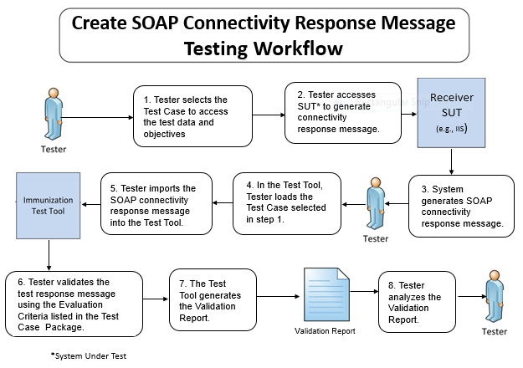

The instructions in the derived test procedures listed below reference the numbered test steps in **Figure 2**.

Required Vendor Information

VE-IZ-CRT-RCVRCON-SOAP – 1.01: Vendor shall identify the system function(s) that are available to 1) create SOAP conformant connectivity response messages, and 2) import the SOAP connectivity response messages into the NIST Immunization Test Tool

VE-IZ-CRT-RCVRCON-SOAP – 1.02: Vendor shall provide the mechanism necessary to capture and import SOAP connectivity response messages into the NIST Immunization Test Tool

Required Test Procedures

TE-IZ-CRT-RCVRCON-SOAP – 1.01: Tester shall select the Test Case for a Receiver SOAP connectivity response message [Figure 2, Step 1]

TE-IZ-CRT-RCVRCON-SOAP – 1.02: Using the Vendor-identified system function(s) [Figure 2, Step 2], the Tester shall

* Cause the system to generate the indicated Receiver SOAP connectivity response message based on the SOAP 1.2 standard and CDC WSDL 1.0 [Figure 2, Step 3]
* Load the Test Case selected in TE-IZ-CRT-RSPCON-SOAP – 1.01 [Figure 2, Step 4]
* Import the Receiver SOAP connectivity response message into the NIST Immunization Test Tool identified in the Conformance Test Tools section of this test procedure [Figure 2, Step 5]

TE-IZ-CRT-RCVRCON-SOAP – 1.03: Using the Inspection Test Guide, the Tester shall verify that the SOAP connectivity response message is conformant to the SOAP 1.2 standard and CDC WSDL 1.0

Inspection Test Guide

IN-IZ-CRT-RCVRCON-SOAP – 1.01: Using the Evaluation Criteria listed in the Test Case-specific Test Case Package**,** theTester shall verify that the SOAP 1.2 standard and CDC WSDL 1.0 conformance requirements being tested are met [Figure 2, Step 6]

IN-IZ-CRT-RCVRCON-SOAP - 1.02: Using the Validation Report produced by the NIST Immunization Test Tool identified in the Conformance Test Tools section of this test procedure**,** theTester shall analyze the Report and verify that the SOAP 1.2 standard and CDC WSDL 1.0 conformance requirements tested are met [Figure 2, Steps 7 & 8]

**DTR-IZ-CRT-RCVR-SOAPENV - 1: Electronically Create a SOAP Response Message**

Figure . Create SOAP Response Message

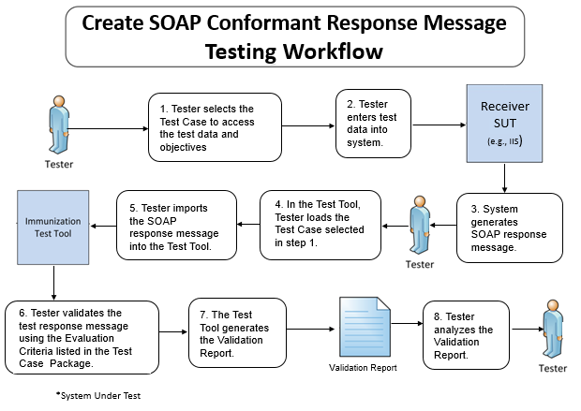

The instructions in the derived test procedure listed below reference the numbered test steps in **Figure 3**.

**DTR-IZ-CRT-RCVR-SOAPENV** **- 1: Electronically Create a SOAP Response Message**

Required Vendor Information

VE-IZ-CRT-RCVR-SOAPENV – 1.01: Vendor shall identify the system function(s) that are available to 1) input the test data into the system, 2) create SOAP conformant response messages using the test data, and 3) import the SOAP response messages into the NIST Immunization Test Tool

VE-IZ-CRT-RCVR-SOAPENV – 1.02: Vendor shall provide the mechanism necessary to capture and import SOAP response messages into the NIST Immunization Test Tool

Required Test Procedures

TE-IZ-CRT-RCVR-SOAPENV – 1.01: Tester shall select a Test Case consisting of Receiver SOAP response message test data [Figure 3, Step 1]

TE-IZ-CRT-RCVR-SOAPENV – 1.02: Using the Vendor-identified system function(s), the Tester shall input the provided test data for the Receiver SOAP response message selected in TE-IZ-CRT-RSP-SOAP – 1.01 (input can be performed using a manual or automated process) [Figure 3, Step 2]

TE-IZ-CRT-RCVR-SOAPENV – 1.03: Using the Vendor-identified system function(s) and the selected test data for the Receiver SOAP response message, the Tester shall

* Cause the system to generate the indicated Receiver SOAP response message based on the SOAP 1.2 standard and CDC WSDL 1.0 [Figure 3, Step 3]
* Load the Test Case selected in TE-IZ-CRT-RSP-SOAP – 1.01 [Figure 3, Step 4]
* Import the Receiver SOAP response test message into the NIST Immunization Test Tool identified in the Conformance Test Tools section of this test procedure [Figure 3, Step 5]

TE-IZ-CRT-RCVR-SOAPENV – 1.04: Using the Inspection Test Guide, the Tester shall verify that the SOAP response message is conformant to the SOAP 1.2 standard and CDC WSDL 1.0

Inspection Test Guide

IN-IZ-CRT-RCVR-SOAPENV – 1.01: Using the Evaluation Criteria listed in the Test Case-specific Test Case Package**,** theTester shall verify that the SOAP 1.2 standard and CDC WSDL 1.0 conformance requirements being tested are met [Figure 2, Step 6]

IN-IZ-CRT-RCVR-SOAPENV - 1.02: Using the Validation Report produced by the NIST Immunization Test Tool identified in the Conformance Test Tools section of this test procedure**,** theTester shall analyze the Report and verify that the SOAP 1.2 standard and CDC WSDL 1.0 conformance requirements tested are met [Figure 2, Steps 7 & 8]

### Test Data

Test data are provided for each Test Case in the NIST Immunization Test Tool to ensure that functional and interoperability requirements can be adequately evaluated for conformance, as well as to provide consistency in the testing process across multiple testing labs. The provided test data focus on evaluating the basic capabilities required of Receiver technology, rather than exercising the full breadth/depth of capability that installed Receiver technology might be expected to support.

The Tester shall use and apply the provided test data during the testing, without exception, unless one of the following conditions exists:

* The Tester determines that the Vendor product is sufficiently specialized that the provided test data needs to be modified in order to conduct an adequate test. Having made the determination that some modification to the provided test data is necessary, the Tester shall record the modifications made as part of the test documentation.
  + - The Tester determines that changes to the test data will improve the efficiency of the testing process; primarily through using consistent demographic data throughout the testing workflow. The Tester shall ensure that the identified functional and interoperable requirements can be adequately evaluated for conformance and that the test data provides a comparable level of robustness.

The test procedures require that the Tester enter the test data into the Receiver technology being evaluated for conformance. The intent is that the Tester fully controls the process of entering the test data in order to ensure that the data are correctly entered as specified in the test procedure. If a situation arises where it is impractical for a Tester to directly enter the test data, the Tester, at the Tester’s discretion, may instruct the Vendor to enter the test data, so long as the Tester remains in full control of the testing process, directly observes the test data being entered by the Vendor, and validates that the test data are entered correctly as specified in the test procedure.

The primary purpose of the provided test data is to assist the Tester in verifying that the vendors’ Receiver technology is capable of supporting the required functions. Verifying the ability to support the specific content is not the purpose of the test data.  Such testing and verification is more appropriate for local installations of the Receiver technologies.

For this test procedure, the Tester shall select the Test Case for the Test Scenario listed. The Tester shall follow the normative test procedures to conduct these tests. Table 1 (Receiver SOAP Envelope Test Cases) lists the **six** Receiver SOAP Envelope Test Cases included in the test tool. Details of the Test Cases, including the test description, test objectives, evaluation criteria, and test data, are accessible dynamically in the test tool; and are provided in PDF files that also are accessible in the test tool.

Table 1. Receiver SOAP Envelope Test Cases

|  |  |
| --- | --- |
| **Receiver SOAP Test Scenarios** | **Receiver SOAP Test Cases** |
| ConnectivityTest_Response | Receiver_SOAPENV_1_ConnectivityTest_Response |
| SubmitSingleMessage_Response | Receiver_SOAPENV_2_SubmitSingleMessage_Response |
| MessageTooLarge_Fault | Receiver_SOAPENV_3_MessageTooLarge_Fault |
| Security_Fault | Receiver_SOAPENV_4_Security_Fault |
| UnsupportedOperation_Fault | Receiver_SOAPENV_5_UnsupportedOperation_Fault |
| Unknown_Fault | Receiver_SOAPENV_6_Unknown_Fault |

### Conformance Test Tools

The following test tool is available to evaluate conformance to the standards referenced in this test procedure:

* HL7 v2 – NIST provides an HL7 v2 validation tool designed specifically to support this test procedure. The tool is available as a Web Application.
* The validation tool is available via the Web site for pre-testing
* The application can be downloaded for local installation
* The web application validation service is available at:

<http://hl7v2-iz-testing.nist.gov>

Support for these tools is available by submitting questions to the following user’s group:

<https://groups.google.com/d/forum/hl7v2-immunization-testing>

The following information is provided to assist the Tester in interpreting the validation reports generated by the NIST test tools:

The NIST Test Tool evaluates conformance requirements that are specified or have been derived from the standards identified in this test procedure document. The Test Tool evaluates the submitted message/envelope for each conformance requirement, and then produces a validation report. The Tester should consider that a report containing only Alerts and Warning notifications indicates a sufficient level of conformance to the standard and test data expectations. If an Error notification is reported, it should be considered a signal that significant departures from the standard or test data requirements have been found that need to be corrected in order for the Receiver technology being tested to claim conformance. Testers will need to further analyze each Error notification to determine if, in the context of meeting the test criterion, the error results in a failure of the test procedure by the Receiver technology.

## Document History

| **Version Number** | **Description** | **Date Published** |
| --- | --- | --- |
| 1.0 | Released for public comment | Month D, 2014 |

## 

1. Centers for Disease Control and Prevention