NIST Normative Test Process Document: LRI-LIS Test Tool for Transmission of Laboratory Values/Results

Test Tool and Test Descriptions to Conduct HIT Conformance Testing

NIST Approved Version 1.3

Date: November 16, 2016

**Developed by the National Institute of Standards and Technology (NIST) in collaboration with the Association of Public Health Laboratories (APHL) and the Centers for Disease Control and Prevention (CDC)**

**List of Contents**

**Conformance Criteria**

Description of the specifications for conformance testing

**Explanation of Terms**

A table containing a key of equivalents for names and terms used frequently in this document

**Informative Test Description**

Key background information for conducting the conformance testing; includes information about

* Definition of “Tester” for this document
* Care settings and profiles that are in-scope for the testing
* Capabilities the Health IT Module must be able to demonstrate during the conformance testing

**Normative Test Description**

Detailed description of the testing process, including Derived Test Requirement(s), Testing Workflow Diagram(s), Required Vendor Information, Required Testing Actions, and Inspection Test Guide

**Test Data**

Detailed description of the purpose and use of the provided test data, including allowed exceptions

**Navigating a Test Case**

Detailed description of the information and instructions available in the NIST Test Tool related to the Test Cases

**How to Interpret the Message Content Data Sheet**

Detailed description of the purpose of and information available in the Message Content Data Sheet, including the meaning of the NIST Test Data Categories and Qualifiers

**Conformance Test Tools**

Links to the web-based NIST Test Tool and Support sites

**Document History**

Listing of Version Numbers and Publication Dates for the final published versions of the NIST Testing Process document

## NIST Normative Test Process Document for LRI-LIS: Transmit laboratory tests and values/results

This document explains the testing process for which a National Institute of Standards and Technology (NIST) validation test tool is used in evaluating conformance of a health information technology module (Health IT Module) for creating HL7 laboratory result messages in accordance with the *HL7 Version 2.5.1 Implementation Guide: S&I Framework Lab Results Interface, Release 1, DSTU Release 2 – US Realm, Sep 2015* interoperability standard and, at a minimum, the *LOINC version 2.50* vocabulary standard.

### Conformance Criteria

Transmit laboratory test reports

Electronically create laboratory test reports for electronic transmission in accordance with *HL7 Version 2.5.1 Implementation Guide: S&I Framework Lab Results Interface, Release 1, DSTU Release 2 – US Realm, Sep 2015*, interoperability standard and, at a minimum, the Logical Observation Identifiers Names and Codes (LOINC) version 2.50 vocabulary standard

### Explanation of Terms

| **Key for Names and Terms Used Frequently in this Document** | |
| --- | --- |
| **Referenced Names and Terms** | **Equivalent Used in Document** |
| *Version 2.5.1 Implementation Guide: S&I Framework Lab Results Interface, Release 1, DSTU Release 2 – US Realm, Sep 2015* | **“LRI Implementation Guide” or “LRI IG”** |
| Logical Observation Identifiers Names and Codes (LOINC) version 2.50 | **“LOINC” or “LOINC v2.50”** |
| Health IT Module | **“HIT Module” or “Module”** |
| [NIST HL7 v2 Validation tool - Laboratory Results Interface, Release 2 - US Realm](http://hit-dev.nist.gov:8081/lri-r2/) | **“LRI Test Tool” or “Tool”** |
| Context-based LIS Test Plan | **“Context-based LRI-LIS Test Plan” or “LRI-LIS Test Cases”** |

### Informative Test Description

This section provides an executive summary describing how the NIST testing process is organized and conducted. The *Understanding LRI-LIS Messaging Conformance Testing* document is available via the Documentation tab in the NIST LRI Test Tool; this document is an additional resource that explains the process of Health IT Module conformance testing for HL7 v2 LRI Messaging on the LIS sender side.

This document has been developed to be used by testers in conformance testing of Health IT Modules. The term “Tester”, when used in this document, refers to a person (such as a testing lab employee) acting on behalf of a testing lab or other entity for conformance testing of a Vendor’s HIT Module. In addition, a Vendor may use this document to test their own HIT Modules during development of their product and in preparation for conformance testing by a testing lab, and individual implementations of the LRI IG may use this document when verifying conformance on the sender side.

The test evaluates the capability for a Health IT Module to generate laboratory test reports for electronic transmission via messages that are conformant to the

* + *HL7 Version 2.5.1 Implementation Guide: S&I Framework Lab Results Interface, Release 1, DSTU Release 2 – US Realm, Sep 2015*
  + Logical Observation Identifiers Names and Codes (LOINC) version 2.50 vocabulary standard

During the process of building the LRI Test Tool, NIST (National Institute of Standards and Technology) discovered conformance requirements that were either conflicting or unclear in the named standard documents and the associated errata. The “*NIST Clarifications and Validation Guidelines for HL7 Version 2.5.1 Implementation Guide: S&I Framework Lab Results Interface, Release 1, DSTU Release 2 – US Realm, Sep 2015*” document clarifies these issues and indicates how they are interpreted in the Tool. This document can be accessed via the Documentation Tab on the LRI Test Tool.

The LRI IG defines four profile options relevant for conformance testing:

* LRI_GU_FRU_Profile – ID: 2.16.840.1.113883.9.195.3.1
* LRI_GU_FRN_Profile – ID: 2.16.840.1.113883.9.195.3.2
* LRI_NG_FRU_Profile – ID: 2.16.840.1.113883.9.195.3.3
* LRI_NG_FRN_Profile – ID: 2.16.840.1.113883.9.195.3.4

The Context-based LRI-LIS Test Plan in the NIST LRI Test Tool includes **seven** Test Scenarios with one or more Test Cases or Test Steps (and specific test data) for testing each profile option. For the purpose of conformance testing, the Vendor can declare to which profile they are claiming conformance—only one is required. Test Cases or Test Steps are provided for each profile option. Instructions regarding which Test Scenarios and Test Cases to use for each profile option are provided in the **Test Data** section of this testing process document.

For this test procedure, the Tester shall execute all **seven** Test Scenarios listed below (and for certain Test Scenarios all of their associated Test Cases and/or Test Steps):

1. PT and INR (Smoke Test – minimally populated[1] messages)

Step 1: Final Result (sent to EHR-S)

Step 2: Accept Acknowledgement (sent from EHR-S)

Step 3: Application Acknowledgement (sent from EHR-S)

Step 4: Accept Acknowledgement for the Application Acknowledgement (sent to EHR-S)

1. SED rate (maximally populated[2] messages)

Final result to corrected

Step 1: Final Result (sent to EHR-S)

Step 2: Corrected Result (sent to EHR-S) (result value is corrected)

Specimen rejected (sent to EHR-S)

1. CBC (typically populated[3] messages)

Partial result to final

Step 1: Partial Result (sent to EHR-S)

Step 2: Final Result (sent to EHR-S)

Final result to wrong patient

Step 1: Final Result (sent to EHR-S)

Step 2: Corrected Result (sent to EHR-S)

1. Lipid Panel (typically populated messages)

Step 1: Final Results with handling of Ask-at-Order-Entry question (sent to EHR-S)

OBR-13 Relevant Clinical Information:

* Patient was fasting prior to the procedure

1. Culture and Susceptibility (typically populated parent and parent-child messages)

Preliminary result (sent to EHR-S)

Final result to corrected

Step 1: Final Result (sent to EHR-S)

1. Reflex - Hepatitis (typically populated parent-child messages with reflex order)

Parent child

Step 1: Final Results – Parent (sent to EHR-S)

Step 2: Reflex Result – Child (sent to EHR-S)

1. Pap Smear (typically populated message for anatomic pathology)

Ask-at-Order-Entry questions are included in this result as OBX segments

* + Date of last menstrual period
  + "Did the patient have a previous abnormal Pap report, treatment, or biopsy?" with “Yes”/”No”/”Unknown” as allowed answers

In addition to the Test Steps included in these seven Test Scenarios, the Tester also may execute the following Test Steps for their respective Scenarios (support for the capabilities in these Test Steps is preferred, but not required).:

CBC (typically populated messages)

Final result to amended

Step 1: Final Result (sent to EHR-S)

Step 2: Amended Result (sent to EHR-S) (demographic data are corrected)

Culture and Susceptibility (typically populated parent and parent-child messages)

Final result to corrected

Step 1: Final Result (sent to EHR-S) [same Step 1 as for the mandatory Culture and Susceptibility scenario above]

Step 2: Corrected Result (sent to EHR-S) (susceptibility flag sent in *final* result is corrected)

Step 3: Corrected Result (sent to EHR-S) (susceptibility result added to *final* result)

These scenarios and the test data contained in them were developed by the Association of Public Health Laboratories (APHL) and the Center for Disease Control and Prevention (CDC), in collaboration with NIST.

Test Data Documents, which are accessible from the NIST LRI Test Tool identified in the **Conformance Test Tools** section of this testing process document, contain the test data that are specific to each Test Case. Instructions for use of the provided test data are listed in the **Normative Test Description** and **Test Data** sections of this testing process document.

**Note: Regarding messages/capabilities that are out-of-scope for the Health IT conformance testing**

* The focus of conformance testing is on the ability of the Health IT Module to create conformant LRI messages and **is not on** the operational aspect of transporting the messages.
* The NIST Test Tool support for validation of optional data elements is limited to checking for conformance to the HL7 v2.5.1 base standard.

### Normative Test Description

Using the NIST LRI Test Tool, conformance testing can be completed in either of the following two ways:

* Single message (step by step) LRI-LIS testing
* Multiple message (multiple step) LRI-LIS testing

**Single message (step by step) LRI-LIS testing** is a separate validation of each message in an *opened* Test Scenario or Test Case. After accessing the LIS Test Plan, *opening* either the GU or NG option, and then *opening* a Test Scenario or a Test Case, the Tester will *select* each of the Test Steps in their given sequence, will click on “Load Test Step”, and validate the incorporation or creation of each message individually. Using the features provided on the Test Execution page of the Tool, the Tester is able to keep the default Validation Result value produced by the Tool or use the drop-down menu to select a different value; the Tester also is able to enter free-text into the Comments field by clicking on the pen icon that displays there and then typing into the field. These Validation Result values and free-text Comments become part of the Validation Report generated by the Tool. The Derived Test Requirements (DTR) listed in this document provide the detailed explanation regarding how single message LRI-LIS testing is performed.

**Multiple message LRI-LIS testing** is similar to single message (step by step) LRI-LIS testing, except with the capability of loading a complete Test Scenario or Test Case (all Test Steps) at once instead of selecting individual Test Steps. After accessing the LIS Test Plan and *opening* either the GU or NG option, the Tester will click on a Test Scenario or Test Case, and then will click on the “Load Test Case” button to load the complete Test Scenario or Test Case. This mode allows the Tester to progress from one Test Step to another by clicking the “Next” button after each Test Step message is validated. Using the features provided on the Test Execution page of the Tool, the Tester is able to keep the default Validation Result value produced by the Tool or use the drop-down menu to select a different value; the Tester also is able to enter free-text into the Comments field by clicking on the pen icon that displays there and then typing into the field. These Validation Result values and free-text Comments become part of the Validation Report generated by the Tool. When all Test Steps have been validated, the Tester will click on the “Test Summary” button to complete the testing of the Test Case and download the validation reports.

**Derived Test Requirements**

For the Test Steps in the **seven** Test Scenarios described in the **Test Data** section of this testing process document, when the HIT Module is being tested for *creating* lab result messages follow the instructions in LRI-LIS_DTR - 1 below; and when the Module is being tested for *creating* or *receiving* the Acknowledgement (ACK) messages in the PT & INR Test Scenario follow the instructions in LRI_LIS_DTRs 2, 3, and 4 below.

LRI-LIS_DTR – 1: Electronically Create LRI Messages

LRI-LIS_DTR – 2: Electronically Receive LRI Accept Acknowledgement Message

LRI-LIS_DTR – 3: Electronically Receive LRI Application Acknowledgement Message

LRI-LIS_DTR – 4: Electronically Create LRI Accept Acknowledgement Message for the Application Acknowledgement

**LRI-LIS_DTR - 1: Electronically Create LRI Messages**

Figure 1 Create LRI Messages Testing Workflow

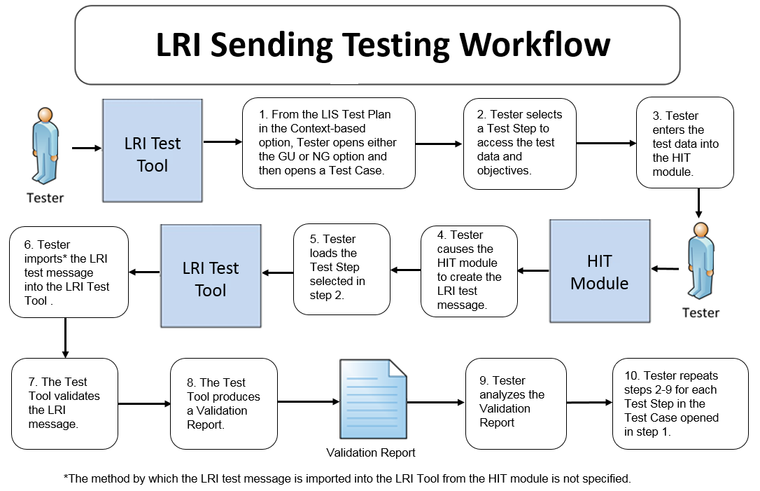

The instructions in the testing process listed below reference the numbered test steps in **Figure 1**.

Required Vendor Information

1. Vendor shall identify the Health IT Module function(s) that are available to 1) create patient records in the Health IT Module and input the test data for the test patients, 2) create lab result messages using the test data, and 3) import[4] the lab result messages into the NIST Test Tool
2. Vendor shall provide the mechanism necessary to capture and import the lab result messages
3. Vendor shall declare conformance to GU/FRU, GU/FRN, NG/FRU, or NG/FRN profile

Required Testing Actions

1. Using the Context-based capability provided in the Tool identified in the **Conformance Test Tools** section of this testing process document, the Tester shall access the **LIS Test Plan** and shall open either the GU or NG option and then shall open a Test Case [Figure 1, Step 1] (the Tester shall open either the FRU or FRN Test Case for the Culture & Susceptibility and the Reflex Hepatitis parent-child Test Steps)
2. The Tester shall select a Test Step [Figure 1, Step 2]
3. Using the capabilities in the Health IT Module, the Tester shall
   1. Input the provided test data for the selected Test Step using the Test Data Specification in the Tool for the Test Step (input can be performed using a manual or automated process) [Figure 1, Step 3]
4. Cause the Module to generate the indicated lab result message [Figure 1, Step 4]
5. In the NIST Tool, the Tester shall load the selected Test Step and import the lab result message generated by the Health IT Module [Figure 1, Steps 5, & 6]
6. The NIST Tool validates the message and produces a Validation Report [Figure 1, Steps 7 & 8]
7. Using the **Inspection Test Guide**, the Tester shall verify that the lab result message is conformant to the **Referenced Standards** and that the message includes the specified lab result information
8. The Tester shall repeat Required Testing Actions 2 – 9 using the next sequential Test Step until all Test Steps in the opened Test Case are completed [Figure 1, Step 10]

(**Note**: for the PT & INR Test Case, the Tester shall proceed now with LRI-LIS_DTR – 2, LRI-LIS_DTR – 3, and LRI-LIS_DTR – 4)

Inspection Test Guide

1. Using the Validation Report produced by the NIST Tool**,** theTester shall analyze the Report and verify that the message created by the Health IT Module meets the conformance requirements in the LRI IG [Figure 1, Step 9]
   1. If the Tester determines that the LOINC or SNOMED CT code in a message created by the Module is a **valid code** for a data item (e.g., lab test) even though it is different from the LOINC or SNOMED CT code provided for that data item in the test data for that message, the Tester shall allow an exception
2. Once during the conformance testing for this criterion, the Tester shall inspect the Health IT Module to verify the capability of the Vendor to support
   1. HL7 Table 0078- Interpretation Codes value set as specified for the abnormal/interpretation flag field
   2. Any of the value sets (selected at the Tester’s discretion) specified in the LRI IG

**LRI-LIS_DTR – 2: Electronically Receive LRI Accept Acknowledgement Message**

Figure 2 Receive LRI Accept Acknowledgement Message Testing Workflow

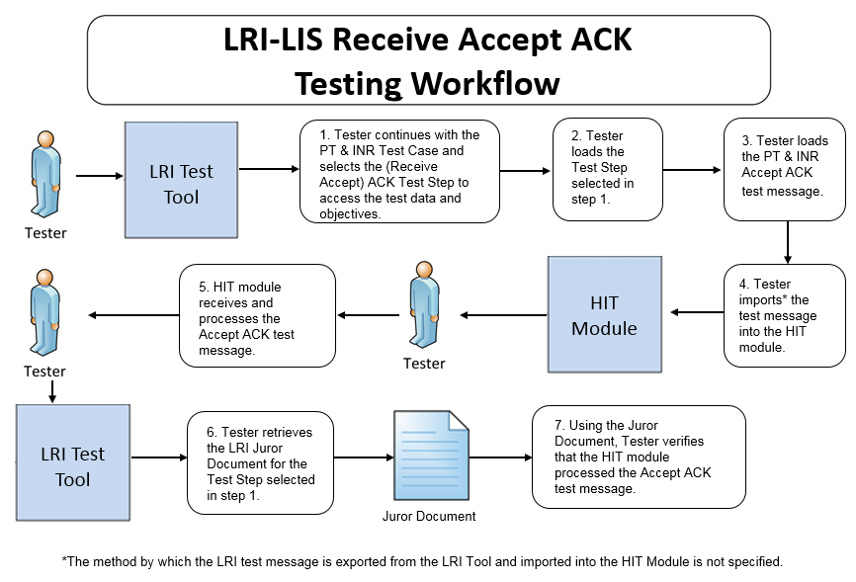

The instructions in the testing process listed below reference the numbered test steps in **Figure 2**.

Required Vendor Information

1. The Vendor shall identify the HIT module function(s) that are available to verify that an ACK message has been received and processed
2. Vendor shall provide the mechanism necessary to capture and import the ACK messages

Required Testing Actions

1. Continuing with the PT & INR Test Case in the Context-based capability, the Tester shall select the first ACK message Test Step [Figure 2, Step 1], which covers the LRI Accept ACK message being sent to the HIT Module from the NIST Tool (which is functioning as an EHR)
2. The Tester shall load the Test Step in the NIST Tool [Figure 2, Step 2]
3. The Tester shall load the LRI Accept ACK message for the selected Test Step and shall import the test message into the Module [Figure 2, Steps 3 & 4]
4. Using the capabilities in the HIT Module, the Tester shall observe the Module receiving and processing the LRI Accept ACK message that was loaded and imported [Figure 2, Step 5]
5. The Tester shall retrieve the LRI Juror Document from the NIST Tool for the Test Step selected [Figure 2, Step 6]
6. Using the **Inspection Test Guide**, the Tester shall verify that the HIT Module processed the message

Inspection Test Guide

1. Using the functions in the HIT Module, the provided example Accept ACK message, and the Test Step-specific Juror Document retrieved from the NIST Tool, the Tester shall verify that the Module received and processed the Accept ACK message according to the named standards [Figure 2, Step 7]

**LRI-LIS_DTR – 3: Electronically Receive LRI Application Acknowledgement Message**

Figure 3 Receive LRI Application Acknowledgement Message Testing Workflow

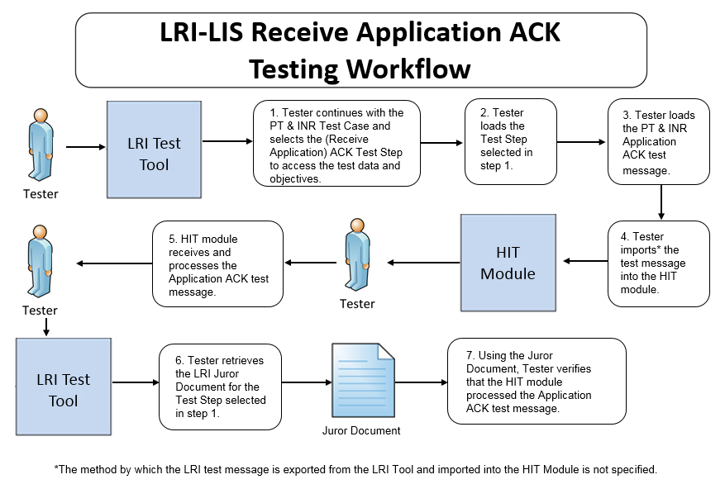

The instructions in the testing process listed below reference the numbered test steps in **Figure 3**.

Required Vendor Information

1. As defined in LRI-LIS_DTR – 2, no additional information is required

Required Testing Actions

1. Continuing with the PT & INR Test Case in the Context-based capability, the Tester shall select the second ACK message Test Step [Figure 3, Step 1], which covers the LRI Application ACK message being sent to the HIT Module from the NIST Tool (which is functioning as an EHR)
2. The Tester shall load the Test Step in the NIST Tool [Figure 3, Step 2]
3. The Tester shall load the LRI Application ACK message for the selected Test Step and shall import the test message into the Module [Figure 3, Steps 3 & 4]
4. Using the capabilities in the HIT Module, the Tester shall observe the Module receiving and processing the LRI Application ACK message that was loaded and imported [Figure 3, Step 5]
5. The Tester shall retrieve the LRI Juror Document from the NIST Tool for the Test Step selected [Figure 3, Step 6]
6. Using the **Inspection Test Guide**, the Tester shall verify that the HIT Module processed the message

Inspection Test Guide

1. Using the functions in the HIT Module, the provided example Application ACK message, and the Test Step-specific Juror Document retrieved from the NIST Tool, the Tester shall verify that the Module received and processed the Application ACK message according to the named standards [Figure 3, Step 7]

**LRI-LIS_DTR – 4: Electronically Create LRI Accept Acknowledgement Message for the Application Acknowledgement**

Figure 4 Create LRI Accept Acknowledgement Message Testing Workflow

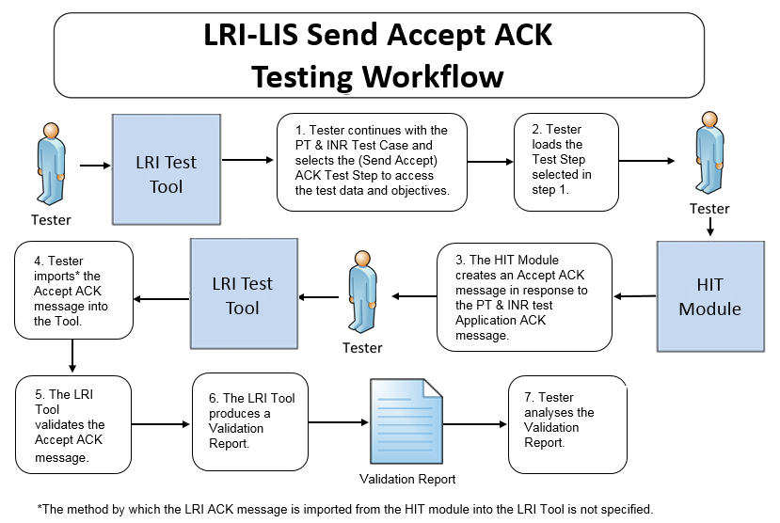 The instructions in the testing process listed below reference the numbered test steps in **Figure 4**.

Required Vendor Information

1. Vendor shall identify the Health IT Module function(s) that are available to 1) create lab result Accept Acknowledgement messages for Application Acknowledgements and 2) import the Accept Acknowledgement messages into the NIST Test Tool
2. Vendor shall provide the mechanism necessary to capture and import the lab result messages

Required Testing Actions

1. Continuing with the PT & INR Test Case in the Context-based capability, the Tester shall select the fourth ACK message Test Step [Figure 4, Step 1], which covers the LRI Accept ACK message being sent from the HIT Module to the NIST Tool (which is functioning as an EHR-S)
2. The Tester shall load the Test Step in the NIST Tool [Figure 4, Step 2]
3. The Tester shall use the function(s) in the HIT Module to generate the Accept ACK message created in response to the Application ACK message [Figure 4, Step 3]
4. The Tester shall import the Accept ACK message into the NIST Tool [Figure 4, Step 4]
5. The Tool validates the Accept ACK message into the NIST Tool [Figure 4 Step 5] and produces a Validation Report [Figure 4, Step 6]
6. Using the **Inspection Test Guide**, the Tester shall verify the conformance of the ACK message generated by the Module

Inspection Test Guide

1. Using the Validation Report, the Tester shall analyze the Report and verify that the Accept ACK message created by the HIT Module meets the conformance requirements in the named standards [Figure 4, Step 7]

### Test Data

Test data are provided for the testing process to ensure that the applicable requirements identified in the conformance criteria can be adequately evaluated, as well as to provide consistency in the testing process across multiple testing entities. The provided test data focus on evaluating the basic capabilities required of the Health IT Module, rather than exercising the full breadth/depth of capability that installed Health IT Modules might be expected to support. The test data are formatted for ease of use by the Tester during the testing process; the format is not intended to prescribe the design of the display presented to the end-user for viewing the data. No additional requirements should be drawn from the format.

The Tester shall use and apply the provided test data during the testing, without exception, unless one of the following conditions exists:

* The Tester determines that the Health IT Module is sufficiently specialized that the provided test data need to be modified in order to conduct an adequate test. Having made the determination that some modification to the provided test data is necessary, the Tester shall record the modifications made as part of the test documentation.
* The Tester determines that changes to the test data will improve the efficiency of the testing process (for example, using consistent demographic data throughout the testing workflow). The Tester shall ensure that the functional and interoperable requirements identified in the criteria can be adequately evaluated for conformance, and that the modified test data provide a comparable level of robustness.
* The Tester determines that the LOINC or SNOMED CT code in a message created by the Health IT Module is a **valid code** for a data item (e.g., lab test) even though it is different from the LOINC or SNOMED CT code provided for that data item in the test data for that message

Any departure from the provided test data shall focus on meeting the basic capabilities required of the Health IT Module relative to the conformance criteria rather than exercising the full breadth/depth of capability that the installed Health IT Module might be expected to support.

The testing process requires that the applicable test data be entered into the Health IT Module being evaluated for conformance. The intent is that the Tester performs or observes the process of entering the test data in order to ensure that the data are correctly entered as specified in the testing process.

For conformance testing, the primary purpose of the provided test data is to assist the Tester in verifying that the vendor’s Module is capable of supporting the required functions. The clinical test data are relevant for the given Test Stories; however, these data should not be expected to represent standards of practice.

Test data for conformance testing related to the LRI-LIS Transmit laboratory test reports criterion are available in the NIST LRI Test Tool (see the **Conformance Test Tools** section of this testing process document for instructions on how to access the Test Tool).

### Navigating a Test Case

A LRI-LIS Test Case contains multiple Test Steps, each consisting of a Test Story, a Test Data Specification, a Message Content Data Sheet, and, where applicable, a Juror Document. All of these artifacts are accessible via the NIST Tool.

* The **Test Story** describes a real-world situation that provides the context for the Test Step.
* The **Test Data Specification** provides the data associated with the Test Story and lists the information that would typically be available for a given situation in the specified clinical setting. Together, the Test Story and the Test Data Specification provide sufficient information for the Testers and Health IT Module Vendors to enter into the Module in order to create the LRI message for a particular Test Step. The message is to be created using these data and the Health IT Module functions.
* The **Message Content Data Sheet** shows a conformant message instance for the Test Case. The message content is organized in a table format that provides the HL7 v2 message elements and the data associated with the message elements for a given Test Case. The Message Content Data Sheet may provide assistance to the Tester and Health IT Module Vendor for resolving issues discovered during conformance testing. This data sheet can be thought of as the “answer” to the scenario (“question”) provided by the Test Story and the Test Data Specification.
* The **Juror Document** provides very basic instructions to the Tester for use during conformance testing when assessing the Health IT Module’s ability to receive and process an Acknowledgement message with no errors that is sent by an EHR-S. The LIS need not make a positive notification visible in the system indicating that the Acknowledgement message was processed correctly. The format of the Juror Document is for ease-of-use by the Tester and does not indicate how the Health IT Module display must be designed.

The LRI Implementation Guide defines four profile options relevant for conformance testing:

* LRI_GU_FRU_Profile – ID: 2.16.840.1.113883.9.195.3.1
* LRI_GU_FRN_Profile – ID: 2.16.840.1.113883.9.195.3.2
* LRI_NG_FRU_Profile – ID: 2.16.840.1.113883.9.195.3.3
* LRI_NG_FRN_Profile – ID: 2.16.840.1.113883.9.195.3.4

For the purpose of conformance testing, the Vendor can declare to which profile they are claiming conformance—only one is required. Test Cases and/or Test Steps (and hence specific test data) are provided for each profile option. Table 1 (LRI Test Scenarios and Associated Test Cases and Test Steps) lists the **seven** Test Scenarios and identifies the Test Cases or Test Steps for each scenario.

**If the Vendor selects the GU/GU_FRU profile**, the Tester shall conduct: the GU Test Scenarios 1 and 2; GU Test Scenario 3 – Partial Result to Final, Final Result to Wrong Patient, and, optionally, the Final Result to Amended Test Steps; GU Test Scenario 4; GU Test Scenario 5 - Preliminary Result, Final Result GU-FRU, and, optionally, either or both of the Final Result to Corrected GU-FRU Test Steps; GU Test Scenario 6 – both GU-FRU Test Steps; and GU Test Scenario 7 - Pap Smear Test Step

**If the Vendor selects the GU/GU_FRN profile**, the Tester shall conduct: the GU Test Scenarios 1 and 2; GU Test Scenario 3 – Partial Result to Final, Final Result to Wrong Patient, and, optionally, the Final Result to Amended Test Steps; GU Test Scenario 4; GU Test Scenario 5 - Preliminary Result, Final Result GU-FRN, and, optionally, either or both of the Final Result to Corrected GU-FRN Test Steps; GU Test Scenario 6 – both GU-FRN Test Steps; and GU Test Scenario 7 - Pap Smear Test Step

**If the Vendor selects the NG/NG_FRU profile**, the Tester shall conduct: the NG Test Scenarios 1 and 2; NG Test Scenario 3 – Partial Result to Final, Final Result to Wrong Patient, and, optionally, the Final Result to Amended Test Steps; NG Test Scenario 4; NG Test Scenario 5 - Preliminary Result, Final Result NG-FRU, and, optionally, either or both of the Final Result to Corrected GU-FRU Test Steps; NG Test Scenario 6 - both NG-FRU Test Steps; and NG Test Scenario 7 - Pap Smear Test Step.

**If the Vendor selects the NG/NG_FRN profile**, the Tester shall conduct: the NG Test Scenarios 1 and 2; NG Test Scenario 3 – Partial Result to Final, Final Result to Wrong Patient, and, optionally, the Final Result to Amended Test Steps; NG Test Scenario 4; NG Test Scenario 5 - Preliminary Result, Final Result NG-FRN, and, optionally, either or both of the Final Result to Corrected NG_FRN Test Steps; NG Test Scenario 6 - both NG_FRN Test Steps; and NG Test Scenario 7 - Pap Smear Test Step.

**Table 1: LRI Test Scenarios and Associated Test Cases and Test Steps**

| **Test Scenarios** | **NG Test Cases** | **NG Test Steps** | **GU Test Cases** | **GU Test Steps** |
| --- | --- | --- | --- | --- |
| 1 - Minimally populated PT and INR Messages (Smoke Test) | Not Applicable | LRI_0.0-1.1-NG  (Final Result)  ACK_0.0-3.1-NG  (Receive Accept Acknowledgement)  ACK_0.0-4.1-NG  (Receive Application Acknowledgement)  ACK_0.0-5.1-NG  (Send Accept Acknowledgement) | Not Applicable | LRI_0.0-1.1-GU  (Final Result)  ACK_0.0-3.1-GU  (Receive Accept Acknowledgement)  ACK_0.0-4.1-GU  (Receive Application Acknowledgement)  ACK_0.0-5.1-GU  (Send Accept Acknowledgement) |
| 2 - Maximally Populated SED Rate Messages | Final Results to Corrected | LRI_1.0_1.1-NG  LRI_1.0_2.1-NG | Final Results to Corrected | LRI_1.0_1.1-GU  LRI_1.0_2.1-GU |
|  | Specimen Rejected | LRI_1.2_1.1-NG | Specimen Rejected | LRI_1.2_1.1-GU |
| 3 - Typically Populated CBC Messages | Partial Results to Final | LRI_2.0_0.1-NG  LRI_2.0_1.1-NG | Partial Results to Final | LRI_2.0_0.1-GU  LRI_2.0_1.1-GU |
|  | Final Results to Wrong Patient | LRI_2.1_1.1-NG  LRI_2.1_2.1-NG | Final Results to Wrong Patient | LRI_2.1_1.1-GU  LRI_2.1_2.1-GU |
|  | Final Result to Amended  (**Optional**) | LRI_2.2_1.1-NG  LRI_2.2_2.1-NG | Final Result to Amended  (**Optional**) | LRI_2.2_1.1-GU  LRI_2.2_2.1-GU |
| 4 - Typically Populated Lipid Panel Messages | LRI_3.0_1.1-NG  (Final Results w/AOE)   * OBR-13 Relevant Clinical Information: * Patient was fasting prior to the procedure. | Not Applicable | LRI_3.0_1.1-GU  (Final Results w/AOE)   * OBR-13 Relevant Clinical Information: * Patient was fasting prior to the procedure. | Not Applicable |
| 5 - Typically Populated Culture & Susceptibility Messages | Preliminary Results | LRI_4.0_1.1-NG | Preliminary Results | LRI_4.0_1.1-GU |
|  | Final Results | LRI_4.1_2.1-NG_FRU  OR  LRI_4.2_2.1-NG_FRN | Final Results | LRI_4.1_2.1-GU_FRU  OR  LRI_4.2_2.1-GU_FRN |
|  | Corrected Susceptibility Flag  (**Optional**)  AND / OR  Antibiotic Results Missing  (**Optional**) | LRI_4.1_3.1-NG_FRU OR  LRI_4.2_3.1-NG_FRN  AND / OR  LRI_4.1_4.1-NG_FRU OR  LRI_4.2_4.1-NG_FRN | Corrected Susceptibility Flag  (**Optional**)  AND / OR  Antibiotic Results Missing  (**Optional**) | LRI_4.1_3.1-GU_FRU OR  LRI_4.2_3.1-GU_FRN  AND / OR  LRI_4.1_4.1-GU_FRU OR  LRI_4.2_4.1-GU_FRN |
| 6 - Typically Populated Reflex Hepatitis Messages | Final Results | LRI_5.0_1.1-NG_FRU OR  LRI_5.1_1.1-NG_FRN | Final Results | LRI_5.0_1.1-GU_FRU OR  LRI_5.1_1.1-GU_FRN |
|  | Reflex Results | LRI_5.0_2.1-NG_FRU OR  LRI_5.1_2.1-NG_FRN | Reflex Results | LRI_5.0_2.1-GU_FRU OR  LRI_5.1_2.1-GU_FRN |
| 7 - Typically Populated Pap Smear AP Message | Not Applicable | LRI_6.0_1.1-NG  (Final Results)   * Ask-at-Order-Entry: * Date of last menstrual period * "Did the patient have a previous abnormal Pap report, treatment, or biopsy?" (Yes/No/Unknown) | Not Applicable | LRI_6.0_1.1-GU  (Final Results)   * Ask-at-Order-Entry: * Date of last menstrual period * "Did the patient have a previous abnormal Pap report, treatment, or biopsy?" (Yes/No/Unknown) |

Details for each Test Step, including the test story, test objectives, test data, example HL7 message, and juror document (where applicable) are provided via the tabs that are displayed when a user selects a Test Step in the Conformance Test Tool (See the “LIS Test Plan” using the Context-based tab). These artifacts also are available in PDF files accessible via the tabs displayed with the Test Step as well as via the Test Tool Documentation tab. The Tester shall follow the instructions in the **Normative Test Description** section of this testing process document to conduct the conformance testing.

**HOW TO INTERPRET THE MESSAGE CONTENT DATA SHEET**

The Message Content Data Sheet indicates the location and data of the message for a particular Test Case. The Message Content Datasheet can be used to assist the Tester in loading the HIT Module with the test case specific data and provides a classification of the data. This classification indicates the type and the expected source of the data. How the data are classified is directly related to how the message content is validated. In some cases, the validator is examining the message element for the presence or absence of data whereas in other cases it is examining the message element for both the presence of data and exact content. **Table 2** shows an excerpt of a Message Content Data Sheet.

Table 2 Message Content Data Sheet Excerpt for an OBX Segment in an LRI Message

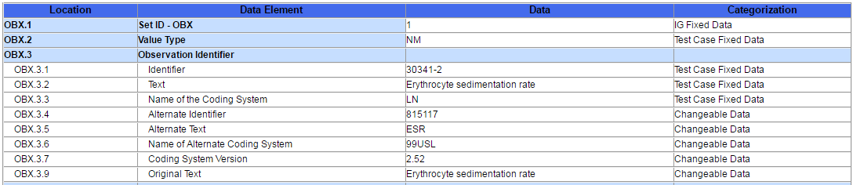

The information in the ***Location*** column indicates the canonical element location in the HL7 V2 message. For example, OBX-3.3 represents the 3rd component in the 3rd field of the OBX segment. The ***Data Element*** column indicates the name of the data element as specified by the Profile contained in the LRI Implementation Guide.

The ***Test Data*** column provides the expected data (if applicable) for that message element. The ***Categorization*** column indicates the validation category of the data. **Table 3** lists the test data categorization options, a description of the categorization, and how each data category is being validated. Additional information about the test data Categories is available in the *Understanding LRI Messaging Conformance Testing* document, which is accessed via the Documentation tab in the LRI Test Tool.

**Table 3 Description of Data Classification and Validation**

| **Data Categorization** | **Description** | **Validation** |
| --- | --- | --- |
| **Configurable** | Data typically configured by the system  (customer-definable). Example data are provided. | Validate for the presence of data |
| **System Generated** | Data typically generated automatically by the system, e.g., message time. Example data are provided. | Validate for the presence of data |
| **IG Fixed** | Data that is fixed by the implementation guide;  data can’t be changed. Specific data are provided. | Validate for the presence and data content |
| **Test Case Fixed** | Data that is specific and fixed by the test case; data should not be changed. Specific data are provided | Validate for the presence and selectively validate for data content |
| **Changeable** | Data where the exact content is not relevant for the test case and can be changed for the purposes of testing. Example data are provided. | Validate for the presence of data |

The Test Cases and the context-based validation test tool are tightly-coupled. In addition to validating message conformance, the test tool performs selective content validation based on the Test Story and Test Data Specification provided. Deviation from the test data may cause the test tool to issue Errors. For this reason, the Tester should use the test data as specified.

The HL7 V2 standard provides flexibility in messaging—many different message instances for a given test case can be considered conformant. The test tool is designed to support such instances; however, it is not a certainty. If the test tool issues an error for a message instance, the Vendor shall provide evidence of equivalency to the Tester.

### Conformance Test Tools

The following testing tool is available to evaluate conformance to the standards referenced in this testing process document:

* [NIST HL7 V2 Validation tool - Laboratory Results Interface](http://hit-dev.nist.gov:8081/lri-r2/) – an HL7v2 messaging validation tool; designed to support the NIST conformance testing process
  + The tool is available as a Web Application
* The application can be downloaded for local installation
* The NIST Lab Results Interface test tool Web application is available at:

<http://hl7v2-lab-r2-testing.nist.gov/lri-r2/>

Support for this tool is available by submitting questions to the following user’s group:

<https://groups.google.com/forum/#!forum/hl7v2-lab-testing>

Inquiries may also be sent to this user group via email: [hl7v2-lab-testing@googlegroups.com](mailto:hl7v2-lab-testing@googlegroups.com)

Several browsers may be used to access the HL7 v2 LRI Test Tool; Firefox (recommended), Chrome (recommended), Safari, and IE 9+ are the supported browsers.

The following information is provided to assist the Tester in interpreting the **Validation Reports** generated by the LRI Tool:

The Context-based capability in the Tool evaluates conformance requirements that are specified or have been derived from the standards and implementation guides identified in the conformance criteria and the test data provided for this testing process. The Test Tool evaluates the submitted HL7 message for each conformance requirement, and then produces a Validation Report.

The Tester should consider a Validation Report that contains only Warning and Alert messages to be indicative of a sufficient level of conformance to the standard and test data expectations. If reported, Errors should be considered significant departures from the standard or test data requirements, and these Errors must be corrected in order to claim conformance. Testers will need to further analyze each Error to determine if, in the context of meeting the conformance criterion, the Error results in a failure of the testing process by the Health IT Module.

The NIST context-based testing performs specific content validation depending on the Category/Qualifier combination assigned to the Data Elements in the message (see How to Interpret the Message Content Data Sheet section for more details). In some cases, in order to perform this type of validation the NIST Tool expects the fields/segments/segment groups in the message to be sequenced in a certain order. The complexity of automatically evaluating specific content necessitates this approach. If the Message Validation Result generated by the NIST Tool indicates content-related errors, the Tester may change the order of the fields/segments/segment groups in the test message to match the Test Step once the message has been loaded into the Message Content window of the Test Tool. These kinds of content-related errors do not imply a failure of the vendor product nor a requirement to create the message with the fields/segments/segment groups in a certain order (beyond the base message structure).

## Document History

|  |  |  |
| --- | --- | --- |
| **Version Number** | **Description of Change** | **Date Published** |
| 1.0 | Approved Normative Test Process Document | June 30, 2016 |
| 1.1 | Conformance Test Tools Section  “IE 9+” added to set of browsers supported | July 18, 2016 |
| 1.2 | Normative Test Description Section   * Replaced Figure 1 Create LRI Messages Testing Workflow; verbiage in step 10 changed from “Tester repeats steps 2-9 for each Test Step in the Test Case opened in step 2.” to “Tester repeats steps 2-9 for each Test Step in the Test Case opened in step 1.” | August 2, 2016 |
| 1.3 | Added Ask-at-Order-Entry question information for Lipid Panel and Pap Smear messages   * Informative Test Description Section * Test Data Section, Table 1 | November 16, 2016 |

1. Minimally populated means the LRI example messages contain single occurrences of all required ("R") elements
2. Maximally populated means the LRI example messages contain all the R, RE, C(a/b) elements defined in the implementation guide
3. Typically populated means the LRI example message contains data that are routinely sent whether the data element is R (Required) or RE (Required, but may be empty)
4. During conformance testing, the mechanism by which the lab result test message is imported (sent) from or to the Health IT Module being tested is not specified. The Tester may have their own utility, they may allow the Module vendor to use a utility created by that vendor, or the message can be cut from the Module and pasted into the NIST Test Tool or cut from the NIST Test Tool and pasted into the Module. For conformance testing, the key requirement is for the Module to demonstrate real time/dynamic import.