NIST Normative Test Process Document: Vital Records Test Tool

Test Tool and Test Descriptions to Conduct HIT Conformance Testing

NIST Approved Version 1.0

Date: January 6, 2017

**Developed by the National Institute of Standards and Technology (NIST) in collaboration with the Centers for Disease Control and Prevention (CDC) National Centers for Health Statistics (NCHS)**

**List of Contents**

**Explanation of Terms**

A table containing a key of equivalents for names and terms used frequently in this document

**Informative Test Description**

Key background information for conducting the conformance testing; includes information about

* Definition of “Tester” for this document
* Care settings and profiles that are in-scope for the testing
* Capabilities the Health IT Module must be able to demonstrate during the conformance testing

**Normative Test Description**

Detailed description of the testing process, including Derived Test Requirement(s), Testing Workflow Diagram(s), Required Vendor Information, Required Testing Actions, and Inspection Test Guide

**Test Data**

Detailed description of the purpose and use of the provided test data, including allowed exceptions

**Navigating a Test Case**

Detailed description of the information and instructions available in the NIST Test Tool related to the Test Cases

**How to Interpret the Message Content Data Sheet**

Detailed description of the purpose of and information available in the Message Content Data Sheet, including the meaning of the NIST Test Data Categories and Qualifiers

**Conformance Test Tools**

Links to the web-based NIST Test Suite and Support sites, as well as information to assist the Tester in interpreting the Validation Reports generated by the Tool

**Document History**

Listing of Version Numbers and Publication Dates for the final published versions of the NIST Testing Process document

## NIST Normative Test Process Document for Vital Records Death Reporting

This document explains the testing process for which a National Institute of Standards and Technology (NIST) validation test tool is used in evaluating conformance of a health information technology module (Health IT Module) for creating HL7 vital records death reporting messages in accordance with the *HL7 Version 2.6 Implementation Guide: Vital Records Death Reporting, Release 1 - US Realm, Standard for Trial Use August 2016* interoperability standard.

### Conformance Criteria

Transmit vital records death reports

Electronically create vital records death reporting messages for electronic transmission in accordance with *HL7 Version 2.6 Implementation Guide: Vital Records Death Reporting, Release 1 - US Realm, Standard for Trial Use August 2016* interoperability standard

### Explanation of Terms

| **Key for Names and Terms Used Frequently in this Document** | |
| --- | --- |
| **Referenced Names and Terms** | **Equivalent Used in Document** |
| *HL7 Version 2.6 Implementation Guide: Vital Records Death Reporting, Release 1 - US Realm, Standard for Trial Use August 2016* | **“Vital Records Death Reporting Guide” or “Vital Records Messaging Guide” or “Vital Records IG”** |
| Current Procedures Terminology code set | **“CPT”** |
| International Classification of Diseases, 10th Revision, Clinical Modification | **“ICD-10-CM” or “ICD-10”** |
| Logical Observation Identifiers Names and Codes (LOINC) version 2.50 | **“LOINC” or “LOINC v2.50”** |
| International Healthcare Terminology Standards Developing Organization (IHTSDO) SNOMED CT® International | **“SNOMED CT” or “SNOMED”** |
| National Center for Health Statistics | **“NCHS”** |
| Centers for Disease Control and Prevention | **“CDC”** |
| Health IT Module | **“HIT Module” or “Module”** |
| HL7 v2.6 Context-based capability of the NIST Vital Records 2016 Test Tool | **“VR Tool” or “Tool”** |

### Informative Test Description

This section provides an executive summary describing how the NIST testing process is organized and conducted. The *Understanding Vital Records Death Reporting Messaging Conformance Testing* document is available via the Documentation tab in the NIST Vital Records Test Tool; this document is an additional resource that explains the process of Health IT Module conformance testing for HL7 V2 Vital Records Death Reporting messaging.

This document has been developed to be used by testers in conformance testing of Health IT Modules. The term “Tester”, when used in this document, refers to a person (such as a testing lab employee) acting on behalf of a testing lab or other entity for conformance testing of a Vendor’s HIT Module. In addition, a Vendor may use this document to test their own HIT Modules during development of their product and in preparation for conformance testing by a testing lab, and individual implementations of the Vital Records IG may use this document when verifying conformance on the sender side.

The test evaluates the capability for a Health IT Module to

1. Create ADT messages for electronic transmission from a healthcare provider that
   * Deliver relevant clinical information to a jurisdictional Electronic Death Registration System (EDRS) including
     + A new Death Report
     + A revision notification (update) for the Death Report
     + A cancellation notification (retraction) for the Death Report
   * Are conformant to the Vital Records Death Reporting Guide
2. Create ADT messages for electronic transmission from a jurisdictional EDRS that
   * Deliver relevant clinical information to the National Center for Health Statistics (NCHS) including
     + A new Death Report
     + A revision notification (update) for the Death Report
     + A cancellation notification (retraction) for the Death Report
   * Are conformant to the Vital Records Death Reporting Guide

During the process of building the Vital Records Test Tool, NIST discovered conformance requirements that were either conflicting or unclear in the named standard document. The “HL7 Version 2.6 Implementation Guide: Vital Records Death Reporting, Release 2, NIST Clarifications and Validation Guidelines, Version 1.0” document clarifies these issues and indicates how they are interpreted in the Tool. This document can be accessed via the “Documentation” tab on the NIST Vital Records 2016 Test Tool.

The Vital Records Death Reporting Guide defines three ADT Message Types that are relevant for conformance testing of a Health IT Module:

* ADT^A04 Register a Patient
* ADT^A08 Update Patient Information
* ADT^A11 Cancel Patient Information

The Vital Records Death Reporting Guide defines six Base Profile IDs that are relevant for conformance testing of a Health IT Module:

* PSDIA04_V1.0 Report Provider Supplied Death Information
* PSDIA08_V1.0 Revise Provider Supplied Death Information
* PSDIA11_V1.0 Cancel Provider Supplied Death Information
* JDIA04_V1.0 Report Jurisdiction Death Information
* JDIA08_V1.0 Revise Jurisdiction Death Information
* JDIA11_V1.0 Cancel Jurisdiction Death Information

The Context-based feature of the NIST Vital Records Test Tool used for conformance testing includes **two** Groups of Test Cases (see **Table 1** (Vital Records Death Reporting Test Cases and Associated Test Steps by Group) for more details):

1. Provider Supplied Death Information Group – to be used in conformance testing for HIT modules used by healthcare providers for reporting to a jurisdictional EDRS, e.g., an electronic health record system (EHR-S)
2. Jurisdictional Death Information Group – to be used in conformance testing for HIT modules used by jurisdictions for reporting to the NCHS, e.g., a jurisdictional EDRS

Each of these Groups includes three different Test Cases composed of three Test Steps that correspond to the Report, Revise, and Cancel messaging requirements. When the system under test (SUT) is one used by healthcare providers for death reporting, the Tester shall select all three Test Steps from the three Test Cases in the Provider Supplied Death Information Group to execute conformance testing. When the SUT is one used by jurisdictions for death reporting, the Tester shall select all three Test Steps from the three Test Cases in the Jurisdictional Death Information Group to execute conformance testing.

The Centers for Disease Control and Prevention (CDC) National Center for Health Statistics, in collaboration with NIST, provided the Test Cases and Test Data for this testing process.

Test data PDF documents, which are accessible from the NIST Vital Records Test Tool identified in the **Conformance Test Tools section** of this testing process document, contain the test data that are specific to each Test Case. Instructions for use of the provided test data are listed in the **Normative Test Description** and **Test Data sections** of this testing process document.

**Note: Regarding messages/capabilities that are out-of-scope for the Health IT conformance testing**

* The focus of conformance testing is on the ability of the Health IT Module to create conformant Vital Records Death Reporting messages and **is not on** the operational aspect of transporting the messages.
* Batch requirements are not included in the conformance testing

### Normative Test Description

Using the NIST Vital Records Test Tool, conformance testing can be completed in either of the following two ways:

* Single message (step by step) testing
* Multiple message (multiple step) testing

**Single message (step by step) testing** is a separate validation of each message in an *opened* Test Case. After opening one of the Information Groups in the Test Cases window and then *opening* a Test Case, the Tester will *select* each of the Test Steps in their given sequence, will click on “Load Test Step”, and validate each message individually. Using the features provided on the Test Execution page of the Tool, the Tester is able to keep the default Validation Result value produced by the Tool or use the drop-down menu to select a different value; the Tester also is able to enter free-text into the Comments field by clicking on the pen icon that displays there and then typing into the field. These Validation Result values and free-text Comments become part of the Validation Report generated by the Tool. The Derived Test Requirements (DTR) listed in this document provide the detailed explanation regarding how single message is performed.

**Multiple message (multiple step) testing** is similar to single message (step by step) testing, except with the capability of loading a complete Test Case (all Test Steps) at once instead of selecting individual Test Steps. After opening one of the Information Groups in the Test Cases window, the Tester will click on a Test Case, and then will click on the “Load Test Case” button to load the complete Test Case. This mode allows the Tester to progress from one Test Step to another by clicking the “Next” button after each Test Step message is validated. Using the features provided on the Test Execution page of the Tool, the Tester is able to keep the default Validation Result value produced by the Tool or use the drop-down menu to select a different value; the Tester also is able to enter free-text into the Comments field by clicking on the pen icon that displays there and then typing into the field. These Validation Result values and free-text Comments become part of the Validation Report generated by the Tool. When all Test Steps have been validated, the Tester will click on the “Test Summary” button to complete the testing of the Test Case and download the validation reports.

**Derived Test Requirements**

VR_DTR - 1: Electronically Create New Vital Records Death Report Message

VR_DTR - 2: Electronically Create Revise Vital Records Death Report Message

VR_DTR - 3: Electronically Create Cancel Vital Records Death Report Message

**VR_DTR - 1: Electronically Create New Vital Records Death Report Message**

Figure 1 Create New Vital Records Death Report Message

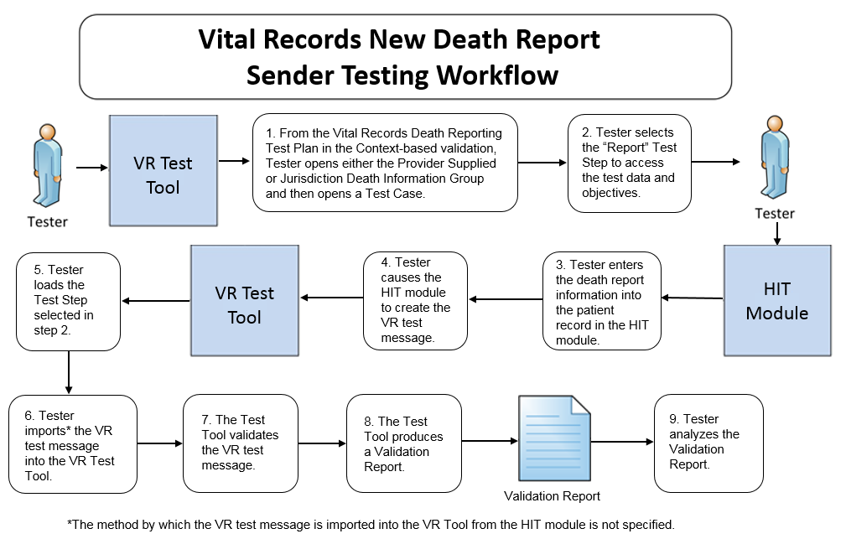

The instructions in the testing process listed below reference the numbered test steps in **Figure 1**.

Required Vendor Information

1. Vendor shall identify the Health IT Module function(s) that are available to 1) create patient records in the Health IT Module for the test patients, 2) enter vital records death report information into the test patients’ records, 3) create vital records death report messages using the information entered, and 4) import[1] the vital records death report messages into the NIST Test Tool
2. Vendor shall provide the mechanism necessary to capture and import vital records death report messages into the Tool
3. Vendor shall declare whether their HIT Module is used by healthcare providers for death reporting, by jurisdictions for death reporting, or by both

Required Testing Actions

1. Using the Context-based capability provided in the Tool identified in the **Conformance Test Tools section** of this testing process document, the Tester shall access the **Vital Records Death Reporting** test plan, shall open either the Provider Supplied Death Information Group or the Jurisdiction Death Information Group, and then shall open a Test Case [Figure 1, Step 1]
2. The Tester shall select the “Report” Test Step in the selected Test Case [Figure 1, Step 2]
3. Using the information provided in the Test Story Description and Message Content sheet in the VR Tool and the capabilities provided in the Health IT Module, the Tester shall
   1. Enter the vital records death report information for the selected Test Step into the record for the test patient (input can be performed using a manual or automated process) [Figure 1, Step 3]
4. Cause the Module to generate the indicated vital records death report message [Figure 1, Step 4]
5. In the NIST Tool, the Tester shall load the selected Test Step and import the vital records death report message generated by the Health IT Module, and the NIST Tool validates the message [Figure 1, Steps 5, 6, & 7]
6. The NIST Tool produces a Validation Report [Figure 1, Step 8]
7. Using the **Inspection Test Guide**, the Tester shall verify that the vital records death report message is conformant to the **Referenced Standard** and that the message includes the specified vital records death report information

Inspection Test Guide

1. Using the Validation Report produced by the NIST Tool**,** theTester shall analyze the Report and verify that the message created by the Health IT Module meets the conformance requirements in the **Referenced Standard** [Figure 1, Step 9]
2. Once during the testing for this conformance criterion, the Tester shall inspect the Health IT Module to verify the capability of the Vendor to support the value sets specified
   1. Using the Module’s function(s) and the NIST Tool, the Vendor shall demonstrate to the Tester that their Module supports any of the value sets (selected at the Tester’s discretion) specified in the Vital Records Death Reporting Guide

**NOTE**: After completion of VR_DTR – 1, the Tester shall continue with the same Test Case used for VR_DTR – 1 and shall select the “Revise” Test Step to begin validating that the HIT Module is able to create a message that would revise the vital records new death report (see VR_DTR – 2 for the testing process)

**VR_DTR - 2: Electronically Create Revise Vital Records Death Report Message**

Figure 2 Create Revise Vital Records Death Report Message

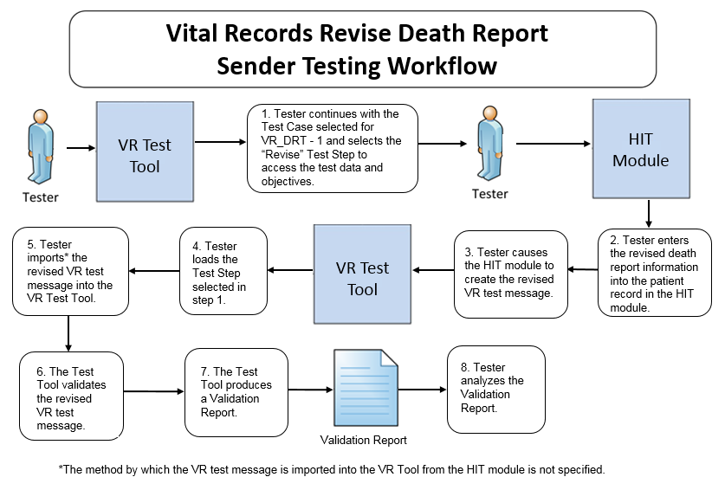

The instructions in the testing process listed below reference the numbered test steps in **Figure 2**.

Required Vendor Information

Same as for VR_DTR – 1

Required Testing Actions

1. In the Tool, the Tester shall continue with the same Test Case selected for VR_DTR – 1 and shall select the “Revise” Test Step [Figure 2, Step 1]
2. Using the information provided in the Test Story Description and Message Content sheet in the VR Tool and the capabilities in the Health IT Module, the Tester shall
   1. Enter the revised vital records death report information into the record for the test patient for the selected Test Step (input can be performed using a manual or automated process) [Figure 2, Step 2]
3. Cause the Module to generate the vital records death report revise message [Figure 2, Step 3]
4. In the NIST Tool, the Tester shall load the “Revise” Test Step and import the vital records death report revise message generated by the Health IT Module, and the Tool validates the message [Figure 2, Steps 4, 5, & 6]
5. The NIST Tool produces a Validation Report [Figure 2, Step 7]
6. Using the **Inspection Test Guide**, the Tester shall verify that the vital records death report message is conformant to the **Referenced Standard** and that the message includes the specified vital records death report information

Inspection Test Guide

1. Using the Validation Report produced by the NIST Tool**,** theTester shall analyze the Report and verify that the revise message created by the Health IT Module meets the conformance requirements in the **Referenced Standard** [Figure 2, Step 8]

**NOTE**: After completion of VR_DTR – 2, the Tester shall continue with the same Test Case used for VR_DTR – 1 and shall select the “Cancel” Test Step to begin validating that the HIT Module is able to create a message that would cancel the vital records death report (see VR_DTR – 3 for the testing process)

**VR_DTR - 3: Electronically Create Cancel Vital Records Death Report Message**

Figure 3 Create Cancel Vital Records Death Report Message

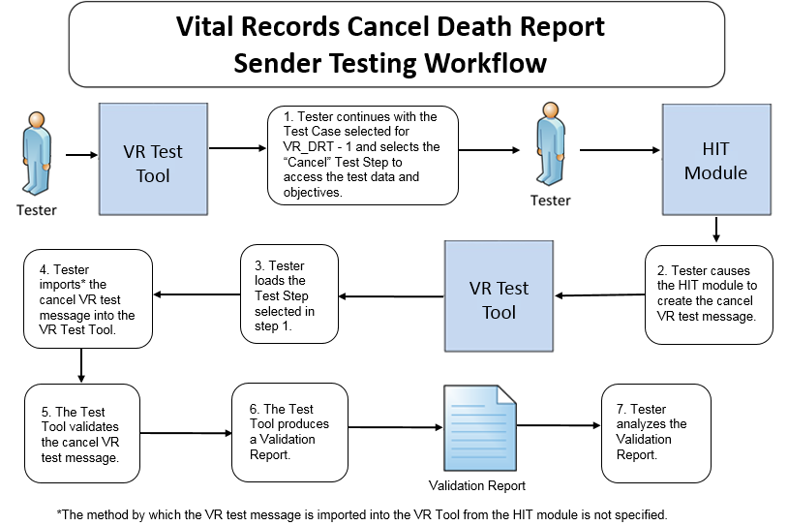

The instructions in the testing process listed below reference the numbered test steps in **Figure 3**.

Required Vendor Information

Same as for VR_DTR – 1

Required Testing Actions

1. In the Tool, the Tester shall continue with the same Test Case selected for VR_DTR – 1 and shall select the “Cancel” Test Step [Figure 3, Step 1]
2. Using the information provided in the Test Story Description and Message Content sheet in the VR Tool and the capabilities in the Health IT Module, the Tester shall cause the Module to generate the vital records death report cancel message [Figure 3, Step 2]
3. In the NIST Tool, the Tester shall load the “Cancel” Test Step and import the vital records death report cancel message generated by the Health IT Module, and the Tool validates the message [Figure 3, Steps 3, 4, & 5]
4. The NIST Tool produces a Validation Report [Figure 3, Step 6]
5. Using the **Inspection Test Guide**, the Tester shall verify that the vital records death report message is conformant to the **Referenced Standard** and that the message includes the specified vital records death report information

Inspection Test Guide

1. Using the Validation Report produced by the NIST Tool**,** theTester shall analyze the Report and verify that the cancel message created by the Health IT Module meets the conformance requirements in the **Referenced Standard** [Figure 3, Step 7]

### Test Data

Test data are provided for the testing process to ensure that the applicable requirements identified in the conformance criteria can be adequately evaluated, as well as to provide consistency in the testing process across multiple testing entities. The provided test data focus on evaluating the basic capabilities required of the Health IT Module, rather than exercising the full breadth/depth of capability that installed Health IT Modules might be expected to support. The test data are formatted for ease of use by the Tester during the testing process; the format is not intended to prescribe the design of the display presented to the end-user for viewing the data. No additional requirements should be drawn from the format.

The Tester shall use and apply the provided test data during the testing, without exception, unless one of the following conditions exists:

* The Tester determines that the Health IT Module is sufficiently specialized that the provided test data need to be modified in order to conduct an adequate test. Having made the determination that some modification to the provided test data is necessary, the Tester shall record the modifications made as part of the test documentation.
* The Tester determines that changes to the test data will improve the efficiency of the testing process (for example, using consistent demographic data throughout the testing workflow). The Tester shall ensure that the functional and interoperable requirements identified in the criterion can be adequately evaluated for conformance, and that the modified test data provide a comparable level of robustness.
* The Tester determines that the code (e.g., ICD-10, SNOMED CT, or LOINC) in a message created by the Health IT Module is a **valid code** for a data item even though it is different from the code provided for that data item in the test data for that message

Any departure from the provided test data shall focus on meeting the basic capabilities required of the Health IT Module relative to the conformance criterion rather than exercising the full breadth/depth of capability that the installed Health IT Module might be expected to support.

The testing process requires that the Tester enter the applicable test data into the Health IT Module being evaluated for conformance. The intent is that the Tester fully controls the process of entering the test data in order to ensure that the data are correctly entered as specified in the testing process. If a situation arises where it is impractical for a Tester to enter the test data directly, the Tester, at the Tester’s discretion, may instruct the Vendor to enter the test data, so long as the Tester remains in full control of the testing process, directly observes the test data being entered by the Vendor, and validates that the test data are entered correctly as specified in the testing process document.

The testing process requires that the applicable test data be entered into the Health IT Module being evaluated for conformance. The intent is that the Tester performs or observes the process of entering the test data in order to ensure that the data are correctly entered as specified in the testing process.

For conformance testing, the primary purpose of the provided test data is to assist the Tester in verifying that the vendor’s Module is capable of supporting the required functions; *verifying* the ability to support *specific* content is applicable only when the test data are categorized as, for example, “Value-Profile Fixed” (see How to Interpret the Message Content Data Sheet section below for additional details about the categorization of test data). The clinical test data are relevant for the given Test Stories; however, these data should not be expected to represent standards of practice.

Test data for conformance testing related to Vital Records Death Reporting are available in the NIST Vital Records Test Tool (see the **Conformance Test Tools section** of this testing process document for instructions on how to access the Test Tool).

### Navigating a Test Case

A Vital Records Death Reporting Messaging Test Case contains multiple Test Steps, each consisting of a Test Story, a Message Content Data Sheet, and an Example Message. All of these artifacts are accessible via the NIST Tool.

* The **Test Story** describes a real-world situation that provides the context for the Test Step.
* The **Message Content Data Sheet** shows a conformant message instance for the Test Step. The message content is organized in a table format that provides the HL7 v2 message elements and the data associated with the message elements for a given Test Step. The Message Content Data Sheet may provide assistance to the Tester and Health IT Module Vendor for resolving issues discovered during conformance testing. This data sheet can be thought of as the “answer” to the scenario (“question”) provided by the Test Story.
* The **Example Message** shows a conformant message for the Test Step, including appropriate segments and populated fields.

If the HIT developer indicates their HIT module supports both healthcare providers’ and jurisdictions’ needs for death reporting, the Tester shall use all of the Test Cases from both the Provider Supplied Death Information Group and the Jurisdictional Death Information Group in the Tool to execute conformance testing. Otherwise, the Tester shall use all of the Test Cases from just the Provider Supplied Death Information Group to execute conformance testing for HIT Modules that support only healthcare providers and shall use all of the Test Cases from just the Jurisdictional Death Information Group to execute conformance testing for HIT Modules that support only jurisdictions.

The Vital Records Death Reporting Test Plan consists of **two** Groups, each of which include **three** Test Cases:

* Provider Supplied Death Information Group
* Jurisdiction Death Information Group

**Table 1** (Vital Records Death Reporting Test Cases and Associated Test Steps by Group) lists the **two** Groups, the **three** Test Cases in each Group, and the **three** Test Steps for each Test Case. The three Test Steps are to be executed according to the sequence in which they appear in the Tool.

Table 1 Vital Records Death Reporting Test Cases and Associated Test Steps by Group

| **Group** | **Test Cases** | **Test Steps** |
| --- | --- | --- |
| Provider Supplied Death Information Group | VR-1 Death at Home | Report_PSDI_A04_V1.0 |
| Revise_PSDI_A08_V1.0 |
| Cancel_PSDI_A11_V1.0 |
| VR-2 Death caused by Transportation injury at work | Report_PSDI_A04_V1.0 |
| Revise_PSDI_A08_V1.0 |
| Cancel_PSDI_A11_V1.0 |
| VR-3 Death of a Pregnant Woman | Report_PSDI_A04_V1.0 |
| Revise_PSDI_A08_V1.0 |
| Cancel_PSDI_A11_V1.0 |
| Jurisdiction Death Information Group | VR-1 Death at Home | Report_JDI_A04_V1.0 |
| Revise_JDI_A08_V1.0 |
| Cancel_JDI_A11_V1.0 |
| VR-2 Death caused by Transportation injury at work | Report_JDI_A04_V1.0 |
| Revise_JDI_A08_V1.0 |
| Cancel_JDI_A11_V1.0 |
| VR-3 Death of a Pregnant Woman | Report_JDI_A04_V1.0 |
| Revise_JDI_A08_V1.0 |
| Cancel_JDI_A11_V1.0 |

Details for each Test Step, including the test story, test objectives, message content, and example HL7 message, are provided via the tabs that are displayed when a user selects a Test Step in the Context-based feature of the Test Tool. These artifacts are available as PDF files accessible via the tabs displayed with each Test Step as well as via the Test Tool Documentation tab. The Tester shall follow the instructions in the **Normative Test Description** section of this testing process document to conduct the conformance testing.

### How to Interpret the Message Content Data Sheet

The Message Content Data Sheet indicates the data that are to be included in the Vital Records Death Reporting message based on the test data entered into the Health IT Module for a particular Test Step. **Tables 2 and 3** show portions of a Message Content Data Sheet.

Table 2 Message Content Data Sheet Excerpt for MSH Segment in a PSDI_A04 Message

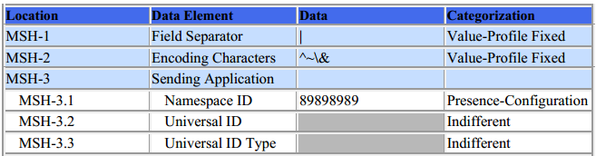

Table 3 Message Content Data Sheet Excerpt for an OBX Segment in a PSDI_A04 Message

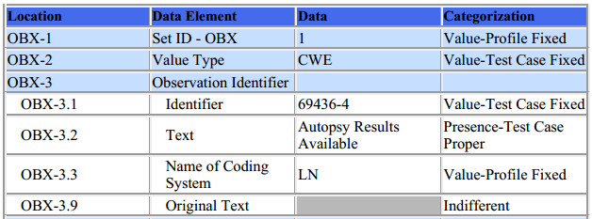

The information in the ***Location*** column indicates the canonical element location in the HL7 v2 message. For example, OBX-3.1 represents the 1st component in the 3rd field of the OBX segment. The ***Data Element*** column indicates the name of the data element as specified by the Vital Records Death Reporting Guide. The ***Test Data*** column lists the data to be included for each Data Element in the Vital Records message created by the Health IT Module.

The ***Categorization*** column indicates the type and expected source of the data as well as how the Context-based feature in the NIST Tool will validate the data for the given Data Element in the Vital Records message. In some cases, the test tool validator simply examines the message element for the presence of data, whereas in other cases the validator examines the message element for the presence of data and for exact content. **Table 4** shows the descriptions of the test data Categories and their associated Qualifiers. Additional information about the test data Categories and Qualifiers is available in *Understanding Vital Records Death Reporting Messaging Conformance Testing* document, which is accessed via the Documentation tab in the NIST Vital Records Test Tool.

Table 4 Test Data Categories, Associated Qualifiers, and Descriptions

| **Test Data Categorization** | **Description** | **Qualifier** | **Description** |
| --- | --- | --- | --- |
| **Indifferent** | No content is specified. | ***None*** | None |
| **Presence** | Example content is specified. | ***Content Indifferent*** | Content is expected to be present in the message, but not a specific value. |
| ***Configuration*** | Content is expected to be present in the message, but not a specific value. The value is usually determined at installations. |
| ***System Generated*** | Content is expected to be present in the message, but not a specific value. The value is system generated. |
| ***Test Case Proper*** | Content is expected to be present in the message, but not a specific value. However, content is expected to be consistent with the clinical test story. |
| **Presence-Length** | Example content is specified to a minimum length. | ***Same qualifiers as for Presence*** | Content of a minimum length is expected to be present in the message, but not a specific value. |
| **Value** | Specific content is specified. | ***Profile Fixed*** | Content is defined as a constant in the conformance profile. The constant is specified in the test data. |
| ***Profile Fixed - List*** | Content is defined as a set of allowable values in the conformance profile. One value from the allowable set is specified in the test data. |
| ***Test Case Fixed*** | Content that is defined as a constant in the test case. |
| ***Test Case Fixed - List*** | Content is defined as a set of allowable values in the test case. One value from the allowable set is specified in the test data. |
| **Non-presence** | No content is explicitly specified. | ***None*** | None |

The Message Content Data Sheet can be used to assist the Tester and Health IT Module Vendor in loading the test data into the Module for a given Test Step.

The Test Cases and the Context-based feature in the NIST Test Tool are tightly-coupled. In addition to validating message conformance, the Tool performs selective content validation based on the test data provided, and deviation from the test data may cause the Tool to issue Error notifications. For this reason, the Tester should use the test data as specified.

### Conformance Test Tools

The following testing tools are available to evaluate conformance to the standard(s) referenced in this testing process document:

* NIST HL7 v2 Vital Records Test Tool – an HL7 v2 messaging validation tool; designed to support the NIST conformance testing process
  + The tool is available as a Web Application
* The application can be downloaded for local installation
* The NIST Vital Records test tool Web Application is available at:

<http://hl7v2-vr-r2-testing.nist.gov/vr>

Support for these tools is available by submitting questions to the following user’s group:

<https://groups.google.com/forum/#!forum/hl7v2-vitalrecords-testing>

Inquiries may also be sent to this user group via email: [hl7v2-vitalrecords-testing@googlegroups.com](mailto:hl7v2-vitalrecords-testing@googlegroups.com)

Several browsers may be used to access the HL7 v2 Vital Records Test Tool; Firefox (recommended), Chrome (recommended), Safari, and IE 9+ are the supported browsers.

The following information is provided to assist the Tester in interpreting the Validation Reports generated by the HL7 v2 Vital Records Test Tool:

The Context-based capability in the HL7 v2 Vital Records Test Tool evaluates conformance requirements that are specified or have been derived from the implementation guide identified in the **Conformance Criteria section** of this testing process document. The Test Tool evaluates the submitted HL7 message for each conformance requirement, and then produces a Validation Report.

The Tester should consider a Report that contains only Warning and Alert messages to be indicative of a sufficient level of conformance to the standard and test data expectations. If reported, Errors should be considered significant departures from the standard or test data requirements, and these Errors must be corrected in order to claim conformance. Testers will need to further analyze each Error to determine if, in the context of meeting the conformance criterion, the Error results in a failure of the testing process by the Health IT Module.

The NIST context-based testing performs specific content validation depending on the Category/Qualifier combination assigned to the Data Elements in the message (see How to Interpret the Message Content Data Sheet section for more details). In some cases, in order to perform this type of validation the NIST Tool expects the fields/segments/segment groups in the message to be sequenced in a certain order. The complexity of automatically evaluating specific content necessitates this approach. If the Message Validation Result generated by the NIST Tool indicates content-related errors, the ATL may change the order of the fields/segments/segment groups in the test message to match the Test Case once the message has been loaded into the Message Content window of the Test Tool. These kinds of content-related errors do not imply a failure of the vendor product nor a requirement to create the message with the fields/segments/segment groups in a certain order (beyond the base message structure).

## Document History

|  |  |  |
| --- | --- | --- |
| **Version Number** | **Description of Change** | **Date Published** |
| 1.0 | Approved Normative Test Process Document | January 6, 2017 |

1. During conformance testing, the mechanism by which the vital records death report test message is imported (sent) from or to the Health IT Module being tested is not specified. The Tester may have their own utility, they may allow the Module vendor to use a utility created by that vendor, or the message can be cut from the Module and pasted into the NIST Test Tool or cut from the NIST Test Tool and pasted into the Module. For conformance testing, the key requirement is for the Module to demonstrate real time/dynamic import.