Immunization Test Suite

Receiver SOAP Connectivity Testing

Version 1.0
March 29, 2016

Immunization Test Case
Receiver
SOAPCON_1_BasicMessage_Connectivity

BasicMessage_Connectivity
Test Description

Description
This test evaluates the capability of a receiver (responder) technology conforming to the SOAP 1.2 standard and CDC WSDL 1.0 to receive a request message from a sender (initiator) technology, and to generate and transmit an appropriate response message, in order to verify the accessibility of an Immunization Information System (IIS).

Test Objectives
The receiver (responder) technology will demonstrate the ability to:
- Receive a SOAP message with the Body element containing the element connectivityTest and corresponding child element echoBack, as defined in the CDC WSDL 1.0
- Transmit a SOAP response message to the sender (initiator) which contains
  - the element connectivityTestResponse as defined in the CDC WSDL 1.0
  - the child element return as defined in the CDC WSDL 1.0, with a string value containing the string received in the echoBack element in the request message

SOAP Connectivity Testing Diagram

Receiver
SOAPCON_1_BasicMessage_Connectivity

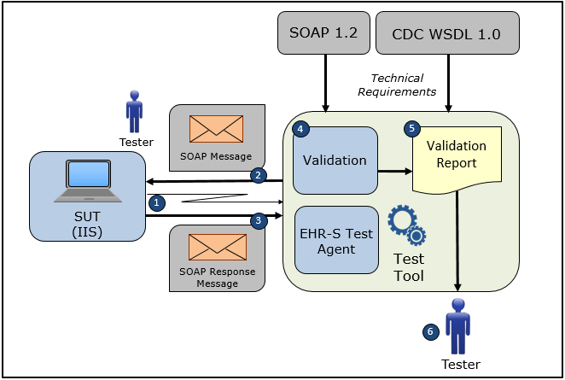

- The Tester accesses the System Under Test (IIS) and causes it to connect to the NIST Test Tool representing an EHR-S Test Agent
- The Tester causes the NIST Test Tool to electronically generate and transmit to the System Under Test a SOAP connectivity request message connectivityTest that conforms to the SOAP 1.2 standard and CDC WSDL 1.0 in order to verify the accessibility of the IIS NIST Test Agent
3) The System Under Test electronically generates and transmits to the EHR-S Test Agent in the NIST Test Tool a SOAP connectivity response message connectivityTestResponse that conforms to the SOAP 1.2 standard and CDC WSDL 1.0 and that confirms the accessibility of the IIS
4) The Test Tool validates the SOAP connectivity response message for conformance to the SOAP 1.2 standard and CDC WSDL 1.0, and also validates that the connectivityTestResponse return element contains the string sent to the System Under Test (IIS) in the echoBack element of the connectivityTest message, and the Tester can view the validation results on-line
5) The Test Tool generates a Validation Report listing the results of the validation
6) The Tester reviews the Validation Report and compares the results to the Objectives and Evaluation Criteria associated with the Receiver SOAPCON_1_BasicMessage_Connectivity Test Case

Test Data Specification

Connectivity Response Message Information

Element Name | Data | Classification of Data
connectivityTest: echoBack | Hello world! | Changeable

Explanation of Data Classification

Data Classification | Description | Validation
Configurable | Data typically that are configured by the system (customer-definable). Example data are provided. | Validate for the presence of data
System Generated | Data typically generated automatically by system, e.g., message time. Example data are provided. | Validate for the presence of data
IG Fixed | Data that are fixed by the implementation guide; data can’t be changed. Specific data are provided. | Validate for the presence and data content
Test Case Fixed | Data that are specific and fixed by the test case; data should not be changed. Specific data are provided. | Validate for the presence and selectively validate for data content
Changeable | Data where the exact content is not relevant for the test case and can be changed for the purposes of testing. Example data are provided. | Validate for the presence of data
Test Tool-Assigned | Data that are assigned by the test tool for the specific System Under Test in real-time. Example data are provided. | Validate for the presence and for data content
Test System-Provided | Data that are provided by the System Under Test in real-time. Example data are provided. | Validate for the presence and for data content

Message Content Table

Test Case Information
Element Name | Data
Test Case ID | Receiver SOAPCON_1_BasicMessage_Connectivity

Connectivity Response

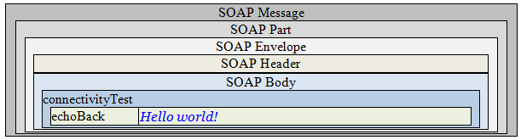

Message Content

Response Message Sent by Receiver System

<?xml version='1.0' encoding='UTF-8'?>
<Envelope xmlns="http://www.w3.org/2003/05/soap-envelope">
<Header />
<Body>
<connectivityTest xmlns="urn:cdc:iisb:2011">
<echoBack>Hello world!</echoBack>
</connectivityTest>
</Body>
</Envelope>

