Immunization Test Suite

Receiver SOAP Connectivity Testing

Version 1.0
March 29, 2016

Immunization Test Case
Receiver
SOAPCON_5_FaultDetection-Generation_UnsupportedOpFaults

FaultDetection-Generation_UnsupportedOpFaults
Test Description

Description
This test evaluates the capability of a Receiver technology conforming to the SOAP 1.2 standard and CDC WSDL 1.0 to receive a SOAP request message that specifies an undefined operation, and respond with an appropriate fault message.

Test Objectives
The Receiver technology will demonstrate the ability to:
- Receive a SOAP message with the Body element not containing either a submitSingleMessage or a connectivityTest element, as defined in the CDC WSDL 1.0
- Transmit a SOAP response message to the Sender that contains the element UnsupportedOperationFault, as defined in the CDC WSDL 1.0
  - with arbitrary conforming values for the Code and Detail child elements
  - with conforming fixed value for the Reason child element UnsupportedOperationFault.

SOAP Connectivity Testing Diagram

Receiver
SOAPCON_5_FaultDetection-Generation_UnsupportedOpFaults

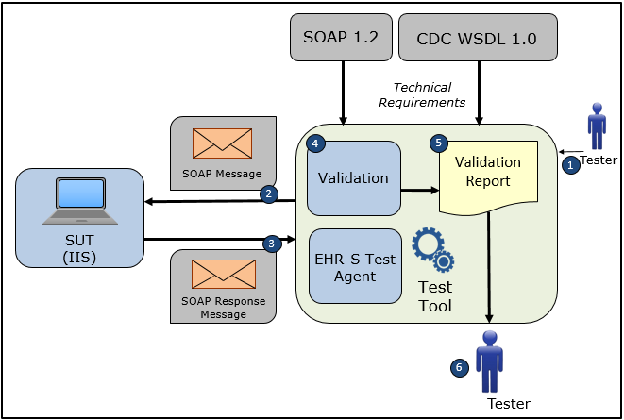

- The Tester configures the NIST Test Tool with Username, Password, FacilityID, and Endpoint information.
- The Tester causes the NIST Test Tool to electronically generate and transmit to the System Under Test a SOAP message that conforms to the SOAP 1.2 standard but not to the CDC WSDL 1.0 because it does not contain either a submitSingleMessage or a connectivityTest element
- The System Under Test electronically generates and transmits to the EHR-S Test Agent in the NIST Test Tool a SOAP response message UnsupportedOperationFault that conforms to the SOAP 1.2 standard and CDC WSDL 1.0 and that is used for transporting an appropriate HL7 fault response message to a sender (initiator) system
- The Test Tool validates the SOAP response message for conformance to the SOAP 1.2 standard and CDC WSDL 1.0
- The Test Tool generates a Validation Report listing the results of the validation
- The Tester reviews the Validation Report and compares the results to the Objectives and Evaluation Criteria associated with the Receiver SOAPCON_5_FaultDetection-Generation_UnsupportedOpFaults Test Case

Test Data Specification

Submit Single Message Request with Unsupported Operations Fault Information

Element Name | Data | Classification of Data
submitSingleMessage: username | ??? | Test System-Provided
submitSingleMessage: password | ??? | Test System-Provided
submitSingleMessage: facilityID | ??? | Test System-Provided
submitSingleMessage: HL7 Message | MSH|^~\&amp;|Test EHR Application|X68||NIST Test Iz Reg|201207010822||VXU^V04^VXU_V04|NIST-IZ-007.00|P|2.5.1|||AL|ER&#xD;PID|1||MR-99922^^^NIST MPI^MR||Montgomery^Lewis^^^^^L||20010821|M&#xD;ORC|RE||IZ-783276^NDA&#xD;RXA|0|1|20110215||118^HPV^CVX|999|||01^Historical information - source unspecified^NIP001 | Changeable
Note: A unique value for the username, password, and facilityID will be assigned by the System Under Test.

Explanation of Data Classification

Data Classification | Description | Validation
Configurable | Data typically that are configured by the system (customer-definable). Example data are provided. | Validate for the presence of data
System Generated | Data typically generated automatically by system, e.g., message time. Example data are provided. | Validate for the presence of data
IG Fixed | Data that are fixed by the implementation guide; data can’t be changed. Specific data are provided. | Validate for the presence and data content
Test Case Fixed | Data that are specific and fixed by the test case; data should not be changed. Specific data are provided. | Validate for the presence and selectively validate for data content
Changeable | Data where the exact content is not relevant for the test case and can be changed for the purposes of testing. Example data are provided. | Validate for the presence of data
Test Tool-Assigned | Data that are assigned by the test tool for the specific System Under Test in real-time. Example data are provided. | Validate for the presence and for data content
Test System-Provided | Data that are provided by the System Under Test in real-time. Example data are provided. | Validate for the presence and for data content

Example Message Content Table

Test Case Information
Element Name | Data
Test Case ID | Receiver SOAPCON_5_FaultDetection-Generation_UnsupportedOpFaults

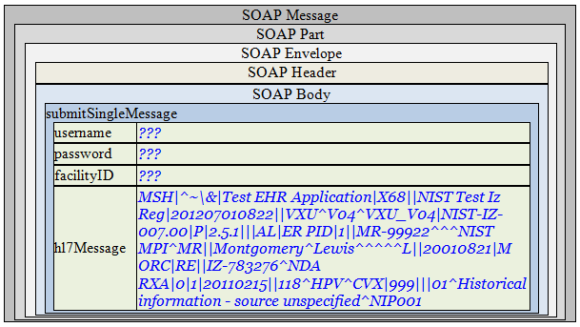

Note: A unique value for the username and password will be assigned by the System Under Test.

Example Message Content

Request Message Sent by Sender System

<?xml version='1.0' encoding='UTF-8'?>
<Envelope xmlns="http://www.w3.org/2003/05/soap-envelope">
<Header />
<Body>
<submitSingleMessageX xmlns="urn:cdc:iisb:2011">
<username>???</username>
<password>???</password>
<facilityID>???</facilityID>
<hl7Message>MSH|^~\&amp;|Test EHR Application|X68||NIST Test Iz Reg|201207010822||VXU^V04^VXU_V04|NIST-IZ-007.00|P|2.5.1|||AL|ER&#xD;PID|1||MR-99922^^^NIST MPI^MR||Montgomery^Lewis^^^^^L||20010821|M&#xD;ORC|RE||IZ-783276^NDA&#xD;RXA|0|1|20110215||118^HPV^CVX|999|||01^Historical information - source unspecified^NIP001</hl7Message>
</submitSingleMessageX>
</Body>
</Envelope>

Note: A unique value for the username, password, and facilityID will be assigned by the System Under Test.

