Immunization Test Suite

Sender SOAP Connectivity Testing

Version 1.0
March 29, 2016

Immunization Test Case
Sender
SOAPCON_3_SubmitSingleMessage_Message

SubmitSingleMessage_Message
Test Description

Description
This test evaluates the capability of a sender (initiator) technology to connect to an immunization information system (IIS) and to generate and transmit a message conforming to the SOAP 1.2 standard and CDC WSDL 1.0 that may be used for transporting an HL7 message to an immunization information system (IIS).

Comments
The username, password and facilityID for this test are obtained from the test data provided in the test tool.

Test Objectives
The body of the SOAP message must contain
- the element submitSingleMessage, as defined in the CDC WSDL 1.0
- the hl7Message element set to a single HL7 v2 message (properly formatted for inclusion within XML, e.g. CDATA)
- the tool-assigned string values for the username, password and facilityID elements

SOAP Connectivity Testing Diagram

Sender
SOAPCON_3_SubmitSingleMessage_Message

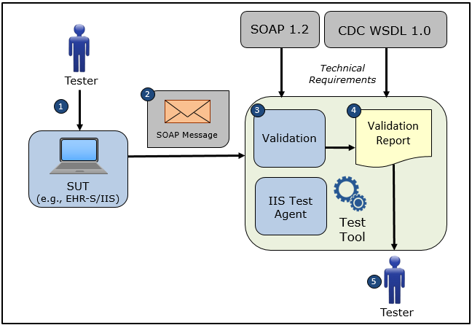

- The Tester obtains the username, password, and facilityID from the test data provided in the test tool and causes the System Under Test to connect to the NIST Test Tool representing an IIS Test Agent using the NIST web service endpoint specified on the screen of the Test Tool
- The Tester causes the System Under Test to electronically generate and transmit to the NIST Test Tool a submitSingleMessage request message that conforms to the SOAP 1.2 standard and CDC WSDL 1.0 used for transporting an HL7 test message to an IIS
- The Test Tool validates the submitSingleMessage request message for conformance to the SOAP 1.2 standard and CDC WSDL 1.0
- The Test Tool generates a Validation Report listing the results of the validation
- The Tester reviews the Validation Report and compares the results to the Objectives and Evaluation Criteria associated with the SOAPCON_3_SubmitSingleMessage_Message Test Case

Test Data Specification

Submit Single Message Request Message Information

Element Name | Data | Classification of Data
submitSingleMessage: username | vendor_? | Test Tool-Assigned
submitSingleMessage:password | vendor_? | Test Tool-Assigned
submitSingleMessage:facilityID | vendor_? | Test Tool-Assigned
submitSingleMessage:HL7 Message | MSH|^~\&amp;|||||20180726102500-0600||VXU^V04^VXU_V04|1cuT-A.01.01.3n|P|2.5.1|||ER|AL|||||Z22^CDCPHINVS&#xD;PID|1||L05M820^^^AIRA^MR||Northumberland^Kaja^Hetal^^^^L|Iversen^Trinidad^^^^^M|20020715|F||2106-3^White^CDCREC|93 Scott Cir^^Fountain^MI^49410^USA^P||^PRN^PH^^^231^6541667|||||||||2186-5^not Hispanic or Latino^CDCREC||N||||||N&#xD;PD1|||||||||||02^Reminder/Recall - any method^HL70215|N|20180726|||A|20180726|20180726&#xD;NK1|1|Northumberland^Iversen^Marion^^^^L|MTH^Mother^HL70063|93 Scott Cir^^Fountain^MI^49410^USA^P|^PRN^PH^^^231^6541667&#xD;ORC|RE||BL05M820.1^AIRA&#xD;RXA|0|1|20060726||03^MMR^CVX|999|||01^Historical^NIP001|||||||||||CP|A | Changeable

Explanation of Data Classification
Data Classification | Description | Validation
Configurable | Data typically that are configured by the system (customer-definable). Example data are provided. | Validate for the presence of data
System Generated | Data typically generated automatically by system, e.g., message time. Example data are provided. | Validate for the presence of data
IG Fixed | Data that are fixed by the implementation guide; data can’t be changed. Specific data are provided. | Validate for the presence and data content
Test Case Fixed | Data that are specific and fixed by the test case; data should not be changed. Specific data are provided. | Validate for the presence and selectively validate for data content
Changeable | Data where the exact content is not relevant for the test case and can be changed for the purposes of testing. Example data are provided. | Validate for the presence of data
Test Tool-Assigned | Data that are assigned by the test tool for the specific System Under Test in real-time. Example data are provided. | Validate for the presence and for data content
Test System-Provided | Data that are provided by the System Under Test in real-time. Example data are provided. | Validate for the presence and for data content

Message Content Table

Test Case Information
Element Name | Data
Test Case ID | Sender SOAPCON_3_SubmitSingleMessage_Message

Submit Single Message Request

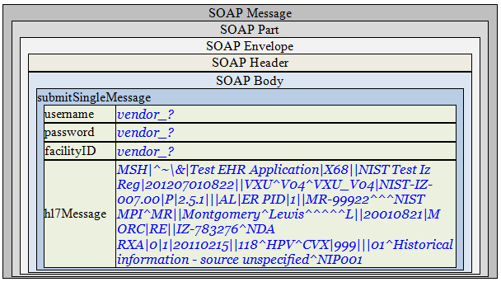

Message Content

Request Message Sent by Sender System

<?xml version='1.0' encoding='UTF-8'?>
<Envelope xmlns="http://www.w3.org/2003/05/soap-envelope">
<Header />
<Body>
<submitSingleMessage xmlns="urn:cdc:iisb:2011">
<username>vendor_?</username>
<password>vendor_?</password>
<facilityID>vendor_?</facilityID>
<hl7Message>MSH|^~\&amp;|||||20180726102500-0600||VXU^V04^VXU_V04|1cuT-A.01.01.3n|P|2.5.1|||ER|AL|||||Z22^CDCPHINVS&#xD;PID|1||L05M820^^^AIRA^MR||Northumberland^Kaja^Hetal^^^^L|Iversen^Trinidad^^^^^M|20020715|F||2106-3^White^CDCREC|93 Scott Cir^^Fountain^MI^49410^USA^P||^PRN^PH^^^231^6541667|||||||||2186-5^not Hispanic or Latino^CDCREC||N||||||N&#xD;PD1|||||||||||02^Reminder/Recall - any method^HL70215|N|20180726|||A|20180726|20180726&#xD;NK1|1|Northumberland^Iversen^Marion^^^^L|MTH^Mother^HL70063|93 Scott Cir^^Fountain^MI^49410^USA^P|^PRN^PH^^^231^6541667&#xD;ORC|RE||BL05M820.1^AIRA&#xD;RXA|0|1|20060726||03^MMR^CVX|999|||01^Historical^NIP001|||||||||||CP|A</hl7Message>
</submitSingleMessage>
</Body>
</Envelope>

