Immunization Test Suite

SOAP Envelope Testing

Version 1.0
March 29, 2016

Immunization Test Case
Generic
SOAPENV_1_MinTest

MinimalTest_Create_SOAP_Envelope

Test Description

Description
This test evaluates the capability of a technology to generate a message envelope conforming to the minimal requirements of the SOAP 1.2 standard.

Test Objectives
The generated SOAP message will demonstrate these minimal capabilities:
- element Envelope with child element Body as defined by the SOAP 1.2 standard
- user-chosen (conformant) XML content within Body (including no content) is permitted
- optional SOAP 1.2 elements (e.g. Header) are permissible but not required

SOAP Envelope Testing Diagram

Generic - SOAPENV_1_MinTest

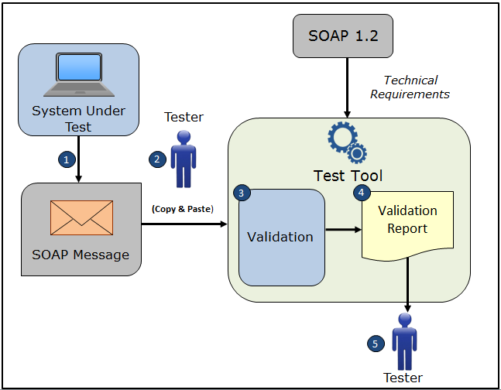

- The System Under Test (SUT) generates a SOAP message envelope
- The Tester copies this SOAP message envelope and pastes it into the Test Tool
- The Test Tool validates the SOAP message envelope for conformance to the minimal requirements of the SOAP 1.2 standard
- The Test Tool generates a Validation Report listing the results of the validation
- The Tester reviews the Validation Report and compares the results to the Objectives and Evaluation Criteria associated with the SOAPENV_1_MinTest Test Case

Envelope Content (Example) Table

Test Case Information
Element Name | Data
Test Case ID | Generic SOAPENV_1_MinTest

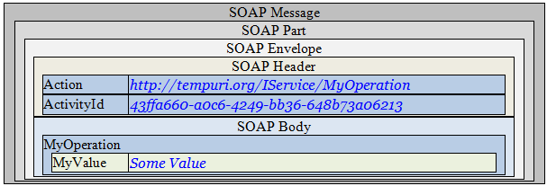

Example Envelope Content

Simple SOAP Message

<?xml version='1.0' encoding='UTF-8'?>
<!-- this is just an example SOAP message with non-empty Header and Body from the Web -->
<Envelope xmlns="http://www.w3.org/2003/05/soap-envelope">
<Header>
<Action mustUnderstand="1"
xmlns="http://schemas.microsoft.com/ws/2005/05/addressing/none">
http://tempuri.org/IService/MyOperation
</Action>
<ActivityId CorrelationId="7224e2a9-8f9c-4acb-a924-17cb6af67b23" xmlns="http://schemas.microsoft.com/2004/09/ServiceModel/Diagnostics">
43ffa660-a0c6-4249-bb36-648b73a06213</ActivityId>
</Header>
<Body>
<MyOperation xmlns="http://tempuri.org">
<MyValue>Some Value</MyValue>
</MyOperation>
</Body>
</Envelope>

