Immunization Test Suite

Receiver SOAP Envelope Testing

Version 1.0
March 29, 2016

Immunization Test Case
Receiver
SOAPENV_1_ConnectivityTest_Response

ConnectivityTest_Response
Test Description

Description
This test evaluates the capability of a Receiver technology to generate a valid message conforming to the SOAP 1.2 standard and CDC WSDL 1.0 that may be used for confirming the accessibility of the Immunization Information System (IIS) Web Service.

Test Objectives
The Receiver technology will demonstrate the ability to generate the SOAP message where the body of the message contains:
- the element connectivityTestResponse, as defined in the CDC WSDL 1.0
- arbitrary string value for the child element of connectivityTestResponse: return.

SOAP Envelope Testing Diagram

Receiver
SOAPENV_1_ConnectivityTest_Response

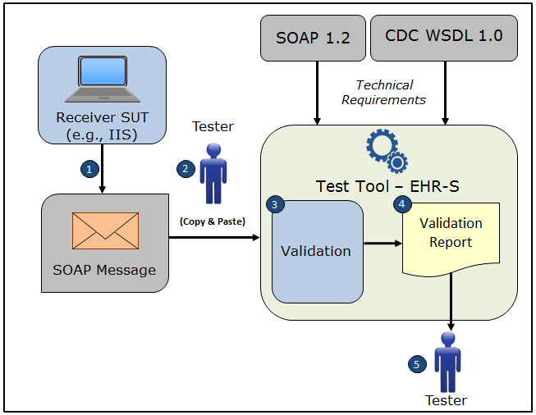

- The System Under Test (SUT) generates a valid connectivityTestResponse message envelope that conforms to the SOAP 1.2 standard and CDC WSDL 1.0 and that confirms the accessibility of the Immunization Information System (IIS) Web Service
- The Tester copies this SOAP connectivityTestResponse message envelope and pastes it into the Test Tool, which is functioning as the initiator system (e.g., EHR-S)
- The Test Tool validates the SOAP connectivityTestResponse message envelope for conformance to the SOAP 1.2 standard and CDC WSDL 1.0
- The Test Tool generates a Validation Report listing the results of the validation
- The Tester reviews the Validation Report and compares the results to the Objectives and Evaluation Criteria associated with the SOAPENV_1_ConnectivityTest_Response Test Case

Test Data Specification

Message Information

Element Name | Data | Classification of Data
connectivityTestResponse: return | You sent: Hello world! | Changeable

Explanation of Data Classification
Data Classification | Description | Validation
Configurable | Data typically that are configured by the system (customer-definable). Example data are provided. | Validate for the presence of data
System Generated | Data typically generated automatically by system, e.g., message time. Example data are provided. | Validate for the presence of data
IG Fixed | Data that are fixed by the implementation guide; data can’t be changed. Specific data are provided. | Validate for the presence and data content
Test Case Fixed | Data that are specific and fixed by the test case; data should not be changed. Specific data are provided. | Validate for the presence and selectively validate for data content
Changeable | Data where the exact content is not relevant for the test case and can be changed for the purposes of testing. Example data are provided. | Validate for the presence of data

Envelope Content Table

Test Case Information
Element Name | Data
Test Case ID | Receiver SOAPENV_1_ConnectivityTest_Response

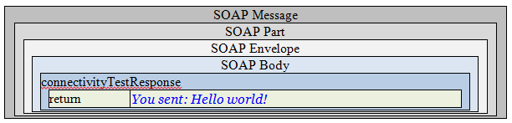

Envelope Content

Connectivity Test Response Message Sent by Receiver System

<?xml version='1.0' encoding='UTF-8'?>
<Envelope xmlns="http://www.w3.org/2003/05/soap-envelope">
<Body>
<connectivityTestResponse xmlns="urn:cdc:iisb:2011">
<return>You sent: Hello world!</return>
</connectivityTestResponse>
</Body>
</Envelope>

