Immunization Test Suite

Receiver SOAP Envelope Testing

Version 1.0
March 29, 2016

Immunization Test Case
Receiver
SOAPENV_2_SubmitSingleMessage_Response

SubmitSingleMessage_Response
Test Description

Description
This test evaluates the capability of a Receiver technology to generate a valid message conforming to the SOAP 1.2 standard and CDC WSDL 1.0 that may be used for transporting an HL7 response message to an electronic health record system (EHR-S) or an Immunization Information System (IIS).

Test Objectives
The Receiver technology will demonstrate the ability to generate the SOAP message where the body of the message contains:
- the element submitSingleMessageResponse, as defined in the CDC WSDL 1.0
- arbitrary string values for the child element of submitSingleMessageResponse: return.

SOAP Envelope Testing Diagram

Receiver
SOAPENV_2_SubmitSingleMessage_Response

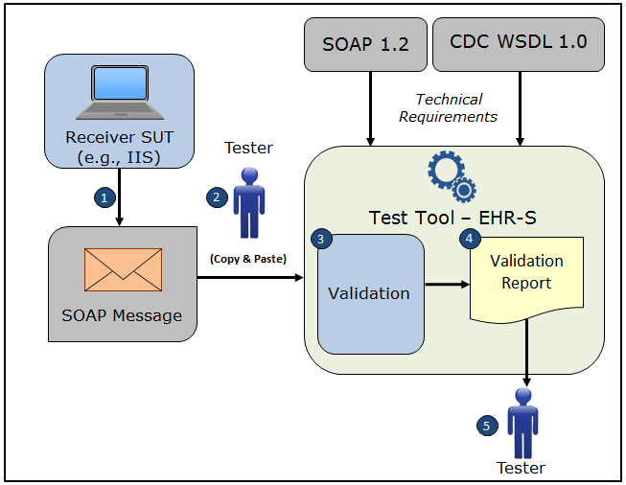

- The System Under Test (SUT) generates a SOAP submitSingleMessageResponse message envelope
- The Tester copies this SOAP submitSingleMessageResponse message envelope and pastes it into the Test Tool, which is functioning as the initiator system (e.g., EHR-S)
- The Test Tool validates the SOAP submitSingleMessageResponse message envelope for conformance to the SOAP 1.2 standard and CDC WSDL 1.0
- The Test Tool generates a Validation Report listing the results of the validation
- The Tester reviews the Validation Report and compares the results to the Objectives and Evaluation Criteria associated with the SOAPENV_2_SubmitSingleMessage_Response Test Case

Test Data Specification

Message Information

Element Name | Data | Classification of Data
submitSingleMessageResponse: return | MSH|^~|&|IISSUT|IISSUT|NISTEHR||<date/timeMSG>||ACK^V04^ACK|<msgControlID>|P|2.5.1|||NE | Changeable

Explanation of Data Classification
Data Classification | Description | Validation
Configurable | Data typically that are configured by the system (customer-definable). Example data are provided. | Validate for the presence of data
System Generated | Data typically generated automatically by system, e.g., message time. Example data are provided. | Validate for the presence of data
IG Fixed | Data that are fixed by the implementation guide; data can’t be changed. Specific data are provided. | Validate for the presence and data content
Test Case Fixed | Data that are specific and fixed by the test case; data should not be changed. Specific data are provided. | Validate for the presence and selectively validate for data content
Changeable | Data where the exact content is not relevant for the test case and can be changed for the purposes of testing. Example data are provided. | Validate for the presence of data

Envelope Content Table

Test Case Information
Element Name | Data
Test Case ID | Receiver SOAPENV_2_SubmitSingleMessage_Response

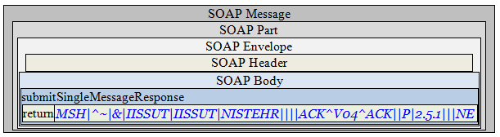

Envelope Content

Response Message Sent by Receiver System

<?xml version='1.0' encoding='UTF-8'?>
<Envelope xmlns="http://www.w3.org/2003/05/soap-envelope">
<Header />
<Body>
<submitSingleMessageResponse xmlns="urn:cdc:iisb:2011">
<return><![CDATA[MSH|^~|&|IISSUT|IISSUT|NISTEHR||<date/timeMSG>||ACK^V04^ACK|<msgControlID>|P|2.5.1|||NE]]></return>
</submitSingleMessageResponse>
</Body>
</Envelope>

