Immunization Test Suite

Receiver SOAP Envelope Testing

Version 1.0
March 29, 2016

Immunization Test Case
Receiver
SOAPENV_3_MessageTooLarge_Fault

MessageTooLarge_Fault
Test Description

Description
This test evaluates the capability of a Receiver technology to generate a valid message conforming to the SOAP 1.2 standard and CDC WSDL 1.0 which may be used to return a MessageTooLargeFault message in response to a submitSingleMessage request from a Sender (EHR-S or IIS).

Test Objectives
The Receiver technology will demonstrate the ability to generate the SOAP message where the body of the message contains:
- the Fault/Code/Value element set to the string ‘Receiver’
- the Fault/Reason/Text element set to an arbitrary string value
- the Fault/Detail element set to MessageTooLargeFault, as defined in the CDC WSDL 1.0
- the MessageTooLargeFault/Code element set to an arbitrary integer value
- the MessageTooLargeFault/Reason element set to the string ‘MessageTooLarge’
- the MessageTooLargeFault/Detail element set to an arbitrary string value
- SOAP Fault elements not specified here are optional and if used must conform to SOAP 1.2

SOAP Envelope Testing Diagram

Receiver
SOAPENV_3_MessageTooLarge_Fault

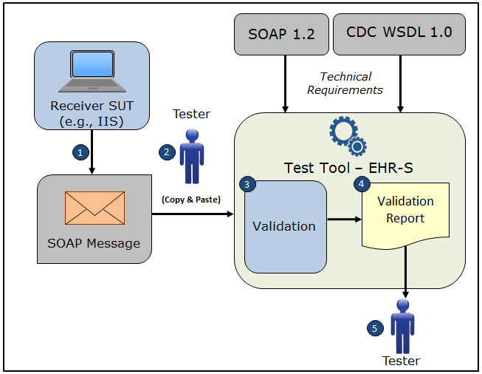

- The System Under Test (SUT) generates a valid MessageTooLargeFault SOAP response message envelope that conforms to the SOAP 1.2 standard and CDC WSDL 1.0 and that would be in response to a submitSingleMessage SOAP request from a Sender system
- The Tester copies this MessageTooLargeFault SOAP response message envelope and pastes it into the Test Tool, which is functioning as the initiator system (e.g., EHR-S)
- The Test Tool validates the MessageTooLargeFault SOAP response message envelope for conformance to the SOAP 1.2 standard and CDC WSDL 1.0
- The Test Tool generates a Validation Report listing the results of the validation
- The Tester reviews the Validation Report and compares the results to the Objectives and Evaluation Criteria associated with the SOAPENV_3_MessageTooLarge_Fault Test Case

Test Data Specification

Message Information

Element Name | Data | Classification of Data
Fault/Code/Value | Sender | Test Case Fixed
Fault/Reason/Text | Message Too Large Message Here | Changeable
Fault/Detail | MessageTooLargeFault | Test Case Fixed
MessageTooLargeFault/Code | 1313 | Changeable
MessageTooLargeFault/Reason | MessageTooLarge | Test Case Fixed
MessageTooLargeFault/Detail | More than one HL7 message was submitted. Please submit one and only one HL7 message per transaction | Changeable

Explanation of Data Classification
Data Classification | Description | Validation
Configurable | Data typically that are configured by the system (customer-definable). Example data are provided. | Validate for the presence of data
System Generated | Data typically generated automatically by system, e.g., message time. Example data are provided. | Validate for the presence of data
IG Fixed | Data that are fixed by the implementation guide; data can’t be changed. Specific data are provided. | Validate for the presence and data content
Test Case Fixed | Data that are specific and fixed by the test case; data should not be changed. Specific data are provided. | Validate for the presence and selectively validate for data content
Changeable | Data where the exact content is not relevant for the test case and can be changed for the purposes of testing. Example data are provided. | Validate for the presence of data

Envelope Content Table

Test Case Information
Element Name | Data
Test Case ID | Receiver SOAPENV_3_MessageTooLarge_Fault

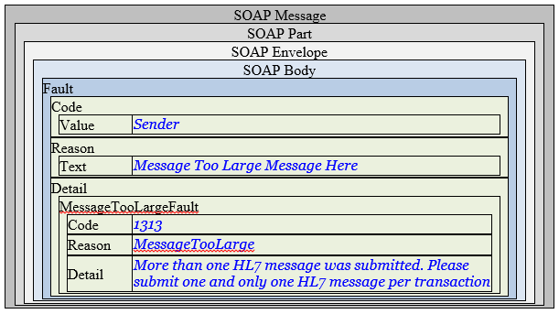

Envelope Content

Fault Response Message Sent by Receiver System

<?xml version='1.0' encoding='UTF-8'?>
<Envelope xmlns="http://www.w3.org/2003/05/soap-envelope" xmlns:junk="urn:foo:bar">
<Body>
<Fault>
<Code>
<Value>Sender</Value>
</Code>
<Reason>
<Text xml:lang="en">Message Too Large Message Here</Text>
</Reason>
<Detail>
<MessageTooLargeFault xmlns="urn:cdc:iisb:2011">
<Code>1313</Code>
<Reason xmlns:xs="http://www.w3.org/2001/XMLSchema" xmlns:xsi="http://www.w3.org/2001/XMLSchema-instance" xsi:type="xs:string">MessageTooLarge</Reason>
<Detail> More than one HL7 message was submitted. Please submit one and only one HL7
message per transaction </Detail>
</MessageTooLargeFault>
</Detail>
</Fault>
</Body>
</Envelope>

