Immunization Test Suite

Sender SOAP Envelope Testing

Version 1.0
March 29, 2016

Immunization Test Case
Sender
SOAPENV_1_ConnectivityTest_Request

ConnectivityTest_Request

Test Description

Description
This test evaluates the capability of a Sender technology to electronically generate a message conforming to the SOAP 1.2 standard and CDC WSDL 1.0 that may be used to electronically verify the accessibility of an IIS Web Service.

Test Objectives
The Sender technology will demonstrate the ability to electronically generate the SOAP message where the body of the message contains:
- the element connectivityTest, as defined in the CDC WSDL 1.0
- arbitrary string value for the child element of connectivityTest: echoBack.

SOAP Envelope Testing Diagram

Sender
SOAPENV_1_ConnectivityTest_Request

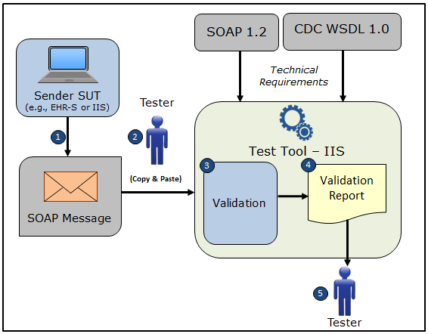

- The System Under Test (SUT) generates a valid connectivityTest request message envelope that conforms to the SOAP 1.2 standard and CDC WSDL 1.0 and that requests verification of the accessibility of an IIS Web Service
- The Tester copies this SOAP connectivityTest request message envelope and pastes it into the Test Tool, which is functioning as the receiver system
- The Test Tool validates the SOAP connectivityTest request message envelope for conformance to the SOAP 1.2 standard and CDC WSDL 1.0
- The Test Tool generates a Validation Report listing the results of the validation
- The Tester reviews the Validation Report and compares the results to the Objectives and Evaluation Criteria associated with the SOAPENV_1_ConnectivityTest_Request Test Case

Test Data Specification

Message Information

Element Name | Data | Classification of Data
ConnectivityTest: echoBack | Hello World! | Changeable

Explanation of Data Classification
Data Classification | Description | Validation
Configurable | Data typically that are configured by the system (customer-definable). Example data are provided. | Validate for the presence of data
System Generated | Data typically generated automatically by system, e.g., message time. Example data are provided. | Validate for the presence of data
IG Fixed | Data that are fixed by the implementation guide; data can’t be changed. Specific data are provided. | Validate for the presence and data content
Test Case Fixed | Data that are specific and fixed by the test case; data should not be changed. Specific data are provided. | Validate for the presence and selectively validate for data content
Changeable | Data where the exact content is not relevant for the test case and can be changed for the purposes of testing. Example data are provided. | Validate for the presence of data

Envelope Content Table

Test Case Information
Element Name | Data
Test Case ID | Sender SOAPENV_1_ConnectivityTest_Request

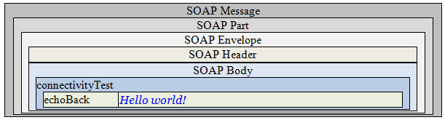

Envelope Content

Connectivity Test Request Message Sent by Sender System

<?xml version='1.0' encoding='UTF-8'?>
<Envelope xmlns="http://www.w3.org/2003/05/soap-envelope">
<Header/>
<Body>
<connectivityTest xmlns="urn:cdc:iisb:2011">
<echoBack>Hello world!</echoBack>
</connectivityTest>
</Body>
</Envelope>

