Immunization Test Suite

Sender SOAP Envelope Testing

Version 1.0
March 29, 2016

Immunization Test Case
Sender
SOAPENV_2_SubmitSingleMessage_Request

SubmitSingleMessage_Request

Test Description

Description
This test evaluates the capability of a Sender technology to electronically generate a message envelope conforming to the SOAP 1.2 standard and CDC WSDL 1.0 that may be used for electronically transporting an HL7 message to an immunization information system (IIS).

Test Objectives
The Sender technology will demonstrate the ability to electronically generate the SOAP message where the body of the message contains:
- the element submitSingleMessage, as defined in the CDC WSDL 1.0
- arbitrary string values for all child elements of submitSingleMessage: username, password, facilityID, and HL7Message.

SOAP Envelope Testing Diagram

Sender
SOAPENV_2_SubmitSingleMessage_Request

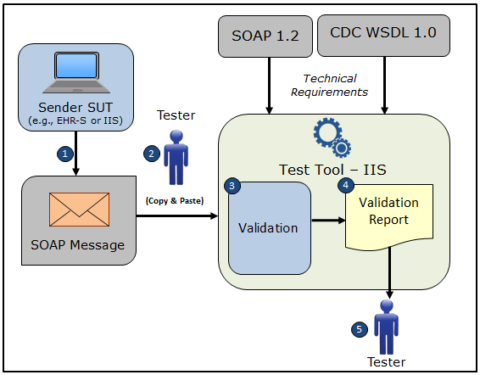

- The System Under Test (SUT) generates a SOAP submitSingleMessage request message envelope
- The Tester copies this SOAP submitSingleMessage request message envelope and pastes it into the Test Tool, which is functioning as the receiver system
- The Test Tool validates the SOAP submitSingleMessage message envelope for conformance to the SOAP 1.2 standard and CDC WSDL 1.0
- The Test Tool generates a Validation Report listing the results of the validation
- The Tester reviews the Validation Report and compares the results to the Objectives and Evaluation Criteria associated with the SOAPENV_2_SubmitSingleMessage_Request Test Case

Test Data Specification

Message Information

Element Name | Data | Classification of Data
submitSingleMessage: username | leonidas | Changeable
submitSingleMessage: password | Spartans300! | Changeable
submitSingleMessage: facilityID | EHR1234 | Changeable
submitSingleMessage: HL7 Message | MSH|^~\&amp;|Test EHR Application|X68||NIST Test Iz Reg|201207010822||VXU^V04^VXU_V04|NIST-IZ-007.00|P|2.5.1|||AL|ER&#xD;PID|1||MR-99922^^^NIST MPI^MR||Montgomery^Lewis^^^^^L||20010821|M&#xD;ORC|RE||IZ-783276^NDA&#xD;RXA|0|1|20110215||118^HPV^CVX|999|||01^Historical information - source unspecified^NIP001 | Changeable

Explanation of Data Classification
Data Classification | Description | Validation
Configurable | Data typically that are configured by the system (customer-definable). Example data are provided. | Validate for the presence of data
System Generated | Data typically generated automatically by system, e.g., message time. Example data are provided. | Validate for the presence of data
IG Fixed | Data that are fixed by the implementation guide; data can’t be changed. Specific data are provided. | Validate for the presence and data content
Test Case Fixed | Data that are specific and fixed by the test case; data should not be changed. Specific data are provided. | Validate for the presence and selectively validate for data content
Changeable | Data where the exact content is not relevant for the test case and can be changed for the purposes of testing. Example data are provided. | Validate for the presence of data

Envelope Content Table

Test Case Information
Element Name | Data
Test Case ID | Sender SOAPENV_2_SubmitSingleMessage_Request

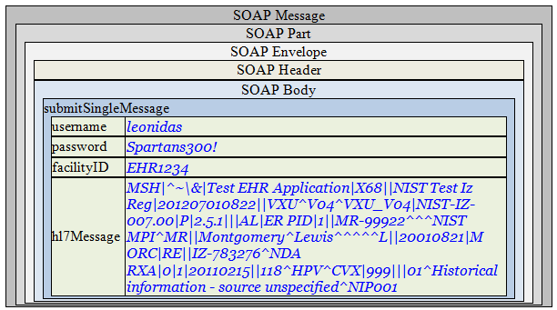

Envelope Content

Request Message Sent by Sender System

<?xml version='1.0' encoding='UTF-8'?>
<Envelope xmlns="http://www.w3.org/2003/05/soap-envelope">
<Header />
<Body>
<submitSingleMessage xmlns="urn:cdc:iisb:2011">
<username>leonidas</username>
<password>Spartans300!</password>
<facilityID>EHR1234</facilityID>
<hl7Message>MSH|^~\&amp;|Test EHR Application|X68||NIST Test Iz Reg|201207010822||VXU^V04^VXU_V04|NIST-IZ-007.00|P|2.5.1|||AL|ER&#xD;PID|1||MR-99922^^^NIST MPI^MR||Montgomery^Lewis^^^^^L||20010821|M&#xD;ORC|RE||IZ-783276^NDA&#xD;RXA|0|1|20110215||118^HPV^CVX|999|||01^Historical information - source unspecified^NIP001</hl7Message>
</submitSingleMessage>
</Body>
</Envelope>

