**DARQ Command Line Tool Documentation**

## Required files :

* darq-cli.jar : command line Jar file
* patient.tsv : tab separated values file containing patient records following extract specification
* vaccination.tsv : tab separated values file containing vaccination records following extract specification
* configuration.json : configuration file provided by AIRA

## Required Environment :

* Java 8 installed.
* Terminal access.

## Usage :

1. Open a Terminal Window
2. Run command :

java -jar *[PATH_TO_JAR]* -p=*[PATH_TO_PATIENT_EXTR]* -v=*[PATH_TO_VACC_EXTR]* -c=*[PATH_TO_CONF_JSON]*

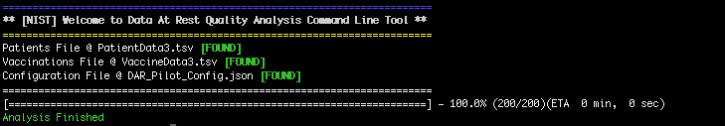

When the processing is finished a folder named darq_analysis is going to appear in the current folder pointed to by the Terminal

## Analysis Result :

* darq_analysis / summary / **index.html** 
  + HTML file containing the summary of what was extracted and how data has been aggregated
* darq_analysis / **ADF.data**
  + Encrypted file containing de identified and aggregated data

*[SEND TO AIRA FOR REPORT]*

## Troubleshooting :

### Make sure terminal is configured to use Java 8

To check which version of java you are using run command `java -version` its output should be : java version "1.8.*" in case your terminal is using a different version of java there might be some issue that arise.

### Change Java version in Mac OS X

First run command `/usr/libexec/java_home -V` which will output your installed java version, if java 1.8.* does not appear in the list you can install it from <https://www.oracle.com/technetwork/java/javase/downloads/jdk8-downloads-2133151.html>

Once installed you can configure your terminal to use that version :

export JAVA_HOME=`/usr/libexec/java_home -v 1.8`

### Change Java version in Windows

<https://www.java.com/en/download/help/path.xml>

### Other problems

In case of failure, please send the output darq_cli.log file to AIRA to examine.