Setting up Windows Terminal for ROS Noetic

Installation by going to Microsoft Store website and searching for Windows Terminal. Install.

Add ROS Noetic terminal to Window terminal. To open or create other types of tabs, click the downward arrow button and select one from the list of available options.

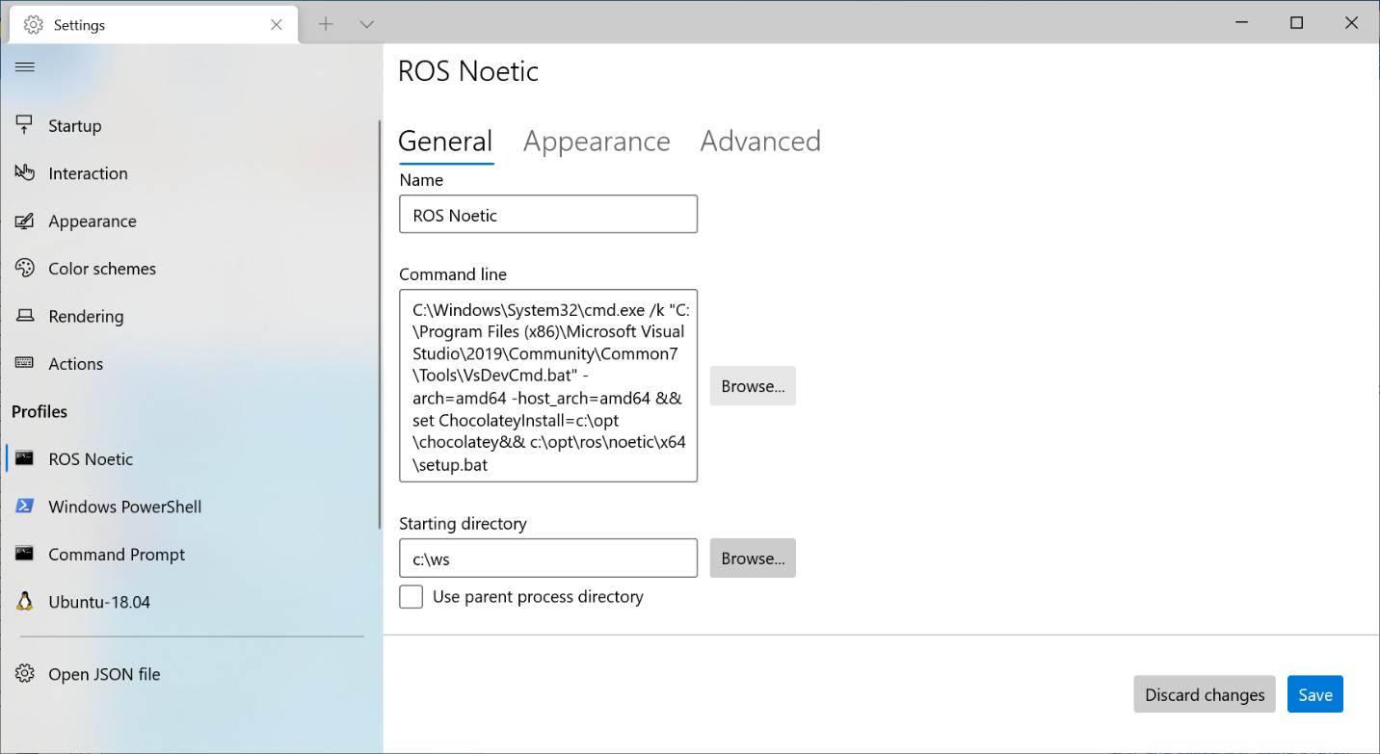

Copy in ROS command line:

C:\Windows\System32\cmd.exe /k "C:\Program Files (x86)\Microsoft Visual Studio\2019\Community\Common7\Tools\VsDevCmd.bat" -arch=amd64 -host_arch=amd64&& set ChocolateyInstall=c:\opt\chocolatey&& c:\opt\ros\noetic\x64\setup.bat

I eventually changed starting directory to C:\opt\ros\noetic

Next change the default terminal to the ROS Noetic:

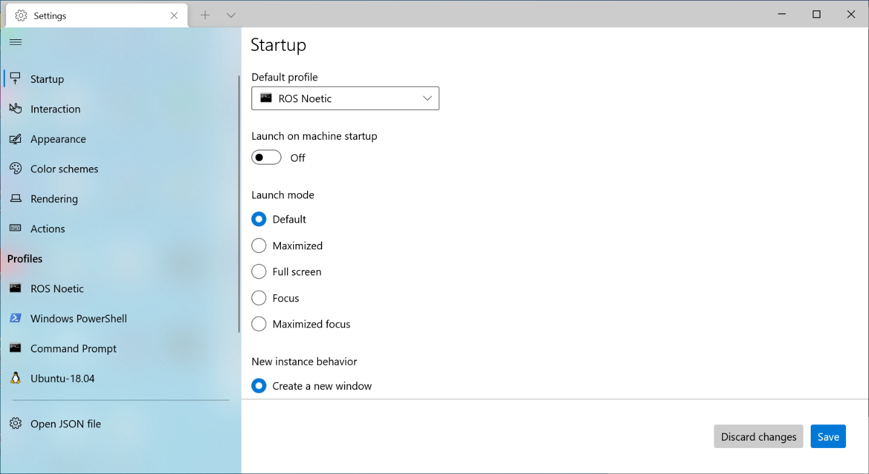

More advanced configuration options can be found here: <https://helpdeskgeek.com/windows-10/how-to-install-use-the-new-windows-10-terminal/>