# Instructions

Assume clean logon. ROS1 noetic installed on Windows, and 'new' windows terminal setup. ROS1 on Windows is installed to C:\opt\ros\noetic.

# Install and Build

Assume ROS 1 noetic is installed C:\opt\ros\noetic.

> C:\opt\ros\noetic

> git clone [git@gitlab.nist.gov:michalos/gzpegboard.git](mailto:git@gitlab.nist.gov:michalos/gzpegboard.git)

> cd gzpegboard

> catkin_make

> catkin_make install

# Run

## Setup from Windows Terminal

You will need two terminals to run the code. I used Windows Terminal (google it). After starting environment variables:

GAZEBO_MASTER_URI=http://localhost:11345

GAZEBO_MODEL_DATABASE_URI=http://models.gazebosim.org

GAZEBO_MODEL_PATH=C:\opt\ros\noetic\x64\share\gazebo-10\models;

GAZEBO_PLUGIN_PATH=C:\opt\ros\noetic\x64\lib\gazebo-10\plugins;

GAZEBO_RESOURCE_PATH=C:\opt\ros\noetic\x64\share\gazebo-10;

HOME=C:\Users\michalos

HOMEDRIVE=C:

HOMEPATH=\Users\michalos

This sets up VC 2019, noetic bin and gazebo paths

Settings:

C:\Windows\System32\cmd.exe /k "C:\Program Files (x86)\Microsoft Visual Studio\2019\Community\Common7\Tools\VsDevCmd.bat" -arch=amd64 -host_arch=amd64&& c:\opt\ros\noetic\x64\setup.bat && C:\opt\ros\noetic\x64\share\gazebo-10\setup.bat

Start two windows terminal and

To run:

TERMINAL 1:

> cd C:\opt\ros\noetic\gzpegboard

> devel\setup.bat

> cd bin

> gzpegboard.bat

TERMINAL 2:

> cd C:\opt\ros\noetic\gzpegboard

> devel\setup.bat

> rosrun test_gazebo_package test_gazebo_package rosbreak:=0 deadReckoning:=1

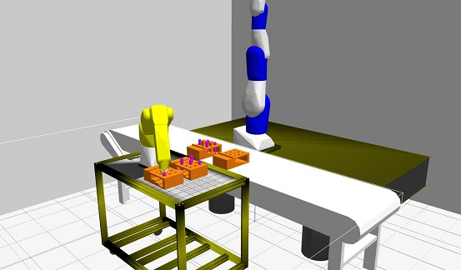

rosbreak:=0 ignores a breakpoint in vscode

deadReckoning:=1 performs the dead reckoning peg in hole insertion.

deadReckoning:=0 performs demo of guarded move.

