**Implementation of a Viscoelastic UMAT in CalculiX**

The theory and derivations for this implementation are from:

[1] Kaliske, M., Rothert, H. Formulation and implementation of three-dimensional viscoelasticity at small and finite strains. *Computational Mechanics* **19**, 228–239 (1997). <https://doi.org/10.1007/s004660050171>

However, instead of a generalized Maxwell model with *N* chains, we have chosen to implement just one chain (*N* = 1). This is also known as the standard linear solid (SLS) model, or the Zener model. The combination of springs and dampers representing the SLS model is given below in Figure 1.

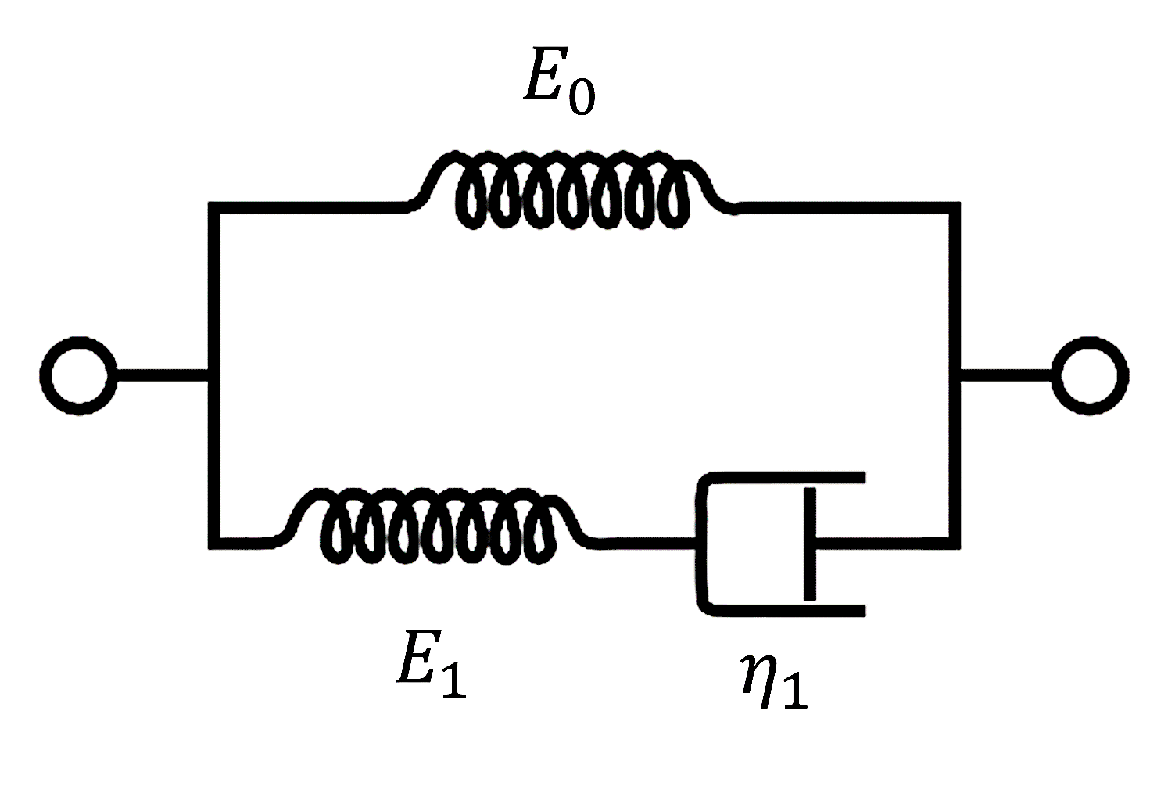

Figure . Maxwell representation of the standard linear solid (SLS) model.

The 1D ordinary differential equation of this system is given next,

|  |  |  |
| --- | --- | --- |
|  | $$σ+\frac{η}{E_{1}}\dot{σ}=E_{0}ε+\frac{η_{1}\left(E_{0}+E_{1}\right)}{E_{1}}\dot{ε}$$ | 1 |

where $σ$ is the total stress, $ε$ is the total strain, $η_{1}$ is the damping viscosity of the dashpot component, and $E_{0}$ and $E_{1}$ are the stiffnesses of the remaining spring components. The dot notation implies a derivative with respect to time, $\dot{σ}={dσ}/{dt}$.

The development of a numerical model in rate-form that solves for the new stress at a given time increment is described in detail by Kaliske and Rothert [1]. We chose to restrict our model to small strains, and our 3D implementation represents a total viscoelasticity model, in contrast to a volumetric and isochoric split of the stresses.

When solving for the stress at time, $t=n+1$, the total stress can be broken into two components,

|  |  |  |
| --- | --- | --- |
|  | $$σ^{n+1}=h_{e}^{n+1}+h_{1}^{n+1}$$ | 2 |

where $h_{e}^{n+1}$ is the elastic stress of the single-spring component, and $h_{1}^{n+1}$ is the stress related to the spring-dashpot chain. Note, we use boldface letters to denote rank-2 tensors, while double-struck fonts will be used for rank-4 tensors.

First, let us tackle the simpler update equation for $h_{e}^{n+1}$,

|  |  |  |
| --- | --- | --- |
|  | $$h_{e}^{n+1}=h_{e}^{n}+ Δh_{e}={h_{e}^{n}+C}_{e} Δε$$ | 3 |

where $C_{e}$ is the rank-4 elastic stiffness tensor. In Eq 3, it is assumed that the current increment in total strain, $Δε$, is provided as input to the stress-update subroutine. For completeness, $C_{e}$ can be portrayed in matrix form using Voigt notation,

|  |  |  |
| --- | --- | --- |
|  | $$\left[C_{e}\right]=\frac{E_{0}}{\left(1+ν\right)\left(1-2ν\right)}\left[\begin{matrix}1-ν & ν & ν & 0 & 0 & 0 \\ ν & 1-ν & ν & 0 & 0 & 0 \\ ν & ν & 1-ν & 0 & 0 & 0 \\ 0 & 0 & 0 & \frac{1-2ν}{2} & 0 & 0 \\ 0 & 0 & 0 & 0 & \frac{1-2ν}{2} & 0 \\ 0 & 0 & 0 & 0 & 0 & \frac{1-2ν}{2}\end{matrix}\right]$$ | 4 |

where, as before, $E_{0}$ is the stiffness of the single-spring component, which in 3D, can be interpreted as the Young’s modulus. Poisson’s ratio, $ν$, has also been introduced to the model in order to extend the SLS model into 3D. When using Voigt notation, be sure to include a two on the kinematic terms, like so,

|  |  |  |
| --- | --- | --- |
|  | $$\left[h_{e}^{n+1}\right]=\left[\begin{matrix}{\left(h_{e}^{n+1}\right)}_{11} \\ {\left(h_{e}^{n+1}\right)}_{22} \\ {\left(h_{e}^{n+1}\right)}_{33} \\ {\left(h_{e}^{n+1}\right)}_{12} \\ {\left(h_{e}^{n+1}\right)}_{13} \\ {\left(h_{e}^{n+1}\right)}_{23}\end{matrix}\right] ; \left[Δε\right]=\left[\begin{matrix}{\left(Δε\right)}_{11} \\ {\left(Δε\right)}_{22} \\ {\left(Δε\right)}_{33} \\ {2\left(Δε\right)}_{12} \\ {2\left(Δε\right)}_{13} \\ {2\left(Δε\right)}_{23}\end{matrix}\right]$$ | 5 |

Next, the update equation for $h_{1}^{n+1}$,

|  |  |  |
| --- | --- | --- |
|  | $$h_{1}^{n+1}=\exp\left(-\frac{Δt}{τ_{1}}\right)h_{1}^{n}+γ_{1}\frac{1-\exp\left(-\frac{Δt}{τ_{1}}\right)}{\frac{Δt}{τ_{1}}} Δh_{e}$$ | 6 |

where $τ_{1}$ and $γ_{1}$ are material parameters, and $Δt$ is the current increment in time (i.e., $Δt=t^{n+1}-t^{n}$). Furthermore, $τ_{1}$ is the relaxation time of the spring-dashpot chain, and it is defined as,

|  |  |  |
| --- | --- | --- |
|  | $$τ_{1}≡\frac{η_{1}}{E_{1}}$$ | 7 |

Additionally, $γ_{1}$ is a normalized parameter that relate the stiffness of springs,

|  |  |  |
| --- | --- | --- |
|  | $$γ_{1}≡\frac{E_{1}}{E_{0}}$$ | 8 |

With the update equations defined for $h_{e}^{n+1}$ and $h_{1}^{n+1}$, it is now straightforward to update the total stress, $σ^{n+1}$, using Eq 2. The next step is to calculate the algorithmic tangent modulus, $C_{alg}$, which is necessary for implicit finite element schemes,

|  |  |  |
| --- | --- | --- |
|  | $$C_{alg}≡\frac{∂σ^{n+1}}{∂ε^{n+1}}=\left(1+γ_{1}\frac{1-\exp\left(-\frac{Δt}{τ_{1}}\right)}{\frac{Δt}{τ_{1}}}\right)C_{e}$$ | 9 |

In the implementation, $C_{alg}$ has major and minor symmetries. Moreover, is symmetric $h_{e}$ and $h_{1}$ are state variables that are initialized to all zeros and must be stored between calls to the stress update subroutine.