Names:

Chance Potter: cpotte4 UIN:671387635

Urja Soni: usoni3 UIN:676438205

-We are using Stanford Core NLP for this project.

**#Assumptions:**

tools/Stanford directory has the following jar files in it:

**Note:**

This has 2 new Jar files to run the database on the terminal:

* Ojdbc6
* Sqlite-jdbc-3.8.11.2

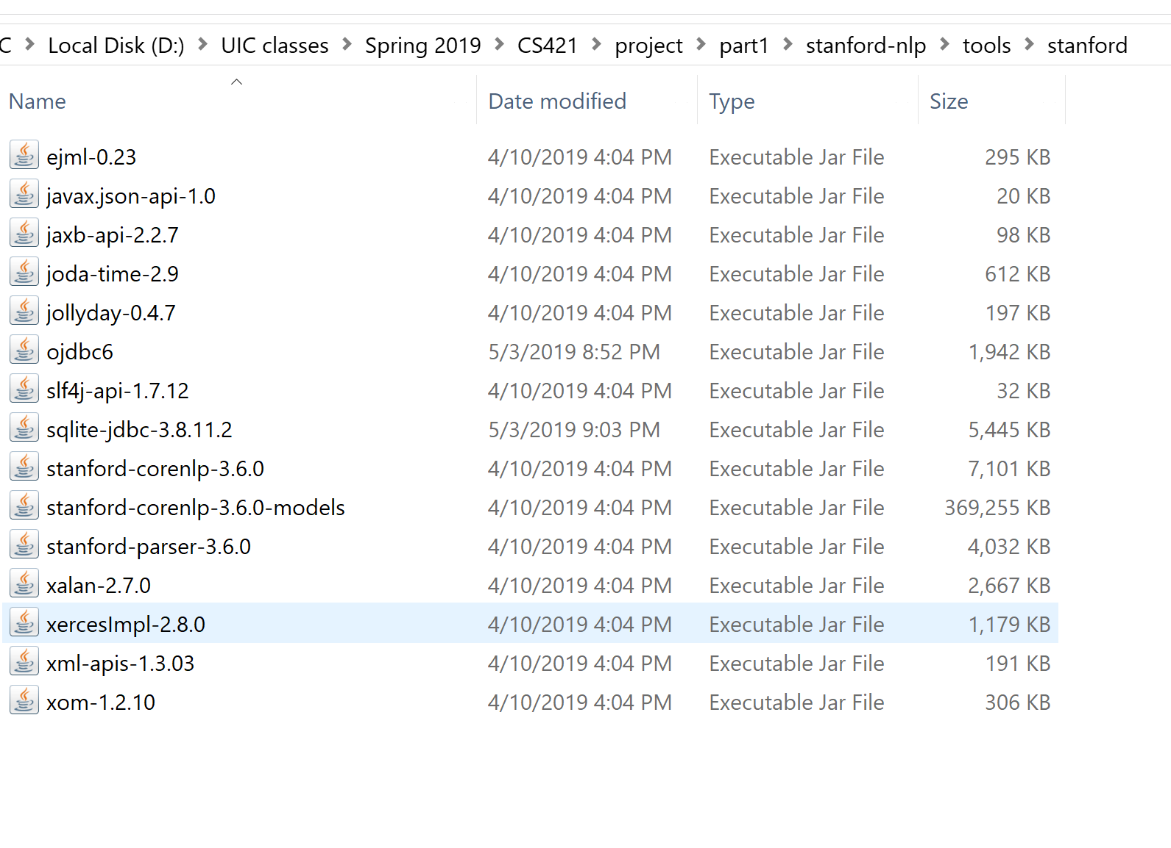

**1. Unzip the folder which will contain following files:**

-custom.rules

-Parser.java (This file contains the output from the sentences mentioned in the document.)

-usoni3_cpotte4.jar

-pom.xml

- Ojdbc6

- Sqlite-jdbc-3.8.11.2

-parsed.txt (This is file contains the output of the sentences that were being asked to turn in with the assignment)

-#Run the jar file **[in order to run the file, you need to have the two jar files mentioned above in the tools\stanford directory]**

**NOTE:** We were having problem running the following jar file on the terminal using the command mentioned in the guideline file. For the alternative, there are two ways you can run the code to get the outfit:

1. In terminal
2. Eclipse
3. To run on terminal:

**run the following command:**

java -classpath ./tools/stanford/*;usoni3_cpotte4.jar nlp.parser.Parser input.txt

This will show the output of the code with questions, query and it’s answers.

1. To run it on eclipse:

-Make sure there is tools\stanford folder in same place as all the other files. That directory should have all the jar files from Stanford in addition to two additional one to run the database.

-In eclipse import the folder that contains everything

-Run the Parser.java file

-This should give you the same output which has questions, query and answer.