When Coding Agents Repeat: Persistence, Selection, and the Limits of Loop Breaking
A study of repeated tool calls in Gemma 4's coding agent
Jiarui Zha, zha.j@northeastern.edu
Abstract
We study why Gemma 4 31B, as a coding agent with thinking off, sends the same tool call again and again until its budget runs out. On 109 tasks in the harness of Kaggle's Gemma 4 Developer Agent competition, at least half the calls are repeats or malformed in a quarter of task runs, and these runs resolve 20% of the time, against 37%. Using one-step replays at fixed histories and whole-task runs under three levers, we find that: (1) the chance of one more identical call rises from 78% after two calls to 99% after ten even when a proxy holds the request fixed, so most of the rise is selection of states where the model is already near certain of the call, and identical copies in context add to it; (2) loops can be broken but not removed: where the model, free to think, chose not to, a forced thought lets the next call escape 58% of the time, against 11%; and (3) no lever measurably changes resolution.
1 Introduction
Coding agents often send the same tool call again and again until the budget runs out. In SWE-Gym, 29–40% of zero-shot runs of open models repeat one action three times in a row (Pan et al., 2025), and harnesses such as OpenHands and Gemini CLI ship loop detectors. We met this failure while building an agent with Gemma 4 31B, thinking off, for Kaggle's Gemma 4 Developer Agent competition: in one early run, half the failed tasks (23 of 46) spent at least a fifth of their calls on repeats.
Self-reinforcing repetition is known in text generation (Holtzman et al., 2020; Xu et al., 2022). After two identical actions, agents take a third 37% of the time (Liu et al., 2026), and branches of a research agent restarted with a fresh context sometimes land in a new “idea basin”, which their score then selects (Cai et al., 2026). We ask whether the chance of a repeat rises because of the copies or because runs start where the model is already near certain of the call, and whether breaking loops over whole tasks, with no grader to choose among the escapes, solves more tasks.
We answer with one-step replays at recorded histories and with whole-task runs of three levers against a control. Our contributions are:
(1) Lock-in is mostly selection. With a proxy that holds the request fixed, the chance of one more identical call still rises from 78% to 99%, and identical copies add to it. Gemma 4 12B, without the proxy, locks in at the same rates (§4).
(2) Loops end from outside: at T = 0.2 the agent never ended a run of five or more identical calls itself, in 1,342 chances (§5).
(3) The pattern of the context cues the copy, not what the results say; a forced thought breaks it where the model chose not to think (§6).
(4) No lever that breaks loops measurably changes resolution (§7).
2 Setting and measures
The agent is Gemma 4 31B (int4, w4a16) with thinking off, in the competition's harness, with the host's sample prompts plus rules for tool-call arguments. Each task allows 4 minutes, 60 tool calls and 100 turns; sampling is T = 0.2, top-p 0.95, top-k 64. The tasks are the 109 of the competition's 129 public development tasks whose grading is sound (the reference patch passes and an empty patch fails), from fastapi, requests, httpx and rich. A run is resolved when the grader's tests pass.
Whole-task runs compare a control with three levers, two passes each unless noted: T = 1, as Google recommends (Google, 2026); a chat template with an empty thought before every model turn, as a Hugging Face pull request proposes (Hugging Face, 2026; one pass); and a proxy that collapses each run of identical tool turns (same call, same result) to its first. The harness still runs every call, but while a run lasts the model gets the same request again. Two passes of Gemma 4 12B test generality. One-step replays score the next call at recorded histories that we edit (adding copies, rewriting results, forcing a thought open): the probability of the recorded call, and one to three sampled calls per state. The histories were recorded on an earlier serving stack; where we checked, the replayed copy rate matches the recorded one (0.639 against 0.634).
A call is stale if it repeats an earlier one (same tool and arguments) with no successful file edit since, and a copy if that call came just before. A malformed call's arguments do not fit the tool. A loop task run has at least half its calls stale or malformed. After k identical calls, the hazard h(k) is the probability that the next is identical too, counted on clean steps: no budget warning in the last result and no compaction before the call. An escape, one step ahead, is a sampled call that is neither stale nor malformed. Intervals are 95%, from resampling tasks.
3 Loops are common and mark lost runs
In the control, 38.6% of calls are stale and 28.0% are copies, and a quarter of task runs (54 of 218) are loop task runs. Most long runs repeat a search or a command: of the 116 runs of three or more identical calls, 39 are read-only searches, 50 other commands and 26 malformed calls. Loop task runs resolve 20% of the time (11 of 54), against 37% (61 of 164) for the rest. Within the 20 sometimes-solved tasks that have both kinds of run, the runs that loop resolve 22.8 points less often (−41.1 to −4.3). Which tasks loop is largely a property of the task: the two control passes share 15 of their 27 loop tasks, against about 7 by chance. Gemma 4 12B loops in 44.5% of its task runs. These are associations: a run that is already lost may loop because it is lost. §7 tests whether removing loops helps.
4 Selected, then sealed
In the control, a fresh call is followed by an identical one 2.4% of the time. After two identical calls the hazard is 0.68, after three or four 0.96, and from five on the agent continued at every clean step (Fig. 1b). Two mechanisms predict a curve that rises like this. Under reinforcement, each copy in context makes the next one likelier, as repetition does in text generation (Xu et al., 2022). Under selection, runs start where the model is already near certain of the call, and the longer a run lasts, the more it consists of such states.
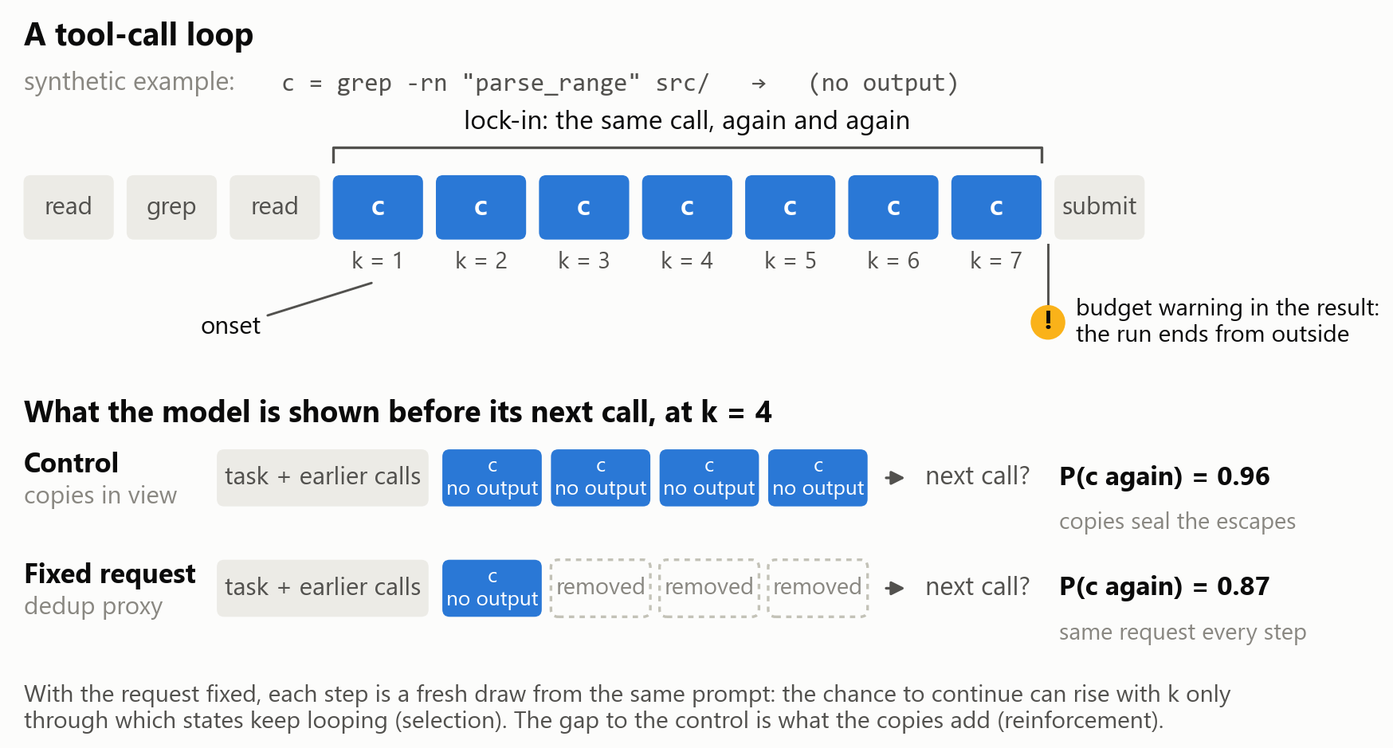
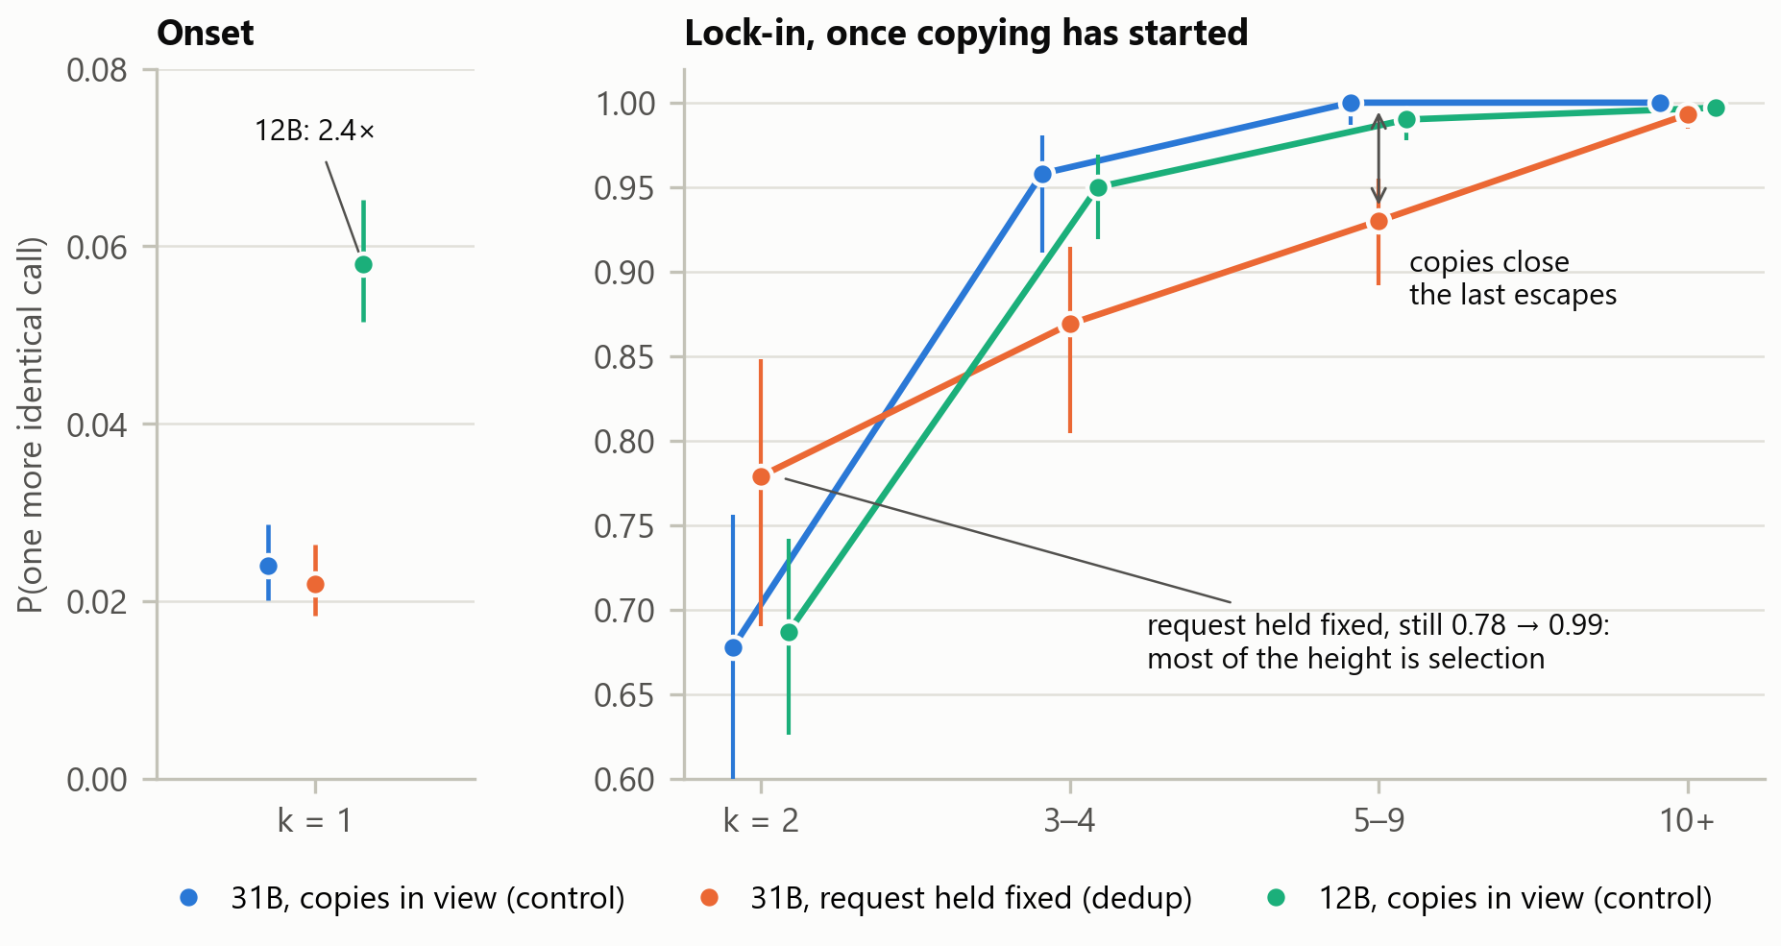
Figure 1. (a) A tool-call loop and the fixed-request test, on a synthetic call c. Before the next call at k = 4, the control shows the model every copy; the proxy collapses the run to its first call, so the request is the same at every step. (b) The hazard of one more identical call on clean steps, with the copies in view (31B and 12B) and with the request held fixed (31B). Bars are binomial 95% intervals, not clustered by task.
A rising hazard is no evidence of reinforcement by itself. Suppose each state s draws the same call again with a fixed probability p, as it does when the request is held fixed. Over the states where runs start, h(k) = E[p^k] / E[p^(k−1)], and since E[p^k]^2 ≤ E[p^(k−1)] E[p^(k+1)] (Cauchy–Schwarz), h(k) never falls with k, whatever the mix of states. This is the frailty effect of survival analysis, where differences between individuals alone make a population's hazard rise (Vaupel et al., 1979). The proxy separates the two mechanisms: with the request fixed, any rise is selection, and the gap to the control is what the copies add (Fig. 1a).
With the request fixed, the hazard still rises: 0.78 after two identical calls, 0.87 after three or four, 0.93 after five to nine and 0.99 after ten or more. Most of the curve's height is selection. The copies add nothing measurable at k = 2 (proxy minus control, paired over tasks: +7.6 points, −8.9 to +22.4). From three calls on, they close the escapes that remain: −7.0 points (−13.3 to −0.8) at three or four, and −4.1 (−7.3 to −1.1) at five to nine. Without the copies in view the agent ends 47% of its runs of three or more itself, against 15% (+32 points, +20 to +45), yet about three quarters of its runs of ten or more persist. One step ahead, at 60 fixed histories after a search that found nothing, identical copies raise the probability of the same search from 0.002 with one copy to 0.43 with four. Re-spelled copies of it, with the same results, leave it near 0.03. The copies reinforce on their exact tokens.
Gemma 4 12B starts runs more readily: it copies a fresh call 5.8% of the time, against 2.4% (+3.2 points, +2.2 to +4.2). From k = 2 on its hazard matches the 31B's, and no difference's interval excludes zero. Size moves the onset, not the lock-in. We did not run the proxy at 12B, so selection is measured at 31B only.
Use of AI tools
Claude (Anthropic) helped write the experiment and analysis code, checked the references, and drafted parts of this text from the author's records. ChatGPT (OpenAI) gave advice on the experiment’s design and helped interpret and analyze the experiment results. The author directed the study, revised the text, and is responsible for its content.
References (cited so far)
Cai et al. 2026. Fork-and-Flush: Escaping Idea Basins in Autoresearch Agents. arXiv:2610.07447.
Google. 2026. Gemma 4 model card. https://ai.google.dev/gemma/docs/core/model_card_4.
Holtzman et al. 2020. The Curious Case of Neural Text Degeneration. ICLR. arXiv:1904.09751.
Hugging Face. 2026. google/gemma-4-31B-it, pull request #147. https://huggingface.co/google/gemma-4-31B-it/discussions/147.
Liu et al. 2026. When History Fails to Become Experience: Action Calibration in Language Agents. arXiv:2610.02769.
Pan et al. 2025. Training Software Engineering Agents and Verifiers with SWE-Gym. arXiv:2412.21139.
Vaupel et al. 1979. The Impact of Heterogeneity in Individual Frailty on the Dynamics of Mortality. Demography 16(3), 439–454. doi:10.2307/2061224.
Xu et al. 2022. Learning to Break the Loop: Analyzing and Mitigating Repetitions for Neural Text Generation. NeurIPS. doi:10.52202/068431-0223.

