When Coding Agents Repeat: Persistence, Selection, and the Limits of Loop Breaking
  - A study of repeated tool calls in Gemma 4's coding agent
Jiarui Zha, zha.j@northeastern.edu

Abstract
We study why Gemma 4 31B, as a coding agent with thinking off, sends the same tool call again and again until its budget runs out. On 109 tasks in the harness of Kaggle's Gemma 4 Developer Agent competition, at least half the calls are repeats or malformed in a quarter of task runs, and these runs resolve 20% of the time, against 37%. Using one-step replays at fixed histories and whole-task runs under three levers, we obtain three findings. (1) The chance of one more identical call rises from 78% after two calls to 99% after ten even with a fixed request, showing that accumulating copies is unnecessary for increasing persistence. Fixed-history edits independently show that identical copies reinforce immediate repetition. (2) One-step escapes can be induced: where the model, free to think, chose not to, a forced thought lets the next call escape 58% of the time, against 11%. (3) None of the three whole-task interventions produced a detectable improvement in resolution under the tested budget.

1 Introduction
Coding agents often send the same tool call again and again until the budget runs out. In SWE-Gym, 29–40% of zero-shot runs of open models repeat one action three times in a row (Pan et al., 2025), and harnesses such as OpenHands and Gemini CLI ship loop detectors.
Self-reinforcing repetition is known in text generation (Holtzman et al., 2020; Xu et al., 2022). After two identical actions, agents take a third 37% of the time (Liu et al., 2026), and branches of a research agent restarted with a fresh context sometimes land in a new “idea basin”, which their score then selects (Cai et al., 2026). We ask whether the chance of a repeat rises because of the copies or because runs start where the model is already near certain of the call, and whether breaking loops over whole tasks, with no grader to choose among the escapes, solves more tasks.
We answer with one-step replays at recorded histories and with whole-task runs of three levers against a control. Our contributions are:
(1) Persistence rises even with a fixed request. Continuation increases from 78% to 99% under the proxy, consistent with selection of persistent states; fixed-history edits separately establish reinforcement by identical copies. The two model sizes show similar continuation curves once copying has begun (§4).
(2) In the 31B control at T = 0.2, no spontaneous exit occurred in 1,342 observed clean transitions after five or more identical, well-formed calls (§5).
(3) The pattern of the context cues the copy, not what the results say; a forced thought breaks it where the model chose not to think (§6).
(4) The three whole-task interventions alter repetition, but none produces a detectable improvement in resolution under the tested budget (§7).

2 Setting and measures
The agent is Gemma 4 31B (int4, w4a16) with thinking off, in the competition's harness, with the host's sample prompts plus rules for tool-call arguments. Each task allows 4 minutes, 60 tool calls and 100 turns; sampling is T = 0.2, top-p 0.95, top-k 64. The tasks are the 109 of the competition's 129 public development tasks whose grading is sound (the reference patch passes and an empty patch fails), from fastapi, requests, httpx and rich. A run is resolved when the grader's tests pass.
Whole-task runs compare a control with three levers, two passes each unless noted: T = 1, as Google recommends (Google, 2026); a chat template with an empty thought before every model turn, as a Hugging Face pull request proposes (Hugging Face, 2026; one pass); and a proxy that collapses each run of identical tool turns (same call, same result) to its first. The harness still runs every call, but while a run lasts the model gets the same request again. Two passes of Gemma 4 12B test generality. One-step replays score the next call at recorded histories that we edit (adding copies, rewriting results, forcing a thought open): the probability of the recorded call, and one to three sampled calls per state. The histories were recorded on an earlier serving stack; where we checked, the replayed copy rate matches the recorded one (0.639 against 0.634).
A call is stale if it repeats an earlier one (same tool and arguments) with no successful file edit since, and a copy if that call came just before. A malformed call's arguments do not fit the tool. A loop task run has at least half its calls stale or malformed. After k identical calls, h(k) is the probability that the next call is identical. Figure 1b uses transitions following well-formed calls on clean steps: no budget warning in the last result and no compaction before the next call. For the proxy at k ≥ 2, the figure additionally requires that the entire current run was collapsed. Paired differences reported for all well-formed steps use a separate population. The conventional exit hazard is 1 − h(k). An escape, one step ahead, is a sampled call that is neither stale nor malformed. Intervals are 95%, from resampling tasks.

3 Loops are common and mark lost runs
In the control, 38.6% of calls are stale and 28.0% are copies, and a quarter of task runs (54 of 218) are loop task runs. Loop task runs resolve 20% of the time (11 of 54), against 37% (61 of 164) for the rest. Within the 20 sometimes-solved tasks that have both kinds of run, the runs that loop resolve 22.8 points less often (−41.1 to −4.3). Which tasks loop is largely a property of the task: the two control passes share 15 of their 27 loop tasks, against about 7 by chance. Gemma 4 12B loops in 44.5% of its task runs. These are associations: a run that is already lost may loop because it is lost. §7 tests whether removing loops helps.

4 Selected, then sealed
In the control, a fresh call is followed by an identical one 2.4% of the time. After two identical calls the continuation probability is 0.68, after three or four 0.96, and from five on the agent continued at every clean step (Fig. 1b). Two mechanisms predict a curve that rises like this. Reinforcement predicts that added copies increase the chance of another copy at a fixed history. Selection also predicts increasing continuation: under a fixed request, states with higher repeat probabilities are more likely to survive to longer runs. The proxy tests whether the curve can rise without accumulating copies; the fixed-history edits test reinforcement directly.
(a)
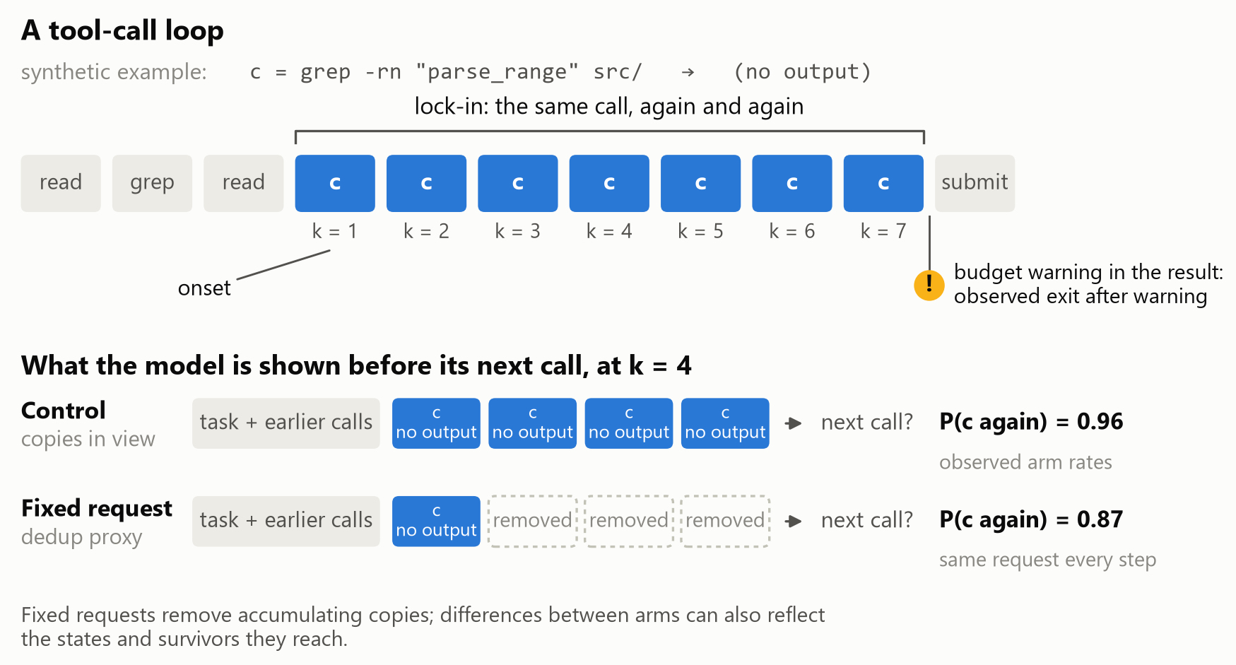
(b)
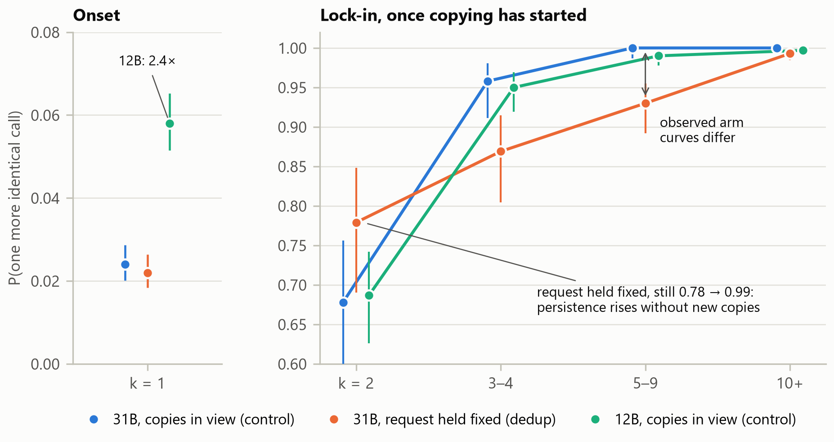
Figure 1. (a) A tool-call loop and the fixed-request test, on a synthetic call c. Before the next call at k = 4, the control shows every copy; the proxy collapses the run to its first turn. The rates illustrate pooled three-to-four-call bins, not probabilities of the synthetic call. (b) Continuation on clean transitions following well-formed calls; proxy values at k ≥ 2 additionally require complete collapse of the current run. Binomial 95% bars are descriptive and do not account for task clustering.
A rising continuation probability alone does not establish reinforcement. Suppose each state’s draws the same call again with a fixed probability p, as it does when the request is held fixed. Over the states where runs start, $h(k) = \frac{E[p^{k}]}{E[p^{k - 1}]}$, and since ${E[p^{k}]}^{2} ≤ E[p^{k - 1}] E[p^{k + 1}]$ (Cauchy–Schwarz), h(k) never falls with k, whatever the mix of states. This is analogous to frailty selection in survival analysis (Vaupel et al., 1979): more persistent states become enriched among survivors, so continuation rises and the corresponding exit hazard falls. Under a fixed request and stationary, independent draws within a state, the rise can arise through selection alone. Because the two arms reach different states and retain different survivors, their gap does not identify the fraction of the control curve caused by accumulating copies.
With the request fixed, the continuation probability still rises: 0.78 after two identical calls, 0.87 after three or four, 0.93 after five to nine and 0.99 after ten or more. High continuation persists without accumulating copies. In a separate analysis of all well-formed steps, paired differences over tasks (proxy minus control) are +7.6 points (−8.9 to +22.4) at k = 2, −7.0 (−13.3 to −0.8) at k = 3–4, and −4.1 (−7.3 to −1.1) at k = 5–9. These estimates include warning and compaction transitions and are not differences between the clean, fully collapsed values in Figure 1b. The between-arm differences are consistent with a contribution from copies, which the fixed-history edits test directly. Among runs of three or more calls that ended before the task, own exits occurred in 43 of 91 proxy runs (47%) and 16 of 107 control runs (15%; difference +32 points, +20 to +45). One step ahead, at 60 fixed histories after a search that found nothing, identical copies raise the probability of the same search from 0.002 with one copy to 0.43 with four. Re-spelled copies of it, with the same results, leave it near 0.03. The copies reinforce on their exact tokens.
On clean steps, Gemma 4 12B copies a fresh call 5.8% of the time, versus 2.4% for 31B. A separate all-step comparison gives +3.2 points (+2.2 to +4.2). Once copying begins, the observed continuation curves are similar; the all-step paired intervals include zero, which does not establish equivalence. We did not run the proxy at 12B, so the fixed-request selection test is limited to 31B.

5 Observed exits of long runs
In the 31B control at T = 0.2, no spontaneous exit was observed after five or more identical, well-formed calls on clean steps: 290 of 290 transitions continued at k = 5–9 and 1,052 of 1,052 at k ≥ 10. Of the 58 well-formed runs of ten or more, 43 ended after the harness's budget warning (“Only 10 tool call(s) remaining …”), 14 at a context compaction and one with the task. Neither exit helps much: after the warning at most ten calls remain, and after a compaction the agent sends the same call again 30–41% of the time. With the request held fixed, long runs end the same way (31 of 54 at the warning), and Gemma 4 12B ends only 4 of its 119 runs of ten or more itself. These observed long control runs ended following a budget warning, at compaction, or with task termination; this descriptive classification does not by itself identify the causal effect of either intervention. Malformed runs and the 12B control can end spontaneously.

6 What cues the copy
A clearer result does not stop the copy. At 101 states where an empty search had just been repeated (23 tasks), we rewrote the repeated results in a 2 × 2 design. Varying their IDs changes the probability of the copy by −0.005 (−0.009 to −0.002), and a faithful note (“The search completed and found zero matches …”) raises it slightly, by +0.020 (+0.005 to +0.036; its added tokens alone: −0.004). An instruction does move it: a controller's note that the call repeated the one before, and to try a different approach, took the probability of a third or later copy from 0.94 to 0.49, at other states. So does a break in the pattern. At the 56 copy states, ending the context with an empty thought takes it from 0.79 to 0.22; with an empty thought before every earlier call too, it returns to 0.82. The empty thought breaks the pattern; it does not switch the model's mode.
The model's own thinking does not supply that break. Free to think, it wrote a thought at 72% of second copies but at only 23% of third or later ones. At 213 looping states in 44 tasks, we forced a thought open for 32 tokens. Where the model had skipped the thought (114 states), the next call escaped 57.9% of the time, against 10.5% (+47.4 points, 33.0 to 61.1); where it had thought (99 states), forcing changed nothing (62.6% against 61.6%). The model skips thinking where a thought would help. These escapes are one step ahead (§9).

7 Breaking loops over whole tasks
Each lever changes the loops (Table 1). At T = 1, continuation remains 87% after three or more identical calls.
Table 1. Whole-task levers against the control, Gemma 4 31B on 109 tasks unless noted. Differences are lever minus control, paired over tasks, with 95% intervals from 2,000 task resamples. Resolution and share differences are in percentage points; run-length and frequency differences use calls and runs per task, respectively. The 12B comparison provides an observed large contrast, rather than a formal estimate of the minimum detectable effect.
Lever | Passes | Effect on loops | Resolved | Difference
None (control, T = 0.2) | 2 | stale 38.6% of calls; loop task runs 24.8%; run length 19.8 calls | 72 of 218 | –
T = 1 | 2 | stale −18.2 (−24.8 to −11.0); loop task runs 9.2% | 71 of 218 | −0.5 (−5.0 to +4.1)
Empty thought before every call | 1 | runs 9 calls shorter, +0.35 runs per task; stale +1.6 (−4.5 to +7.6) | 38 of 109 | +1.8 (−3.7 to +7.8)
Proxy: request held fixed | 2 | own exits of runs of 3+ 47% vs 15%; copies −2.6 (−8.2 to +2.8) | 73 of 218 | +0.5 (−3.7 to +4.6)
Gemma 4 12B, no lever | 2 | stale +14.8 (+8.9 to +20.7); loop task runs 44.5% | 24 of 218 | −22.0 (−29.8 to −15.1)
None of the three interventions produced a detectable improvement in resolution under the tested budget. T = 1 un-looped 46 of the control's 54 loop task runs: the control solved 10 of those tasks and T = 1 solved 9, spending the freed budget on new calls and source edits. In 23 of 24 such tasks in the first pass, the control's first stale call came before its first source edit. The resolution intervals retain uncertainty about small and moderate benefits; the two-pass design does not establish equivalence.

8 Related work
Repetition in text. Generators repeat themselves more with each repetition in context (Holtzman et al., 2020; Xu et al., 2022), and reasoning models loop at low temperature, where raising it is “a stopgap” (Pipis et al., 2026). Our tool-call loops show a similar rising curve, and holding the request fixed demonstrates that such a curve can arise without accumulating copies; fixed-history edits separately show reinforcement by identical copies.
Agents copying themselves. Agents condition on their own errors (Sinha et al., 2026) and imitate their earlier responses (Wan et al., 2026). In models up to 1.7B, a failed call-in context makes the same call likelier, mostly through its surface form (Gumaan, 2026); we find the same exact-token effect at 31B. On screened histories, agents take a third identical action after two 37% of the time (Liu et al., 2026); ours does 68% of the time. Gemma 4 31B without thinking also loops in another harness (Yuan et al., 2026).
Repeats as symptoms. In SWE-smith, warnings, resampling and temperature bumps cut repeats while resolution fell, and the authors read repeats as “symptoms of the model's difficulty” (Yang et al., 2025). Our three whole-task interventions provide further evidence that reducing repetition alone need not improve resolution, although their confidence intervals do not exclude useful benefits. Fork-and-Flush escapes idea basins when fresh-context branches are scored and the best is kept (Cai et al., 2026); a coding agent has no such score during a run, and removing the copies produced no detectable increase in resolution in our experiment.
Detectors. OpenHands acts after four identical action–observation pairs, and Gemini CLI after five identical calls (OpenHands, 2026; Gemini CLI, 2026). At 31B, lock-in is near complete after three.

9 Limits and implications
The evidence comes from two sizes of one model family (int4), with thinking off, in one harness, on 109 tasks from four repositories. The mechanisms and the levers were measured at 31B only; the 12B tests the descriptive claims. With two passes, the resolution estimates remain too uncertain to establish equivalence or exclude benefits affecting only a small number of tasks. The forced thought was tested one step ahead, never over whole tasks, and an escape one step ahead need not be progress. The probabilities we report are re-draws of the same call, not calibrated confidence, and nothing here looks inside the model. The empty-thought template and the proxy test mechanisms, not entries: a competition submission can change neither the chat template nor the requests.
Three things follow for agent builders. Lock-in is near complete by the third identical call, earlier than common detectors act. Raising the temperature, breaking the pattern, and removing copies altered repetition without producing a detectable resolution improvement. The results are consistent with loops marking difficult states, while leaving open a causal contribution of repetition to failure. A lever worth testing next acts where the model chose not to think, or brings the agent information it lacks. Breaking a loop can free budget, but these interventions did not demonstrate improved task recovery under the tested conditions.

GitHub Repository
https://github.com/usp787/Gemma4_paper_track

Use of AI tools
Claude (Anthropic) helped write the experiment and analysis code, checked the references, and drafted parts of this text from the author's records. ChatGPT (OpenAI) gave advice on the experiment’s design and helped interpret, analyze the experiment results and paper review. The author directed the study, revised the text, and is responsible for its content.

References
Cai et al. 2026. Fork-and-Flush: Escaping Idea Basins in Autoresearch Agents. arXiv:2610.07447.
Gemini CLI. 2026. Loop detection service (packages/core/src/services/loopDetectionService.ts, commit acae712). https://github.com/google-gemini/gemini-cli.
Google. 2026. Gemma 4 model card. https://ai.google.dev/gemma/docs/core/model_card_4.
Gumaan. 2026. Feedback That Backfires: Why Small Language Model Agents Repeat the Call They Just Watched Fail. arXiv:2608.23651.
Holtzman et al. 2020. The Curious Case of Neural Text Degeneration. ICLR. arXiv:1904.09751.
Hugging Face. 2026. google/gemma-4-31B-it, pull request #147. https://huggingface.co/google/gemma-4-31B-it/discussions/147.
Liu et al. 2026. When History Fails to Become Experience: Action Calibration in Language Agents. arXiv:2610.02769.
OpenHands. 2026. StuckDetector (openhands/controller/stuck.py, commit 6e4ac8e). https://github.com/OpenHands/OpenHands.
Pan et al. 2025. Training Software Engineering Agents and Verifiers with SWE-Gym. arXiv:2412.21139.
Pipis et al. 2026. Wait, Wait, Wait… Why Do Reasoning Models Loop? ICML. arXiv:2512.12895.
Sinha et al. 2026. The Illusion of Diminishing Returns: Measuring Long Horizon Execution in LLMs. ICLR. arXiv:2509.09677.
Vaupel et al. 1979. The Impact of Heterogeneity in Individual Frailty on the Dynamics of Mortality. Demography 16(3), 439–454. doi:10.2307/2061224.
Wan et al. 2026. Mitigating Conversational Inertia in Multi-Turn Agents. ICML. arXiv:2602.03664.
Xu et al. 2022. Learning to Break the Loop: Analyzing and Mitigating Repetitions for Neural Text Generation. NeurIPS. doi:10.52202/068431-0223.
Yang et al. 2025. SWE-smith: Scaling Data for Software Engineering Agents. arXiv:2504.21798.
Yuan et al. 2026. Agentic AI Workload Characterization. arXiv:2605.26297.

