Loading the data from HDFS to Pig, Parsing the data & processing according to the requirement.
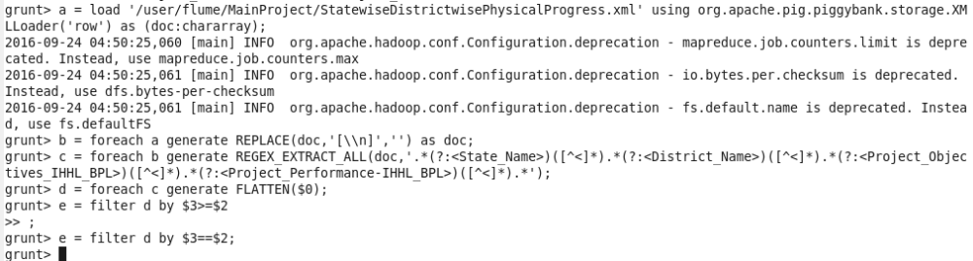
Dump of the above statement. & Storing the result to HDFS.
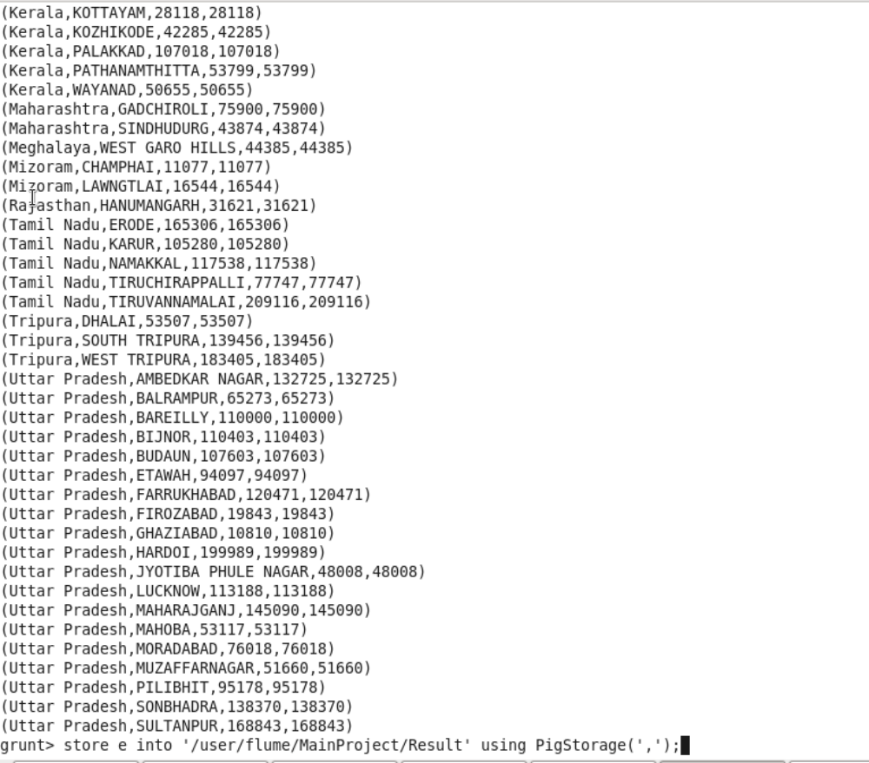

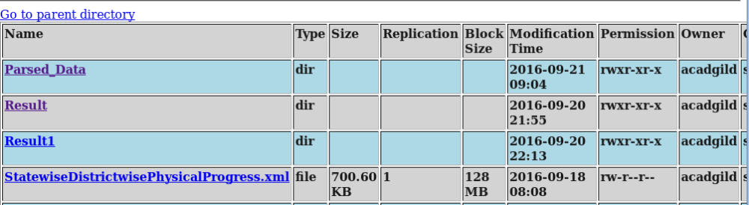
Create a table in mysql
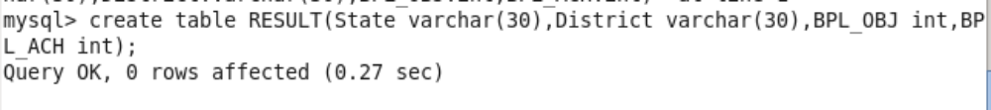
Export the result to mysql using sqoop command
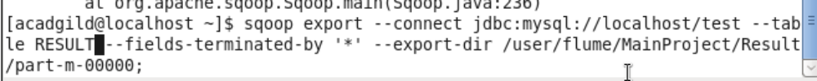
Find the data in mysql after export.
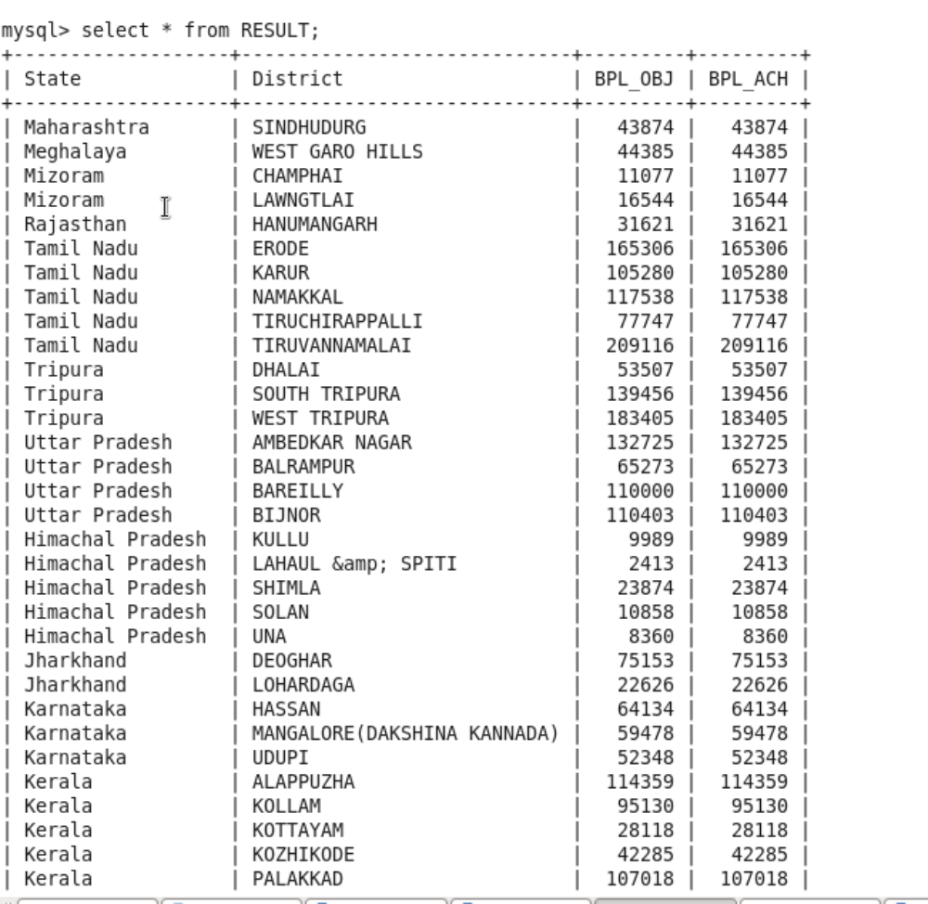
Districts which reached 80% and above
Java Code to calculate Disctircts who have reached the milestone of 80%
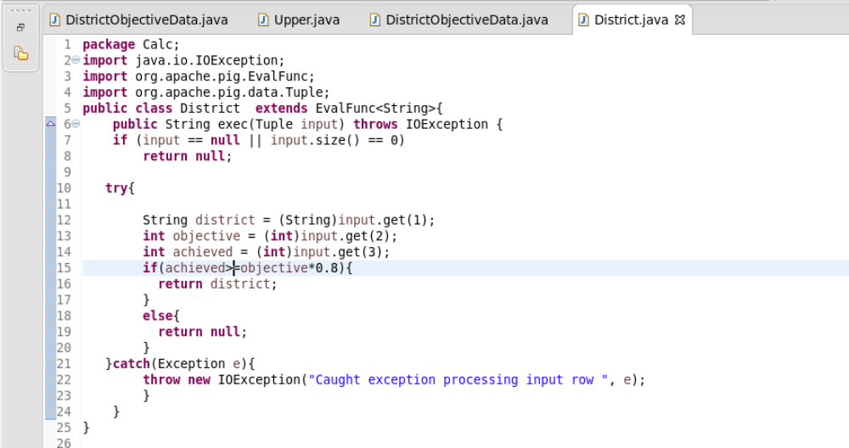
Exporting the above code into District.jar file
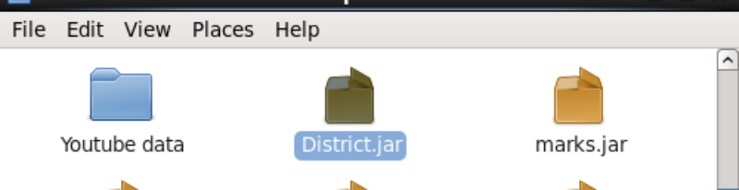
Next we have to load the xml data, Parse it & process according to the requirement
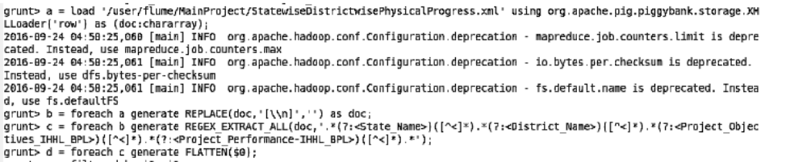
Store it in HDFS as we are going to use it for Pig UDF
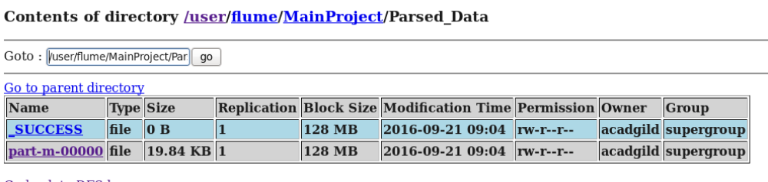
Next Register the jar, load the data from hdfs into a bad, process it using the pig UDF and get the result.
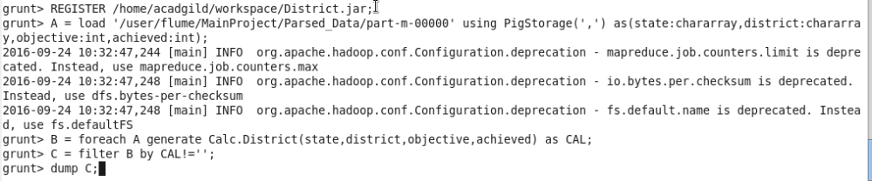
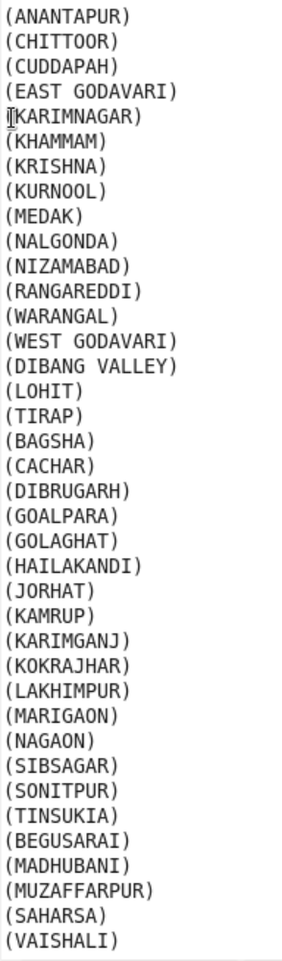
Store C into hdfs
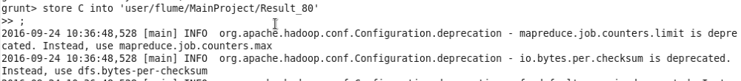

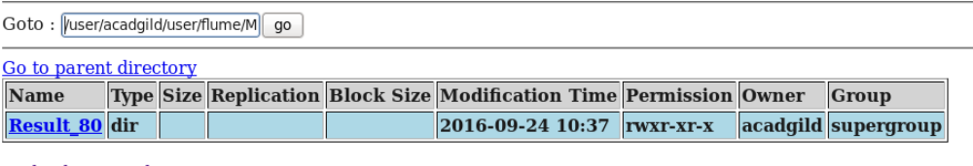
Create a table in sql to export the data to sqoop
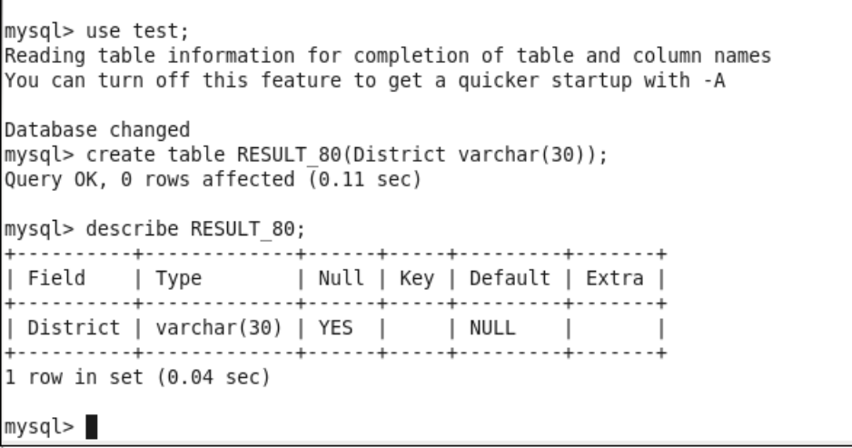
Export the data to sqoop
