Hudson Founding Comparison Chart

 | Hudson Bay Company (Crown Corporation) | Dominion of Canada (Crown Corporation) | Hudson Republic (Sovereign Republic)
Banner / Image | 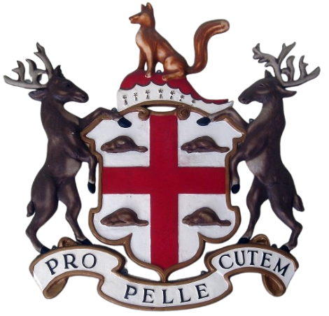 | 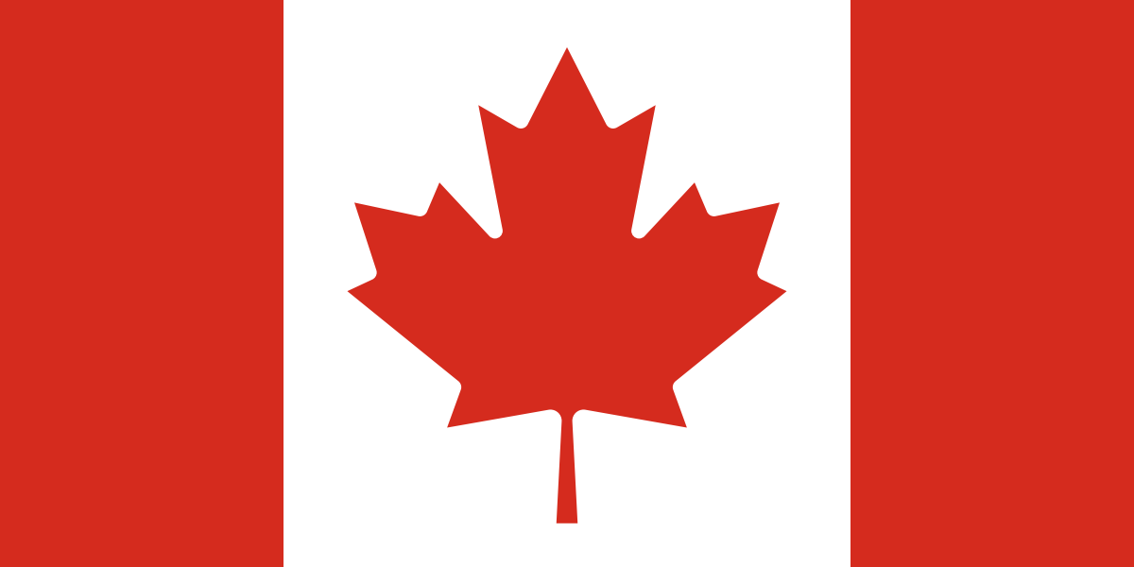 | 
National Mascot | Beaver and Crown | Maple Leaf (Acer saccharum) | Beaver
Ethos / Character | Survival / Trade | Bureaucratic Administration | Engineering / Enterprise / Stewardship
Founding | Discovery (Fur trade) | Controversial Trade Deal | Necessity (Escaping the crown's exploitation)
Territory | Hudson Bay Region (Rupert's Land, old NWT, Province of Canada Lower/Upper) | Today's modern Canada | Manitoba, Ontario, except the satellite states GTA and Ottawa. Quebec and others may be pitched to as satellite state members.
Country Codes | N/A | CAN / CA | HRP
Birth Date | May 2nd, 1670 | July 1st, 1867 | April 1st, 2026 (Google drive drop for private members only, then released in June 2026 on Github).
Collapse Trigger | Red River Resistance (1869) | Freedom Convoy (2022) | N/A
Wind down event | Creation of the dominion of Canada | CUSMA/USMCA expiration, Alberta 2026 referendum, Quebec 2028 referendum | N/A
Wrap up event / Death Date | Deed of Surrender (1870) | External Unilateral trade pressure and Western Alienation. Approximately (Q2, Q3 2027) | Potentially Quebec take over, hence the satellite state status
Those responsible for the creation | Settlers | Prime Minister Sir John A MacDonald | Hudson Republic team.
Those responsible for the collapse | Sir John A MacDonald | Former PM Justin Trudeau / Current PM Mark Carney | N/A

