Git
Document Update: 16.11.2017

Table of Contents
Git References 1
Installation 2
Git "config" 2
Working with a Local Repository 2
Create a new Git repository 2
Git "add" 2
Git "commit" 2
Git "status" 2
Working with a Remote Repository 2
Put your own local repository to a server 2
Git "push" / "pull" 3
Git "clone" 3
Put your repository to GitHub 3
Branches 4
Examples 4
Git and Visual Studio Code 5
Step-1: Create a new Angular project 5
Step-2: Make changes 5
Step-3: Stage changes 5
Step-4: Commit changed files 5
Step-5: Create new files 6
Ignoring files 6
Command summary 7

Git References
- https://git-scm.com
- https://git-scm.com/book/en/v2 (Pro Git book)
- https://github.com/

Installation

Git "config"
Setup your user name and email address:
$ git config --global user.name "John Doe"
$ git config --global user.email johndoe@example.com

Working with a Local Repository

Create a new Git repository
Create a new empty Git repository in the current directory:
$ git init
Create a new folder named "git-demo" with an empty Git repository:
$ git init git-demo

Git "add"
Add files to a repository:
$ git add xyz.txt
$ git add *.xlsx

Git "commit"
Commit a single file to your local repository:
$ git commit xyz.txt -m "Some commit text"
Note:
- you must supply a commit text
- commit is always to your local repository only

Git "status"
View the status of a repository:
$ git status
Example:
C:\Work\WebDev\repo\playground\WebVisionera>git status
On branch sandbox
nothing to commit, working tree clean

Working with a Remote Repository

Put your own local repository to a server
Create a (local) bare repository from your local repository:
$ git clone --bare play-it play-it.git
Copy the bare repository to a server:
$ xcopy play-it.git \\gitsrv\repo\test /e
Add (connect) the remote server to your repository:
$ git remote add origin \\gitsrv\repo\git-docs
Display the remote servers:
$ git remote -v

Git "push" / "pull"
Now you can "push" your changes to the server:
$ git push origin master
"Pull" from the remote server:
$ git pull origin master

Git "clone"
Anyone can now clone the repo from the (remote) server to local storage:
$ git clone //gitsrv/git-test/git-docs C:\work\myrepos\git-docs
Clone a repository from github:
$ git clone "https://github.com/ussebatz/angular"

Put your repository to GitHub
Create an empty repo on GitHub (e.g. "tour-of-heroes").
Add the repository:
$ git remote add origin https://github.com/ussebatz/tour-of-heroes
Push the local repo to GitHub:
$ git push -u origin master

Branches
Create a new branch:
$ git branch testing
Switch to a branch (in order to work on that branch):
$ git checkout testing
Create a branch and switch to that branch:
$ git checkout -b branch53
Delete a branch:
$ git branch -d branch53
View current branches:
$ git branch
Push branch "TAC102":
$ git push origin TAC102

Examples
Show available branches:
C:\Work\WebDev\repo\playground\WebVisionera>git branch
master
* sandbox
Switch to branch 'master':
C:\Work\WebDev\repo\playground\WebVisionera>git checkout master
Switched to branch 'master'
Your branch and 'origin/master' have diverged,
and have 4 and 24 different commits each, respectively.
(use "git pull" to merge the remote branch into yours)

Git and Visual Studio Code

Step-1: Create a new Angular project
$ ng new play-info
VS Code will create the Angular project including some required files. By default VS Code will also automatically setup a new Git repository in the new folder.
The repository will include all the required source files, but will not include generated files (e.g. "node_modules").
The files and folders that are not to be included into the Git repository are listed in ".gitignore".
You can open the new project in VS Code.

Step-2: Make changes
Make changes to some files. The changed files are indicated "M" (modified).
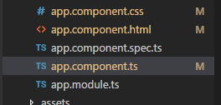

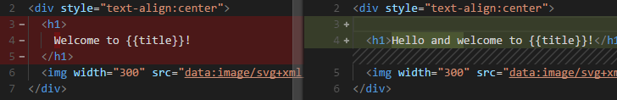
You can view the differences.

Step-3: Stage changes
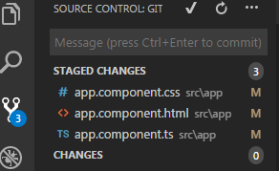

Step-4: Commit changed files
After commit there are no changed files.

Step-5: Create new files
Create new files, new files are indicated as "U" (untracked):
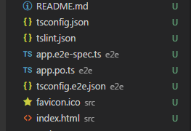

Stage changes, then the new file is indicated "A" (added).
Commit changes.

Ignoring files
Create a .gitignore file.
TODO

Command summary
Git Command | Purpose
git config –global  user.name "Herbert"  git config –global  user.email "email@address"  git config --list | Configure a user.  Configure a user's e-mail.  List the current configuration settings.
git init  git init Project1 | Create a new repository in the current folder.  Create a new folder 'Project1' and init a git repository in that folder.
git clone https://github.com/libgit2/libgit2 | Clone an existing repository.
git add file1.txt  git add *.cpp  git add css | Add a single file to the project.  Add multiple files.  Add a folder.
git rm somefile.txt | Remove a file
git log | View commit history.
git status
"fetch" | Download from remote repository (but do not merge).
"pull" | Download and merge.
git commit -m"Some Message" | Takes all the file contents that have been staged with git add and records a new permanent snapshot in the database. Adds a message to the commit.

