# Association:

If two classes need to communicate with each other then there must be a link and that link is called association.

# Aggregation:

If two classes need to communicate with each other and each class can survive without any dependency of another class so this type of link is called aggregation.

# Composition:

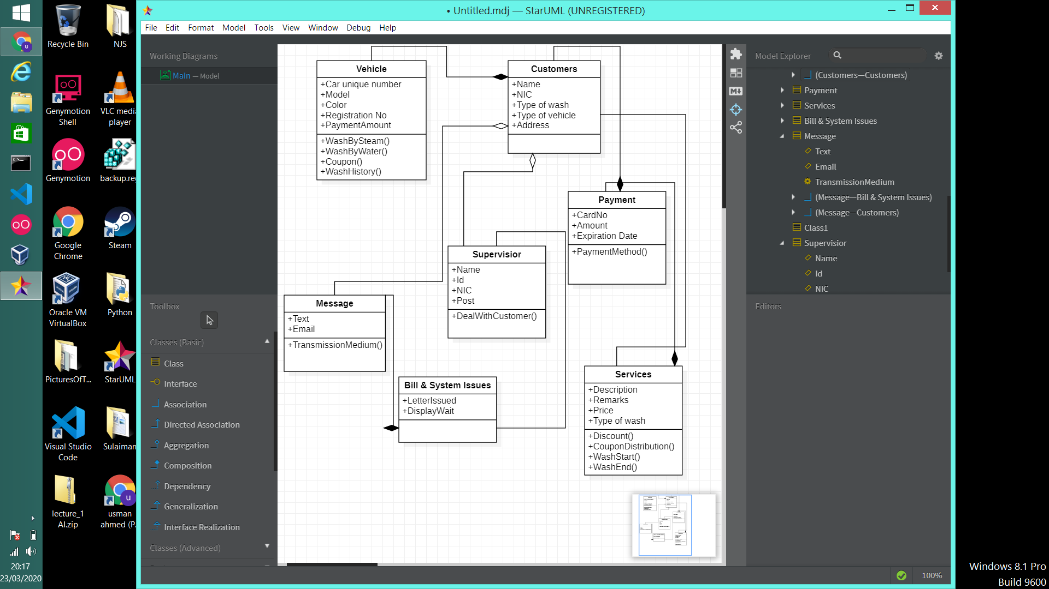If two classes need to communicate with each other and each class cannot survive or exist without the other class so the link established between them is called composition.

