Week 3 Selenium Automation Project Documentation

Introduction
This project is an automation testing framework developed as part of Week 3 Selenium practice.
The purpose of this project is to automate an e-commerce application using Selenium WebDriver with Java.
The framework is designed using Page Object Model (POM) and Behavior Driven Development (BDD) using Cucumber.
The application workflow covers complete checkout functionality:
1. Open catalog
2. Search products
3. Add products to cart
4. Verify cart items
5. Checkout and place order
6. Verify confirmation message
This project simulates real user actions and validates the application behavior.

Detailed Project Structure
1. bdd package:
Contains all Cucumber step definitions and runner files.
- CheckoutSteps.java:
Maps feature file steps to Java methods. Each Given/When/Then step in feature files calls a method here.
Example:
'Given the catalog is open' opens CatalogPage.
- Hooks.java:
Contains setup and teardown methods.
Before scenario -> launches browser.
After scenario -> closes browser and captures screenshots on failure.
- World.java:
Shared context object used to store driver and page references across steps.
- RunCucumberTest.java:
JUnit runner for executing Cucumber scenarios.
2. pages package:
Contains page classes following Page Object Model.
- BasePage:
Parent class containing common Selenium methods such as click(), text(), visible(), wait().
- CatalogPage:
Handles product catalog search and product listing.
- ProductPage:
Handles individual product page actions like Add to Cart.
- CartPage:
Handles cart validations and checkout navigation.
- CheckoutPage:
Handles final order placement and confirmation.
3. components package:
Reusable UI components.
- Header:
Contains navigation/header actions.
- CartBadge:
Validates cart count.
- ProductCard:
Reusable product card behavior.
4. support package:
Framework setup utilities.
- Config:
Reads properties files.
- DriverFactory:
Creates ChromeDriver and browser settings.
5. tests package:
JUnit Selenium test classes.
6. resources:
Contains feature files and configuration properties.
7. target:
Generated build files, reports, screenshots, cucumber reports.

Feature File Explanation
Feature file describes behavior in plain English.
Feature: Catalog checkout
This means we are testing checkout functionality.
Background:
Given the catalog is open
This step runs before every scenario so browser starts from catalog page.
Scenario 1: Smoke Test
Buy one product and complete order.
Scenario Outline: Regression Test
Uses multiple products:
- headphones
- shoes
- lamp
Examples table supplies test data.
Scenario 3:
Validates empty cart behavior.

CheckoutSteps Detailed Explanation
Method 1:
theCatalogIsOpen()
Creates CatalogPage object and opens catalog URL.
Method 2:
iSearchFor(String query)
Takes product name from feature file and searches it in catalog search box.
Method 3:
iAddTheFirstResultToTheCart()
Opens first product result and adds item to cart.
Method 4:
theCartBadgeShows(int count)
Checks cart badge count matches expected value.
Method 5:
iOpenTheCart()
Clicks cart icon and opens cart page.
Method 6:
theCartHasLineItems(int count)
Validates number of products inside cart.
Method 7:
iPlaceOrder()
Moves to checkout and places order.
Method 8:
theOrderIsConfirmed()
Verifies confirmation message contains 'confirmed'.

Execution Steps
1. Open IntelliJ.
2. Open project.
3. Ensure Maven dependencies downloaded.
4. Start application server.
5. Run command:
mvn test '-Dtest=bdd.RunCucumberTest' '-Dcucumber.filter.tags=@smoke'
For regression:
mvn test '-Dtest=bdd.RunCucumberTest' '-Dcucumber.filter.tags=@regression'
After execution:
Check terminal logs and cucumber reports.

Screenshots

1.Project structure.

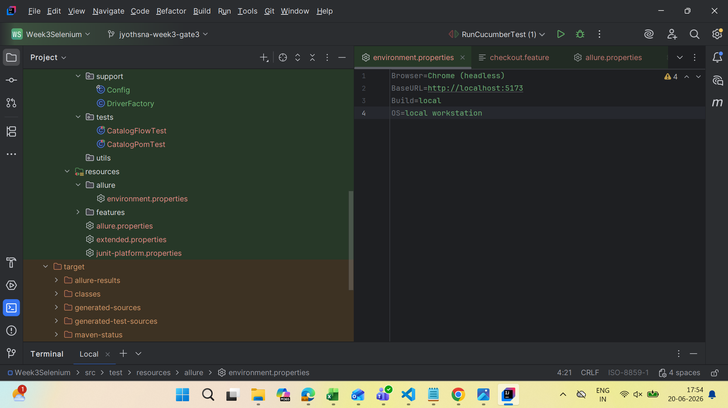

2.Running somke test of Cucumber

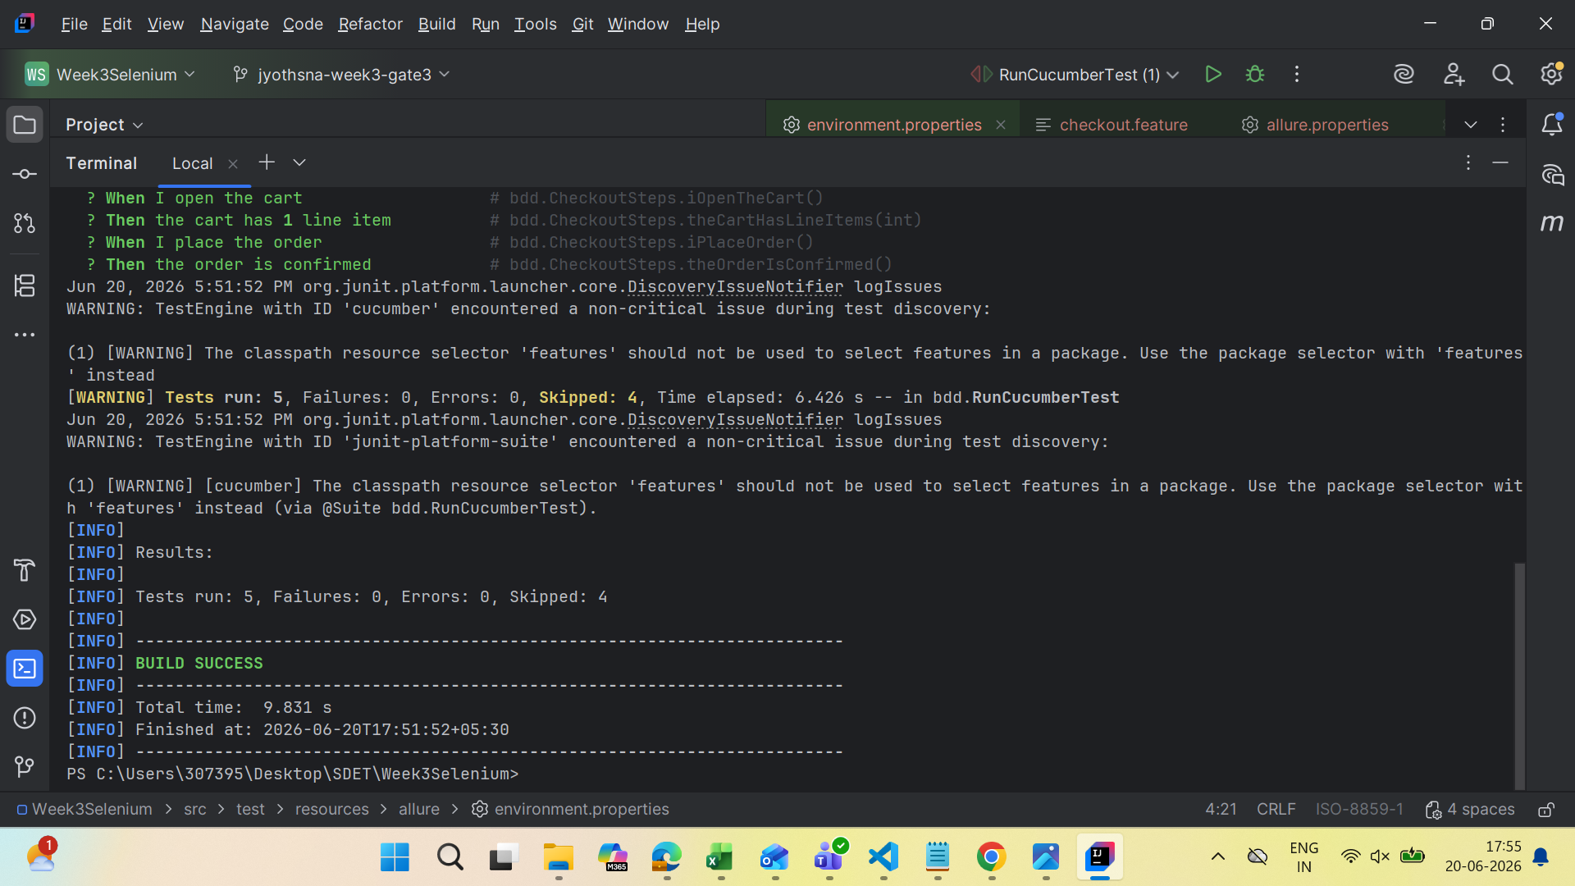

3.Running Full-Flow of the Catalogpage
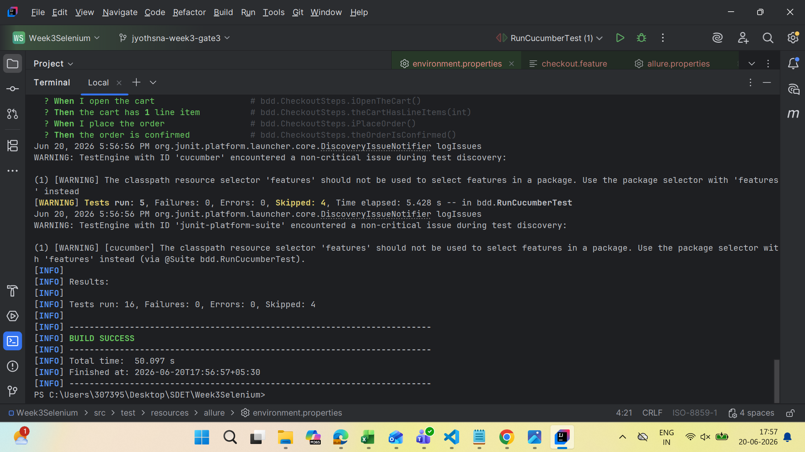

4. The report of the flow.
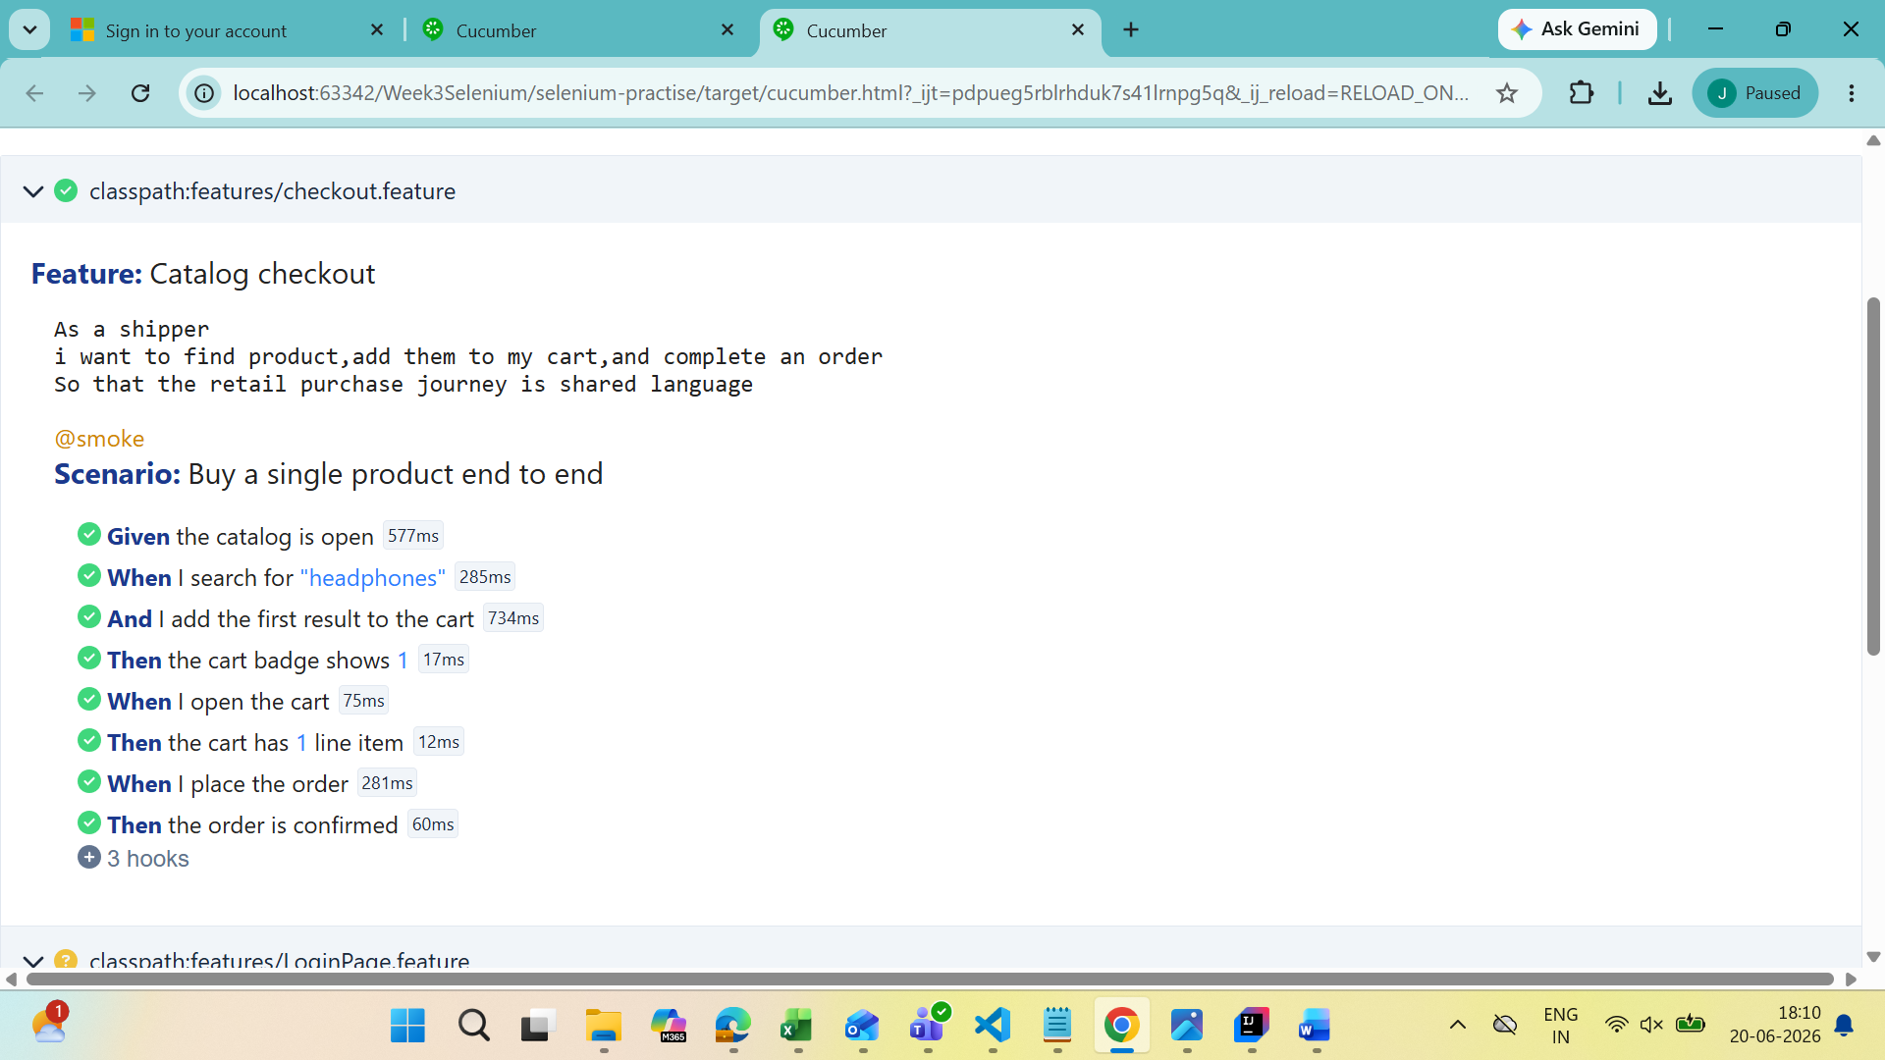

Conclusion
This Selenium automation project helped in understanding automation framework design,
Page Object Model, BDD implementation, debugging, waits, assertions, and report generation.
The framework is scalable and maintainable for future enhancements.

