Selenium Testing
To perform Api testing on https://restful-booker.herokuapp.com/booking using rest-assured

Tests Performed
Test 1: Post request for booking
- Prepare the payload
- Send the post request to ‘/booking’
- Verify the response status code (200) and response
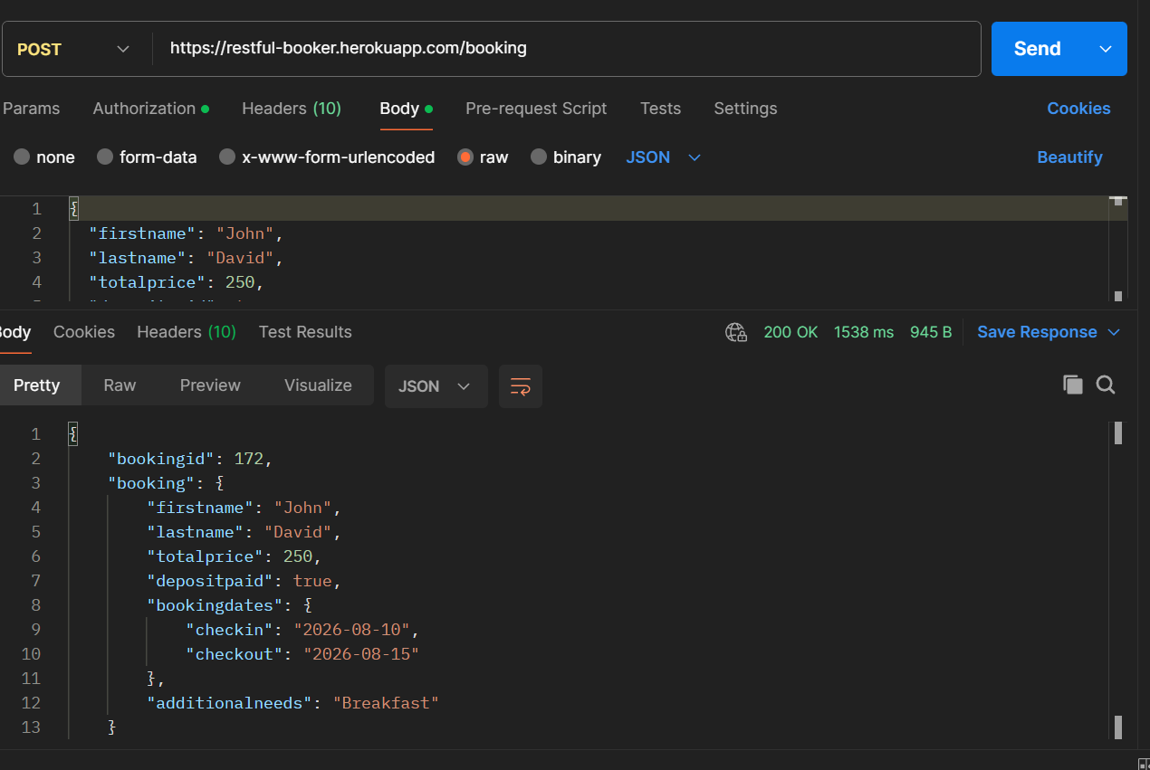
Test 2: Get request for retrieving booking
- Prepare the payload
- Send the get request to ‘/booking/{id}’
- Verify the response status code (200) and response
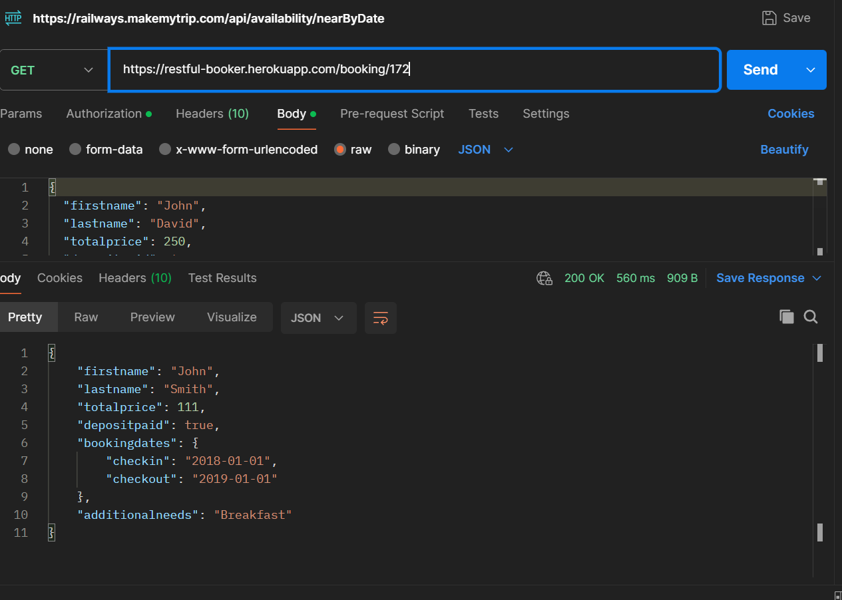

Sample Data

Environment & Setup
A new java project in Intellij

Folder Structure
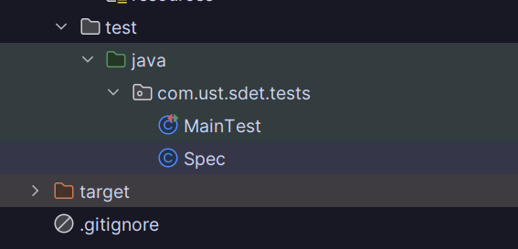
MainTest:-Contains the test functions for testing the post and get requests
Spec:-Contains the required specs like setup for helping with api requests

Pom.xml – Contains the dependencies
junit-jupiter ---> For the test Tag recognitions
rest-assured ---> provide the functions given,when, then for the rest api calls and response handling
json-schema-validator --->provides the function for schema validation
hamcrest matchers --> provides the functions for assertions
maven-surefire plugin ---> Helps in running the Test files and setting up the configuration

Results:
